Additional Problems: Periodic Functions

**Reflections**

**Some problems include the solution. Please remove before sharing with students.**

1. Using $g\left(x\right)=3cosx$, find the y-values in the second row of the table by substituting each x-value in to the function. Which of the following is the graph of ?

|  |  |  |  |  |  |
| --- | --- | --- | --- | --- | --- |
|  |  |  | 0 |  |  |
|  |  |  |  |  |  |

* 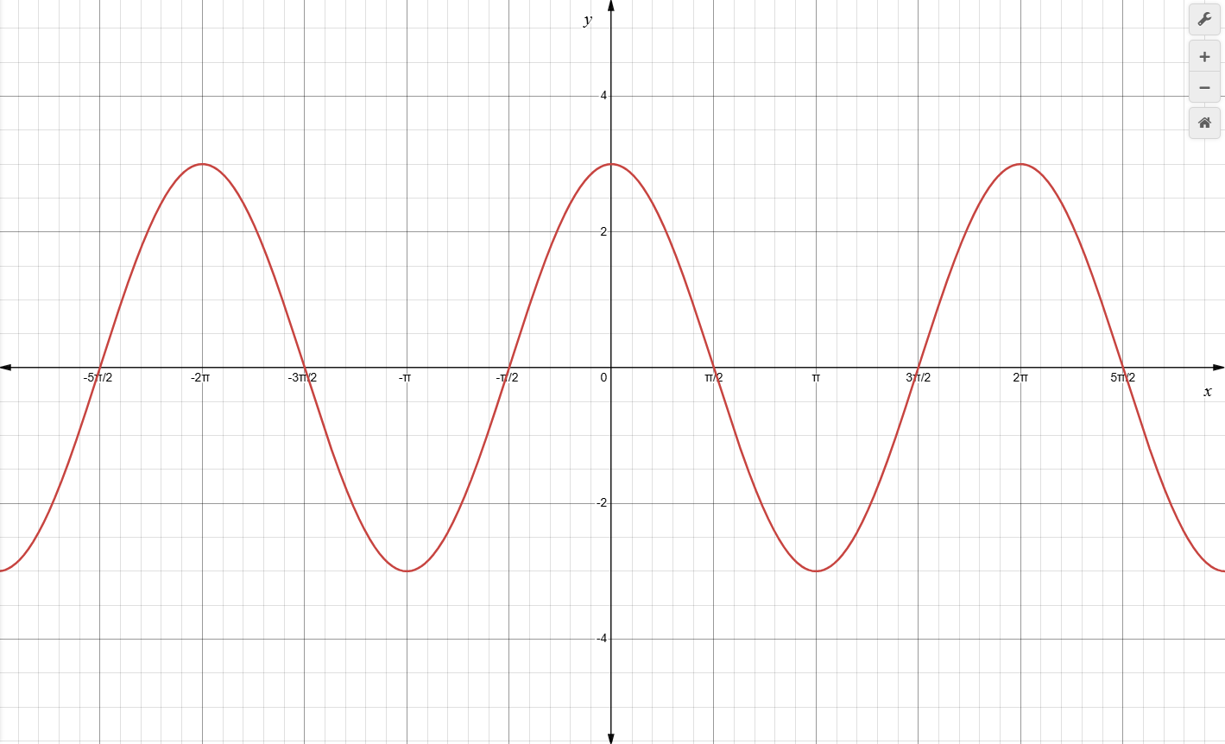
* 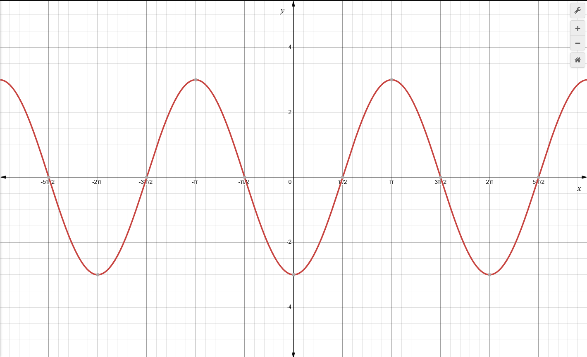
* 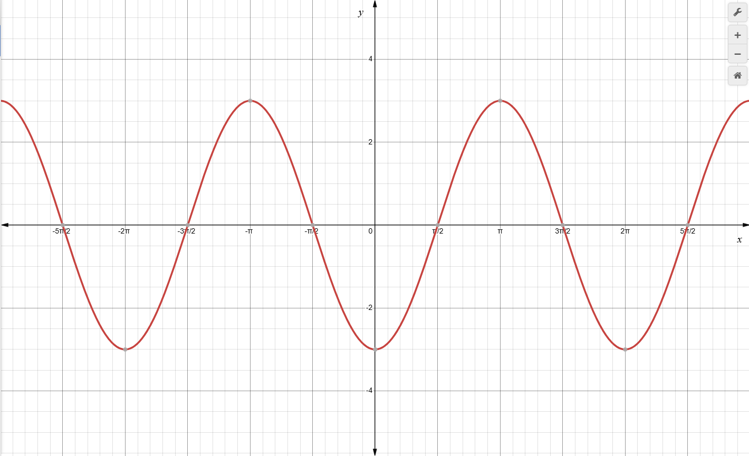
* 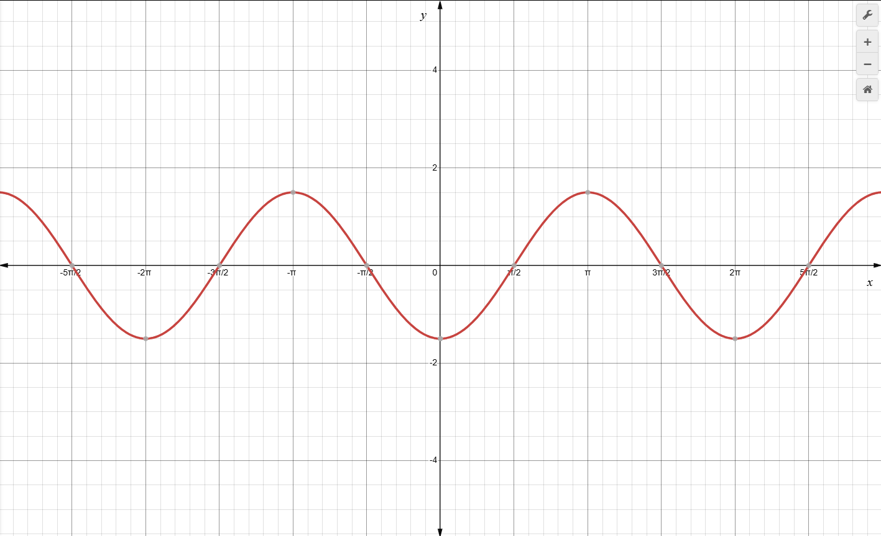

**Solution: 

1. Using , find the y-values in the second row of the table by substituting each x-value into the function. Which of the following is the graph of ?

|  |  |  |  |  |  |
| --- | --- | --- | --- | --- | --- |
|  |  |  |  |  |  |
|  |  |  |  |  |  |

* 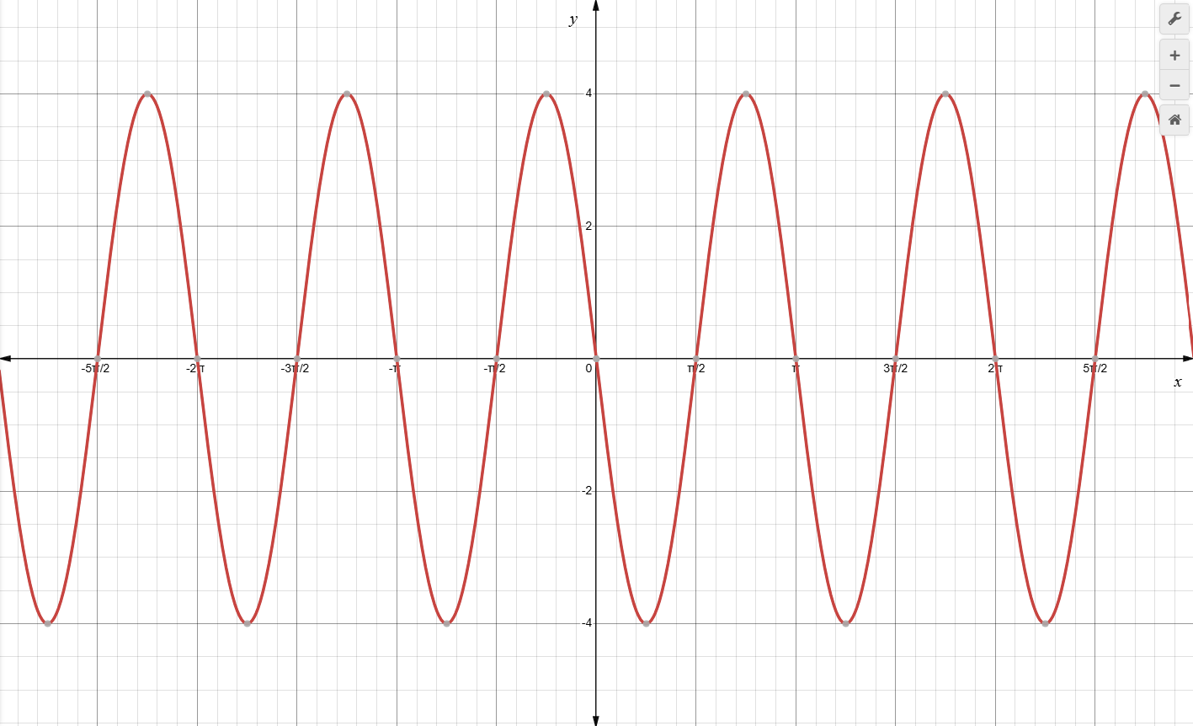
* 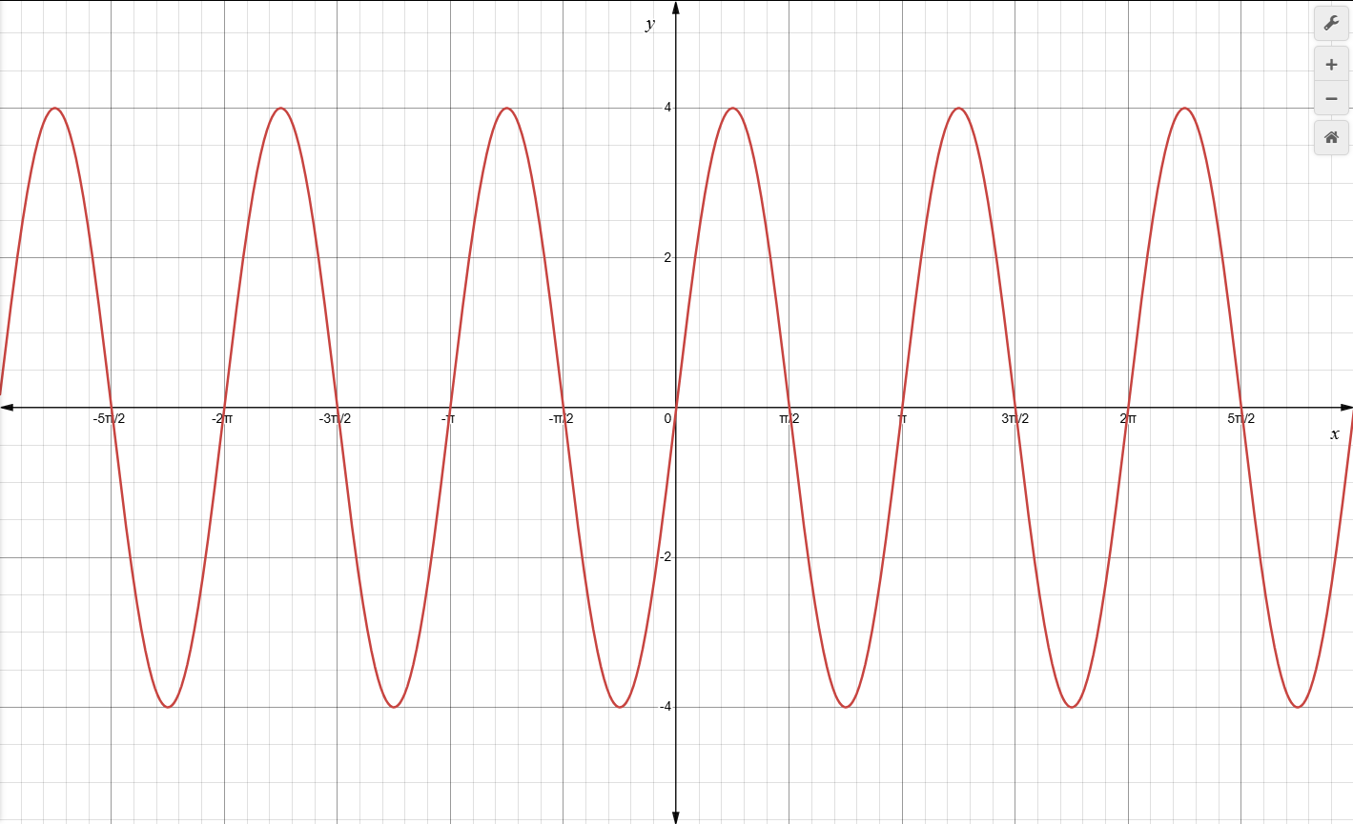
* 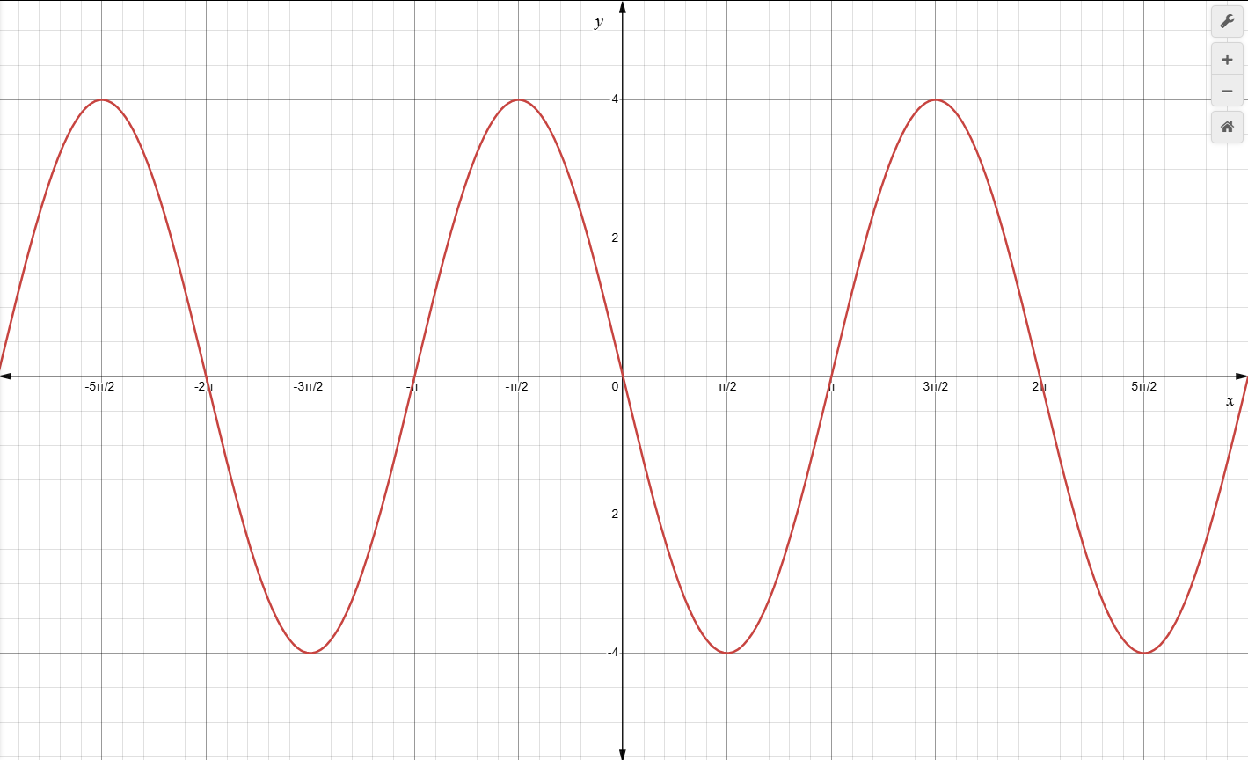
* 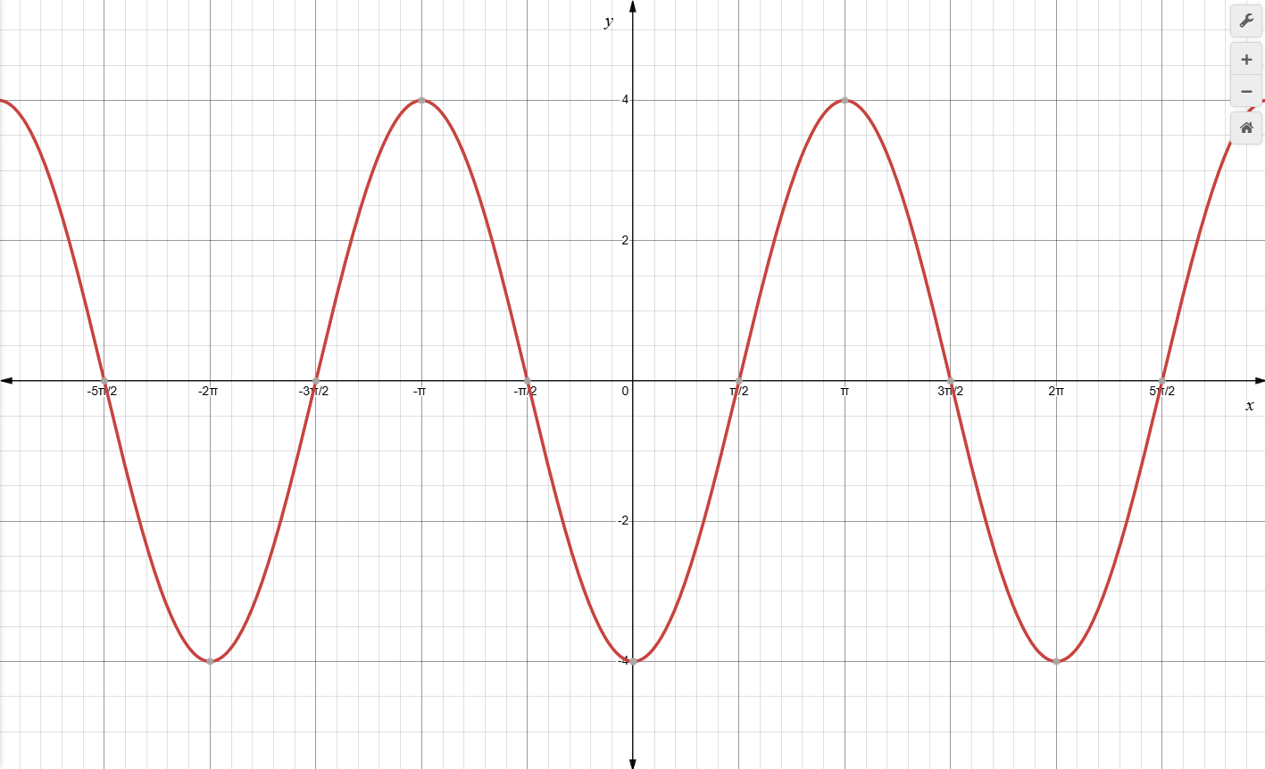

**Solution: 

1. Using , find the y-values in the second row of the table by substituting each x-value into the function. Which of the following is the graph of ?

|  |  |  |  |  |
| --- | --- | --- | --- | --- |
|  |  | 0 |  |  |
|  |  |  |  |  |

* 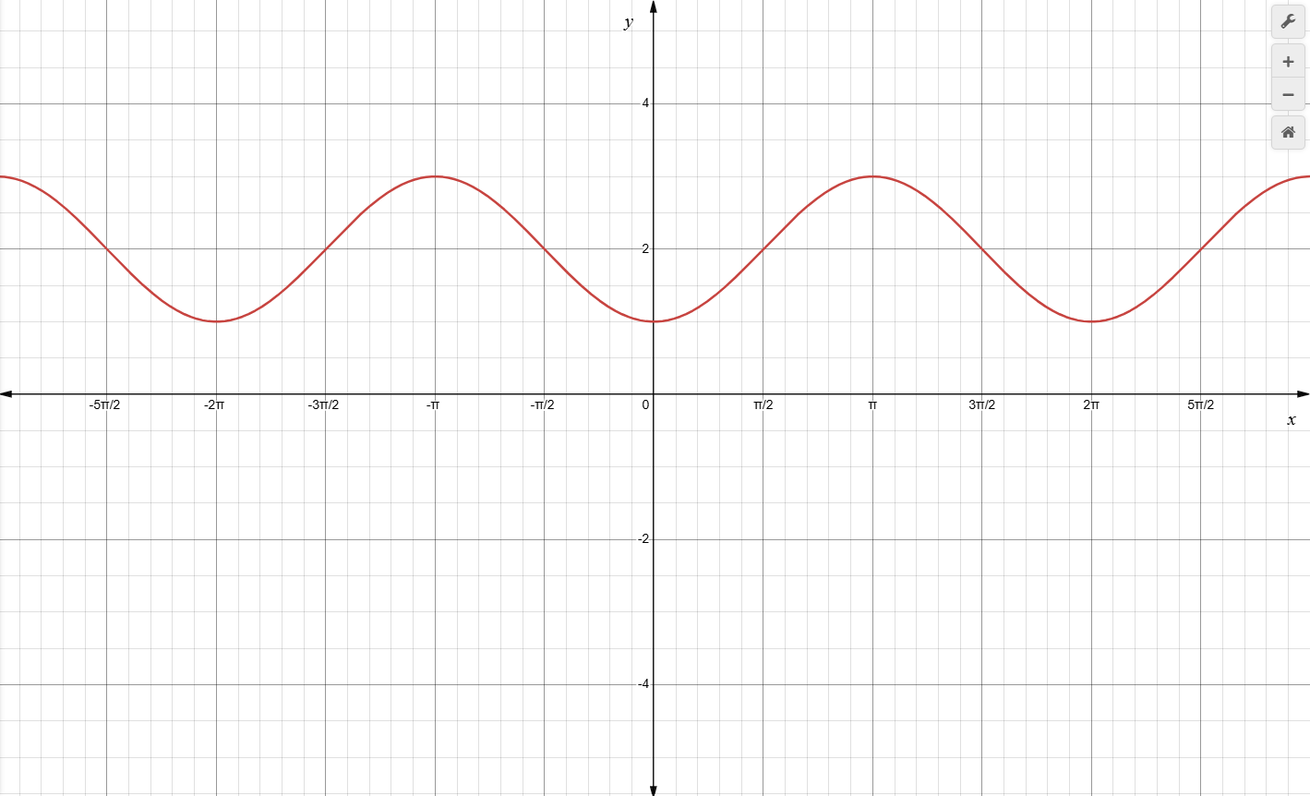
* 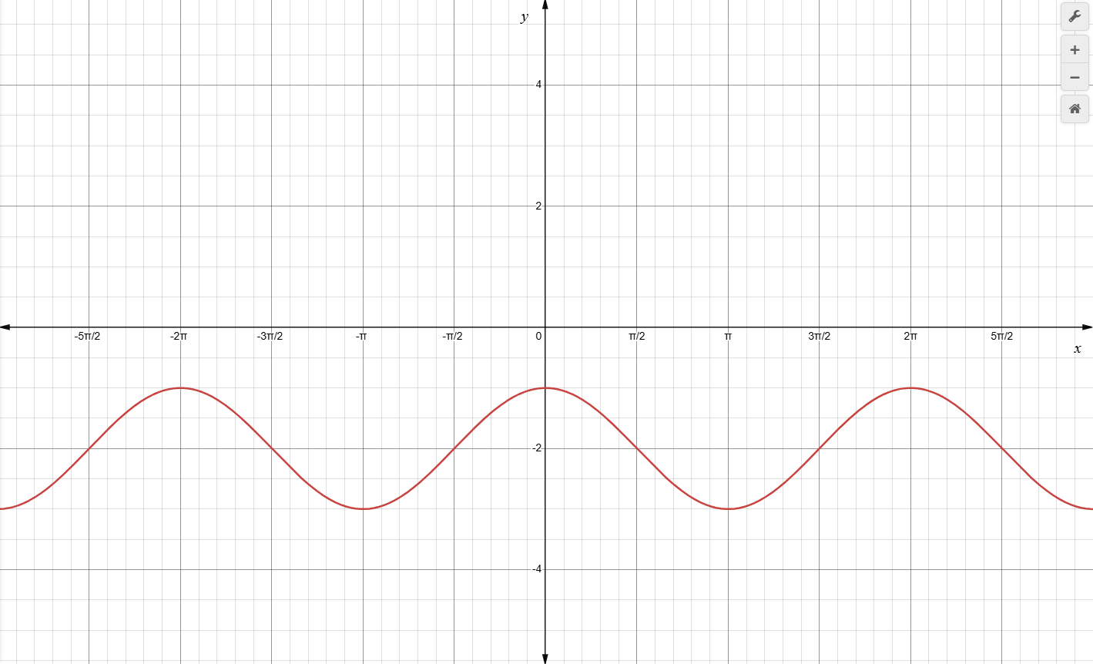
* 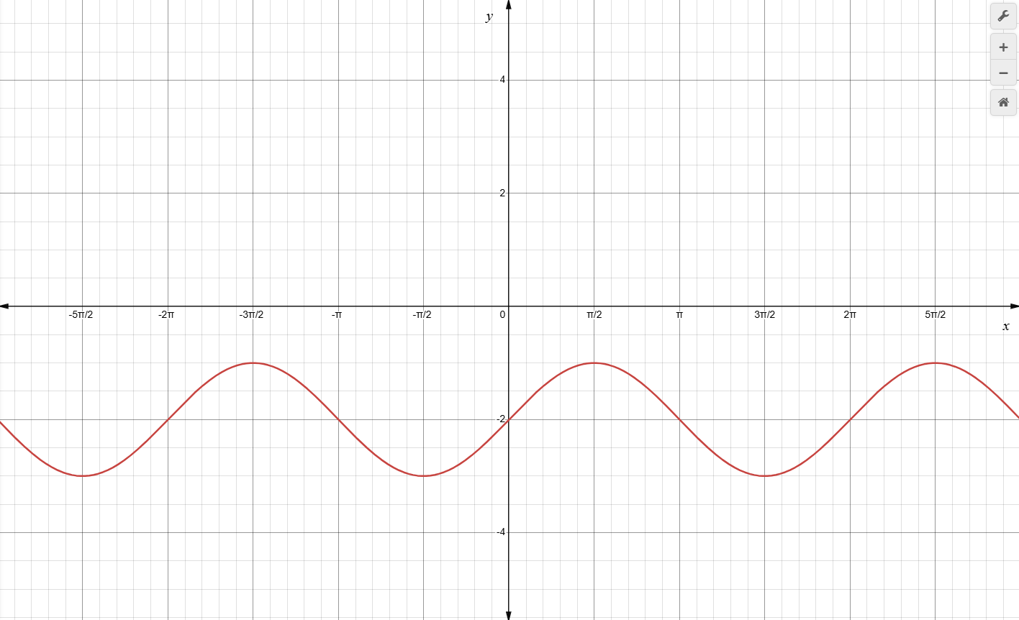
* 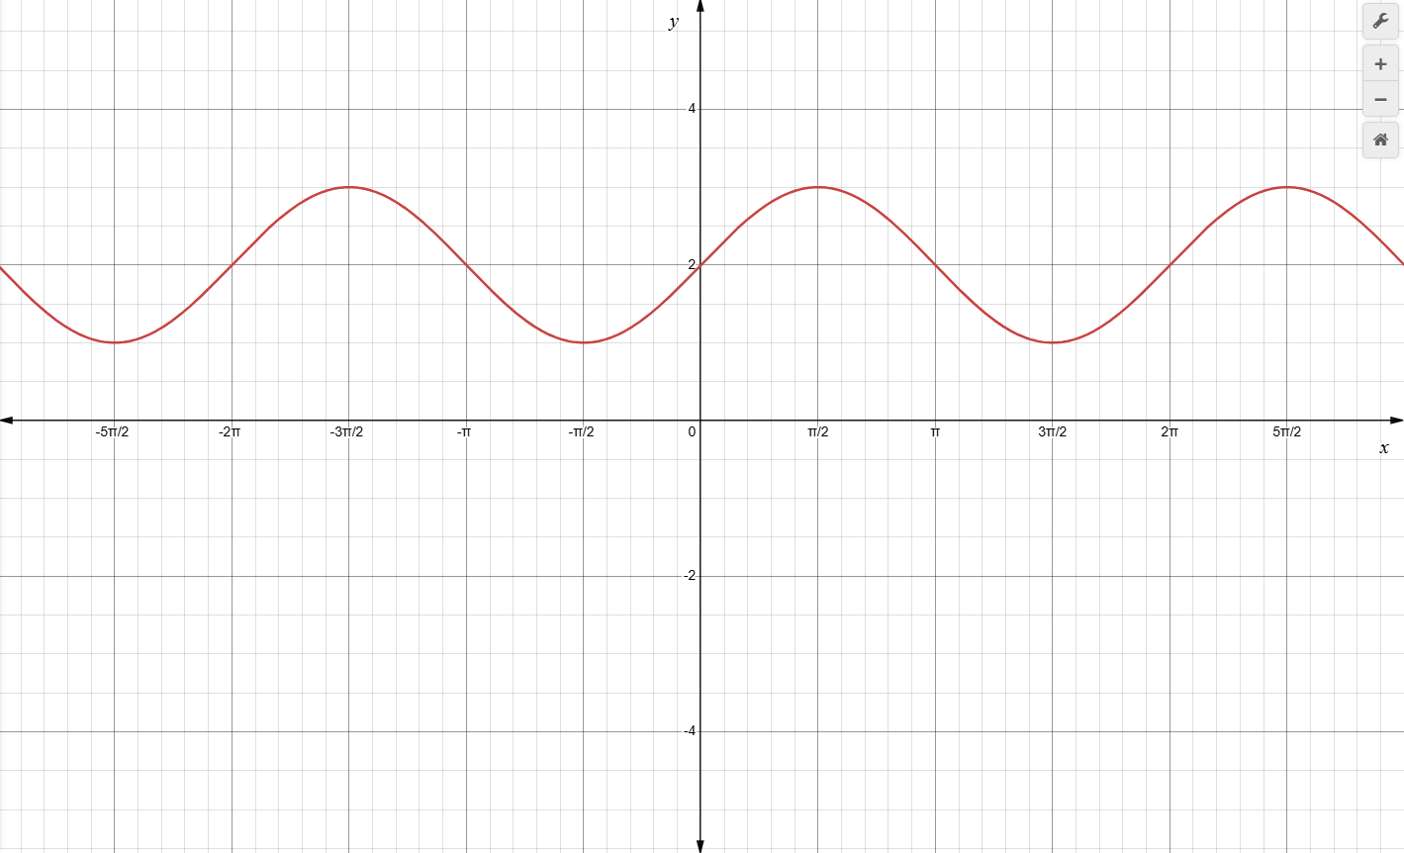

** Solution: 

1. Using , find the y-values in the second row of the table by substituting each x-value into the function. Which of the following is the graph of ?

|  |  |  |  |  |
| --- | --- | --- | --- | --- |
|  |  |  |  |  |
|  |  |  |  |  |

* 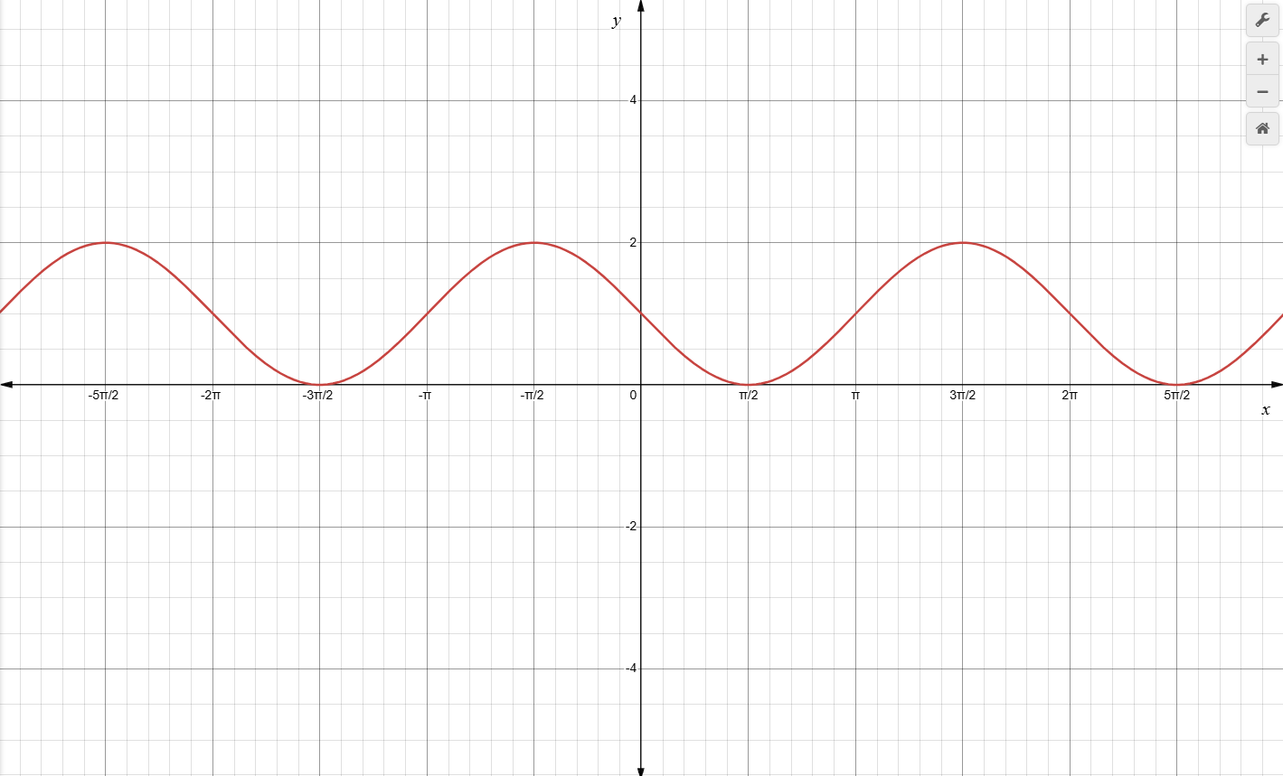
* 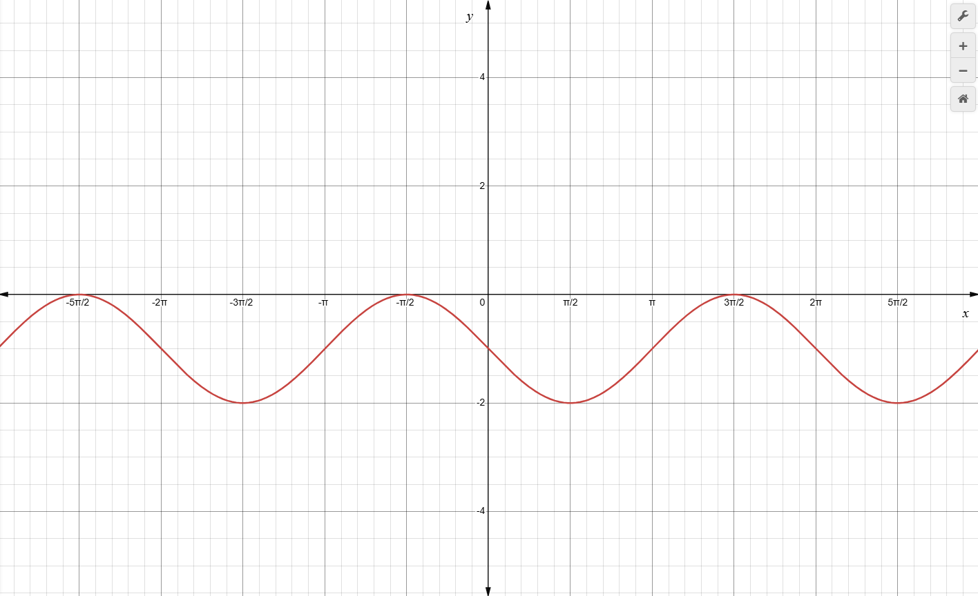
* 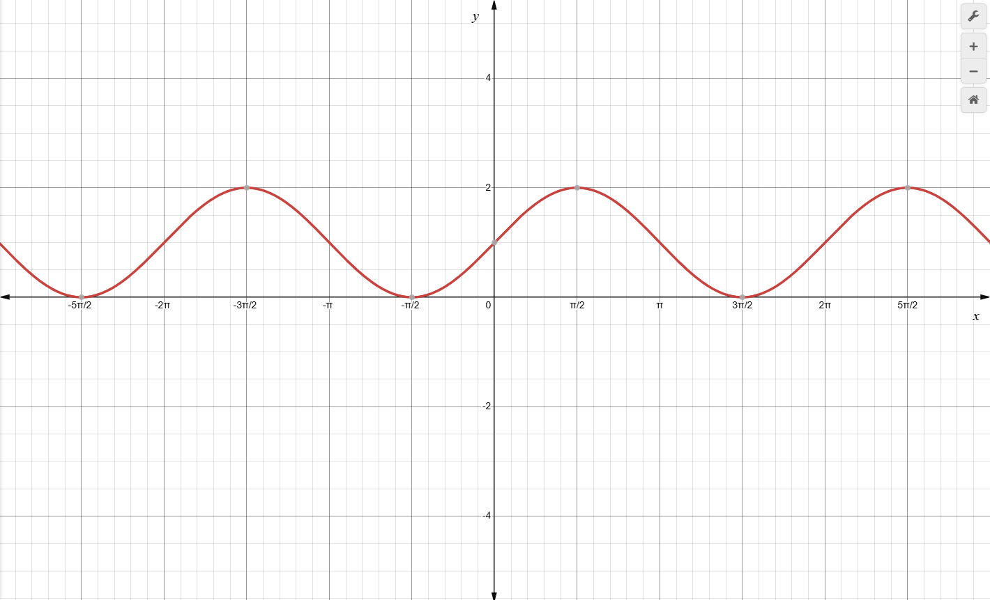
* 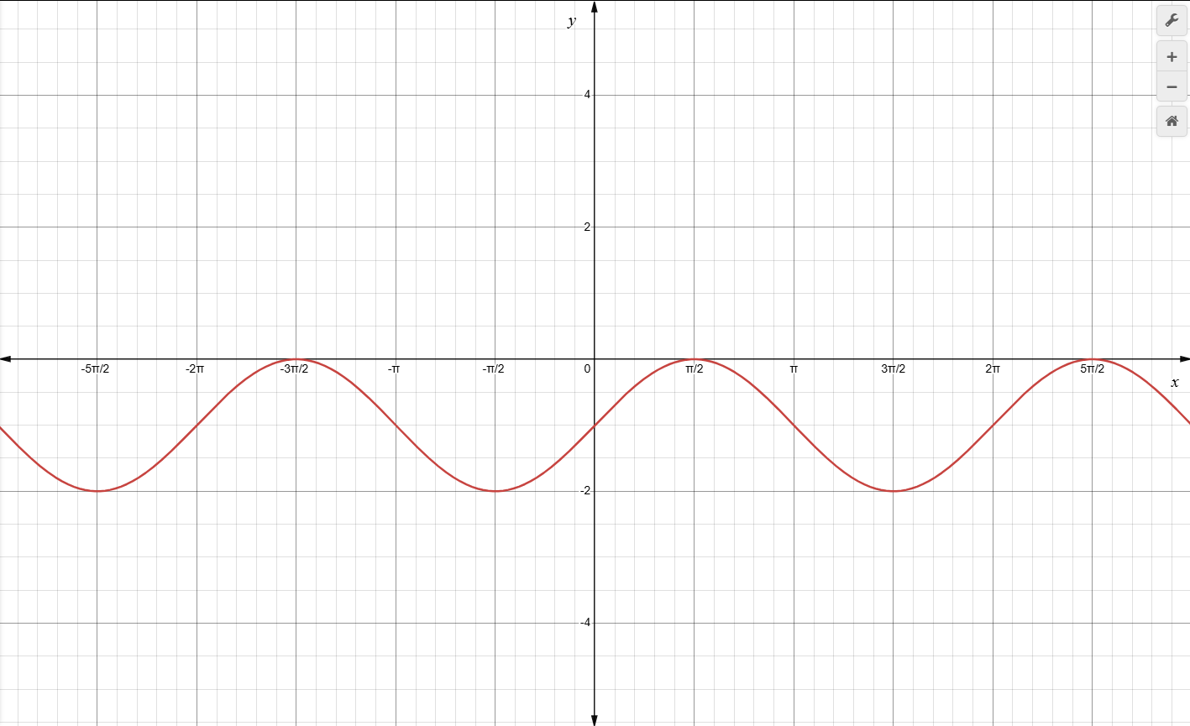

**Solution: 

1. Using find the y-values in the second row of the table by substituting each x-value into the function. Which of the following is the graph of ?

|  |  |  |  |  |
| --- | --- | --- | --- | --- |
|  |  |  | 0 |  |
|  |  |  |  |  |

* 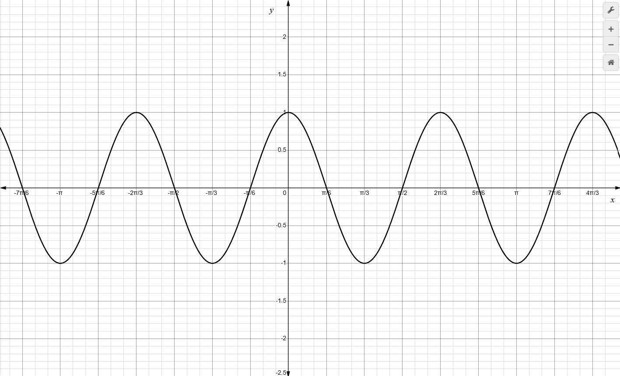
* 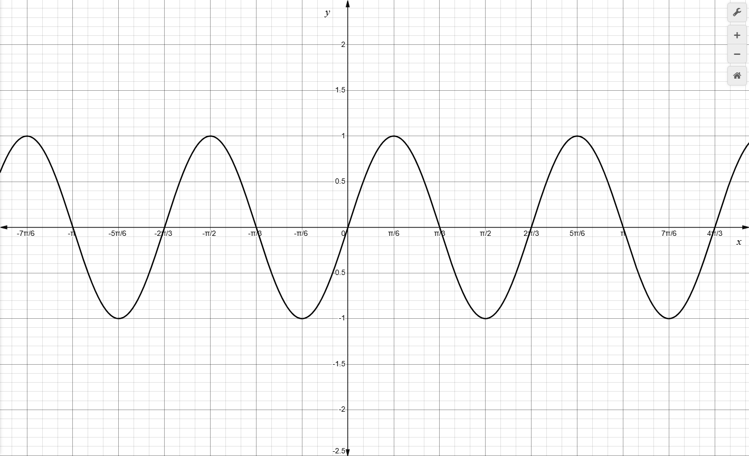
* 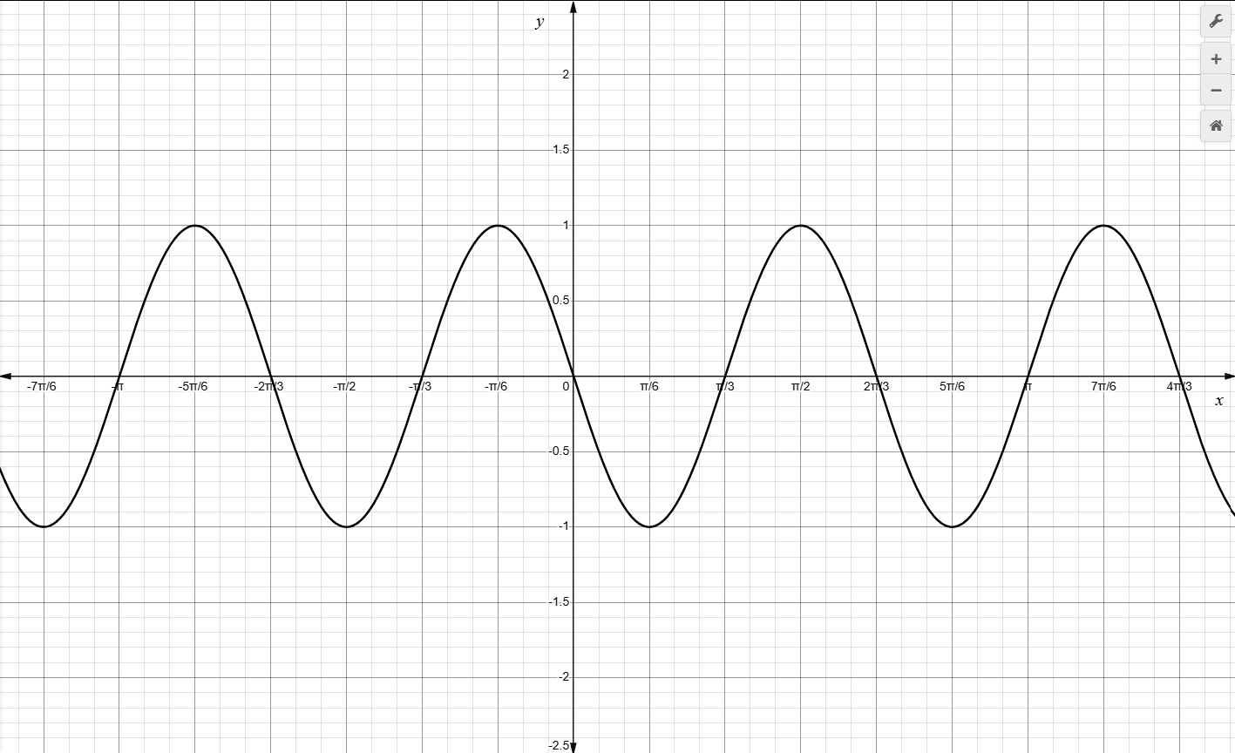
* 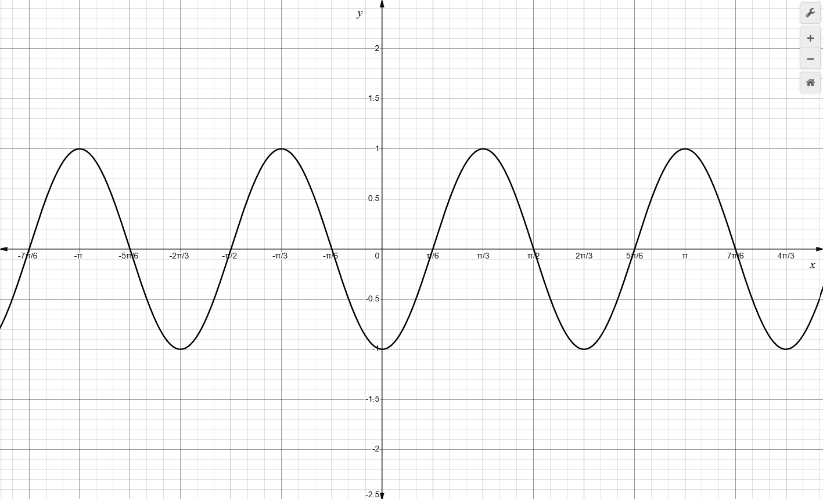

**Solution: 

1. Using find the y-values in the second row of the table by substituting each x-value into the function. Which of the following is the graph of $f\left(x\right)$?

|  |  |  |  |  |
| --- | --- | --- | --- | --- |
| $$x$$ | $$-\frac{π}{2}$$ | $$-\frac{π}{4}$$ | 0 | $$\frac{π}{4}$$ |
| $$f(x)$$ |  |  |  |  |

* 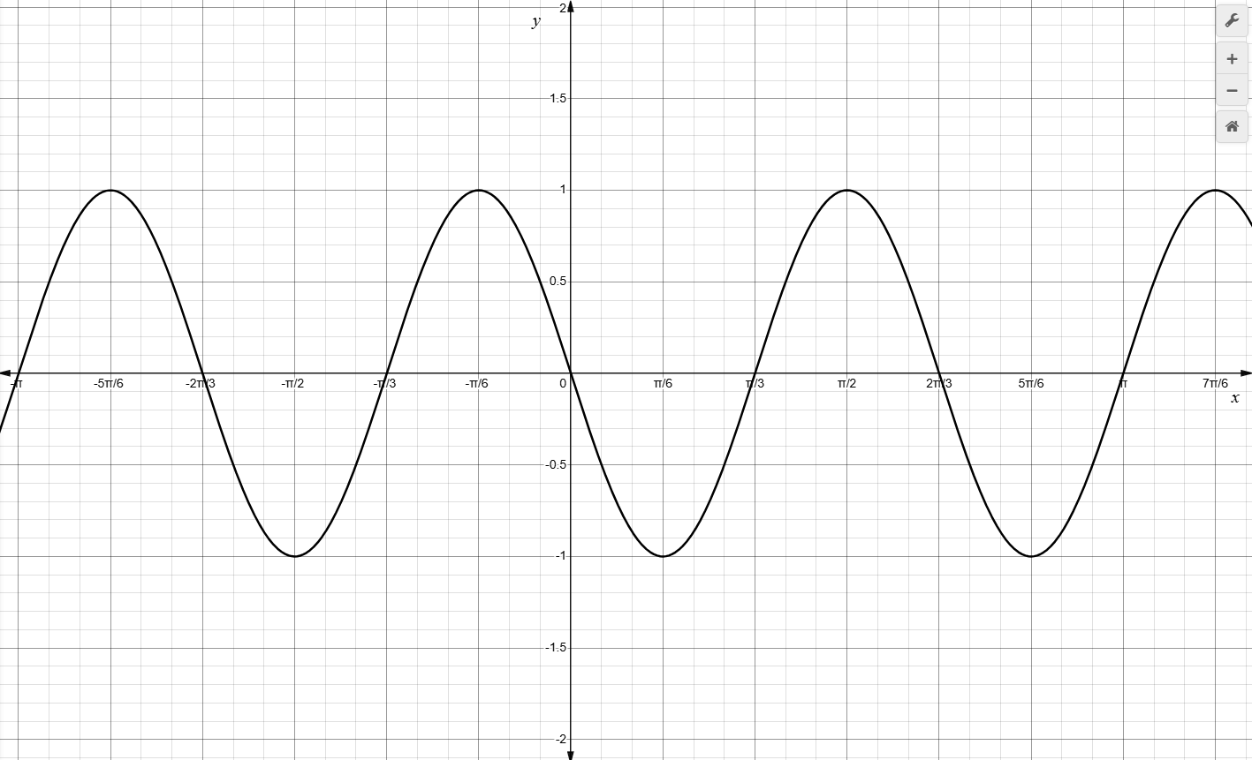
* 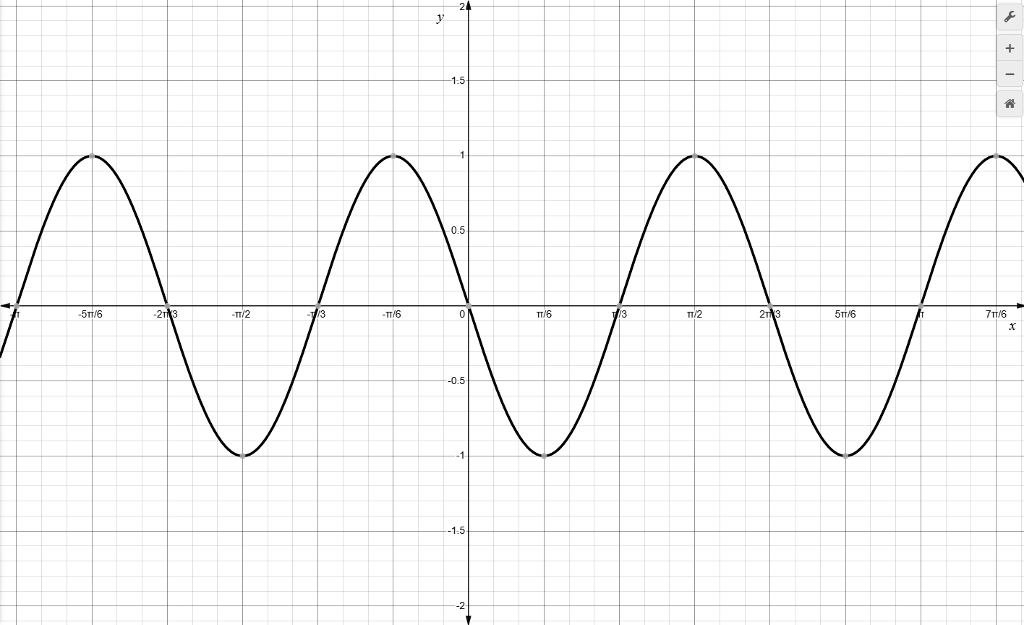
* 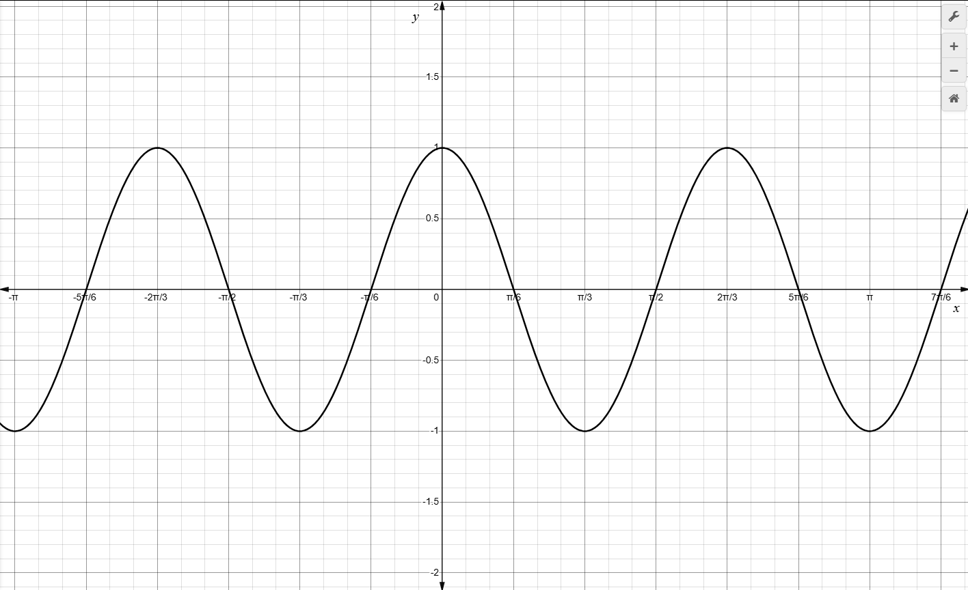
* 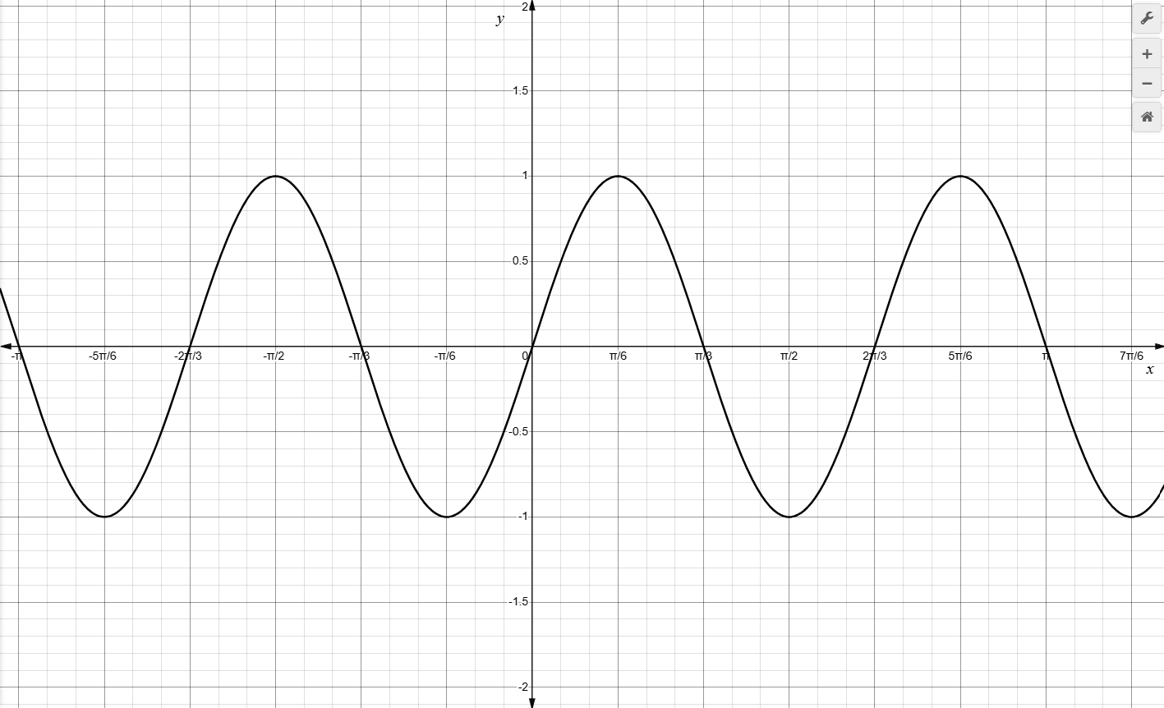

**Solution: 

1. Which of the following could be found in a table of values for the function $h(x)=\sin\left(-2x\right)+1$?

$\left(\frac{π}{2},1\right)$

* There is no viable option provided.

**Solution:

1. Which of the following could be found in a table of values for the function $g(x)=\cos\left(-3x\right)+2$?

$\left(\frac{π}{3},3\right)$

* There is no viable option provided.

**Solution:

1. Which of the following could be found in a table of values for the function $k(x)=\tan\left(-0.5x\right)-3$?

$\left(π,-3\right)$

* There is no viable option provided.

$\left(π,-2\right)$

$\left(π,-4\right)$

**Solution: There is no viable option provided.

1. When the function $f\left(x\right)=\sin{x}$ is reflected across the x-axis, the resulting function is $g\left(x\right)=-\sin{x}$. If the coordinates of the y-intercept of $f\left(x\right)=\sin{x}$ are (0,0), what are the coordinates of the y-intercept of the reflected function $g(x)$?

$\left(1,0\right)$

$\left(0, -1\right)$

$\left(0, 0\right)$

$\left(0,1\right)$

**Solution: $\left(0,0\right)$

1. When the function $f\left(x\right)=e^{x}$ is reflected across the x-axis, the resulting function is $g\left(x\right)={-e}^{x}$. If the coordinates of the y-intercept of $f\left(x\right)=e^{x}$ are (0,1), what are the coordinates of the y-intercept of the reflected function $g(x)$?

$\left(0, -1\right)$

$\left(1, 0\right)$

$\left(0, 0\right)$

$\left(0,1\right)$

**Solution: $\left(0,-1\right)$

1. When the function $f\left(x\right)=x^{2}$ is reflected across the x-axis, the resulting function is $g\left(x\right)={-x}^{2}$. If the coordinates of the y-intercept of $f\left(x\right)=x^{2}$ are (0,0), what are the coordinates of the y-intercept of the reflected function ?

**Solution: