**Guided Notes: Water Resources Controversies**

Water resource management faces many ________________ in the United States, including debates over privatization, bottled vs. tap water, and dam construction.

**Key Concepts:**

• By 2025, over _______ of the world's population may face water ____________.

• Three major water usage controversies in the U.S. are:

1. Privatization of water _____________

2. Bottled vs. ______ water

3. Building _______ on rivers

• Water ________________ refers to private companies taking over public water systems.

• Dams provide benefits like ______________, irrigation, and flood control, but can negatively impact water _________ and ecosystems.

• The Rio Grande River faces both ____________ and economic water scarcity.

• The Colorado River Compact of 1922 divided the river basin into ________ and ________ basins.

• Cities can be categorized as ________-wise or __________ based on their water management.

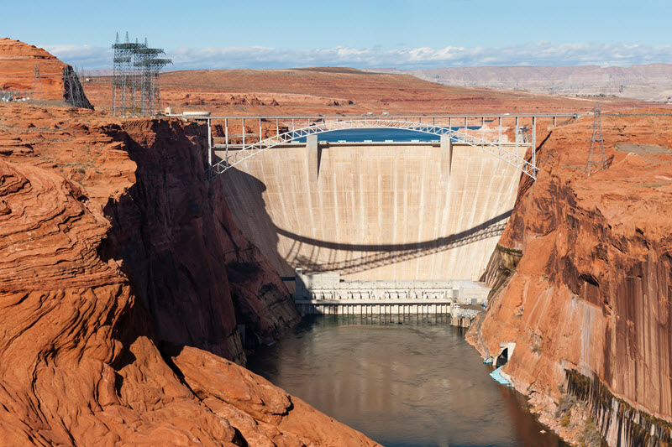

**Real World Examples:**

1. Michigan Bottled Water Controversy: A company was approved to pump ______ gallons of water per minute from White Pine Springs, paying only $200 per year.

2. Lake Mead on the Colorado River has seen _____________ water levels since the 2000s due to drought and overuse.

**Word Bank:**

controversies

two-thirds

scarcity

treatment

tap

dams

privatization

hydropower

quality

physical

upper

lower

water

wasteful

400

decreasing