**Guided Notes: Water Filtration**

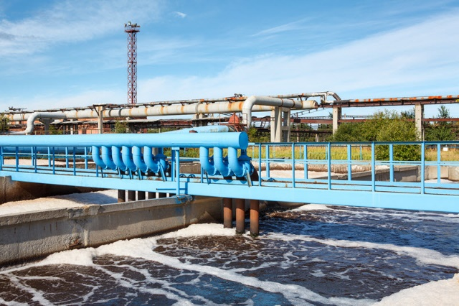

Water must be __________ to remove __________ that are harmful to the environment and human health.

**Key Concepts:**

• Common household water purification methods include:

- __________

- __________

- __________

- Adding __________

• Water treatment plants use __________, __________, and __________ processes to purify water.

• The two basic stages of wastewater treatment are:

1. __________

2. __________

• A __________ chamber removes large debris from wastewater.

• __________ is the solid waste produced during water treatment.

• __________ __________ is more effective than trickling filters for treating wastewater.

• __________ is added as a final step to disinfect the water.

**Real World Examples:**

1. Portable water filters for hiking/camping: These small devices allow hikers to safely drink from rivers and streams by removing __________ from the water.

2. Home water filter pitchers: Many students may have these in their refrigerators at home to improve the taste and quality of their __________ water.

**Word Bank:**

purified

contaminants

distillation

filtering

boiling

chlorine

physical

chemical

biological

primary treatment

secondary treatment

grit

sludge

activated sludge

chlorine

contaminants

tap