**Guided Notes: Water as a Resource**

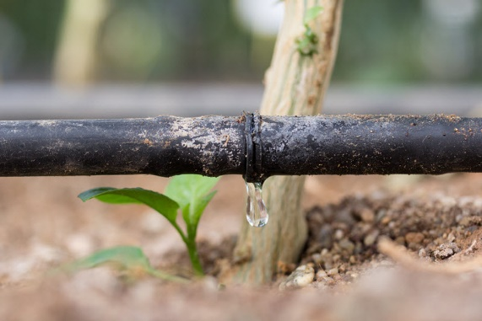

Water, _______, and _______ are interconnected resources that are essential for sustaining life on Earth.

**Key Concepts:**

• By 2070, Texas is predicted to have a ___% gap between water demand and supply.

• Water _______ includes direct water use like drinking water, and _______ water use in food/product production.

• Agriculture uses ___% of freshwater consumption globally.

• Agricultural _______ can contaminate water sources with fertilizers, pesticides, and animal waste.

• Understanding the relationship between water, food, and energy can help reduce _______ demands and address challenges like water scarcity.

• Sustainable agricultural practices like efficient _______ technologies and using _______ crops can help conserve water.

• Groundwater _______ is a critical concern in Texas as demand increases and supply decreases.

**Real World Examples:**

1. Texting and Water Usage: Every time you send a text message, you're using a tiny amount of _____. The data centers that process your texts require water for cooling. It's estimated that sending a single text message uses about 0.014 liters of water. Think about how many texts you send in a day - it adds up!

2. Water in Your Favorite Snacks: A small bag of potato chips (about 1 ounce) takes approximately 7 gallons of water to produce. This includes water used to grow the potatoes, process them, and manufacture the packaging. Next time you grab a snack during lunch or after school, consider its hidden water footprint!

**Word Bank:**

food

energy

41

footprint

virtual

70

runoff

competing

irrigation

cover

availability

water