**Guided Notes: Water and Climate Change**

Climate change is impacting the water cycle and _______ resources globally.

**Key Concepts:**

• _______ temperatures are causing more extreme weather events like droughts, floods, and wildfires.

• The global average temperature has been _______ since the year 2000.

• Climate change affects the water cycle by:

- Increasing _______ rates

- Changing _______ patterns

- Melting snow cover and _______

- Causing sea levels to _______

• Rising sea levels lead to:

- Coastal _______

- Salt water _______ into freshwater sources

- Displacement of coastal _______

• About _______% of the world's population lives within 100 km of a coast.

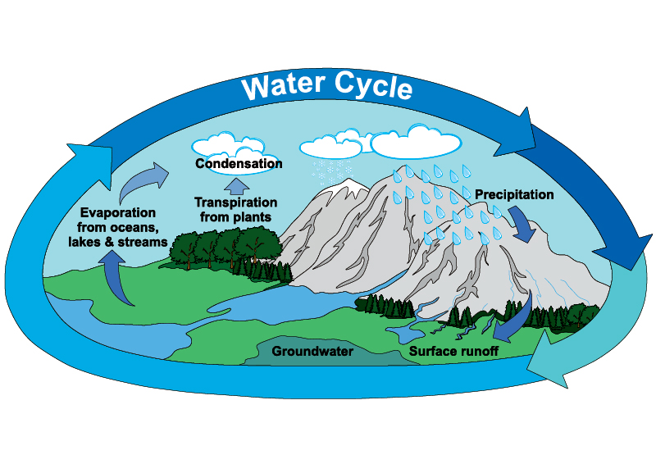

**Real World Examples:**

1. Wildfires in California: Hotter temperatures and _______ conditions have led to more extreme wildfires, affecting air quality and forcing students to stay indoors.

2. Flooding of coastal areas: Rising sea levels are causing increased ________ in coastal towns, potentially impacting students' homes or favorite beach spots.

**Word Bank:**

water

rising

increasing

evaporation

precipitation

glaciers

rise

erosion

intrusion

populations

40

drought

flooding