**Guided Notes: The Atmosphere**

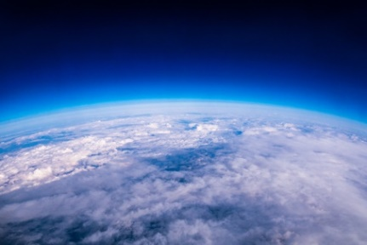

The atmosphere is composed of different ________ that impact Earth's ________ and ________.

**Key Concepts:**

• The atmosphere extends from Earth's surface into ________ ________.

• The layer closest to Earth's surface is called the ________.

• Most weather occurs in the ________.

• The ________ contains the ozone layer which absorbs ultraviolet radiation.

• Temperature ________ with altitude in the stratosphere.

• The ________ is the middle layer where temperature decreases with altitude.

• The ________ is the hottest layer and absorbs X-rays and gamma rays.

• The outermost layer is the ________, where particles may escape into space.

• The atmosphere absorbs, reflects and redistributes ________ energy from the sun.

• ________ is the transfer of energy by particle movement in fluids like air.

• ________ refers to atmospheric conditions at a specific time and place.

• ________ is the long-term pattern of atmospheric conditions in an area.

**Real World Examples:**

1. Sunburn: The ozone layer in the ________ protects us from harmful ultraviolet rays that can cause sunburn. That's why it's important to wear sunscreen, especially when the ozone layer is thinner.

2. Auroras: The colorful northern and southern lights occur in the ________ layer of the atmosphere when charged particles from the sun interact with gases.

**Word Bank:**

Layers

weather

climate

outer space

troposphere

stratosphere

increases

mesosphere

thermosphere

exosphere

solar

convection

weather

climate

stratosphere

thermosphere

troposphere