**Guided Notes: Weather Modeling**

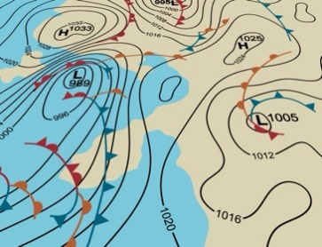

Weather forecasts are created using complex ____________ models that analyze data from various ____________ to predict future weather conditions.

**Key Concepts:**

• A ____________ is a person who studies weather and weather patterns.

• Tools used to collect weather data include:

1. ____________

2. Doppler ____________

3. ____________ on weather balloons

4. Surface weather ____________

• Weather models use ____________ ____________ to incorporate observed weather measurements into their predictions.

• The two most-used global weather models are:

1. The ____________ model

2. The ____________ model

• Differences between the European and American models:

- Use different ____________ equations

- ____________ data differently

- Have different ____________ between grid points

- Make different ____________ about weather processes

• ____________ is generally considered more accurate on average.

**Real World Examples:**

1. Winter Storm Juno (2015): The European model predicted over ____________ of snow for New York City, while the American model correctly predicted about ____________ inches.

2. Precipitation forecasts: Models can show different predictions for the same time and location, as seen in the June 6, 2019 example.

**Word Bank:**

computer

tools

meteorologist

satellites

radar

radiosondes

stations

data assimilation

European

American

Mathematical

Assimilate

Spacing

assumptions

The European model

two feet

eight