**Guided Notes: Household Water Use**

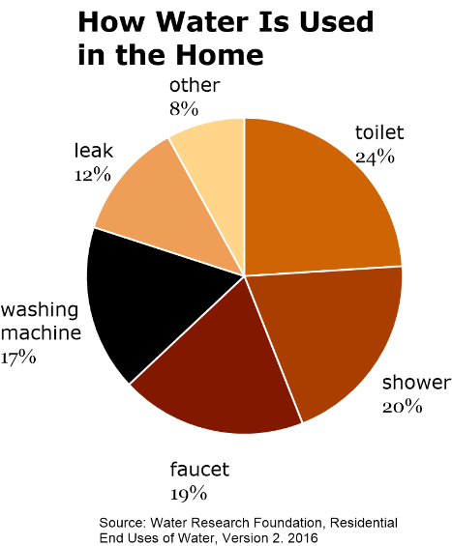

Households can implement various _____________ technologies and strategies to conserve water and reduce their environmental impact.

**Key Concepts:**

• The average American household uses about _____ gallons of water per person per day.

• Four general categories of water conservation strategies:

1. Limiting _____________

2. _____________ and recycling

3. Eliminating _____________

4. Preventing _____________

• Water-saving technologies are applications of _____________ knowledge to save water.

• _____________ water refers to water that is not safe for drinking but can be reused for other purposes.

• _____________ water reclamation involves reusing gently used household water.

• Smart water _____________ systems can help detect leaks in homes.

• It's important to avoid household products with _____________ that pollute the water supply.

**Real World Examples:**

1. Installing a low-flow _____________ head can significantly reduce water use while showering.

2. Using a _____________ barrel to collect rainwater for watering plants or washing cars helps recycle water and reduce consumption from the main water supply.

**Word Bank:**

water-saving

90

consumption

reusing

losses

pollution

scientific

nonpotable

Gray

detection

chemicals

showerhead

rain