**Guided Notes: Human Activity and Water**

The availability of ________ has significantly influenced human activity and settlement patterns in America.

**Key Concepts:**

• The ________ ________ is the boundary between the Piedmont Plateau and the coastal plain where waterfalls and rapids form.

• Upstream from the fall line, rivers move ________ through narrow valleys.

• Downstream from the fall line, rivers are large, relatively ________, and navigable by large boats.

• Many major cities on the East Coast are located along the ________ ________.

• Rivers provided important resources for early settlers including:

- ________ for drinking and irrigation

- ________ for transporting goods

- Source of ________

- Key part of thriving ________

• The location of ________, Virginia on the fall line of the James River shaped its development as one of America's oldest major cities.

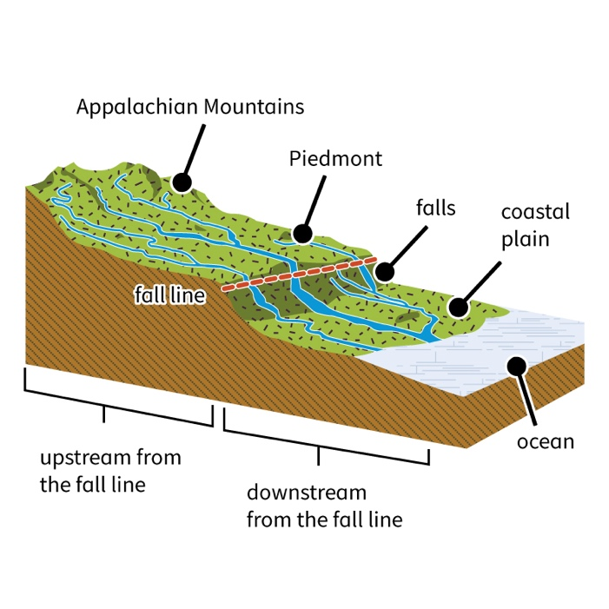

**Real World Examples:**

1. School Location: Think about where your high school is located. Is it near a river, lake, or other water source? Many schools are built in areas with easy access to water for drinking fountains, bathrooms, and sports fields. Next time you're at school, try to spot how water availability has influenced its location and facilities.

2. Summer Jobs: If you or your friends have had summer jobs at waterparks, pools, or beachside restaurants, you've experienced firsthand how water influences human activity. These popular summer hangouts and job spots exist because of nearby water sources. Consider how different your summer opportunities might be if you lived in an area with limited water access.

**Word Bank:**

water

fall line

swiftly

calm

fall line

water

routes

power

ecosystems

Richmond