**Guided Notes: Greenhouse Gases and Ozone**

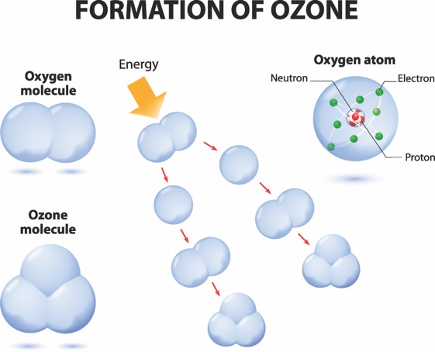

____________ gases absorb and reradiate infrared radiation in the atmosphere, contributing to the ____________ effect and climate change.

**Key Concepts:**

• The greenhouse effect:

- Earth's surface absorbs ____________ and near-infrared light

- Surface reradiates energy as ____________ infrared

- Some gases absorb and ____________ this energy, warming the atmosphere

• Main greenhouse gases:

1. Water ____________

2. Carbon ____________

3. ____________

4. Nitrous ____________

5. ____________ (in troposphere)

6. Industrial gases (e.g., ____________)

• Ozone (O3):

- "Good ozone" in ____________: forms protective layer against UV radiation

- "Bad ozone" in ____________: can cause respiratory issues

- Ozone hole: ____________ in ozone over Antarctica

• Montreal Protocol (1987):

- Agreement to stop production of ____________-depleting gases

- Has led to slow ____________ of the ozone hole

**Real World Examples:**

1. Car interior heating: Similar to greenhouse effect, trapping heat inside

2. Seasonal ozone variations: Levels ____________ at middle and high latitudes in winter and peak in spring

**Word Bank:**

Greenhouse

greenhouse

visible

far

reradiate

vapor

dioxide

methane

oxide

ozone

chlorofluorocarbons

stratosphere

troposphere

decrease

ozone

reduction

increase