**Guided Notes: Fossil Fuels**

Fossil fuels are _________________ resources formed from the remains of plants and animals over millions of years.

**Key Concepts:**

•The three main types of fossil fuels are _______, _______, and ___________ ____.

• Coal forms from ________ matter buried in swamps over millions of years.

• Oil and natural gas form from ________ plants and animals buried on the ocean floor.

• Fossil fuels are considered ________________ resources.

• Coal is extracted through ________ or surface mining.

• Crude oil is extracted by ________ and refined into products like gasoline.

• Natural gas is extracted by ________ or hydraulic _________.

• Processing fossil fuels involves removing _________ and separating useful components.

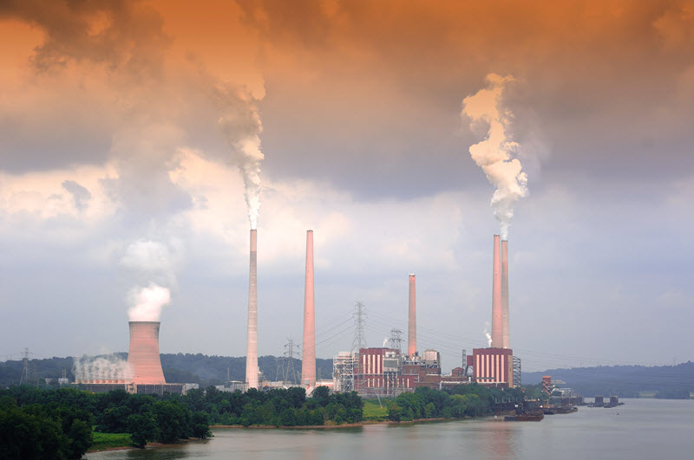

**Real World Examples:**

1. Filling up your car with ________ at the gas station.

2. Using ________ gas for cooking or heating your home.

**Word Bank:**

nonrenewable

coal

oil

natural gas

plant

marine

nonrenewable

drilling

drilling

drilling

fracturing

impurities

gasoline

natural