**Guided Notes: Global Water Rights**

Water is a vital but _____________ resource, leading to global issues surrounding water _____________ and _______________.

**Key Concepts:**

• Physical water scarcity refers to limited _____________ to water supply.

• Economic water scarcity occurs when people lack _____________ to use existing water resources.

• _____________ is power produced by capturing the energy of flowing water.

• Water _____________ involves private companies buying or operating public water utilities.

• Lack of clean water and adequate _____________ can affect people's health, education, and economic well-being.

• Engineers use the _____________ process to design solutions for water access issues, considering _____________ and trade-offs.

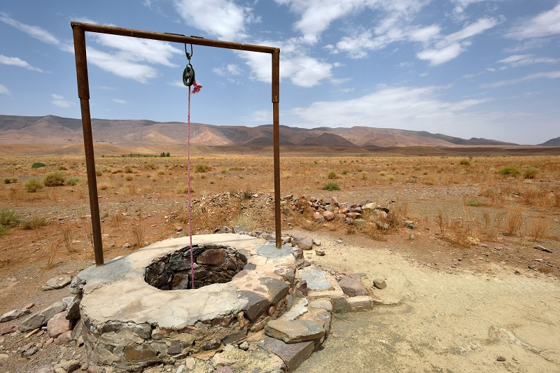

**Real World Examples:**

1. Cape Town Water Shortage: In 2018, Cape Town, South Africa nearly ran out of water due to _____________, highlighting the impact of climate change on urban water supplies.

2. School Attendance: In many developing countries, lack of access to clean water and proper sanitation facilities at schools can lead to decreased _____________ rates, especially among girls.

**Word Bank:**

limited

rights

access

access

resources

hydropower

privatization

sanitation

engineering

constraints

drought

attendance