**Guided Notes: Land Reclamation**

Land reclamation is the effort to ________ land degraded by mining operations to mitigate environmental damage.

**Key Concepts:**

• Approximately ________ million acres of land have been surface mined in the United States.

• The Surface Mining Control and Reclamation Act (SMCRA) of ________ set standards for mining reclamation.

• Mining companies must now present a detailed ________ plan before mining can begin.

• Three major components of land reclamation are:

1. Replacing and ________ land where digging occurred

2. Cleanup of environmental ________ and contamination

3. Revitalizing ________ or developing land for appropriate use

• Challenges of land reclamation include:

- Setting ________ and measurements for success

- ________ of interest between mining companies and environmental goals

- High ________ of reclamation projects

• Funding for reclamation can come from mining companies, federal grants, mining fees, and ________ organizations.

• Successful reclamation should inform decisions about permitting ________ mining operations.

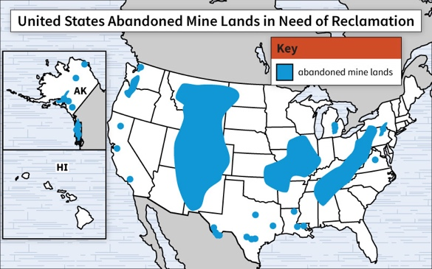

**Real World Examples:**

1. Smartphone Manufacturing: Students can research how companies that produce smartphone components are addressing land reclamation after mining ________ minerals.

2. Local Environment: Students can investigate if there are any reclaimed mining sites in their local area and evaluate the ________ of the reclamation efforts.

**Word Bank:**

restore

8.4

1977

reclamation

reforming

hazards

ecosystems

standards

conflicts

costs

environmental

new

rare earth

success