**Guided Notes: Industry and Climate Change**

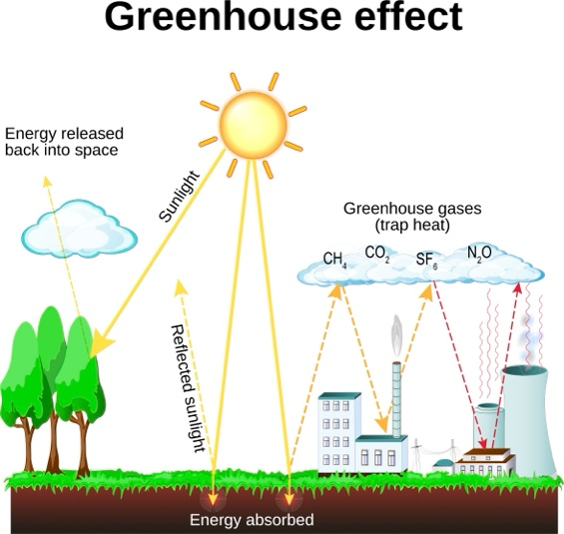

Farming and industrial activities significantly contribute to ____________ climate disruption by releasing greenhouse gases (GHGs) that alter atmospheric composition.

**Key Concepts:**

• Main greenhouse gases (GHGs):

1. Carbon ____________ (CO2)

2. ____________ (CH4)

3. Nitrous ____________ (N2O)

4. Chlorofluorocarbons

5. Fluorinated gases (F-gases)

• Major sources of GHG emissions in the U.S.:

1. ____________ sector: ~30% (mainly from burning gasoline and diesel)

2. ____________ generation: ~28% (mainly from burning fossil fuels)

3. ____________: ~22% direct emissions, ~30% including indirect emissions

• Agricultural sources of GHGs:

1. ____________ animals (e.g., cows): produce methane

2. Livestock ____________: produces methane and nitrous oxide

3. ____________ cultivation: produces methane

4. Soil management: releases ____________ oxide

• Land-use changes:

- ____________ releases stored carbon as CO2

- Clearing land with heavy equipment burns fossil fuels

- Rainforests are important ____________ sinks

**Real World Examples:**

1. Hamburger production: Involves methane from cows, electricity for storage, and fuel for transportation.

2. South American rainforests: Being cleared for agriculture, releasing stored carbon and reducing carbon absorption capacity.

**Word Bank:**

anthropogenic

dioxide

methane

oxide

transportation

electricity

industry

ruminant

manure

rice

nitrous

deforestation

carbon