**Guided Notes: Rocks and Mineral Properties**

Rocks and minerals have various ___________ that determine their uses and influence human activity.

**Key Concepts:**

• Properties used to characterize minerals include _________, _________, luster, _________, cleavage, and fracture.

• Luster refers to how _________ interacts with the surface of a rock or mineral.

• Hardness is a mineral's ability to resist _________.

• Density is the ratio between a mineral's _________ and its _________.

• Magnetism describes how a mineral reacts when placed in a _________ field.

• The availability of rocks and minerals has shaped _________ _________ throughout history.

• Mining booms can cause rapid _________ growth but may lead to _________ towns once resources are depleted.

• _________ sand has many uses due to its ability to withstand high pressures and absorb moisture.

• _________ is a key mineral used in fertilizers to support food production for a growing population.

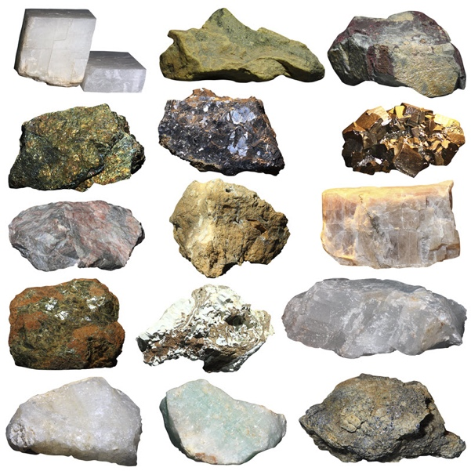

**Real World Examples:**

1. Jewelry: Different rocks and minerals are used in jewelry because of their _________, which can be metallic, vitreous (glassy), or pearly.

2. Smartphones: Rare earth minerals are used in the production of _________ like smartphones and other electronic devices.

**Word Bank:**

properties

hardness

density

magnetism

light

scratching

mass

volume

magnetic

human activity

population

ghost

silica

phosphorous

luster

technology