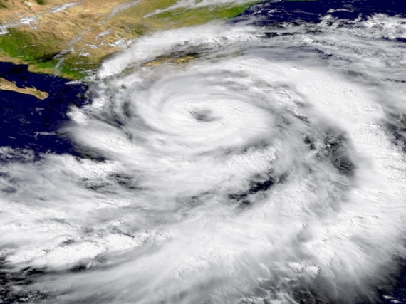**Guided Notes: Oceans and Climate**

The ocean plays a crucial role in the ____________, ____________, ____________, and redistribution of electromagnetic energy from the sun, significantly impacting weather and climate patterns.

**Key Concepts:**

• Oceans absorb sunlight to depths of up to ______ meters, unlike land which absorbs energy in a thin surface layer.

• Water has a specific heat capacity about ______ times that of land, allowing it to absorb more energy before its temperature rises significantly.

• Oceans cover approximately ______% of Earth's surface.

• ____________ is the measure of how much light a surface reflects.

• The ocean is divided into three layers:

1. ____________ waters

2. ____________

3. ____________ ocean

• The ocean exchanges ____________, ____________ ____________, and ____________ with the atmosphere, driving weather patterns.

• Just the top ______ meters of the ocean store more heat than the entire atmosphere.

**Real World Examples:**

1. Coastal vs. Inland Temperatures: San Francisco experiences milder summers and winters compared to Stockton, which is ______ miles inland, due to the ocean's moderating effect.

2. Hurricane Formation: Hurricanes and typhoons draw energy from ____________ ocean waters, demonstrating the ocean's impact on extreme weather events.

**Word Bank:**

reflection

absorption

storage

tens

four

70

Albedo

surface

thermocline

deep

heat

carbon dioxide

moisture

three

60

warm