**Guided Notes: Impact of Fossil Fuels**

Burning fossil fuels releases ____________ that negatively impact Earth's ____________, ____________, and ____________ systems.

**Key Concepts:**

• Fossil fuel emissions include greenhouse gases like ____________ that trap heat in the atmosphere

• Common pollutants released include ____________ oxides and ____________ dioxide

• These pollutants can form ____________ matter and contribute to ____________

• Acid rain forms when pollutants react with ____________ in the atmosphere

• Increased CO2 leads to ____________ of the oceans

• Burning fossil fuels impacts the ____________ through feedback loops involving ice melt and albedo changes

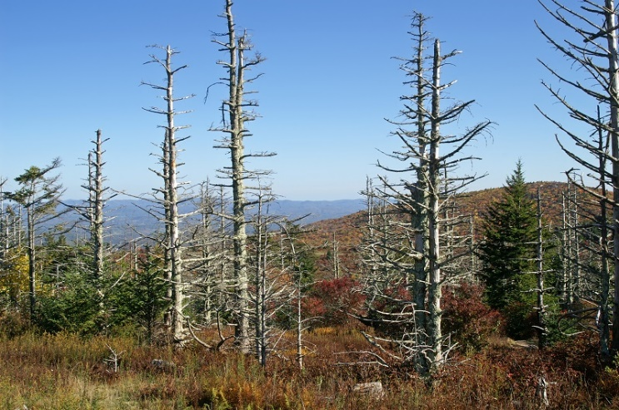

**Real World Examples:**

1. Smog in big cities like Los Angeles ________ visibility and can trigger asthma attacks in teens.

2. Warmer temperatures from ________ _____ are causing earlier snow melts, impacting winter sports seasons at popular ski resorts.

**Word Bank:**

emissions

atmospheric

hydrospheric

biospheric

carbon dioxide

nitrogen

sulfur

particulate

smog

water

acidification

cryosphere

reduces

greenhouse gases