**Guided Notes: Mining Methods**

There are two main types of mining - ________ mining and ________ mining - both of which have significant environmental impacts.

**Key Concepts:**

• Surface mining involves stripping ________ vegetation, dirt, bedrock and other layers to reach ore deposits underneath.

• Underground mining involves drilling ________ below the surface to extract ores.

• The major environmental impacts of mining fall into two categories: ________ impacts and ________ pollution.

• Surface mining methods like open-pit and ________ removal can destroy entire ecosystems.

• ________ is the material dug up to expose the seam of ore being mined.

• Surface mining can lead to increased ________ runoff into waterways.

• Underground mining requires water for clearing tunnels and processing ore, which can become ________.

• Contaminated water from mines is often stored in large ________-ground lakes.

• Both types of mining can release ________ and heavy metals into the environment.

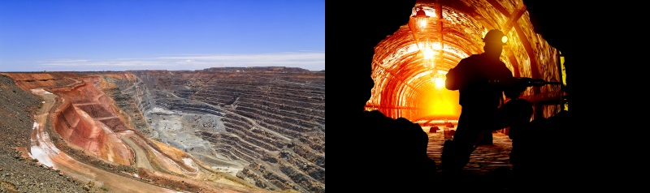

**Real World Examples:**

1. Muffin Mining: Students can simulate surface and underground mining by extracting "ore" (chocolate chips) from muffins using different methods, observing the ________ to the muffin structure.

2. Smartphone Manufacturing: Many of the minerals used in smartphones are obtained through mining. Students can research which components of their phones require ________ materials and how they are obtained.

**Word Bank:**

surface

underground

surface

deep

land

water

mountaintop

overburden

sediment

contaminated

above

acids

impacts

mined