**Guided Notes: Health and Safety of Mining Methods**

Mining carries numerous health and safety risks for miners and surrounding ________, requiring careful management and regulation.

**Key Concepts:**

• Modern life depends on ________ resources extracted through mining.

• Major health and safety risks in mining include:

- Underground mining: ________, fires, and loss of ________

- Surface mining: Exposure to ________ rays

- Both types: Injuries from heavy ________, hearing loss, and lung diseases

• ________ dams hold toxic waste materials left over from mineral extraction.

• In the U.S., ________ mining is generally more dangerous than surface mining.

• The Federal Mine Safety and Health Act of ________ set health and safety standards for mines.

• Over time, mining fatalities in the U.S. have ________ significantly.

• The prevalence of coal workers' pneumoconiosis (black lung) has ________ over time, then increased again recently.

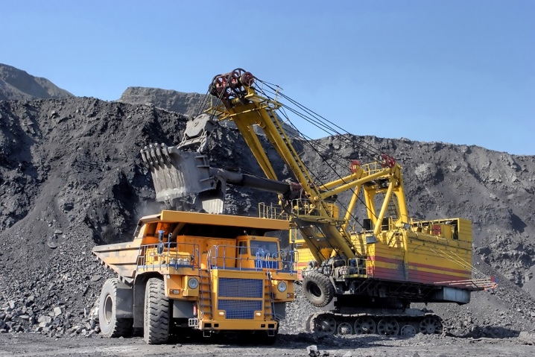

**Real World Examples:**

1. Smartphone components: The minerals in your phone were likely mined, potentially exposing workers to health and safety risks.

2. Local power supply: If your area uses coal for electricity, consider how the health and safety of miners affects your daily ________.

**Word Bank:**

communities

mineral

explosions

oxygen

UV

machinery

tailings

underground

1977

decreased

decreased

life