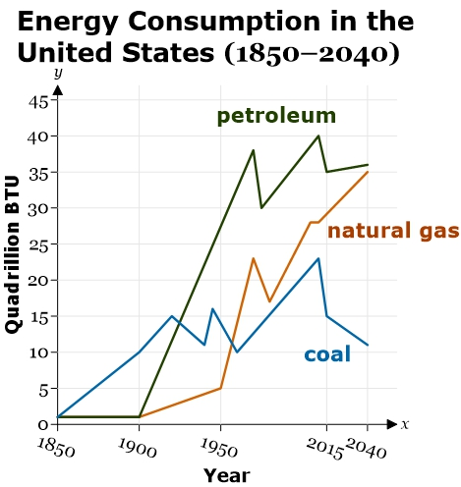**Guided Notes: Fossil Fuels and Humans**

Fossil fuels have significantly influenced ________ ________ since the Industrial Revolution.

**Key Concepts:**

• Fossil fuels began being widely used about ______ years ago.

• The three main types of fossil fuels are ______, _______ ____, and ________.

• Coal has influenced human activity through its use in ______ production and _________ generation.

• Natural gas is used for _______, ________, and powering _________ equipment.

• Petroleum has impacted transportation through ________ and _______ fuel.

• In food production, fossil fuels have influenced:

- __________ through powering farm machinery

- __________ of food products

- __________ made from petroleum-based plastics

• Overall, fossil fuels have increased _________ and _________ in many human activities.

**Real World Examples:**

1. Driving to school: The gasoline in your car is made from _________, allowing faster transportation.

2. Using your smartphone: The electricity powering it likely comes from burning ______ or _______ ___.

**Word Bank:**

human activity

200

coal

natural gas

petroleum

steel

electricity

heating

cooking

refrigeration

gasoline

diesel

harvesting

transporting

packaging

efficiency

productivity

petroleum

coal

natural gas