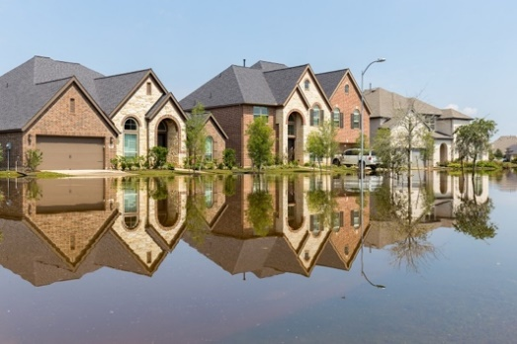**Guided Notes: Flood Mitigation Options**

Flood mitigation techniques are strategies used to _______ and _______ the movement of floodwaters.

**Key Concepts:**

• Floods are the number one _______ _______ in the United States.

• About ___% of flood insurance claims come from areas of low to moderate flood risk.

• Just ___ inches of water can result in over $11,000 worth of damage.

• Homeowners can protect their properties by:

- Elevating the _______

- Relocating furnaces, water heaters, and _______ panels

- Installing _______ valves

- Sealing walls in the _______

- Using _______

• Cities can implement flood mitigation through:

- Building _______ and _______

- Creating _______ spaces

- Improving _______ systems

• The federal government assists with flood mitigation through agencies like:

- U.S. Army Corps of Engineers (USACE), which manages about _____ dams

- Federal Emergency Management Agency (FEMA), which works on solutions like flood _______

**Real World Examples:**

1. A coastal town using seawalls to protect from ocean storm surges

2. A city creating more parks and green spaces to absorb excess rainwater runoff from paved areas

**Word Bank:**

manage

control

natural disaster

25

5

home

electric

check

basement

sandbags

levees

floodwalls

green

drainage

700

diversion