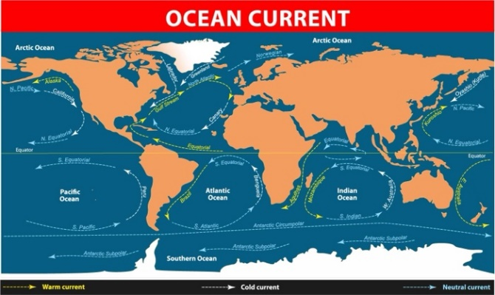**Guided Notes: Currents and Climate**

Ocean currents play a crucial role in redistributing ____________ and ____________ throughout the world's oceans, significantly impacting global climate and weather patterns**.**

**Key Concepts:**

• Surface currents:

- Flow in the top ____________ meters of water

- Caused by ____________ blowing horizontally across the water

- Form ____________ in major ocean basins

- Move in a ____________ direction in the Northern Hemisphere

• Deep currents:

- Caused by differences in ____________ between water masses

- Form the global ocean ____________ ____________

• ____________ occurs when wind pushes surface water away from the coast, pulling up deeper, colder water

• Ocean currents affect climate by:

- Redistributing heat from ____________ regions to ____________ regions

- Influencing ____________ patterns in coastal areas

- Affecting ____________ and ____________ levels in different regions

**Real World Examples:**

1. Temperature differences: Cape Hatteras, NC has higher average temperatures than Monterey, CA (at the same latitude) due to the ____________ current along the California coast.

2. El Niño: During an El Niño year, reduced upwelling along South America's coast leads to ____________ rainfall there and potential ____________ in Indonesia and Australia.

**Word Bank:**

heat

water

few hundred

wind

gyres

clockwise

density

conveyor belt

upwelling

equatorial

polar

temperature

rainfall

drought

cold

increased

droughts