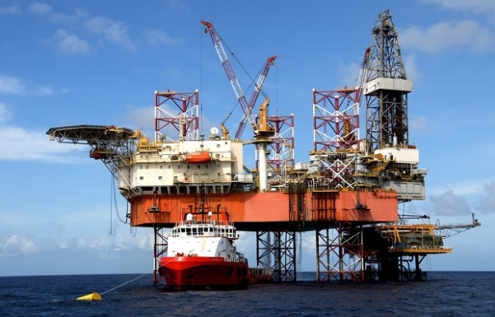**Guided Notes: Extraction and Processing of Fossil Fuels**

Acquiring and processing fossil fuels can have significant _____________ impacts.

**Key Concepts:**

• The three main fossil fuels are _______, _______, and ___________ ____.

• Natural gas is often extracted through hydraulic _________, or fracking.

• Fracking can contaminate _____________ and cause _____________.

• Oil extraction can result in ____________ gas leaks and oil ________.

• Coal is acquired through __________ and underground mining.

• Coal mining can lead to ________ pollution, habitat destruction, and _________.

• Processing fossil fuels produces ____________ and air pollution.

• Coal contributes the most to __________ _________ per energy produced.

• Fossil fuel emissions can cause human health issues like ________, heart problems, and ________.

**Real World Examples:**

1. Checking local air quality reports: Air quality in your area may be affected by nearby fossil fuel _________ or processing. You can use smartphone apps or websites to monitor daily air quality and take precautions on days with poor air quality.

2. Participating in a beach cleanup: If you live near a coast, you might join a beach cleanup event. This hands-on activity can help you understand how oil spills and other fossil fuel-related pollution can impact ________ environments.

**Word Bank:**

environmental

coal

oil

natural gas

fracturing

groundwater

earthquakes

methane

spills

surface

water

erosion

wastewater

climate change

asthma

cancer

extraction

marine