**Guided Notes: Continents and Climate**

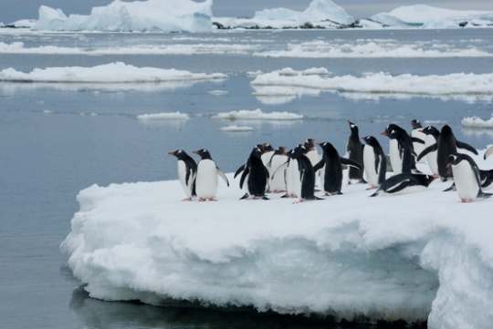

Continental land masses play a key role in the ____________, ____________, ____________, and redistribution of electromagnetic energy from the sun, which impacts weather and climate.

**Key Concepts:**

•Opaque surfaces either ____________ or ____________ incoming electromagnetic energy, rather than transmitting it.

• Energy flows out from land surfaces through:

- ____________ of water

- Heating of ____________ above the surface

- ____________ radiation

• Factors affecting heat absorption on land include:

- ____________ capacity of materials

- ____________ of the surface

- ____________ of the surface

- Moisture content

• ____________ is the amount of light reflected by a surface.

• Different heating patterns of land surfaces affect ____________ and ____________ patterns.

• Human activities like farming and building cities can alter the ____________ of a region.

**Real World Examples:**

1. Beach temperature differences: On a hot summer day, the dry sand feels much hotter on your feet than the wet sand near the water. This is because the dry sand has a lower ____________ capacity and heats up more quickly.

2. Urban heat islands: Cities tend to be several degrees ____________ than surrounding rural areas in summer due to changes in surface materials and lack of vegetation.

**Word Bank:**

reflection

absorption

storage

reflect

absorb

evaporation

air

thermal

heat

color

texture

albedo

weather

climate

albedo

heat

warmer