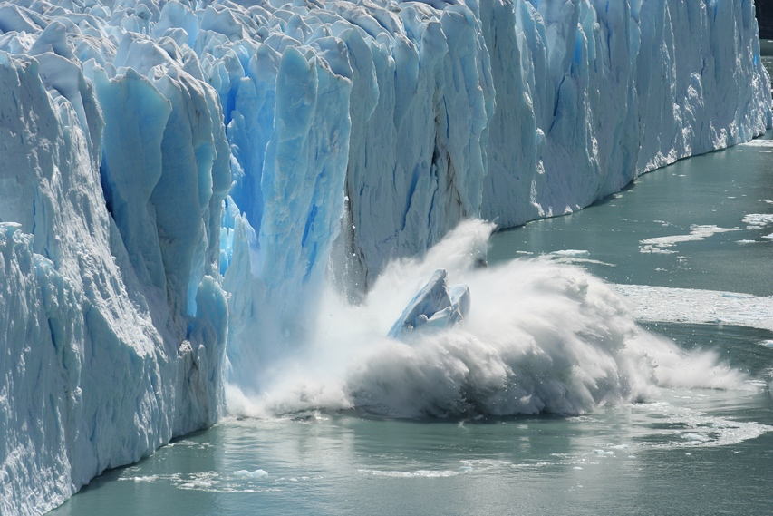**Guided Notes: Climate Change Tests**

Scientists use various ____________ and ____________ to measure climate changes throughout Earth's history and in the present day.

**Key Concepts:**

• Global warming is defined as the gradual increase in the overall ____________ of Earth's atmosphere.

• Climate change refers to long-term changes in ____________ and normal ____________ patterns in a place.

• Measurements used to study climate change include:

1. ____________ dioxide levels

2. Air and ocean ____________

3. Amount of ____________ ice at the poles

4. ____________ levels

5. ____________ size

• Tools for studying past climates:

1. ____________ rings

2. Ice ____________

3. Fossilized ____________ shells

4. Fossilized ____________

• Modern tools for measuring climate change:

1. ____________: measure ocean temperature and salinity

2. ____________: provide images of snow cover, sea ice, and glaciers

3. ____________: measure sea level

4. ____________ stations: measure air temperature and precipitation

• ____________ is the amount of salt dissolved in a body of water.

• Glacial retreat refers to the ____________ of the end of a glacier so it doesn't extend as far down valley.

**Real World Examples:**

1. Tree rings: Wider rings indicate ____________, ____________ weather conditions.

2. Decreasing snowpack in mountains: An observable indicator of climate change noticed by people over time.

**Word Bank:**

scientific tests

tools

temperature

temperature

weather

carbon

temperature

sea

sea

glacier

tree

cores

foraminifera

pollen

argo floats

satellites

tide gauges

weather

salinity

moving up

warm

wet