**Guided Notes: Clean Water Regulations**

The Clean Water Act and other regulations have had significant ___________ and ___________ impacts on water quality in the United States.

**Key Concepts:**

• Before clean water regulations, many waterways were severely ___________ by industrial and sewage waste.

• The Clean Water Act made it illegal to discharge ___________ into waterways without a permit.

• The EPA was created to set ___________ for industrial wastewater and enforce regulations.

• Clean water regulations have economic costs, like businesses having to safely dispose of ___________ instead of dumping it.

• Economic benefits include increased ___________ and higher property values near clean waterways.

• Environmental impacts include more waterways being safe for ___________ and ___________.

• A weakness is that nonpoint source pollution like agricultural ___________ is still not well regulated.

• Most sewage wastewater is now treated at ___________ before being released.

• Scientists are developing ways to turn sewage sludge into ___________ fuel.

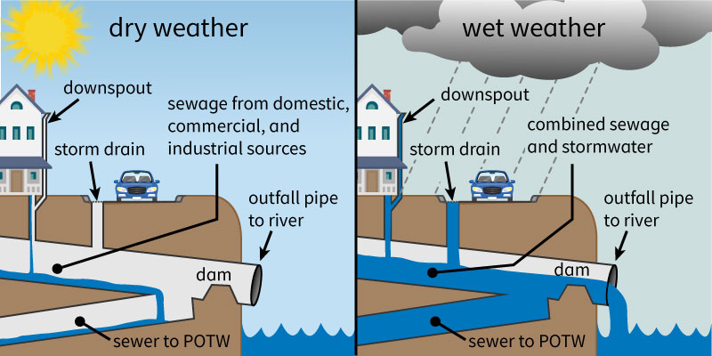

**Real World Examples:**

1. The Cuyahoga River in Cleveland was so polluted it caught fire 13 times. After clean water regulations, it now supports fish like ___________ and ___________.

2. When you flush a toilet or drain a sink, that wastewater goes to a treatment plant instead of directly into rivers and lakes. This helps keep local waterways clean enough for activities like ___________ and ___________.

**Word Bank:**

environmental

economic

polluted

pollutants

standards

waste

tourism

swimming

fishing

runoff

treatment plants

biodiesel

steelhead trout

northern pike

swimming

fishing