**Guided Notes: Carbon Cycle and the Ocean**

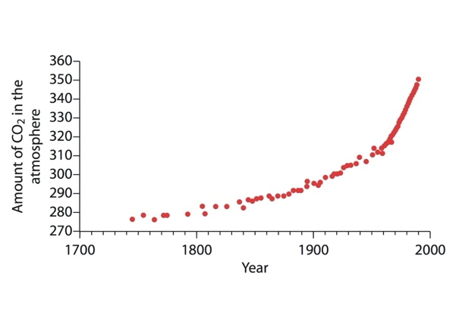The carbon cycle is a complex system where carbon moves between Earth's ____________, ____________, ____________, and ____________.

**Key Concepts:**

• Carbon is found in:

- Living things

- The atmosphere as ____________ ____________

- Oceans (dissolved)

- Rocks (e.g. limestone, coal)

• The carbon cycle involves processes like:

- ____________: organisms obtaining energy by taking in oxygen and releasing CO2

- ____________: plants taking in CO2 to make their structure

- Decomposition of dead organisms

- Formation and burning of ____________ ____________

• Oceans play a crucial role in regulating climate by:

- Absorbing about ______% of excess heat from global warming

- Absorbing about ______% of human-produced CO2 annually

- Driving the global ____________ ____________ of ocean currents

• Climate change impacts on oceans:

- Rising sea levels due to thermal ____________ and melting ice

- ____________ ____________: increasing acidity of ocean water

- Potential disruption of ocean currents like the ____________ ____________

**Real World Examples:**

1. Ireland's climate: Warmer than expected due to the ____________ ____________ current

2. Coral reefs: Threatened by ocean acidification, making it difficult for them to form ____________

**Word Bank:**

atmosphere

biosphere

hydrospher

geosphere

carbon dioxide

respiration

photosynthesis

fossil fuels

90

25

conveyor belt

expansion

ocean acidification

Gulf Stream

Gulf Stream

shells