**Guided Notes: Availability of Water**

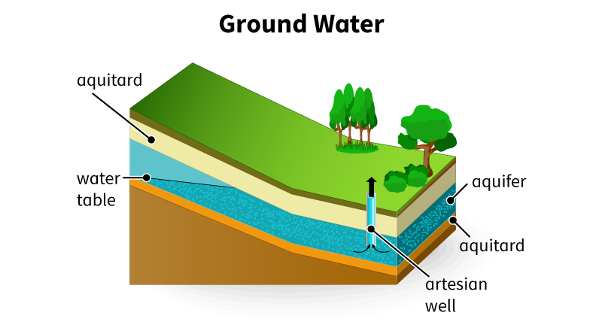

The availability of _______ is affected by geography, weather, and _______ growth.

**Key Concepts:**

• Only ____% of Earth's water is fresh water

• ____% of fresh water is trapped in glaciers and ice caps

• Factors affecting water availability:

- Geology: _______ of rocks determines aquifer capacity

- Climate: Arid regions are more prone to _______

- Geography: Features like mountains create ______ shadows

• As population increases, demand for water ________

• Impacts of increased water usage:

- Lowering of the _______ table

- Land _________

- ________ intrusion into freshwater aquifers

**Real World Examples:**

1. School Water Fountains: Have you noticed some water fountains in your school being shut off or having signs about lead testing? This is because as infrastructure ages and water demand increases, some areas are facing water quality issues. This directly relates to how population growth and aging systems can affect water availability and quality in your own school.

2. Local Reservoir Levels: Next time you're out driving with friends or family, pay attention to any nearby reservoirs or lakes. During dry seasons or in drought-prone areas, you might notice the water levels are lower than usual. This visible change in water availability is a direct result of the interplay between weather patterns, geography, and local water demand - all concepts we've discussed in this lesson.

**Word Bank:**

water

population

2.5

68.7

permeability

drought

rain

increases

water

subsidence

saltwater