**Guided Notes: Alternative Energy Resources**

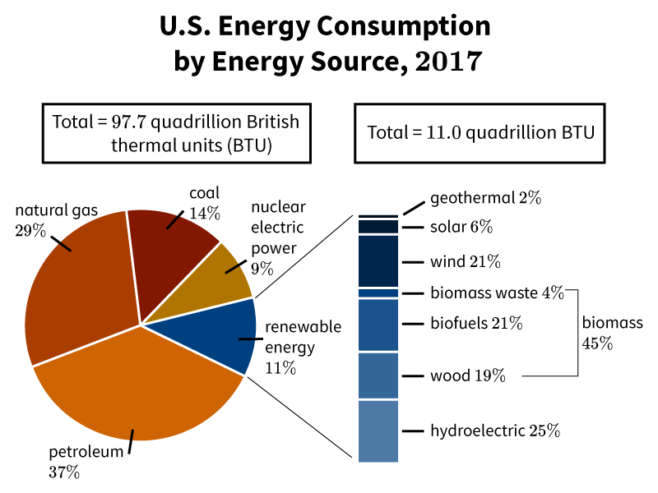

Alternative energy resources are _____________ sources of energy that can help reduce reliance on non-renewable _____________ fuels.

**Key Concepts:**

• Renewable resources can be _____________ or _____________ in a short period of time.

• Examples of renewable alternative energy resources include:

- _____________ energy

- _____________ energy

- _____________ energy

- _____________ energy

- Geothermal energy

- Hydrogen energy

• Solar energy captures energy from the _____________.

• Wind energy harnesses the energy of _____________ _____________.

• Biomass energy comes from _____________ and _____________ material.

• Hydroelectric energy gathers energy from _____________ _____________.

• A major benefit of alternative energy is that it is _____________ and doesn't contribute to global warming.

• Challenges of alternative energy can include:

- _____________ to implement

- Dependence on _____________ conditions

- Potential negative impacts on _____________ and _____________

**Real World Examples:**

1. ______ panels on the roof of your school to power classroom lights and computers.

2. A wind ________ farm visible from the highway on your way to a sports tournament in a neighboring town.

**Word Bank:**

renewable

fossil

replenished

replaced

solar

wind

biomass

hydroelectric

sun

moving air

plant

animal

moving water

clean

expensive

weather

habitats

ecosystems

solar

turbine