**Guided Notes: Flint Water Crisis**

The ____________ water crisis was caused by mismanagement of the water supply, leading to unsafe levels of ____________ and other contaminants in the drinking water.

**Key Concepts:**

• Flint switched its water source from ____________ to the ____________ River to save money.

• The new water source was more ____________, causing lead to leach from old pipes into the water supply.

• The EPA limit for lead in water is ____________ parts per billion.

• In Flint, lead levels as high as ____________ parts per billion were detected in some households.

• Lead poisoning can cause serious health issues, especially in ____________.

• City and state officials initially ____________ reports of high lead levels and downplayed the risks.

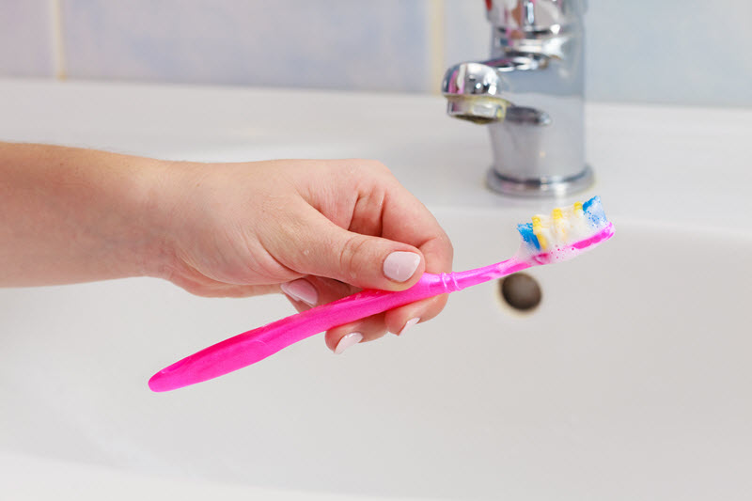

**Real World Examples:**

1. Brushing teeth: Instead of using tap water, Flint residents had to use ____________ water to brush their teeth to avoid ingesting contaminated water.

2. Showering: Many Flint residents had to use ____________ or ____________ showers to bathe safely, as extended skin contact with the contaminated water could be harmful.

**Word Bank:**

Flint

lead

Detroit

Flint

corrosive,

15

13,000

children

denied

bottled

short

filtered