**Guided Notes: Climate Systems**

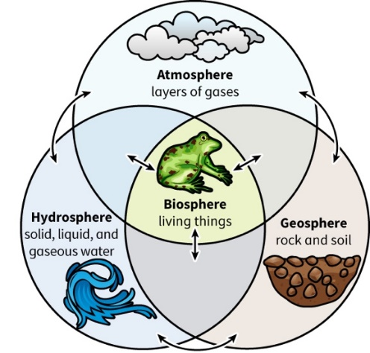

Earth's climate is formed through complex interactions between multiple ____________ systems, which exchange ____________ and ____________.

**Key Concepts:**

• The major spheres of Earth include:

1. ____________: layers of gases surrounding Earth

2. ____________: all living things on Earth and in the atmosphere

3. ____________: rock and soil that make up the solid part of Earth

4. ____________: all water on and around Earth

• Short-term climate changes can be caused by:

- Large ____________ eruptions

- Changes in ____________ currents (e.g., El Niño)

- ____________-year solar output cycles

• Long-term climate changes can result from:

- Movement of ____________ plates

- Changes in Earth's ____________ (Milankovitch cycles)

a) ____________: measure of how elliptical an orbit is

b) ____________: tilt of Earth's axis

c) ____________: rotation of Earth's axis

• Current rapid climate change is mainly caused by:

- Burning of ____________ ____________

- Release of ____________ ____________ into the atmosphere

**Real World Examples:**

1. Volcanic eruptions: Release gases and dust into the atmosphere, reflecting sunlight and cooling Earth.

2. Antarctica's climate change: Movement towards the south pole caused a decrease in temperature, leading to the formation of ____________ sheets.

**Word Bank:**

Earth

energy

matter

atmosphere

biosphere

geosphere

hydrosphere

volcanic

ocean

11

tectonic

orbit

eccentricity

obliquity

precession

fossil fuels

carbon dioxide

ice