**Guided Notes: Climate Change Over Time**

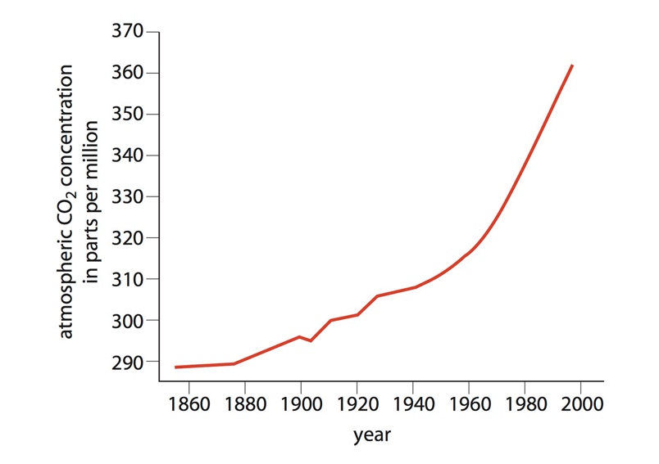

Earth's climate has naturally changed over time due to various factors, but recent climate change is occurring at an unprecedented ____________ and ____________.

**Key Concepts:**

• Natural causes of climate change include:

1. The Great Oxygenation Event:

- Caused by ____________ producing oxygen through photosynthesis

- Led to a drop in Earth's temperature and mass extinction of ____________ bacteria

2. Milankovitch Cycles:

- Changes in Earth's ____________, ____________, and ____________

- Occur over cycles of ____________, ____________, and ____________ years

- Result in periodic ____________ and ____________ periods

• ____________ are changes in a system that lead to further changes

• Recent climate change:

- Began in the late ____________ century

- Caused by increased human emissions of ____________ ____________

- CO2 levels have risen from 180-280 ppm to nearly ____________ ppm

• Evidence of recent climate change:

- Unprecedented ____________ of change

- Rapid increase in global ____________

- Rising ____________ levels

R**eal World Examples:**

1. Glacier National Park: Glaciers that shaped the landscape millennia ago disappeared due to ____________ climate change processes.

2. Arctic ice: Decreasing ice cover due to ____________ climate change.

**Word Bank:**

scale

rate

cyanobacteria

anaerobic

orbit

tilt

wobble

100,000

41,000

26,000

glacial

interglacial

feedbacks

19th

carbon dioxide

420

rate

temperature

sea

natural

rapid