**Guided Notes: Air Pressure and Weather**

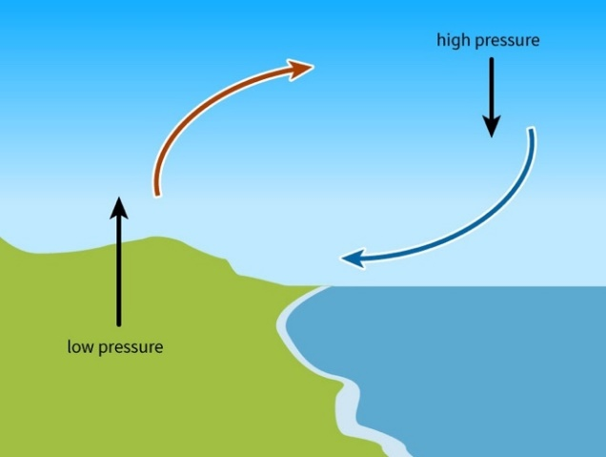

Variations in ____________ create different weather patterns and phenomena.

**Key Concepts:**

• Air pressure is defined as the ____________ of a column of air above a certain spot.

• Factors affecting air pressure:

- ____________

- ____________

- Whether air is ____________ or sinking

• ____________ is the movement of air from areas of higher pressure to areas of lower pressure.

• An ____________ is a large body of air with uniform temperature and moisture.

• Air masses form over ____________ regions, which determine their characteristics.

• A ____________ is the place where two unlike air masses meet.

• Types of fronts:

1. ____________ fronts

2. ____________ fronts

• Both cold and warm fronts are associated with ____________ air pressure due to unstable, rising air.

**Real World Examples:**

1. Sea breeze: On a hot summer day, air moves from the ____________-pressure area over water to the ____________-pressure area over land.

2. Hurricane structure: Extremely ____________ pressure at the center of a hurricane pulls in air from higher-pressure areas around it, creating strong winds.

**Word Bank:**

air pressure

weight

temperature

humidity

rising

wind

air mass

source

front

cold

warm

low

higher

lower

low