**Guided Notes: Analyzing Shoreline Management Effectiveness**

Beach nourishment is a common but ________ solution for managing beach erosion, requiring ongoing analysis of its long-term effectiveness.

**Key Concepts:**

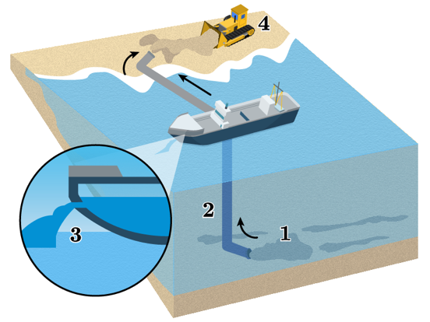• Beach nourishment is defined as adding ________ and sand to a beach to elevate and extend the shoreline.

• The process of beach nourishment involves:

1. ________ sand from offshore locations

2. Filtering out water

3. Piping sand to the beach

4. Using machinery to ________ the sand

• Factors to consider when analyzing beach nourishment projects:

- ________: Projects often cost millions of dollars

- Time: Projects can take several ________

- Materials: Requires specialized equipment and large quantities of sand

- Effectiveness: Typically lasts ________ years before needing to be redone

• Long-term effectiveness challenges:

- ________ events can quickly erode newly added sand

- Repeated nourishment may be necessary every few years

- Environmental impacts on marine ________

• Scientists continue to study the impacts of beach nourishment, including:

- Effects on local ________

- Long-term changes to beach ________

**Real World Examples:**

1. Local beach visit: Observe if your nearest beach shows signs of recent nourishment, such as wider beaches or ongoing ________ work.

2. Coastal community news: Research recent discussions about beach erosion management in a nearby coastal town, noting any mention of ________ or effectiveness.

**Word Bank:**

temporary

sediment

dredging

distribute

cost

months

5-7

weather

ecosystems

wildlife

composition

construction

costs