**Guided Notes: Aquaponics**

Aquaponics is a sustainable farming method that combines _________________ and _________________ in one system.

**Key Concepts:**

• Aquaponics relies on reusing fish _________________ to supply nutrients for plant growth.

• _________________ in the water break down fish waste into a nutrient solution for plants.

• Plants absorb nutrients, _________________ the water before it's recirculated to fish tanks.

• Aquaponics has been used since the _________________ century by Aztec and Chinese civilizations.

• Modern aquaponics arose as a solution to _________________ from fish farms.

• Three main elements of aquaponics systems are: _________________, _________________, and _________________.

• Aquaponics can use _________________ or _________________ water.

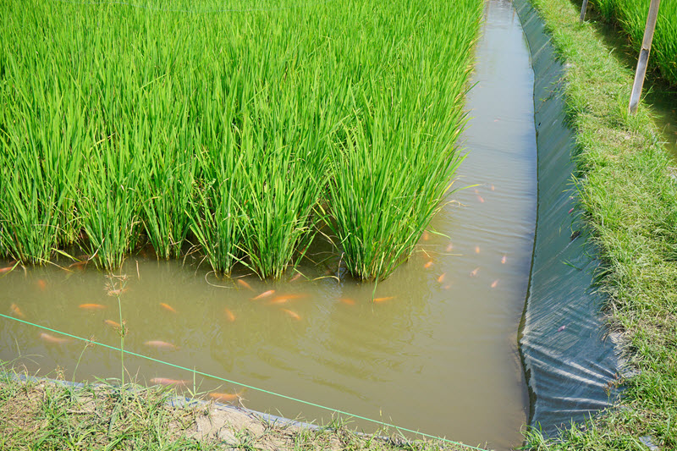

**Real World Examples:**

1. School Garden: Imagine your school setting up an aquaponics system in the cafeteria. You could grow fresh _________________ and raise _________________ for school lunches!

2. Urban Farming: In a city apartment, you could have a small aquaponics setup to grow herbs and vegetables while keeping _________________ as pets, maximizing limited space.

**Word Bank:**

aquaculture

hydroponics

waste

bacteria

cleaning

thirteenth

waste

fish/aquatic animals

bacteria

plants

fresh

salt

vegetables

fish

fish