**Guided Notes: Agriculture, Industry, and Water Resources**

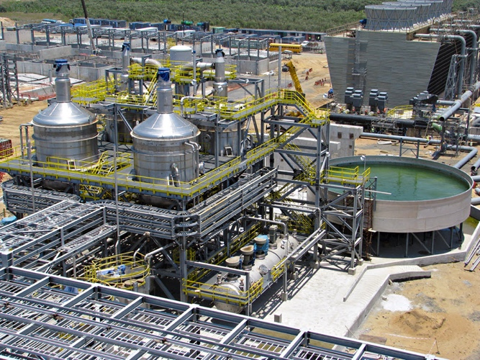

Agriculture and industry use large amounts of water, which impacts water ________ and ________.

**Key Concepts:**

• Industries use water to:

- Manufacture products like ________, ________, pharmaceuticals, and glass

- Generate ________ in thermoelectric power plants

- ________ minerals and extract metals in mining

- Perform hydraulic ________ to recover oil and gas

• Agricultural uses of water include:

- ________

- Applying fertilizers, ________, and insecticides

- Cooling crops

- Raising ________

- ________ control

• Poor agricultural practices can have ________ impacts on water resources

• Agricultural water refers to water used to grow ________ and raise ________

**Real World Examples:**

1. School Sports Field Maintenance: Your school's football field requires regular _______ to keep the grass healthy and safe for players. However, overwatering or using contaminated water could lead to problems like muddy patches or even health risks for athletes. This demonstrates how water quality and quantity in agriculture (even on a small scale like a sports field) can have direct impacts on daily life.

2. Local Car Wash Water Usage: The popular car wash near your school uses a significant amount of water every day to clean vehicles. Consider how this industrial use of water affects the local water supply, especially during drought conditions. Also, think about where the _______ _______ goes and how it might impact nearby streams or groundwater if it contains soaps and chemicals.

**Word Bank:**

quality

availability

food

paper

electricity

dislodge

fracturing

irrigation

pesticides

livestock

frost

negative

produce

livestock

watering

runoff water