**Lesson Plan: Chinuk Wawa - The Language of the Pacific Northwest**

Objective: Students will learn about Chinuk Wawa, its history, significance, and role in facilitating communication among diverse groups in the Pacific Northwest.

**Background for teachers**

* Native Languages: Language is an essential part of human identity and shapes how we view the world. For many Native American tribes, however, language is a complicated and even painful subject. In addition to being forcibly removed from their ancestral homeland, Native American people have faced systematic cultural suppression. Beginning as early as the 17th century, Euro-American government officials, teachers, and other authorities actively discouraged Native American and Alaska Native people from speaking their native languages and even physically punished Native children for doing so at boarding schools. This continued well into the 20th century. As a result, the amazing diversity of languages once spoken by Indigenous people in North America has been depleted, with many languages becoming extinct. Oregon is a case in point. According to the National Geographic Society: *Oregon was probably the most diverse region of [Indigenous] languages in the U.S. California might have the claim, but it is much larger, so the award for density of linguistic diversity goes to Oregon. At the time Lewis and Clark arrived in what’s now Oregon 200 years ago there were 14 language families, more than in all of Europe combined.1 Today, only five Indigenous language families still exist in Oregon, and most of them have only a handful of speakers. Many tribes in Oregon are undertaking language revitalization efforts that include creating children’s books, developing dictionaries, and implementing language programs in the schools or the community. To support student understanding of these efforts, refer to the Oregon Department of Education grade 4 Health lesson: Language Revitalization*
* Chinuk Wawa: chinuk wawa is an intertribal hybrid language indigenous to the Pacific Northwest, where it served as a regional lingua franca facilitating communication between speakers of different tribal languages as well as between tribal people and speakers of English and Canadian French. It arose on the lower Columbia River (The Confederated Tribes of Grand Ronde, 2012). The modern Chinook Indian Nation consists of the Clatsop and Kathlamet tribes of what is now Oregon and the Lower Chinook, Wahkiakum, and Willapa of Washington state. These five tribes have existed since time immemorial in their aboriginal territory in the Lower Columbia River region and along the coast at the river’s mouth. It is here that Chinook families welcomed Lewis and Clark to the Pacific Ocean and helped them survive the winter of 1805/1806. The Indigenous people living along the Lower Columbia River were traders long before Euro-Americans invaded the Pacific Coast. The Indigenous people traded with many other tribes that did not speak the same dialects. To make it easier to communicate and conduct trade, the tribes developed a version of verbal communication that included elements from many Indigenous languages in the Pacific Northwest. This language is known as chinuk wawa. When Euro-Americans invaded the Pacific Northwest, elements of both English and French were incorporated into chinuk wawa, which became an important language for trade throughout the Pacific Northwest and as far north as Alaska. chinuk wawa has survived for many generations among the Native people of the Lower Columbia. chinuk wawa remains a testament to the rich cultural traditions of Native Americans in the Pacific Northwest and is both a source of pride and intertribal identity.

Introduction:

1. Begin with a brief video or audio clip of someone speaking Chinuk Wawa.

Ex: <https://www.youtube.com/watch?v=JH5IuXa6zRk>

2. Ask students to share their thoughts on what language they heard and where it might be from.

3. Introduce the concept of a "lingua franca" and explain that Chinuk Wawa served this purpose in the Pacific Northwest.

Main Activity):

1. Present a digital slideshow about Chinuk Wawa, covering its origins, development, and significance. Include information about the Chinook Indian Nation and their historical interactions with Lewis and Clark.

2. Interactive map activity: Share a digital map of the Pacific Northwest. Ask students to identify and mark important locations related to Chinuk Wawa's development (e.g., Lower Columbia River, territories of the five Chinook tribes). [Maps.google.com](https://www.google.com/maps) works great!

3. Language exploration:

- Introduce some basic Chinuk Wawa words and phrases. Have students practice pronouncing them in small groups using breakout rooms. 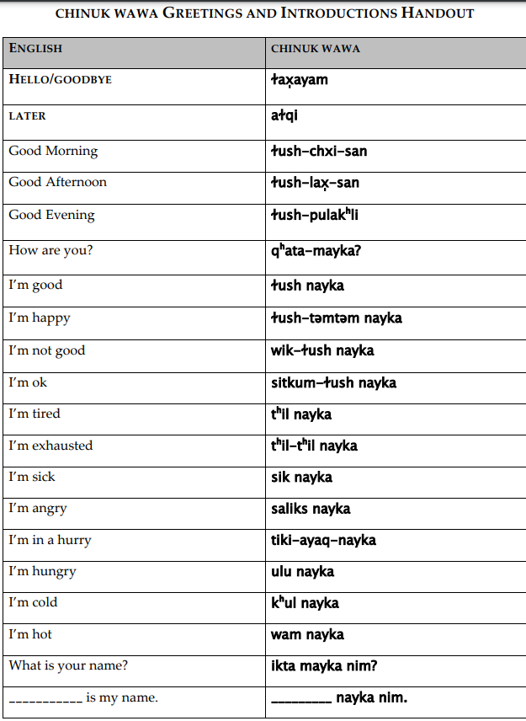

4. Group discussion: Divide the class into small groups to discuss the following questions:

- Why was Chinuk Wawa important for trade in the Pacific Northwest?

- How did the arrival of Euro-Americans change the language?

- Why is Chinuk Wawa still important today?

Conclusion and Assessment:

1. Bring the class back together to share their group discussion insights.

2. Individual writing assignment: Students will write a short opinion piece on why learning about languages like Chinuk Wawa is important for understanding Oregon's history and culture.

Extension Activities:

- Create a digital "trading post" simulation where students use basic Chinuk Wawa phrases to trade virtual goods.

- Research and present on how Chinuk Wawa has influenced modern place names in Oregon and Washington.

This lesson plan incorporates the specified standards by:

- Explaining interactions between Pacific Northwest Native Americans and their environment through trade (4.7)

- Discussing the impact of Euro-American arrival on indigenous cultures and languages (4.10, 4.11)

- Examining the history of the Chinook Indian Nation, which is part of Oregon's federally recognized tribes (4.14)

- Interpreting visual and oral information through map activities and language exercises (4.RI.7)

- Writing an opinion piece on the importance of learning about Chinuk Wawa (4.W.1)

- Engaging in collaborative discussions about the language's significance (4.SL.1)