Periodic Functions
Formula Sheet
Name | Definition | Formula
Unit Circle | In trigonometry, the unit circle has a radius of 1 and is centered at the origin. It is used to find the values for sine and cosine of common angles.  The coordinates of each $\left(x,y\right)$ point are written $\left(cosθ,sinθ\right)$. | 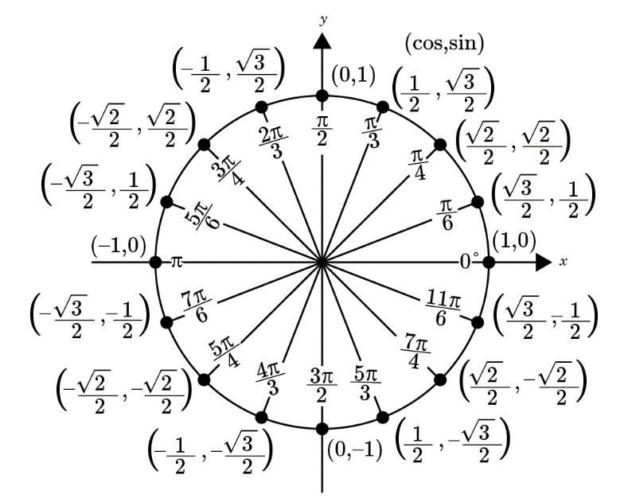
Amplitude | The amplitude is determined by finding one-half of the difference between the maximum and minimum values of the graph. | $$amplitude=\frac{1}{2}\left[\max{v}alue-\min{v}alue\right]$$
Period | The period is the horizontal length of each cycle of a periodic function. | For functions in the form  $f\left(x\right)=\sin\left(bx\right)$ or $f\left(x\right)=\cos\left(bx\right)$  $$period=\frac{2π}{\left|b\right|}$$
Frequency | The number of periods of a periodic function in one unit on the x-axis. | $$frequency=\frac{1}{period}$$  or  $$frequency=\frac{\left|b\right|}{2π}$$
Key Features of Sine and Cosine Functions | 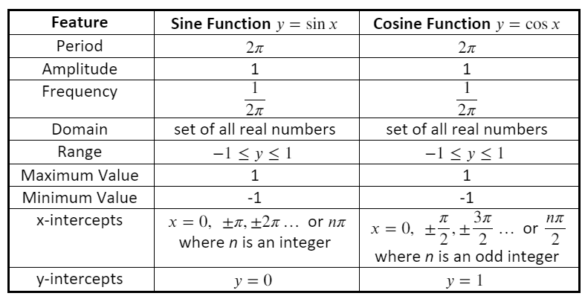
Five Key Points of Sine and Cosine Graphs | Sine Graph  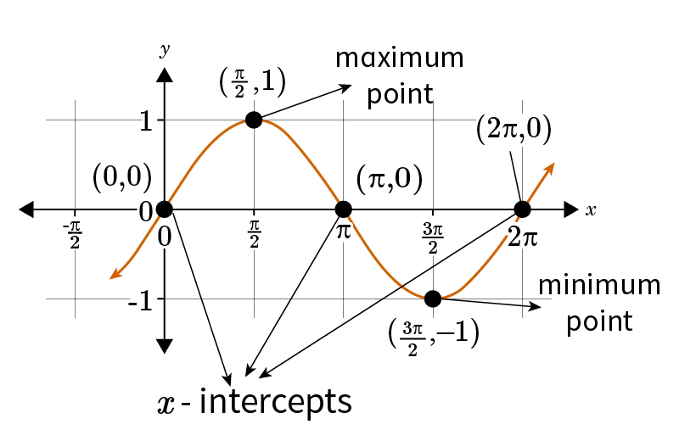  Cosine Graph  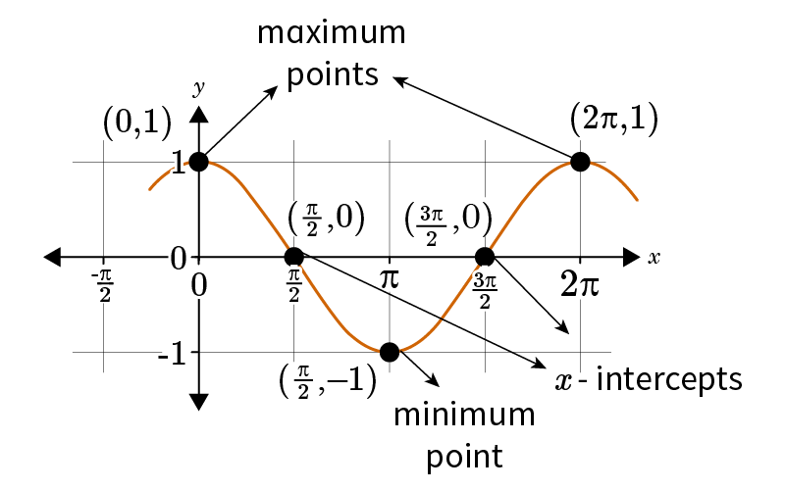
Function Transformations | 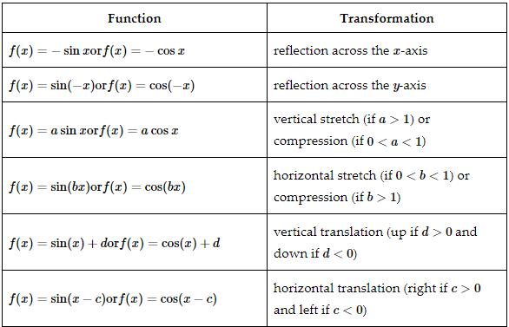
Multiple Transformations | Any sine or cosine function can be written in the form $f\left(x\right)=a\sin{b}\left(x-c\right)+d$ and $f\left(x\right)=a\cos{b}\left(x-c\right)+d$. Each parameter in the equation represents a specific transformation.  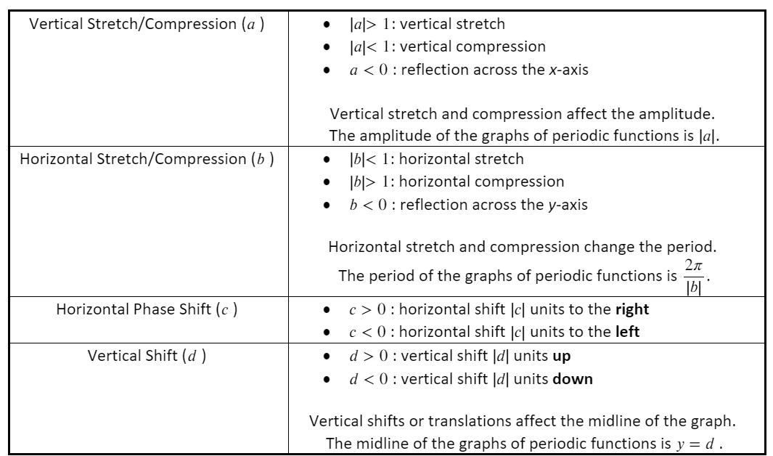
Rewrite a Sine Function as a Cosine Function | When the sine function is expressed as a cosine function, it becomes $f\left(x\right)=\cos\left(x-\frac{π}{2}\right)$, which is obtained by shifting the graph $\frac{π}{2}$ units to the right. | Steps to rewrite a sine function as a cosine function:  - Find the period of the sine function.  - Translate the graph of the cosine function by $\frac{period}{4}$ units to the right.  - Apply other transformations if necessary.
Rewrite a Cosine Function as a Sine Function | When the sine function is expressed as a cosine function, it becomes $f\left(x\right)=\sin\left(x+\frac{π}{2}\right)$, which is obtained by shifting the graph $\frac{π}{2}$ units to the left. | Steps to rewrite a cosine function as a sine function:  - Find the period of the cosine function.  - Translate the graph of the sine function by $\frac{period}{4}$ units to the left.  - Apply other transformations if necessary.

