Exponents & Radicals
Formula Sheet
Name | Definition | Formula
Laws of Exponents | Name Law Example  Product Rule $$x^{m}⋅x^{n}=x^{m+n}$$ $$x^{3}⋅x^{5}=x^{3+5}=x^{8}$$  Quotient Rule $$\frac{x^{m}}{x^{n}}=x^{m−n}$$ $$\frac{x^{11}}{x^{4}}=x^{11−4}=x^{7}$$  Power of a Power Property $${\left(x^{m}\right)}^{n}=x^{mn}$$ $${\left(x^{2}\right)}^{6}=x^{2⋅6}=x^{12}$$  Power of a Product Property $${\left(xy\right)}^{m}=x^{m}x^{m}$$ $${\left(xy\right)}^{9}=x^{9}y^{9}$$  Power of a Quotient Property $${\left(\frac{a}{b}\right)}^{m}=\frac{a^{m}}{b^{m}}$$ $${\left(\frac{a}{b}\right)}^{13}=\frac{a^{13}}{b^{13}}$$  Zero Exponent Rule $$x^{0}=1$$ $${15}^{0}=1$$  Negative Exponent Rule $$x^{−m}=\frac{1}{x^{m}}$$ $$x^{−8}=\frac{1}{x^{8}}$$  One-to-One Property If $$b^{x}=b^{y}$$, then $$x=y$$ If $$5^{4}=5^{x+1}$$, then $$4=x+1$$
Rational Exponent | The denominator of a rational exponent represents the root, while the numerator represents a power. | 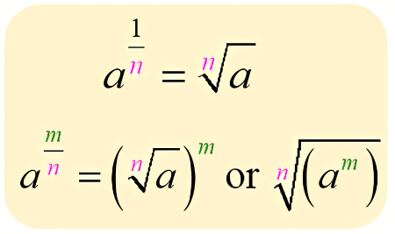
Exponential Function | An equation in which the independent variable appears in the exponent. | $$f\left(x\right)=a⋅b^{x}$$  a = initial value  b = growth or decay factor / multiplier  The growth factor is calculated from the rate, r.  Growth: $$b=1+r$$  Decay: $$b=1−r$$
Radical Expression | In a radical expression, the quantity under the radical symbol is called the radicand. The value in the upper left corner of the radical symbol is called the index. The index indicates what type of root you are taking. |   Example: $$\sqrt[3]{x−5}$$  - The radicand is $$x−5$$ and the index is 3.  - read as “the cube root of x minus 5”
Quadratic Formula | A formula which gives the solutions to any quadratic equation in the form $$ax^{2}+bx+c=0$$ where $$a≠0$$. | $$x=−\frac{b±\sqrt{b^{2}−4ac}}{2a}$$
Euler’s Number, $$e$$ | Even though $$e$$is irrational, we can still use $$e$$as the base of an exponential function. | 