Algebra 2A

**Unit 8: Exponents & Radicals**

**Unit Summary:**

In this unit, you will be solving many different types of equations involving exponents and radicals.

It will be important to remember the basic rules involved in solving equations:

* Always do the same operation to both sides of the equation.
* Isolate the variable that you are trying to solve.
* Reverse operations to get the variable by itself.
* When possible, check your answer by plugging it back into the original equation to make sure it works.

**Lesson 2 – Revisiting Exponents & Their Functions**

**Objective 1:** In this section, you will use the laws of exponents to solve algebraic equations containing integer exponents.

*Mathematical Practice Standard: Make sense of problems and persevere in solving them.*

**Key Words:**

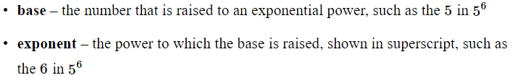

**Big Ideas**:

Laws of exponents:

|  |  |  |
| --- | --- | --- |
| Name | Law | Example |
| One-to-One Property (with a common base) |  |  |
| One-to-One Property (with an uncommon base) |  | |
| Power of a Power Property |  |  |
| Negative Exponent Rule |  |  |
| Zero Product Property | If a product equals zero, then at least one of the factors must equal zero. If 5*x*=0, then *x* must be equal to zero. | $$x-1=0$$ $$x=1$$ |

**Objective 2:** In this section, you will use the laws of exponents to solve algebraic equations containing rational exponents and roots.

*Mathematical Practice Standard: Make sense of problems and persevere in solving them.*

**Big Ideas:**

* The denominator of a rational exponent represents a root
* The numerator represents a power
* Evaluating a term with a rational exponent involves taking a root and then raising the result to a power, or raising a term to a power and then taking the root of the result
  + Ex: 

**Objective 3:** In this section, you will model situations involving exponential growth and decay.

*Mathematical Practice Standard: Make sense of problems and persevere in solving them.*

**Key Words:**

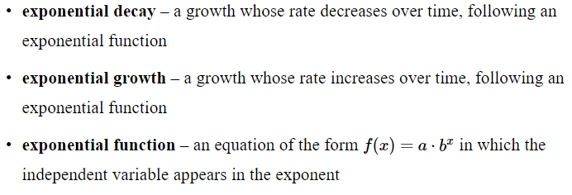

**Big Ideas:**

|  |  |
| --- | --- |
|  | Exponential functions grow or decay by equal factors over equal intervals. In other words, exponential change involves multiplying a start number by a given factor again and again. |
|  |  |
|  |  |
|  |  |

**Practice Questions and Answers**

|  |  |  |
| --- | --- | --- |
|  | Question | Answer |
| P 1 |  | 8 |
| P 2 |  | 38 |
| P 3 |  | 64 |
| P 4 |  | 1= 2,500; 2 = 1.05 |
| P 5 |  | 1 = 8; 2 = 0.5; 3 = 0.25 |

**Quick Check Questions and Answers**

|  |  |  |
| --- | --- | --- |
|  | Question | Answer |
| Q 1 |  |  |
| Q 2 |  |  |
| Q 3 |  |  |
| Q 4 |  | The elephant polulation in 1990 is 315, and the population increases by 7.85% each year. |
| Q 5 |  |  |

**Lesson 3 – Radical Equations**

**Objective 1:** In this section, you will solve radical equations with variables on one side.

*Mathematical Practice Standard: Make sense of problems and persevere in solving them.*

**Key Words:**

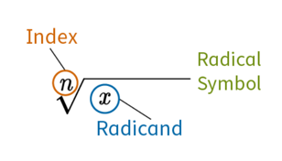

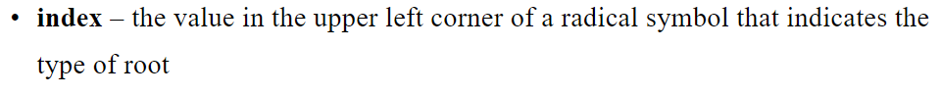



**Big Ideas**:

|  |  |
| --- | --- |
|  | To read a radical expression, say “the [word that denotes index] root of [radicand]” |
|  | Radical equations work like other equations. To solve a radical equation, complete the following steps:  Step 1: Isolate the radical expression onto one side of the equation.  Step 2: Remove the radical by raising both sides of the equation to the power of the index.  Step 3: Solve the resulting equation.  Step 4: Substitute the solutions back into the original equation and check for extraneous solutions. |
|  | Remember to always check for extraneous solutions. A radical equation could have no extraneous solutions, one extraneous solution, or more than one extraneous solution. |

**Objective 2:** In this section, you will solve radical equations with variables on both sides.

*Mathematical Practice Standard: Make sense of problems and persevere in solving them.*

**Key Words:**



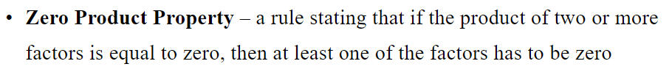

**Big Ideas**:

|  |  |
| --- | --- |
|  | To solve radical equations with variables on both sides of the equation, you will follow the same four steps:  Step 1: Isolate the radical expression onto one side of the equation.  Step 2: Remove the radical by raising both sides of the equation to the power of the index.  Step 3: Solve the resulting equation.  Step 4: Substitute the solutions back into the original equation and check for extraneous solutions. |
|  | Some radical equations have variables inside radicals on both sides of the equation. To solve this type of equation, you will follow the same four steps. The only difference is that you might need to repeat Steps 1 and 2 until no variables remain within a radicand. |

**Practice Questions and Answers**

|  |  |  |
| --- | --- | --- |
|  | Question | Answer |
| P 1 |  | 1 |
| P 2 |  | 3 |
| P 3 |  | 1 |
| P 4 |  | 3 |
| P 5 |  | 2 |

**Quick Check Questions and Answers**

|  |  |  |
| --- | --- | --- |
|  | Question | Answer |
| Q 1 |  |  |
| Q 2 |  | Stubtract 12 from both sides of the equation. |
| Q 3 |  |  |
| Q 4 |  |  |
| Q 5 |  |  |

**Lesson 4 – Irrational Exponents**

**Objective 1:** In this section, you will estimate quantities involving positive rational exponents.

*Mathematical Practice Standard: Model with mathematics.*

**Key Word:**



**Big Ideas**:

|  |  |
| --- | --- |
|  | Always check to see if you can calculate an exact quantity using exponent rules.  For example: |
|  | If you can’t, use nearby integer exponents to help determine a good estimate.  For example: |

**Objective 2:**  In this section, you will use sequences to closely approximate quantities with irrational exponents.

*Mathematical Practice Standard: Model with mathematics.*

**Key Words:**

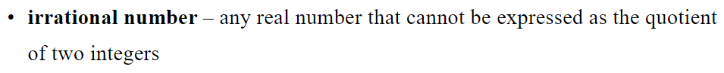

**Big Ideas**:

* Irrational numbers are numbers that cannot be written as a ratio of two integers.
* Therefore, the exponent rule $$x^{\frac{a}{b}}={\left(\sqrt[b]{x}\right)}^{a}$$ does not work with irrational numbers.
* To evaluate an expression with an irrational exponent you can use approximation. You can use a calculator to approximate, or you can create a table like in the following example.

|  |  |
| --- | --- |
| **Example:** Use the function $$g\left(x\right)=5^{x}$$ to approximate $$5^{\sqrt{3}}$$, correct to within four decimal places. | |
| **Step 1:** In the left column, create a sequence of *x-*values that get closer and closer to $$\sqrt{3}$$. |  |
| **Step 2:** In the right column, create a sequence of g(x)-values using your calculator, rounding to four decimal places each time. |
| **Step 3:** State the answer. | As the x-values get closer to $$\sqrt{3}$$, the g(x)-values more closely approximate $$5^{\sqrt{3}}$$. From the table, you can see that $$5^{\sqrt{3}}≈16.2425$$. This approximation is correct to four decimal places. |

**Practice Questions and Answers**

|  |  |  |
| --- | --- | --- |
|  | Question | Answer |
| P 1 |  | 2 |
| P 2 |  | 2 |
| P 3 |  | 2 |
| P 4 |  | 451.8079 |
| P 5 |  | 1= 3.3  2= 3.31  3= 3.316  4= 3.3166  5= 3.31662 |

**Quick Check Questions and Answers**

|  |  |  |
| --- | --- | --- |
|  | Question | Answer |
| Q 1 |  |  |
| Q 2 |  |  |
| Q 3 |  |  |
| Q 4 |  |  |
| Q 5 |  |  |

**Lesson 5 – Euler’s Number, *e***

**Objective 1:** In this section, you will discover Euler’s number *e*, and examine the application of *e* in a variety of mathematical situations.

*Mathematical Practice Standard: Make sense of problems and persevere in solving them.*

**Key Words:**





**Big Ideas**:

|  |  |
| --- | --- |
|  | *e* is an irrational number that is approximately 2.71828, which continues on after the decimal point forever without repeating a pattern. |
|  | Reminders   * Identify and use the commutative properties for addition and multiplication * Identify and use the associative properties for addition and multiplication * Identify and use the distributive property |
|  | Reminder – Product Rule:   * If you multiply two terms and the bases are the same, you must add the exponents ex: $e^{m }· e^{n}=e^{m+n}$* If you multiply two terms and the bases are different, you must multiply the bases and add the exponents; ex: |
|  | Reminder – Quotient Rule:   * If you divide two terms and the bases are the same, you must subtract the exponents ex: $\frac{e^{m}}{e^{n}}=e^{m-n}$* If you divide two terms and the bases are different, you must divide the bases and then subtract the exponents; ex: |

**Objective 2:** In this section, you will apply Euler’s number *e* in a variety of situations.

*Mathematical Practice Standard: Construct viable arguments and critique the reasoning of others.*

**Key Words:**

* asymptote – a line that continually approaches a given curve but does not meet it

**Big Ideas**:

|  |  |
| --- | --- |
|  | In working with Euler’s number, you will keep *e* as *e* and will NOT approximate the value |
|  |  |
|  |  |

**Practice Questions and Answers**

|  |  |  |
| --- | --- | --- |
|  | Question | Answer |
| P 1 |  | 12,214.03 |
| P 2 |  | 112 |
| P 3 |  | 904,021 |
| P 4 |  | 1= 5, 2= 2, 3= 7 |
| P 5 |  |  |

**Quick Check Questions and Answers**

|  |  |  |
| --- | --- | --- |
|  | Question | Answer |
| Q 1 |  |  |
| Q 2 |  |  |
| Q 3 |  |  |
| Q 4 |  |  |
| Q 5 |  |  |

**Lesson 6 – Exponents & Radicals Apply**

Sample work drop box available if teacher would like to collect student work; no Practice or Quick Check

**Lesson 7 – Exponents & Radicals Review**

**Practice Questions and Answers**

|  |  |  |
| --- | --- | --- |
|  | Question | Answer |
| P 1 |  | -2 |
| P 2 |  |  |
| P 3 |  | 25 |
| P 4 |  | 27 |
| P 5 |  | 40,960 |
| P 6 |  |  |
| P 7 |  |  |
| P 8 |  |  |
| P 9 |  |  |
| P 10 |  |  |
| P 11 |  | 128 |
| P 12 |  | 175 |
| P 13 |  | 5.38516 |
| P 14 |  | 2,992.35 |
| P 15 |  | 35 passengers |
| P 16 |  | $1,822.12 |
| P 17 |  |  |
| P 18 |  |  |

**Lesson 8 – Exponents & Radicals Unit Test**