Trigonometry
Formula Sheet
Name | Definition | Formula
Equation of a Circle | The equation of a circle describes all the points that form the circle on a plane. | $${\left(x−h\right)}^{2}+{\left(y−k\right)}^{2}=r^{2}$$  Where $$\left(h,k\right)$$ is the center and the radius is $$r$$.  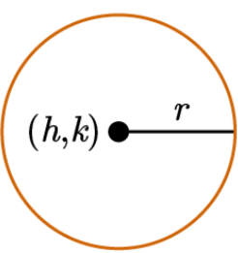
Unit Circle Equation | A circle centered at the origin (0,0) with a radius of 1. | $$x^{2}+y^{2}=1$$  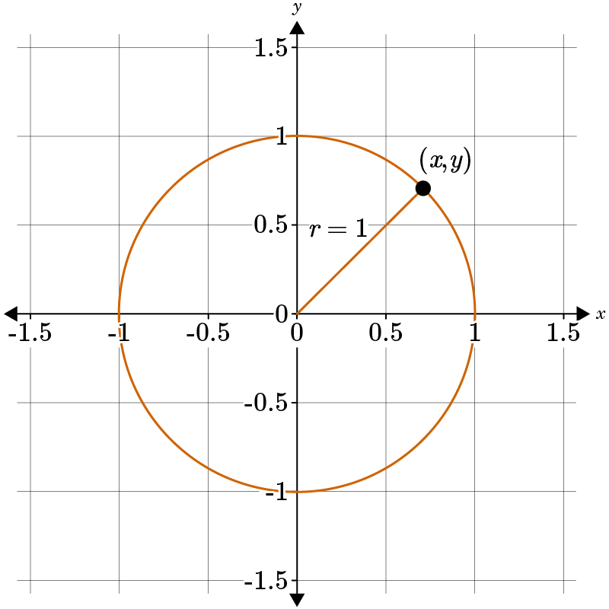
45-45-90 Special Right Triangle | A 45-45-90 special right triangle is made up of two angles, making it an isosceles triangle that form special side relationships. | 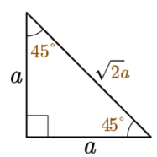
30-60-90 Special Right Triangle | A 30-60-90 special right triangle has one 60° angle and one that is 30° angle that form special side relationships. | 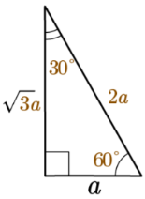
Sine Function | The sine of an angle $$θ$$is equal to the length of the side that is opposite angle $$θ$$divided by the length of the hypotenuse. | $$\sin{θ}=\frac{opposite}{hypotenuse}$$  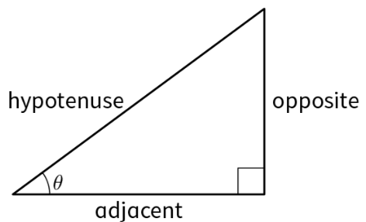
Cosine Function | The cosine of an angle $$θ$$is equal to the length of the side adjacent to the angle $$θ$$divided by the length of the hypotenuse. | $$\cos{θ}=\frac{adjacent}{hypotenuse}$$
Tangent Function | Tangent is the ratio of the sine and cosine functions. | $$\tan{θ}=\frac{opposite}{adjacent}$$
Trigonometric Functions on the Unit Circle | On the unit circle, when angle $$θ$$is formed by drawing a ray from the origin to the circle, they intersect at point $$\left(x,y\right)$$. | - $$sinθ=y$$  - $$cosθ=x$$  - $$tanθ=\frac{sinθ}{cosθ}=\frac{y}{x}$$  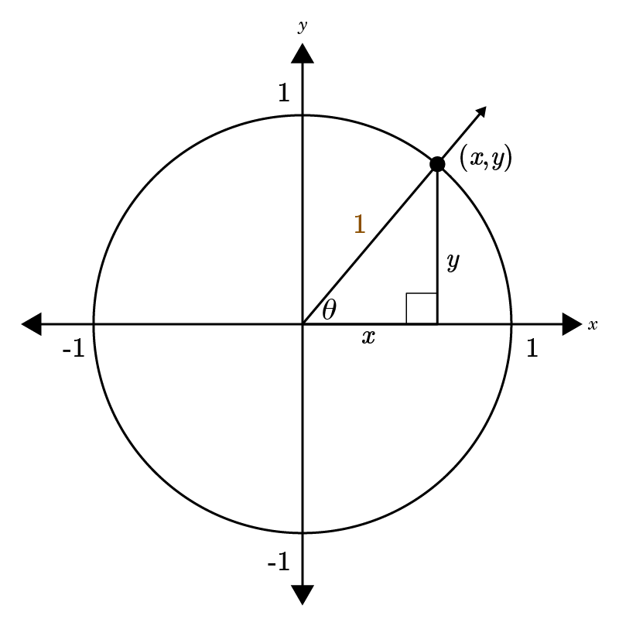
Radians and Degrees | A radian is another unit of measurement for angles, the other measurement being degrees. Using conversion factors, you can convert between the two measurements. | Degrees to Radians Conversion Factor: $$\frac{π}{180°}$$  Radians to Degrees Conversion Factor: $$\frac{180°}{π}$$  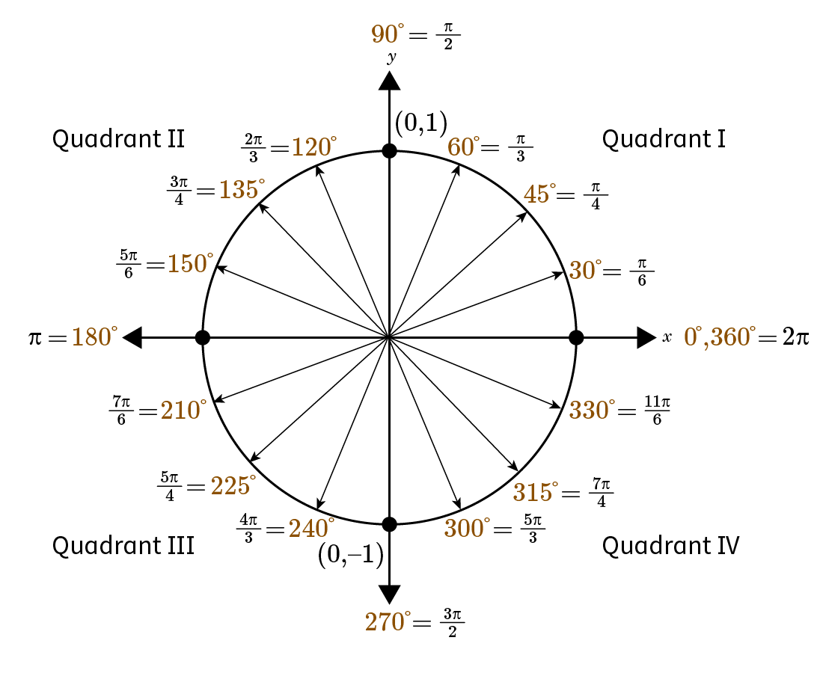
Unit Circle | In trigonometry, the unit circle has a radius of 1 and is centered at the origin. It is used to find the values for sine and cosine of common angles.  The coordinates of each $$\left(x,y\right)$$ point are written $$\left(cosθ,sinθ\right)$$. | 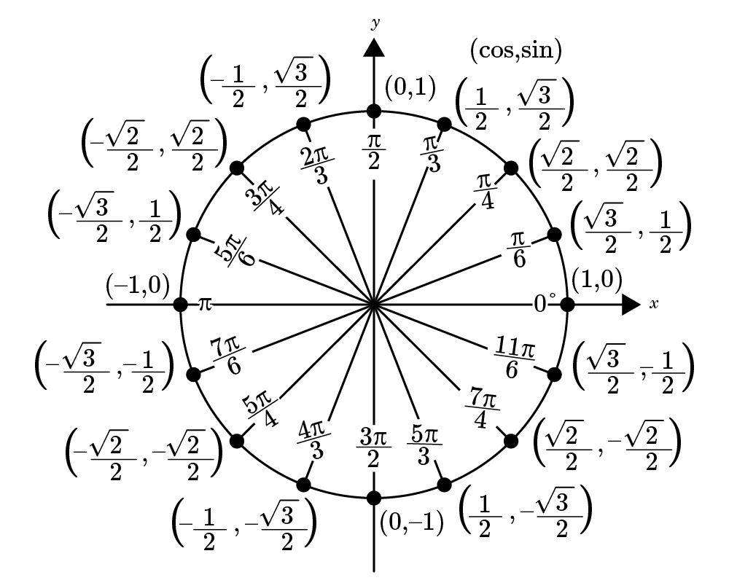
Signs of Trigonometric Functions | The signs of trigonometric functions are dependent on which quadrant the angle is in on the coordinate plane/unit circle. | 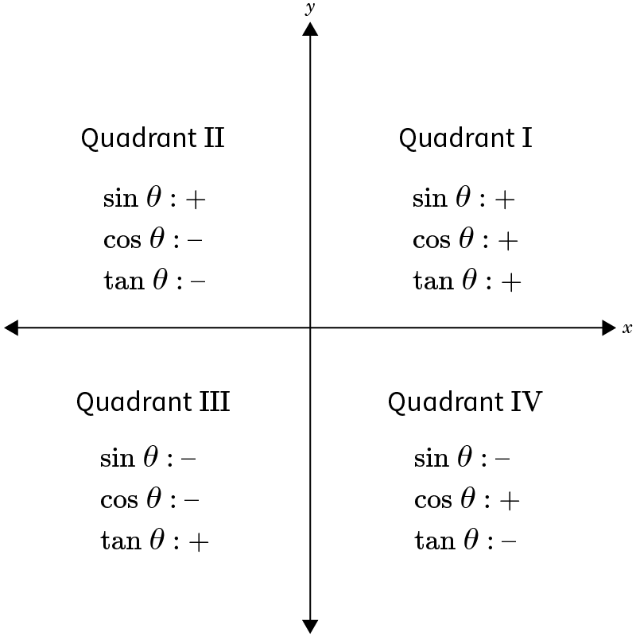
Pythagorean Identity | The Pythagorean Identity is another way of expressing the equation of the unit circle in terms of the angle $$θ$$. It can be used to find the sine, cosine, and tangent of an angle. The identity can be rearranged to isolate a specific function. | $$\sin^{2}{}θ+\cos^{2}{}θ=1$$  The identity can be rearranged to identify a specific function:  - $$sinθ=±\sqrt{1−\cos^{2}{}θ}$$  - $$cosθ=±\sqrt{1−\sin^{2}{}θ}$$

