Algebra 2

**Trigonometry**

**Unit Summary:** In this unit, you will learn about the trigonometric functions – sine, cosine, and tangent. You will use these functions to find the lengths of sides and measure of angles in triangles. You will be able to build on problem-solving skills to apply trigonometric functions in real-world problems.

**GeoGebra:** [Interactive Unit Circle – GeoGebra](https://www.geogebra.org/m/nv9vex3X)

**Lesson 2 – The Unit Circle**

**Key Words:**

* **congruent** – a term for identical in both size and shape
* **equilateral** **triangle** – a triangle that has three sides of equal length and three angles that each equal 60 degrees
* **hypotenuse** – the side of a right-angled triangle that is opposite the right angle
* **isosceles** **triangle** – a triangle in which two sides have the same length
* **perpendicular** – meeting at a 90-degree angle
* **pi** – the ratio of the circumference of a circle to its diameter
* **quadrant** - a division of the unit circle into one of four 90-degree sections
* **similar** – two geometric figures that are the same type of shape have congruent corresponding angles and have corresponding sides with equal ratios
* **unit** – in mathematics, the value of 1
* **unit** **circle** – a circle centered at the origin with a radius of 1

**Formulas:**

* Equation of a Circle: ${\left(x-h\right)}^{2}+{\left(y-k\right)}^{2}=r^{2}$
* Unit Circle Equation: $$x^{2}+y^{2}=1$$

**Objective 1:** In this section, you willestablish the unit circle as a circle centered at the origin with a radius of one and equation $x^{2}+y^{2}=1$**.**

*Mathematical Practice Standard: Make sense of problems and persevere in solving them.*

**Big Ideas**:

* Recall that geometric shapes, like circles, are *similar* because they have the same shape and the same ratio of circumference to radius, which is *pi ($π$*).
* Recall that any circle with a center at $\left(h,k\right)$ and radius $r$ has the equation: ${\left(x-h\right)}^{2}+{\left(y-k\right)}^{2}=r^{2}$
  + 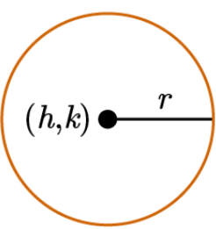
* The *unit circle* is useful when learning trigonometry because the triangle formed inside directly corresponds to Pythagorean’s Theorem, which you will work with later.

|  |  |
| --- | --- |
| **The Unit Circle** | |
| * The unit circle is centered at the origin (0,0) of the coordinate plane and has a radius of 1. * The unit circles equation simplifies to $$x^{2}+y^{2}=1$$* Notice that the unit circle intersects the *x*-axis at $$\left(1,0\right)$$ and $$\left(−1,0\right)$$. * Notice that the unit circle intersects the *y*-axis at $$\left(0,1\right)$$ and $$\left(0,−1\right)$$. |  |
| * Notice that you can draw a triangle inside of the unit circle that is formed by the radius and a line drawn vertically down from the point $$\left(x,y\right)$$. * The triangle formed by the radius, vertical line, and *x*-axis is a right triangle. * The lengths of the legs of the triangle are the values of the x- and y-coordinates from $$\left(x,y\right)$$. * The *hypotenuse* always has a length of 1. |  |

**Objective 2:** In this section, you will use special triangles to show that any point $$\left(x,y\right)$$ on the unit circle satisfies the equation of the unit circle.

*Mathematical Practice Standard: Construct viable arguments and critique the reasoning of others.*

**Big Ideas:**

* Recall the *unit circle* and its equation: $$x^{2}+y^{2}=1$$
* There are two types of right triangles that form special relationships and can be used as a tool in trigonometry. These are called Special Right Triangles.
  + You will use these relationships to show that any point $$\left(x,y\right)$$ on the *unit circle* will satisfy the equation of the unit circle.

|  |  |
| --- | --- |
| **Special Right Triangle: 45-45-90** | |
| * A 45-45-90 special right triangle is made up of two angles, making it an isosceles triangle. * The legs of the triangle are congruent. * The hypotenuse of the triangle is the product of a leg and the square root of two. |  |

|  |  |
| --- | --- |
| **Special Right Triangle: 30-60-90** | |
| * A 30-60-90 special right triangle has one $$60°$$ angle and one that is $$30°$$ angle. * The leg adjacent to the $$60°$$ angle is *x.* * The leg adjacent to the $$30°$$ angle is $$x\sqrt{3}$$. * The hypotenuse is $$2x$$. |  |

* If a point lies on the unit circle, such as the *x*- and *y-*intercepts or the point $$\left(x,y\right)$$, the coordinates of that point will satisfy the equation of a unit circle.
* You can choose any point $$\left(x,y\right)$$ that is on the unit circle and substitute the coordinates into the equation of a unit circle to determine if it is a true statement, and therefore satisfies the equation.

|  |  |
| --- | --- |
| **Example:** Use a unit circle's equation to determine if the following points are on one. | |
| $$\left(\frac{\sqrt{2}}{2},\frac{\sqrt{2}}{2}\right)$$ | Yes, this point lies on the unit circle. |
| $$\left(\frac{1}{2},\frac{\sqrt{2}}{2}\right)$$ | $$x^{2}+y^{2}=1$$ $${\left(\frac{1}{2}\right)}^{2}+{\left(\frac{\sqrt{2}}{2}\right)}^{2}=1$$ $$\frac{1}{4}+\frac{1}{2}=1$$ $$\frac{3}{4}=1$$ False Statement  This is not a point that lies on the unit circle. |
| $$\left(0,−1\right)$$ | $$x^{2}+y^{2}=1$$ $${\left(0\right)}^{2}+{\left(−1\right)}^{2}=1$$ $$0+1=1$$ $$1=1$$ True Statement  Yes, this point lies on the unit circle. |

**Practice Questions and Answers**

|  |  |  |
| --- | --- | --- |
|  | Question | Answer |
| P 1 | A triangle's radius within the unit circle has a radius equal to what? | 1 |
| P 2 | The hypotenuse of any triangle within the unit circle has a measure of what? | 1 |
| P 3 | Use the image to answer the question.  What is the x-coordinate of the point where the 45-45-90 triangle in this image intersects the unit circle? | $$\frac{\sqrt{2}}{2}$$ |
| P 4 | A 30-60-90 triangle drawn inside the unit circle intersects that unit circle at point (𝑥,𝑦). What is the length of the hypotenuse of this triangle? | 1 |
| P 5 | A point (𝑥,𝑦) lies on the unit circle such that 𝑥=−1. What is the y-coordinate for this point? | 0 |

**Quick Check Questions and Answers**

|  |  |  |
| --- | --- | --- |
|  | Question | Answer |
| Q 1 | Which of the following is the correct equation for the unit circle? | $${(x)}^{2}+{(y)}^{2}=1$$ |
| Q 2 | True or false, the origin of the unit circle is at the point (0,0). | True |
| Q 3 | True or false, the hypotenuse of a triangle within the unit circle is always equal to the radius of the unit circle. | true |
| Q 4 | A 30-60-90 triangle intersects the unit circle at point (x,y), where $y=\frac{1}{2}$ . What is the value of x in point (x,y)? Use the equation of the unit circle to determine the missing coordinate. | $$\frac{\sqrt{3}}{2}$$ |
| Q 5 | What type of special right triangle drawn inside the unit circle intersects the unit circle at $\left(\frac{\sqrt{2}}{2}, \frac{\sqrt{2}}{2}\right)$ ? | a 45-45-90 triangle |

**Lesson 3 – The Sine Function**

**Key Words:**

* **coordinates** – the numbers that describe the position of points along certain dimensions
* **function** – a mathematical correspondence that assigns exactly one element of one set to each element of the same or another set
* **ray** – an endpoint with a line extending forever in one direction
* **sine** – a trigonometric function that, for an acute angle of a right triangle, is the ratio of the length of the leg opposite the angle to the length of the hypotenuse
* **sine ratio** – a trigonometric ratio that, for an acute angle of a right triangle, is the ratio of the length of the leg opposite the angle to the length of the hypotenuse

**Formulas:**

* Unit Circle Equation: $$x^{2}+y^{2}=1$$
* Sine Ratio on the Unit Circle: $$sinθ=y$$

**Objective 1:** In this section, you will use the unit circle to establish sine as a function of the angle (θ) of rotation of a ray formed by the positive *x*-axis.

*Mathematical Practice Standard: Make sense of problems and persevere in solving them.*

**Big Ideas**:

|  |  |
| --- | --- |
| **Sine Function** | |
| * The *sine* of an angle $$θ$$ is equal to the length of the side that is opposite angle $$θ$$ divided by the length of the hypotenuse. $$sinθ=\frac{opposite}{hypotenuse}$$ | * On the unit circle, when angle $$θ$$ is formed by drawing a ray from the origin to the circle, they intersect at point $$\left(x,y\right)$$. * Sine is equal to the *y-*coordinate on the unit circle. * The sine of $$θ$$ is calculated with the equation: $$sinθ=y$$ |

* The value of the *sine function* depends on the angle formed by a *ray* and the positive *x*-axis and the intersection of that *ray* with the unit circle.
* As the *ray* rotates about the origin, the *y-*coordinate changes causing the value of the *sine function* to change.
* Knowing that $$sinθ=y$$ on the unit circle, you can find *y* values for various angles and graph them.

|  |  |
| --- | --- |
| **Example:** Use the following image of a portion of the unit circle to determine the value of the function $$y= sinθ$$ when $$θ=30°$$. | |
| **Step 1:** Recall the sine function of a unit circle. | $$\sin{θ}=y$$ This means that $$\sin{θ}$$ is equivalent to the *y* value of the $$\left(x,y\right)$$ coordinate that is on the circle. |
| **Step 2:** Identify the y-value. | $$\left(x,y\right)→\left(\frac{\sqrt{3}}{2},\frac{1}{2}\right)$$ $$y=\frac{1}{2}$$ |
| **Step 3:** State the answer. | $$\sin{3}0°=\frac{1}{2}$$ |

**Objective 2:** In this section, you will use special triangles on the unit circle to determine the values of the sine function for 30, 45, 60, and 90 degrees.

*Mathematical Practice Standard: Reason abstractly and quantitatively.*

**Big Ideas:**

* Recall the *sine ratio* on a unit circle: $$sinθ=y$$
* Recall special right triangles and their side ratios.

|  |  |
| --- | --- |
| **45-45-90** | **30-60-90** |
|  |  |

* You can determine the values of the *sine ratio* for 30, 45, 60, and 90 degrees using special right triangles on the unit circle.
  + The values of *sine* for angles formed by special right triangles are shown in the table below:

|  |  |  |
| --- | --- | --- |
| **Angle $$θ$$** | $$sinθ$$ | **Unit Circle** |
|  |  |  |
|  |  |
|  |  |
|  |  |

|  |
| --- |
| **Example:** Use the unit circle to answer the question. If $$\sin{θ}=\frac{1}{2}$$, what is $$θ$$? |
| * Recall that, on the unit circle, $$sinθ=y$$. * You are looking for the angle that intersects the unit circle with a *y*-value of $$\frac{1}{2}$$. * That happens when $$θ=30°$$ (highlighted below). |

**Objective 3:** In this section, you will connect the sine value of an angle to the y-coordinate of the point of intersection of the terminal ray and the unit circle.

*Mathematical Practice Standard: Reason abstractly and quantitatively.*

**Big Ideas:**

* Recall that *sine* is the *y-*coordinate of a point on the unit circle.
$$sinθ=y$$

* Even if you do not have the angle value ($$θ$$), you can find the sine of the angle formed by the *ray* in the unit circle.
  + Use the *y-*coordinate of the point where the *ray* intersects the unit circle.

|  |  |
| --- | --- |
| **Example:** Use the coordinates to find the sine of angle A. | |
| **Step 1:** Identify the point where the ray intersects the unit circle. | The ray intersects the circle at $$\left(\frac{\sqrt{5}}{5},\frac{2\sqrt{5}}{5}\right)$$. |
| **Step 2:** Identify the *y-*value of the coordinate. | $$y=\frac{2\sqrt{5}}{5}$$ |
| **Step 3:** State the answer. | $$\sin{A}=y$$ $$\sin{A}=\frac{2\sqrt{5}}{5}$$ |

**Practice Questions and Answers**

|  |  |  |
| --- | --- | --- |
|  | Question | Answer |
| P 1 | Which of the following statements is true about the sine ratio? | $$sinθ=\frac{opposite}{hypotenuse}$$ |
| P 2 | The sine ratio on the unit circle is equal to which of these values? | $$sinθ=y$$ |
| P 3 | Use the image to answer the question.  What is sin60°? | $$\frac{\sqrt{3}}{2}$$ |
| P 4 | Use the image to answer the question.  What is sin45°? | $$\frac{\sqrt{2}}{2}$$ |
| P 5 | Use the image to answer the question.  What is the sine of the angle formed by a terminal ray that intersects the unit circle at the point given in the image? | $$\frac{7}{25}$$ |

**Quick Check Questions and Answers**

|  |  |  |
| --- | --- | --- |
|  | Question | Answer |
| Q 1 | Use the image to answer the question.  Using the figure, establish the value of the function $y=sinθ$  when $θ=\frac{π}{3}$ . | $$\frac{\sqrt{3}}{2}$$ |
| Q 2 | On the unit circle, a right triangle with an angle measure of 𝜃 has a leg opposite of 𝜃 with a length of $\frac{1}{2}$  what is the length of the other leg? Use the Pythagorean Theorem. | $$\frac{\sqrt{3}}{2}$$ |
| Q 3 | Use the image to answer the question.  Use the special triangles on the unit circle to determine 𝜃 in degrees when $sinθ=\frac{\sqrt{3}}{2}$ . | $$60°$$ |
| Q 4 | What is the value of sine of 𝜃 when 𝜃=90°? | 1 |
| Q 5 | A point on the unit circle is $\left(\frac{1}{2}, \frac{\sqrt{3}}{2}\right)$ What is the sine of the angle formed by a terminal ray that intersects the unit circle at this point? | $$\frac{\sqrt{3}}{2}$$ |

**Lesson 4 – The Cosine Function**

**Key Words:**

* **absolute value** – a nonnegative number equal in numerical value to a given real number
* **acute angle** – an angle that has a measure greater than 0 degrees and less than 90 degrees
* **cosine** – a trigonometric function that, for an acute angle of a right triangle, is the ratio between the leg adjacent to the angle to the length of the hypotenuse
* **obtuse angle** – an angle with measure exceeding 90 degrees but less than 180 degrees
* **quadrant** – each of four quarters of a circle
* **quadrantal angle** – an angle in standard position whose terminal side lies on an axis
* **reference angle** – the acute angle formed by the terminal side of an angle and the x-axis
* **reflex angle** – an angle with a measure between 180 degrees and 360 degrees
* standard position – an angle in a coordinate plane such that its vertex is at the origin and its initial side lies on the positive x-axis
* **terminal side** – a ray of an angle in standard position that has been rotated about the vertex in a coordinate plane
* **unit circle** – a circle centered at the origin with a radius of 1

**Formulas:**

$$\cos{θ}=\frac{adjacent}{hypotenuse}$$

* Cosine on the Unit Circle: $$\cos{θ}=x$$
* Unit Circle Equation: $$x^{2}+y^{2}=1$$

**Objective 1:** In this section, you will establish cosine as a function of the angle θ of rotation of a ray formed by the positive *x*-axis.

*Mathematical Practice Standard: Make sense of problems and persevere in solving them.*

**Big Ideas**:

|  |  |
| --- | --- |
| **Cosine Function** | |
| * The *cosine* of an angle $$θ$$ is equal to the length of the side adjacent to angle $$θ$$ divided by the length of the hypotenuse: $$cosθ=\frac{adjacent}{hypotenuse}$$ | * On the unit circle, when angle is formed by drawing a ray from the origin to the circle, they intersect at point $$\left(x,y\right)$$. * Cosine is equal to the *x*-coordinate on the unit circle. * The cosine of $$θ$$ is calculated with the equation: $$cosθ=x$$ |

* The values of *cosine* for various angles are summarized below:

|  |  |  |
| --- | --- | --- |
| **Angle $$θ$$** | $$cosθ$$ | **Unit Circle** |
| $$0°$$ | $$1$$ |  |
| $$90°$$ | $$0$$ |
| $$180°$$ | $$−1$$ |
| $$270°$$ | $$0$$ |
| $$360°$$ | $$1$$ |

* Notice that $$0°$$ and $$360°$$ have the same *cosine* value because cosine is a period function that repeats itself every $$360°$$
  + A simple way to check for equivalent values in the unit circle is to subtract $$360°$$ from a value greater than $$360°$$ until you arrive at a value between $$360°$$ and $$0°$$.
  + If you have a value that is negative, add $$360°$$ until you have a positive value.

|  |  |
| --- | --- |
| **Example:** If a ray from the origin is rotated from the positive x-axis, what is the cosine of the angle formed when it is rotated $$810°$$? | |
| **Step 1:** Subtract $$360°$$ until you arrive at a number less than $$360°$$. | $$810°−360°=450°$$ $$450°−360°=90°$$ |
| **Step 2:** Identify the cosine value using the unit circle. | $$cosθ=x$$ $$\cos{9}0=x$$ $$\cos{9}0=0$$ |

**Objective 2:** In this section, you will use special triangles on the unit circle to determine the values of the cosine function for 30°, 45°, 60°, and 90°.

*Mathematical Practice Standard: Make sense of problems and persevere in solving them.*

**Big Ideas:**

* Recall special right triangles and the ratio of their sides. You can use these special ratios to determine the values of *cosine* for $$30°,45°,60°, and 90°$$.
  + 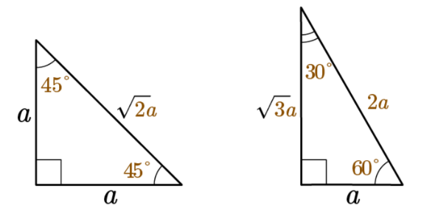
* In summary, the values of *cosine* for the angles formed by special right triangles are shown in the following table:

|  |  |  |
| --- | --- | --- |
| **Angle $$θ$$** | $$cosθ$$ | **Unit Circle** |
|  |  |  |
|  |  |
|  |  |
|  |  |

|  |
| --- |
| **Example:** What is the cosine of $$45°$$? |
| * Recall that on the unit circle $$cosθ=x$$. * You are looking for the $$45°$$ and the point at which the ray intersects the unit circle at $$45°$$. $$\cos{4}5°=\frac{\sqrt{2}}{2}$$ |

**Objective 3:** In this section, you will connect the cosine value of an angle to the x-coordinate of the point of intersection of the terminal ray and the unit circle.

*Mathematical Practice Standard: Make sense of problems and persevere in solving them.*

**Big Ideas:**

* The *cosine* value of angle $$θ$$ can be determined using the x-coordinate of the point where the terminal side of the angle $$θ$$ intersects with the unit circle.

|  |
| --- |
| **Example:** Find the cosine value of the angle in the following image. |
| * Recall that $$cosθ=x$$. * The x-value where the ray intersects the unit circle is $$−\frac{\sqrt{2}}{2}$$ $$cosθ=−\frac{\sqrt{2}}{2}$$ |

**Practice Questions and Answers**

|  |  |  |
| --- | --- | --- |
|  | Question | Answer |
| P 1 | A ray from the positive x-axis is rotated −270°. What is the cosine of the angle formed by this ray? | 0 |
| P 2 | Use the image to answer the question.  If the cosine of an angle 𝜃 is $\frac{1}{2}$ , what is 𝜃? You may assume that $0°≤θ≤180°.$ | 60 |
| P 3 | Use the image to answer the question.  What is cos0°? | 1 |
| P 4 | Find $cosθ$  if the y-coordinate of the point where the terminal side of 𝜃 intersects the unit circle is $\frac{\sqrt{2}}{2}$ , given that 𝜃 is an acute angle and in the first quadrant. | $$\frac{\sqrt{2}}{2}$$ |
| P 5 | Find the coordinates of the point shown on the unit circle, if $cosθ=-\frac{1}{2}.$ | $$-\frac{1}{2}; -\frac{\sqrt{3}}{2}$$ |

**Quick Check Questions and Answers**

|  |  |  |
| --- | --- | --- |
|  | Question | Answer |
| Q 1 | Cosine is established as a rotation of a ray formed initially on which axis? | the positive *x*-axis |
| Q 2 | Use the image to answer the question.  Which of the following correctly uses the special triangles on the unit circle to determine *θ* in degrees when $cosθ=\frac{\sqrt{2}}{2}$? You may assume that $0°≤θ≤180°$ . | $$45°$$ |
| Q 3 | When finding $cosθ=\frac{\sqrt{3}}{2}$  on a unit circle, what type of special right triangle or a ray is used? | 30-60-90 triangle |
| Q 4 | What is the value of $cosθ$  if the terminal side of *θ* and the unit circle intersect at point $\left(\frac{1}{\sqrt{2}},-\frac{1}{\sqrt{2}} \right)$ . | $$\frac{1}{\sqrt{2}}$$ |
| Q 5 | Given that $cosθ=0$ , find the coordinates of the point where the terminal side of θ intersects the unit circle, if *θ* is a reflex angle. | (0, -1) |

**Lesson 5 – Degrees & Radians**

**Key Words:**

* **circumference** – the distance around the edge of a circle
* **degree** – a unit of measure that is used to measure the magnitude of an angle; 1-degree equals 1/360 of the circumference of the circle
* **radian** – a unit of plane angular measurement that is equal to the angle at the center of a circle subtended by an arc whose length equals the radius or approximately 57.3 degrees
* **unit circle** – a circle centered at the origin with a radius of 1

**Formulas:**

* Circumference of a Circle: $$C=2πr$$
* Circumference of a Unit Circle: $$C=2π$$
* Degrees to Radians Conversion Factor: $$\frac{π radians}{180°}$$
* Radians to Degrees Conversion Factor: $$\frac{180°}{π radians}$$
* Sine Function (Unit Circle): $$sinθ=y$$
* Cosine Function (Unit Circle): $$\cos{θ}=x$$

**Objective 1:** In this section, you will use the unit circle to establish the radian as a second unit of angle measure.

*Mathematical Practice Standard: Make sense of problems and persevere while solving them.*

**Big Ideas**:

* In previous lessons, you have practiced using the *unit circle* to find angle measures using *degrees*. Another way to measure angles in a circle is using *radians*.
* A *radian* can be created by taking a circle's radius and tracing along its edge.
  + For example, it takes slightly more than 3 arcs to create a half circle, or $$180°$$.
  + To create a whole circle, or $$360°$$, it takes a little over 6 arcs.

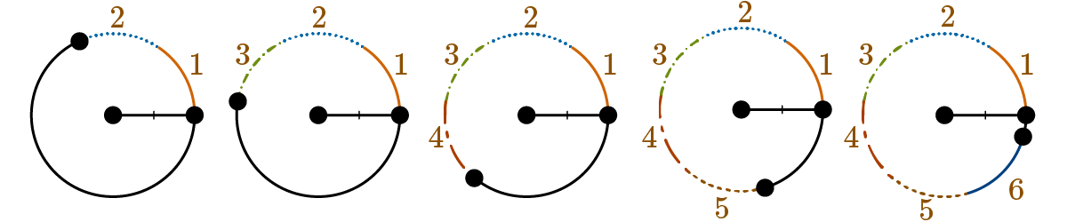

* Recall that the *circumference* of a circle is the distance around the edge of a circle which is $$2π$$ radius lengths, or $$2πr$$ from the formula.
  + On a unit circle, the *circumference* is always 1 unit, so the *circumference* is equal to exactly $$2π$$.
  + This means that you would trace exactly $$2π$$ radii to create a whole circle.
  + Half of that amount would create a half circle, so $$π$$ radii would be needed to create a half circle.
* Below is the *unit circle* with all major *degrees* and *radian* measures labeled:

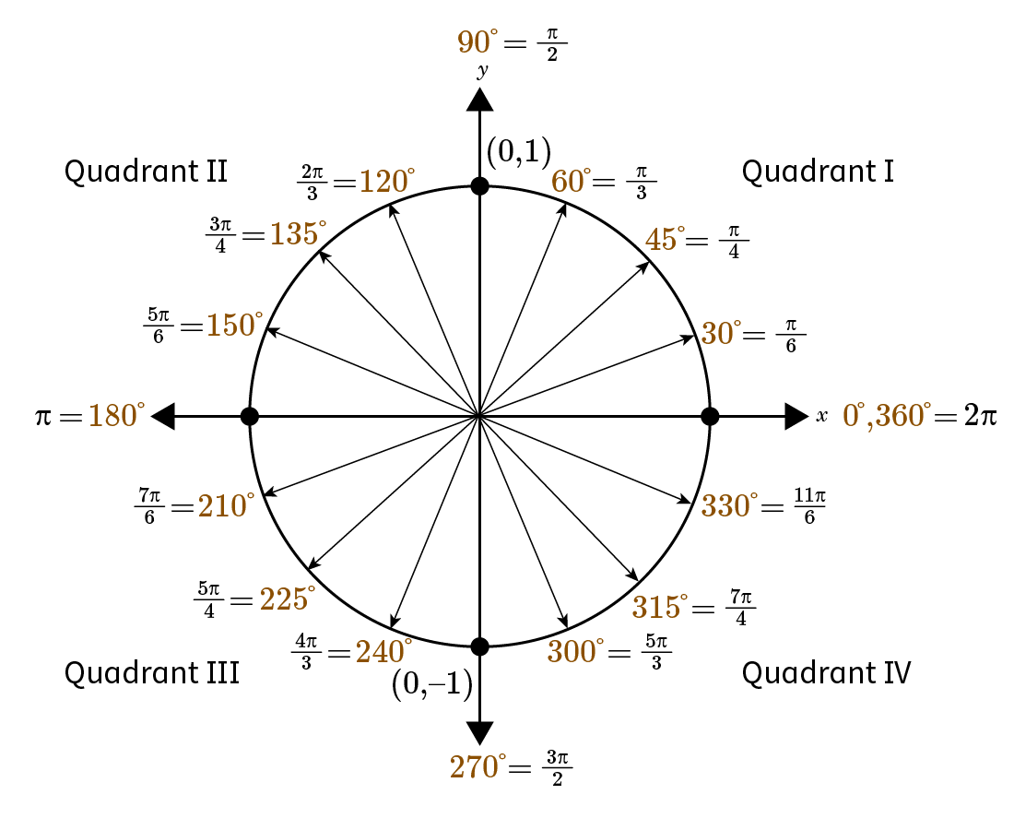

**Objective 2:** In this section, you will use the formula for the circumference of a circle to convert angle measures between degrees and radians.

*Mathematical Practice Standard: Attend to precision.*

**Big Ideas:**

* Recall that the *circumference* of a circle with a known radius is $$C=2πr$$ which describes the distance around a full circle.
* Recall that *radians* are another way of measuring angles. You can convert between *degrees* and *radians* by using the following conversion factors.
  + Degrees to Radians: $$\frac{π radians}{180°}$$
  + Radians to Degrees: $$\frac{180°}{π radians}$$

|  |  |
| --- | --- |
| **Example 1: Degrees to Radians**  Convert $$45°$$ to radians. | |
| **Step 1:** Multiply the degree measure by the conversion factor for degrees to radians. |  |
| **Step 2:** State the answer. | $$45°$$ is equivalent to $$\frac{π}{4}$$ radians. |

|  |  |
| --- | --- |
| **Example 2: Radians to Degrees**  Convert $$\frac{π}{3}$$ radians to degrees. | |
| **Step 1:** Multiply the radian measure by the conversion factor for radians to degrees. |  |
| **Step 2:** State the answer. | $$\frac{π}{3}$$ radians are equivalent to . |

|  |  |
| --- | --- |
| **Example 3: Degrees to Radians (special case)**  Convert $$10π°$$ to radians. | |
| **Step 1:** Multiply the degree measure by the conversion factor for degrees to radians. |  |
| **Step 2:** State the answer. | $$10π°$$ is equivalent to $$\frac{π^{2}}{18}$$ radians. |

**Objective 3:** In this section, you will write statements equating sine measures in degrees and radians and cosine measures in degrees and radians to each other.

*Mathematical Practice Standard: Attend to precision.*

**Big Ideas:**

* Recall how to convert *degrees* to *radians* and vice versa.
* Recall the sine and cosine functions of a unit circle and their equivalencies.
  + $$\sin{θ}=y$$, the *y-*value of the point where the ray intersects the circle.
  + $$\cos{θ}=x$$, the *x-*value of the point where the ray intersects the circle.
  + Below are the most commonly used angles $$0°, 30°, 45°, 60°, and 90°$$.

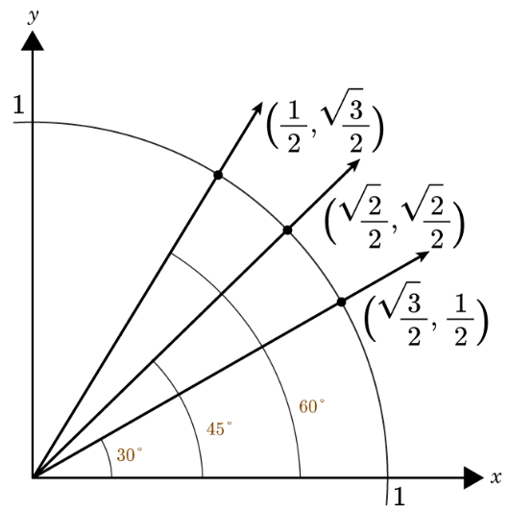

|  |  |
| --- | --- |
| **Example:** Complete the following equivalence statement. | |
| **Step 1:** Use the unit circle to identify which angle has an *y*-value (because we are using sine) of $$\frac{1}{2}$$. | $$\sin{3}0°=\frac{1}{2}$$ |
| **Step 2:** Convert the degree measure found in step 1 to radians. | $$30°⋅\frac{π}{180°}=\frac{π}{6}$$ |
| **Step 3:** Fill in the equivalency statement. | $$\sin{3}0°=\sin{}\frac{π}{6}=\frac{1}{2}$$ |

**Practice Questions and Answers**

|  |  |  |
| --- | --- | --- |
|  | Question | Answer |
| P 1 | What is another unit of angle measure in addition to degrees? | radians |
| P 2 | Convert 60 degrees to radians. | $$\frac{π}{3}$$ |
| P 3 | Convert $\frac{3π}{4}$  radians to degrees. | 135 |
| P 4 | Complete the equivalence statement below. For the first response enter a degree value. For the second response enter an exact value in simplest form. $$sin ____°=\sin{\frac{π}{4}}= ___$$ | 45; $\frac{\sqrt{2}}{2}$ |
| P 5 | Complete the equivalence statement below. Enter a degree value for the first response and enter an exact value in simplest form for the second response. $$cos ____°=\cos{\frac{π}{3}}= ___$$ | 60; $\frac{1}{2}$ |

**Quick Check Questions and Answers**

|  |  |  |
| --- | --- | --- |
|  | Question | Answer |
| Q 1 | A radian is created by tracing what measurement around a circle? | radius |
| Q 2 | Convert 72 degrees to radians. | $\frac{2π}{5}$ radians |
| Q 3 | Convert $\frac{7π}{2}$  radians to degrees. | 630 degrees |
| Q 4 | Which of the following is equivalent to $\sin{\frac{2π}{5}}$? | $$sin24°$$ |
| Q 5 | Which of the following expressions has the same value as $cos30°$ ? | $$\cos{\frac{π}{6}}$$ |

**Lesson 6 – Properties of the Sine & Cosine Functions**

**Key Words:**

* **cosine** – a trigonometric function that, for an acute angle, is the ratio of the length of the leg adjacent to the angle to the length of the hypotenuse
* **coterminal angles** – angles with a common terminal ray
* **degree** – a unit of measure for angles equal to an angle with its vertex at the center of a circle and its sides cutting off 1/360 of the circumference
* **domain** – the set of all possible inputs of a function
* **radian** – a unit of plane angular measurement that is equal to the angle at the center of a circle subtended by an arc whose length equals the radius or approximately 57.3 degrees
* **range** – the set of values a function may take
* **reference angle** – the acute angle formed by the terminal side of an angle and the x-axis
* **sine** – the trigonometric function that, for an acute angle, is the ratio between the leg opposite the angle, when it is considered part of a right triangle, and the hypotenuse
* **terminal ray** – the ray in the final position after a ray, starting along the positive x-axis with its endpoint at the origin, is rotated about the origin

**Formulas:**

* Conversion Factors:
  + Degrees to Radians: $$\frac{π}{180°}$$
  + Radians to Degrees: $$\frac{180°}{π}$$

$$sinθ=y$$

$$cosθ=x$$

**Objective 1:** In this section, you will use patterns to evaluate the sine and cosine functions for commonly used angles.

*Mathematical Practice Standard: Look for and express regularity in repeated reasoning.*

**Big Ideas**:

* Recall the unit circle *sine* and *cosine* functions of the most used angles written in both *degrees* and *radians*.

|  |  |  |  |  |  |
| --- | --- | --- | --- | --- | --- |
| $$θ$$**degrees** | $$0°$$ | $$30°$$ | $$45°$$ | $$60°$$ | $$90°$$ |
| $$θ$$**radians** | $$0$$ | $$\frac{π}{6}$$ | $$\frac{π}{4}$$ | $$\frac{π}{3}$$ | $$\frac{π}{2}$$ |
| $$sinθ$$ | $$\frac{\sqrt{0}}{2}=0$$ | $$\frac{\sqrt{1}}{2}$$ | $$\frac{\sqrt{2}}{2}$$ | $$\frac{\sqrt{3}}{2}$$ | $$\frac{\sqrt{4}}{2}=1$$ |
| $$cosθ$$ | $$\frac{\sqrt{4}}{2}=1$$ | $$\frac{\sqrt{3}}{2}$$ | $$\frac{\sqrt{2}}{2}$$ | $$\frac{\sqrt{1}}{2}$$ | $$\frac{\sqrt{0}}{2}=0$$ |

* Recognizing patterns in the table can help you easily identify the *sine* and *cosine* functions of frequently used angles.
  + In the *sine* function, the number under the square root increases by one as you move to the right.
  + In the *cosine* function, the number under the square root decreases by one as you move to the right.
  + The *sine* and *cosine* of $$45°$$ are equivalent.
  + $$\sin{3}0°$$ and $$\cos{6}0°$$ are equivalent and thus $$\cos{3}0°$$ and $$\sin{6}0°$$ are equivalent.
* You can also use the unit circle to visualize the patterns of *sine* and *cosine* functions.

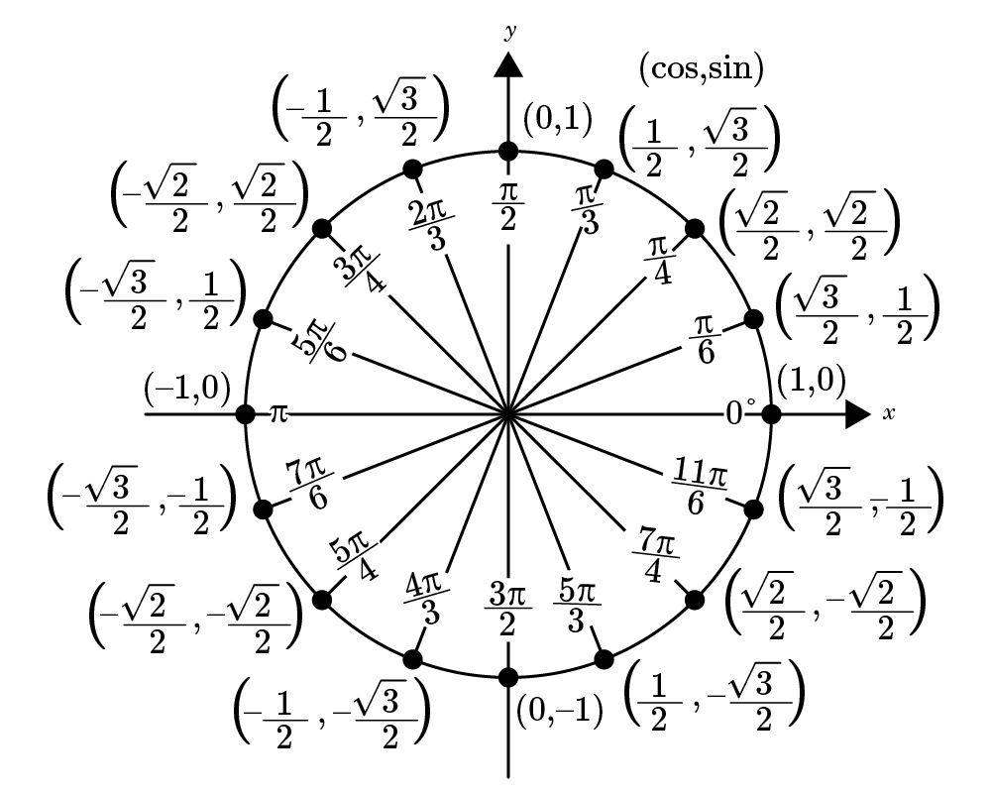

**Objective 2:** In this section, you will establish that the domain of the sine and cosine functions contain all real numbers.

*Mathematical Practice Standard: Make sense of problems and persevere in solving them.*

**Big Ideas:**

* The input of *sine* and *cosine* functions is always an angle measure in *degrees* or *radians*.
  + Angles are defined by the rotation of a ray that starts at the positive *x*-axis and ends in a position called the *terminal ray*.
  + Positive angles are counterclockwise rotations, and negative angles are clockwise rotations.

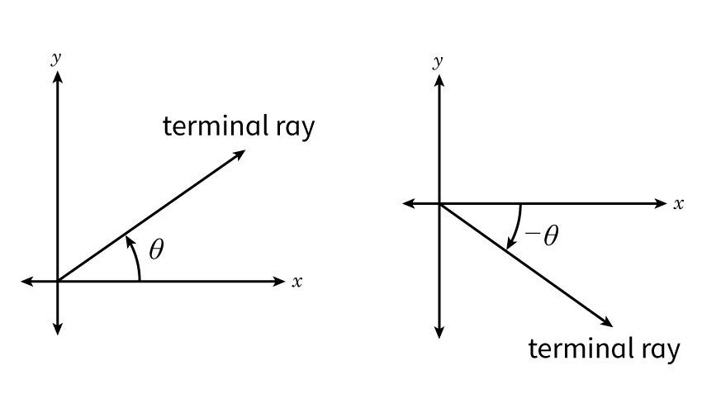

* Angles that share a common *terminal ray* are called *coterminal angles*.
  + For every positive angle, there is a negative angle that is a *coterminal angle*.
  + For example, $$45°$$ and $$−315°$$ are *coterminal angles* and $$315°$$ and $$−45°$$ are *coterminal angles*.

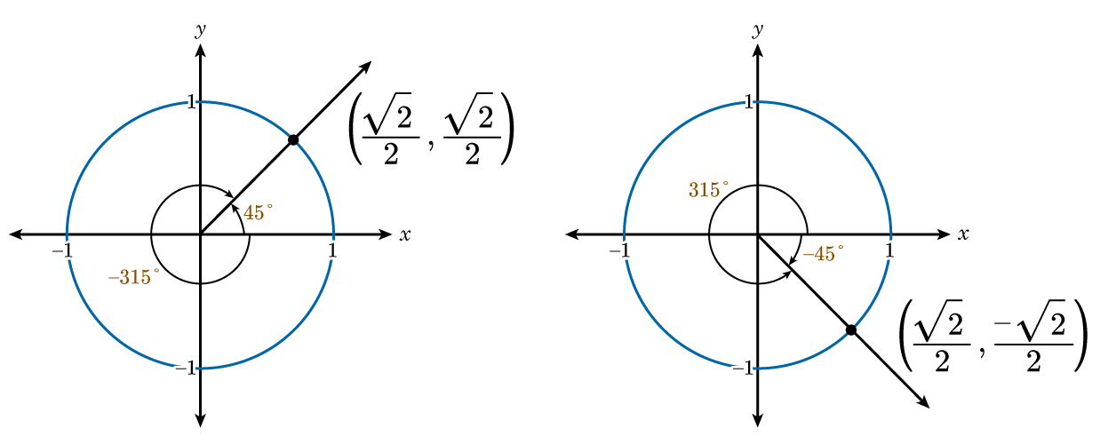

* For any angle, there are infinite numbers of *coterminal angles*.
  + Starting with the original angle, you can add or subtract integer multiples of $$360°$$ to the angle. For radians, you can add or subtract integer multiples of $$2π$$.
  + The resulting angles are *coterminal angles* with the original angle and have the same values of *sine* and *cosine*.
  + This makes it possible to evaluate *sine* and *cosine* functions for any angle measure.
* Any real number *x* is a valid input for both sine and cosine functions since the two functions are defined by any angle on the unit circle, including angles with measures less than 0 or greater than $$2π$$.
  + The *domain* of the function $$f\left(x\right)=\sin{x}$$ is the set of all real numbers, or $$−∞<x<∞$$.
  + The *domain* function $$g\left(x\right)=\cos{x}$$ is the set of all real numbers, or $$−∞<x<∞$$.

**Objective 3:** In this section, you will establish that the ranges of both the sine and the cosine functions are [−1,1].

*Mathematical Practice Standard: Make sense of problems and persevere in solving them.*

**Big Ideas:**

* Recall that the *domain* of *sine* and *cosine* functions is all real numbers, meaning you can plug any real number in to a *sine* or *cosine* ratio and get a corresponding real number solution.
* However, the *range* of *sine* and *cosine* functions are between –1 and 1.
* Recall the unit circle below:
  + Notice that the highest value on the unit circle is 1 and the lowest value is –1.
  + This means that the *range* (set of possible outputs) of the *cosine* and *sine* functions is $$\left[−1,1\right]$$.

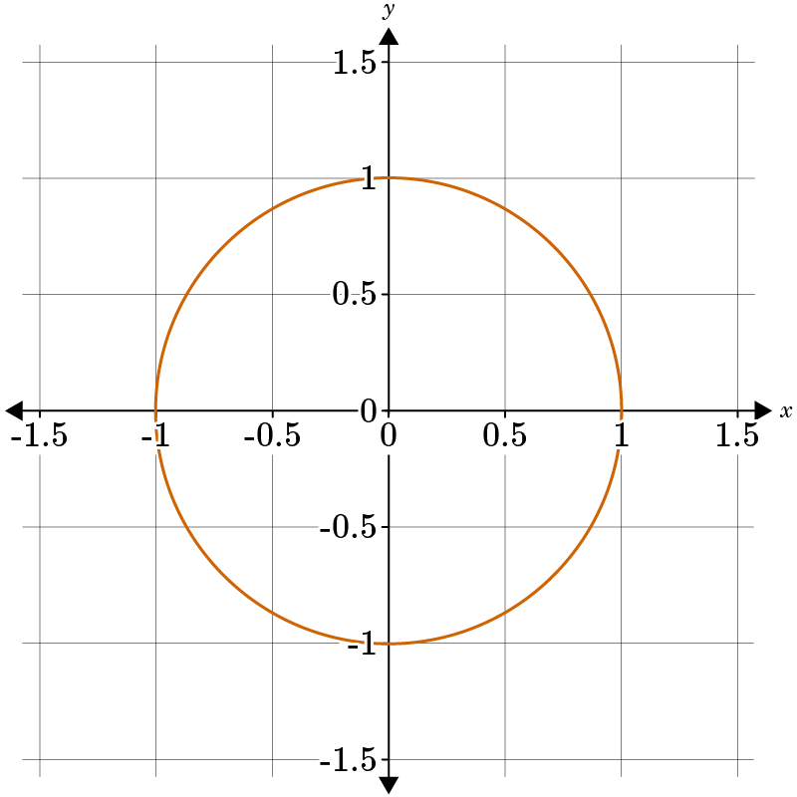

|  |  |
| --- | --- |
| **Example:** Find $$θ$$ if $$sinθ=−2$$. | |
| **Step 1:** Recall the range of sine functions. | The range of sine functions is $$\left[−1,1\right]$$. This means that the output of a sine function must be between –1 and 1. |
| **Step 2:** State the answer. | The sine function will never equal –2. There are no values of $$θ$$ that would produce an answer of –2. Therefore, there is no solution to this problem. |

**Practice Questions and Answers**

|  |  |  |
| --- | --- | --- |
|  | Question | Answer |
| P 1 | Use >, <, or= to compare the following trigonometric expressions. $$sin45°_____cos\left(\frac{π}{6}\right)$$ | < |
| P 2 | What are the cosine and sine of 30°? $$\sin{30°=_____}$$ $$\cos{30°=_____}$$ | $$\frac{1}{2}; \frac{\sqrt{3}}{2}$$ |
| P 3 | True or false, the domain of sine and cosine is all real numbers | true |
| P 4 | What is the largest value of cosine of 𝜃 on the unit circle? What is the smallest value of cosine of 𝜃?  The largest value of cosine of 𝜃 is _____. The smallest value of cosine of 𝜃 ______. | 1; -1 |
| P 5 | What is the cosine of 0°? | 1 |

**Quick Check Questions and Answers**

|  |  |  |
| --- | --- | --- |
|  | Question | Answer |
| Q 1 | Use patterns to find the values of sin 30° and cos 30° and then compare their values. | $$\sin{30°}<\cos{30°}$$ |
| Q 2 | Find the value of $\sin\left(\frac{π}{3}\right)$ . | $$\frac{\sqrt{3}}{2}$$ |
| Q 3 | True or false, is the sine function has a domain of all real numbers. | true |
| Q 4 | Which of the following is **not** a value of 𝜃 when $sin θ=-1$ ? | π |
| Q 5 | At which of the following values is $sin θ$  negative? | $$\sin{θ=270°}$$ |

**Lesson 7 – The Tangent Function**

**Key Words:**

* **tangent** – a trigonometric function that is equal to the sine divided by the cosine for all real numbers θ, for which the cosine is not equal to zero and is exactly equal to the tangent of an angle of measure θ in radians
* **unit circle** – a circle having a radius of 1

**Formulas:**

$$tanθ=\frac{sinθ}{cosθ}$$

$$sinθ=y$$

$$cosθ=x$$

* Conversion Factors:
  + Degrees to Radians: $$\frac{π}{180°}$$
  + Radians to Degrees: $$\frac{180°}{π}$$

**Objective 1:** In this section, you will establish tangent as a function of the angle of rotation in the unit circle.

*Mathematical Practice Standard: Make sense of problems and persevere in solving them.*

**Big Ideas**:

* The *tangent* function, along with the sine and cosine, are the trigonometric functions most often used.
* *Tangent* is the ratio of sine and cosine, often written as $$tanθ=\frac{sinθ}{cosθ}$$, or when referring to any right triangle and its sides $$tanθ=\frac{opposite}{adjacent}$$.
  + Recall that in the unit circle the coordinates of each point $$\left(x,y\right)$$ are written $$\left(cosθ,sinθ\right)$$.
  + To find the *tangent* of an angle, simply substitute the *x-* and *y-*coordinates from the unit circle.
* Recall the unit circle which you use to find values for sine and cosine of common angles.



|  |  |
| --- | --- |
| **Example:** Find the $$\tan\left(\frac{π}{6}\right)$$. | |
| **Step 1:** Recall the tangent function ratio. | $$\tan{θ}=\frac{\sin{θ}}{\cos{θ}}$$ $$\tan\left(\frac{π}{6}\right)=\frac{\sin\left(\frac{π}{6}\right)}{\cos\left(\frac{π}{6}\right)}$$ |
| **Step 2:** Use the unit circle to identify the sine and cosine. | $$\sin\left(\frac{π}{6}\right)=\frac{1}{2}$$ $$\cos\left(\frac{π}{6}\right)=\frac{\sqrt{3}}{2}$$ |
| **Step 3:** Substitute the values into the tangent function. | $$\tan\left(\frac{π}{6}\right)=\frac{\sin\left(\frac{π}{6}\right)}{\cos\left(\frac{π}{6}\right)}$$ $$\tan\left(\frac{π}{6}\right)=\frac{\frac{1}{2}}{\frac{\sqrt{3}}{2}}$$ |
| **Step 4:** Simplify. | $$\tan\left(\frac{π}{6}\right)=\frac{\frac{1}{2}}{\frac{\sqrt{3}}{2}}=\frac{1}{2}⋅\frac{2}{\sqrt{3}}=\frac{2}{2\sqrt{3}}=\frac{1}{\sqrt{3}}$$ |

**Objective 2:** In this section, you will use special triangles on the unit circle to determine the values of the tangent function for 30, 45, 60, and 90 degrees.

*Mathematical Practice Standard: Make sense of problems and persevere in solving them.*

**Big Ideas:**

* Recall that the *tangent* of an angle is a ratio of sine and cosine $$tanθ=\frac{sinθ}{cosθ}$$.
  + Recall that the coordinates of each point on the *unit circle $$\left(x,y\right)$$* are written $$\left(cosθ,sinθ\right)$$, therefore, we can say that $$tanθ=\frac{y}{x}$$.
* Another way to find the *tangent* of an angle in a right triangle is to use the ratio $$tanθ=\frac{opposite}{adjacent}$$.

|  |  |
| --- | --- |
| **Example:** Find $$\tan{6}0°$$. | |
| **Step 1:** Recall the tangent ratio. | $$tanθ=\frac{sinθ}{cosθ}=\frac{y}{x}$$ $$\tan{6}0°=\frac{\sin{6}0°}{\cos{6}0°}=\frac{y}{x}$$ |
| **Step 2:** Use the unit circle to find the x- and y- coordinates. | $$\sin{6}0°=y=\frac{\sqrt{3}}{2}$$ $$\cos{6}0°=x=\frac{1}{2}$$ |
| **Step 3:** Substitute the values into the tangent ratio. | $$\tan{6}0°=\frac{y}{x}=\frac{\frac{\sqrt{3}}{2}}{\frac{1}{2}}$$ |
| **Step 4:** Simplify. | $$\tan{6}0°=\frac{\frac{\sqrt{3}}{2}}{\frac{1}{2}}=\frac{\sqrt{3}}{2}⋅\frac{2}{1}=\frac{2\sqrt{3}}{2}=\sqrt{3}$$ |

**Objective 3:** In this section, you will connect the tangent value of an angle to the quotient of the *y*-coordinate and the *x*-coordinate of the point where the terminal side of the angle and the unit circle intersect.

*Mathematical Practice Standard: Make sense of problems and persevere in solving them.*

**Big Ideas:**

* Recall the *tangent* ratio. You can use this ratio to find the *tangent* of any angle given in the *unit circle*.



|  |  |
| --- | --- |
| **Example 1:** Find $$\tan{2}40°$$. | |
| **Step 1:** Convert from degrees to radians using the conversion factor. | $$240°⋅\frac{π}{180°}=\frac{4π}{3}$$ |
| **Step 2:** Locate the angle and coordinate pair on the unit circle. | The coordinate of the point at $$240°$$ or $$\frac{4π}{3}$$ radians is: $$\left(−\frac{1}{2},−\frac{\sqrt{3}}{2}\right)$$ |
| **Step 3:** Substitute the coordinates into the tangent ratio. | $$\tan{2}40°=\frac{y}{x}=\frac{−\frac{\sqrt{3}}{2}}{−\frac{1}{2}}$$ |
| **Step 4:** Simplify. |  |

|  |  |
| --- | --- |
| **Example 2:** Find $$\tan\left(\frac{5π}{3}\right)$$. | |
| **Step 1:** Locate the angle and coordinate pair on the unit circle. | The coordinate of the point at $$\frac{5π}{3}$$ is: $$\left(\frac{1}{2},−\frac{\sqrt{3}}{2}\right)$$ |
| **Step 2:** Substitute the coordinates into the tangent ratio. | $$\tan\left(\frac{5π}{3}\right)=\frac{y}{x}=\frac{−\frac{\sqrt{3}}{2}}{\frac{1}{2}}$$ |
| **Step 3:** Simplify. | $$\tan\left(\frac{5π}{3}\right)=\frac{−\frac{\sqrt{3}}{2}}{\frac{1}{2}}=−\frac{\sqrt{3}}{2}⋅\frac{2}{1}=−\frac{2\sqrt{3}}{2}=−\sqrt{3}$$ |

**Practice Questions and Answers**

|  |  |  |
| --- | --- | --- |
|  | Question | Answer |
| P 1 | Which ratio should Jadea use to find $\tan\left(\frac{4π}{3}\right)$?  Ratio #1: $\tan\left(\frac{4π}{3}\right)=\frac{-\frac{1}{2}}{-\frac{\sqrt{3}}{2}}=\frac{\sqrt{3}}{3}$ Ratio #2: $\tan\left(\frac{4π}{3}\right)=\frac{-\frac{\sqrt{3}}{2}}{-\frac{1}{2}}=\sqrt{3}$ Jadea should use Ratio # _____. | 2 |
| P 2 | Find $\tan{\frac{π}{3}}$. | $$\sqrt{3}$$ |
| P 3 | What is the tangent of 90 degrees? | Undefined |
| P 4 | Which of the following is the correct ratio for tangent?  Option #1: $\tan{θ=\frac{y}{x}}$ Option #2: $\tan{θ=\frac{x}{y}}$ | 1 |
| P 5 | Use the image to answer the question.  Which ratio should Elise use to find $\tan{π}$ ?  Option #1: $\tan{π}=\frac{y}{x}=\frac{0}{-1}=0$ Option #2: $\tan{π}=\frac{x}{y}=\frac{-1}{0}=undefined$ | 1 |

**Quick Check Questions and Answers**

|  |  |  |
| --- | --- | --- |
|  | Question | Answer |
| Q 1 | Calculate $\tan{\frac{π}{6}}$. | $$\frac{\sqrt{3}}{3}$$ |
| Q 2 | At what which of the following sets of values is the tangent function undefined? | at 90 and 270 degrees |
| Q 3 | Use the image to answer the question.  Use the triangle shown on the unit circle to find $\tan{\frac{π}{3}}$ . | $$\sqrt{3}$$ |
| Q 4 | Use the image to answer the question.  Use the triangle shown on the unit circle to find $tanθ$ . | $$\frac{\sqrt{3}}{3}$$ |
| Q 5 | Use the image to answer the question.  Connect the tangent value of the angle 210° to the quotient of the y-coordinate and the x-coordinate. | $$\tan{210°}=\frac{y}{x}=\frac{-\frac{1}{2}}{-\frac{\sqrt{3}}{2}}=\frac{\sqrt{3}}{3}$$ |

**Lesson 8 – Angles & Quadrants**

**Key Words:**

* **cosine** – a trigonometric function that, for an acute angle of a right triangle, is the ratio between the length of the leg adjacent to the angle to the length of the hypotenuse
* **quadrant** – any of the four parts into which a plane is divided by rectangular coordinate axes lying in that plane
* **sine** – a trigonometric function that, for an acute angle of a right triangle, is the ratio of the length of the leg opposite the angle to the length of the hypotenuse
* **tangent** – a trigonometric function that, for an acute angle of a right triangle, is the ratio between the length of the leg opposite the angle to the length of the leg adjacent to the angle
* **unit circle** – a circle centered at the origin with a radius of 1 a trigonometric function that, for an acute angle of a right triangle, is the ratio of the length of the leg opposite the angle to the length of the hypotenuse

**Formulas:**

$$sinθ=y$$

$$cosθ=x$$

$$tanθ=\frac{sinθ}{cosθ}=\frac{y}{x}$$

**Objective 1:** In this section, you will determine the signs of the sine, cosine, and tangent functions based on their quadrant.

*Mathematical Practice Standard: Make sense of problems and persevere in solving them.*

**Big Ideas**:

* The coordinate plane is divided into four quadrants by the *x-*axis and *y-*axis. The coordinate points $$\left(x,y\right)$$ in each *quadrant* shares the same characteristics.

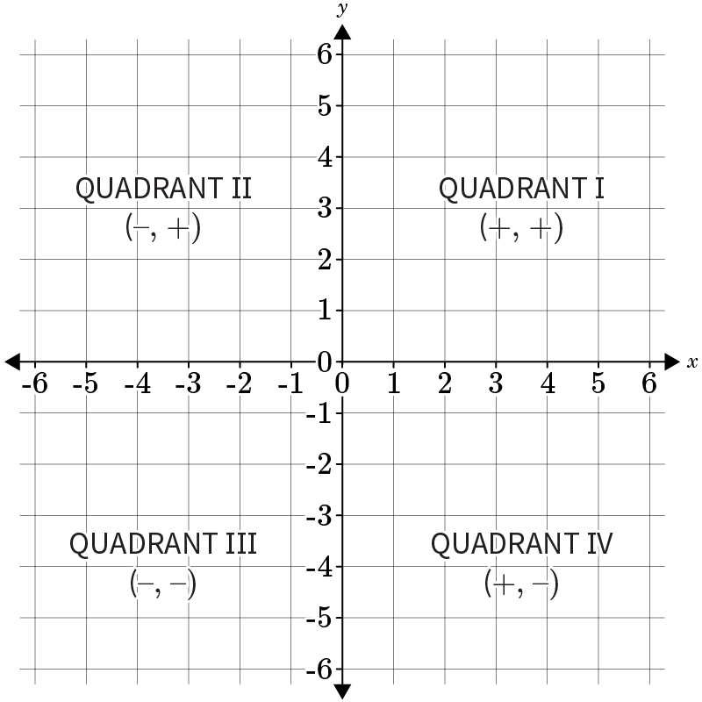

* Recall the *unit circle* and how it helps to find the *sine*, *cosine*, and *tangent* of angles. You will use the *unit circle* to determine the signs of the functions in each *quadrant*.

$$sinθ=y$$

$$cosθ=x$$

$$tanθ=\frac{sinθ}{cosθ}=\frac{y}{x}$$

|  |  |
| --- | --- |
|  |  |

**Objective 2:** In this section, you will determine what quadrant the angle is in given sine, cosine, or tangent function values.

*Mathematical Practice Standard: Make sense of problems and persevere in solving them.*

**Big Ideas:**

* Recall what you learned about the signs of trigonometric functions in each quadrant of the coordinate plane.

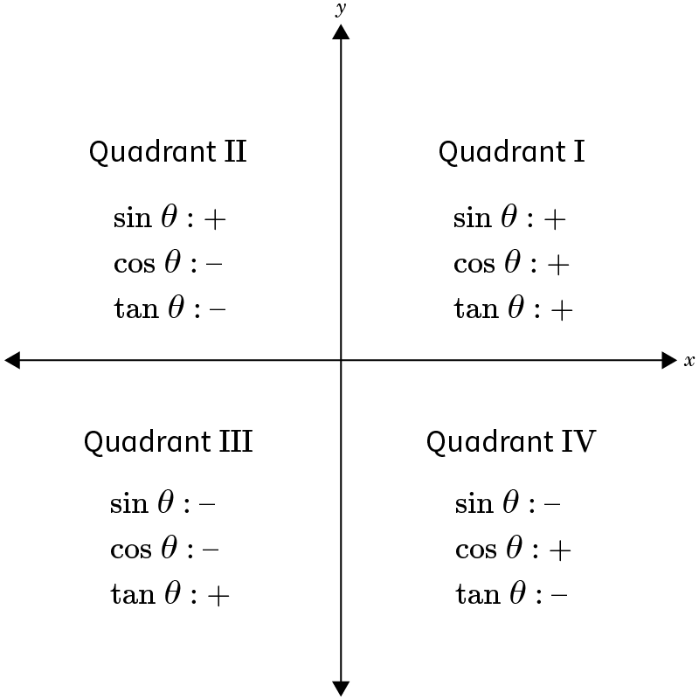

|  |  |
| --- | --- |
| **Example 1:** What quadrant would $$θ$$ be in if $$\sin{θ}=\frac{\sqrt{21}}{7}$$ and $$cosθ=−\frac{2\sqrt{7}}{7}$$? | |
| **Step 1:** Determine the quadrant of each function. | $$\sin{θ}=\frac{\sqrt{21}}{7}$$* : Sine is positive in Quadrants I and II. $$cosθ=−\frac{2\sqrt{7}}{7}$$* : Cosine is positive in Quadrants II and III. |
| **Step 2:** Determine the overlap, or which quadrant the functions share. | The overlap is Quadrant II. So, $$θ$$ would be in Quadrant II. |

|  |  |
| --- | --- |
| **Example 2:** What quadrant is $$θ$$ in if $$\tan{θ}=−\frac{4}{3}$$ and $$sinθ<0$$? | |
| **Step 1:** Determine the quadrant of each function. | $$\tan{θ}=−\frac{4}{3}$$* : Tangent is negative in Quadrants II and IV. $$sinθ<0$$* : Sine is negative in Quadrants III and IV. |
| **Step 2:** Determine the overlap, or which quadrant the functions share. | The overlap is Quadrant IV. So, $$θ$$ would be in Quadrant IV. |

**Practice Questions and Answers**

|  |  |  |
| --- | --- | --- |
|  | Question | Answer |
| P 1 | In which quadrant are all trigonometric functions positive? Use 1, 2, 3 or 4 for your answer.   All trigonometric functions are positive in Quadrant _____. | 1 |
| P 2 | How can you determine the quadrants in which sine will be positive?  Statement #1: Since sine is the y-coordinate in the ordered pair, it will be positive where the y-coordinate is positive. Sine will be positive in Quadrants I and II.  Statement #2: Since sine is the x-coordinate in the ordered pair, it will be positive where the x-coordinate is positive. Sine will be positive in Quadrants I and IV.  Statement # _____ is correct. | 1 |
| P 3 | In which quadrant would 𝜃 be if $cosθ=-\frac{1}{2}$ and $tanθ<0$ ?  Use a digit for your response rather than a Roman numeral.  Quadrant ____ | 2 |
| P 4 | In which quadrant would 𝜃 be if sin $θ=-\frac{\sqrt{3}}{2}$ and $tanθ<0$ ?  Use a digit for your response rather than a Roman numeral.  Quadrant ____ | 4 |
| P 5 | In which quadrant would 𝜃 be if tan $θ=\frac{\sqrt{3}}{3}$ and $\sin{θ=-\frac{1}{2}}$ ?  Use a digit for your response rather than a Roman numeral.  Quadrant ____ | 3 |

**Quick Check Questions and Answers**

|  |  |  |
| --- | --- | --- |
|  | Question | Answer |
| Q 1 | Determine the sign of $\sin\left(\frac{5π}{4}\right)$ and the quadrant in which it lies. | $\sin\left(\frac{5π}{4}\right)$ is negative and lies in Quadrant III. |
| Q 2 | In which quadrant is sine negative, cosine positive, and tangent negative? | Quadrant IV |
| Q 3 | Determine the quadrant of 𝜃 if tan $θ=-\frac{\sqrt{3}}{3}$ and $\cos{θ=-\frac{\sqrt{3}}{2}}.$ | Quadrant II |
| Q 4 | Determine the quadrant of 𝜃 if cos $θ=\frac{\sqrt{3}}{2}$ and $\tan{θ=-\frac{\sqrt{3}}{3}}.$ | Quadrant IV |
| Q 5 | In which quadrant would 𝜃 be if tan $θ=-\sqrt{3}$ and sin $θ>0$? | Quadrant II |

**Lesson 9 – A Pythagorean Identity**

**Key Words:**

* **identity** – an equation that is always true for any value of the variables
* **Pythagorean identity** – a trigonometric identity based on the Pythagorean Theorem
* **trigonometric identity** – a trigonometric equation that is always true for any value of the variables

**Formulas:**

* Pythagorean Identify: $$\sin^{2}{}θ+\cos^{2}{}θ=1$$
$$sinθ=±\sqrt{1−\cos^{2}{}θ}$$

$$cosθ=±\sqrt{1−\sin^{2}{}θ}$$

$$tanθ=\frac{sinθ}{cosθ}$$

* Unit Circle Formulas: $$x^{2}+y^{2}=1$$

**Objective 1:** In this section, you will use the unit circle to prove the Pythagorean Identity $\sin^{2}θ+\cos^{2}θ=1$.

*Mathematical Practice Standard: Construct viable arguments and critique the reasoning of others.*

**Big Ideas**:

* Recall that the Pythagorean Theorem says that $$a^{2}+b^{2}=c^{2}$$ where *a* and *b* are the lengths of the legs of a right triangle and *c* is the hypotenuse of the triangle.
* Recall the formula for the unit circle: $$x^{2}+y^{2}=1$$
* The *Pythagorean Identity* is a direct extension of the Pythagorean Theorem and another way of expressing the equation of the unit circle in terms of the angle $$θ$$.
  + Pythagorean Identity: $$\sin^{2}{}θ+\cos^{2}{}θ=1$$

|  |
| --- |
| **Pythagorean Identity** |
|  |

* Recall the signs of trigonometric functions in the four quadrants.
* In general, if you know $$sinθ$$, you can use the Pythagorean Identity to find $$cosθ$$.
  + If you know $$cosθ$$, you can use Pythagorean Identity to find $$sinθ$$.

|  |  |
| --- | --- |
| **Example 1:** The $$cosθ=\frac{8}{17}$$ and $$\frac{3π}{2}≤θ≤2π$$. Find $$sinθ$$. | |
| **Step 1:** Write the Pythagorean Identity. | $$\sin^{2}{}θ+\cos^{2}{}θ=1$$ |
| **Step 2:** Plug in the given value. | $$\cos{θ}=\frac{8}{17}$$ $$\sin^{2}{}θ+\cos^{2}{}θ=1 → \sin^{2}{}θ+{\left(\frac{8}{17}\right)}^{2}=1$$ |
| **Step 3:** Simplify. |  |
| **Step 4:** Take the square root of both sides. |  |
| **Step 5:** Determine if $$sinθ$$ is positive or negative. | Since you are told that $$\frac{3π}{2}≤θ≤2π$$, you know that $$θ$$ is in Quadrant IV. In Quadrant IV, sine is negative.  So, your final answer is: $$sinθ=−\frac{15}{17}$$ |

**Objective 2:** In this section, you will find the cosine, sine, or tangent of an angle based on the sine or cosine and the quadrant of the angle.

*Mathematical Practice Standard: Make sense of problems and persevere in solving them.*

**Big Ideas:**

* The *Pythagorean Identity* can be used to find the sine, cosine, and tangent of an angle. The identity can be rearranged to isolate a specific function.

|  |  |
| --- | --- |
| **Finding the Sine Given the Cosine** |  |
| **Finding the Cosine Given the Sine** |  |
| **Finding the Tangent Given the Cosine or Sine** | * Use one of the above identities to find cosine or sine, depending on which value you are missing. * Recall that $$tanθ=\frac{sinθ}{cosθ}$$. * Substitute the values for cosine and sine into the tangent function and solve. |

* Recall the signs of trigonometric functions in the four quadrants.

|  |  |
| --- | --- |
| **Example 1:** If the cosine of an angle is 0.8 and the angle is in Quadrant 1, use the Pythagorean Identity $$\sin^{2}{}θ+\cos^{2}{}θ=1$$ to find the sine. | |
| **Step 1:** Solve the identity for $$sinθ$$. |  |
| **Step 2:** Substitute the given value of $$cosθ$$ and simplify. | $$cosθ=0.8$$ $$sinθ=±\sqrt{1−{\left(0.8\right)}^{2}}$$ $$sinθ=±\sqrt{1−0.64}$$ $$sinθ=±\sqrt{0.36}$$ $$sinθ=±0.6$$ |
| **Step 3:** Determine if $$sinθ$$ is positive or negative. | The problem states that the angle is in Quadrant 1. The sine function is positive in Quadrant 1. Therefore, the solution is: |

|  |  |
| --- | --- |
| **Example 2:** If the cosine of an angle is $$−\frac{5}{13}$$ and the angle is in Quadrant III, use the Pythagorean Identity $$\sin^{2}{}θ+\cos^{2}{}θ=1$$ and the trigonometric identity $$tanθ=\frac{sinθ}{cosθ}$$ to find the tangent. | |
| **Step 1:** Use the identity in the form solved for $$sinθ$$. | $$cosθ$$ is given, so we need to find $$sinθ$$. $$sinθ=±\sqrt{1−\cos^{2}{}θ}$$ |
| **Step 2:** Substitute the given value of $$cosθ$$ and simplify. | $$cosθ=−\frac{5}{13}$$ $$\sin{θ}=±\sqrt{1−{\left(−\frac{5}{13}\right)}^{2}}$$ $$\sin{θ}=±\sqrt{1−\frac{25}{169}}$$ $$\sin{θ}=±\sqrt{\frac{144}{169}}$$ $$\sin{θ}=±\frac{12}{13}$$ |
| **Step 3:** Determine if $$\sin{θ}$$ is positive or negative. | The problem states that the angle is in Quadrant III. The sine function is negative in Quadrant III. Therefore, the sine is: $$\sin{θ}=−\frac{12}{13}$$ |
| **Step 4:** Use the trigonometric identity for tangent. | $$\tan{θ}=\frac{\sin{θ}}{\cos{θ}}$$ $$\tan{θ}=\frac{\left(−\frac{12}{13}\right)}{\left(−\frac{5}{13}\right)}=\frac{12}{5}$$ |

**Practice Questions and Answers**

|  |  |  |
| --- | --- | --- |
|  | Question | Answer |
| P 1 | If $\sin{θ=\frac{3}{4}}$ and $\frac{π}{2}<θ<π$, find $\cos{θ}$. | $$-\frac{\sqrt{7}}{4}$$ |
| P 2 | If $\cos{θ=\frac{1}{4}}$ and $θ$ is in Quadrant I, find $\sin{θ}$. | $$\frac{\sqrt{15}}{4}$$ |
| P 3 | David is told that an angle has a cosine of $-\frac{\sqrt{3}}{2}$  and is in Quadrant III. Use the Pythagorean identity $\sin^{2}θ+\cos^{2}θ=1$ and the quadrant to find the sine. | $$-\frac{1}{2}$$ |
| P 4 | Jacques is told that an angle has a cosine of $\frac{\sqrt{5}}{4}$  and is in Quadrant IV. Use the Pythagorean identity $\sin^{2}θ+\cos^{2}θ=1$ and the quadrant to find the sine. | $$-\frac{\sqrt{11}}{4}$$ |
| P 5 | Steph is told that an angle has a sine of $\frac{1}{4}$ and is in Quadrant II. Use the Pythagorean identity $\sin^{2}θ+\cos^{2}θ=1,$ the trigonometric identity $\tan{θ=\frac{\sin{θ}}{\cos{θ}}}$ and the quadrant to find the tangent. | $$\frac{\sqrt{15}}{15}$$ |

**Quick Check Questions and Answers**

|  |  |  |
| --- | --- | --- |
|  | Question | Answer |
| Q 1 | Ana was asked to use triangles formed by angles on the unit circle to prove the Pythagorean Identity $\sin^{2}θ+\cos^{2}θ=1,$ where $\sin{θ=\frac{16}{17}}$ and $\frac{π}{2}<θ<π$. What value should she use for $\cos{θ}$? | $$-\frac{\sqrt{33}}{17}$$ |
| Q 2 | Using the Pythagorean Identity, determine $\cos{θ}$  if $\sin{θ=\frac{7}{9}}$ and $\frac{π}{2}<θ<π$. | $$-\frac{4\sqrt{2}}{9}$$ |
| Q 3 | Find the cosine for an angle that has a sine of $\frac{3\sqrt{40}}{20}$ and is in Quadrant II. Use the Pythagorean identity $\sin^{2}θ+\cos^{2}θ=1$ and the quadrant to solve. | $$-\frac{\sqrt{10}}{10}$$ |
| Q 4 | What is the tangent for an angle that has a cosine of $-\frac{1}{\sqrt{7}}$ and is in Quadrant III? Use the Pythagorean identity $\sin^{2}θ+\cos^{2}θ=1,$ the trigonometric identity $\tan{θ=\frac{\sin{θ}}{\cos{θ}}}$ and the quadrant to solve. | $$\sqrt{6}$$ |
| Q 5 | What is the sine for an angle that has a cosine of $\frac{2}{5}$ and is in Quadrant IV? Use the Pythagorean identity $\sin^{2}θ+\cos^{2}θ=1$ and the quadrant to solve. | $$-\frac{\sqrt{21}}{5}$$ |