Functions & Their Graphs
Formula Sheet
Name | Definition | Formula
Vertical Line Test | The Vertical Line Test is performed by drawing vertical lines on any part of the graph. If any of these vertical lines intersect the graph more than once, then the relation represented by the graph is not a function. | Function:  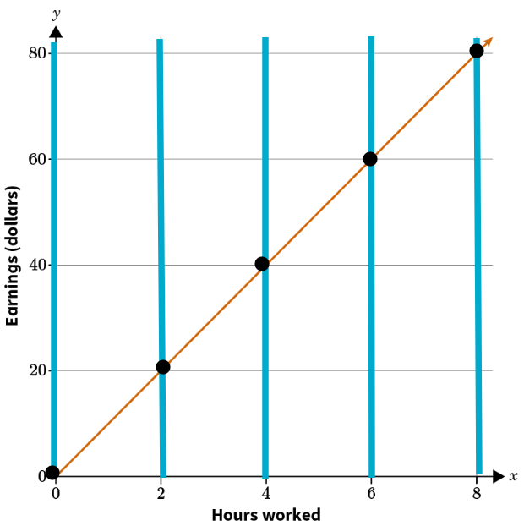  Non-function:  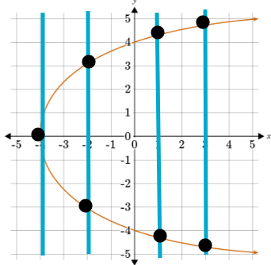
Slope-Intercept Form of a Linear Equation | The slope-intercept form is a way of writing an equation in a form that identifies the slope and y-intercept. | 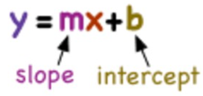  $$m=$$slope or rate of change  $$b=$$y-intercept  $$x=$$independent variable  $$y=$$dependent variable
Slope Formula | The slope of a line is defined by the change in y coordinate with respect to the change in x coordinate of the line. | $$\frac{∆y}{∆x}=\frac{change in y}{chang in x}=\frac{y_{2}−y_{1}}{x_{2}−x_{1}}$$  Where $$\left(x_{1},y_{1}\right)$$ is the first point and $$\left(x_{2},y_{2}\right)$$ is the second point.  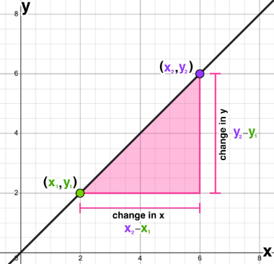
Intercepts | The x- and y-intercepts of a graph can be found where a line crosses the x- and y axes. | 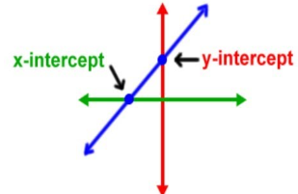  The x-intercept is where the line crosses the x-axis.  The y-intercept is where the line crosses the y-axis.
Function Notation | A way in which a function can be represented using symbols and signs read as “f of x”. Functions can be named with different letters other than f. | $$y=f\left(x\right)$$  For example:  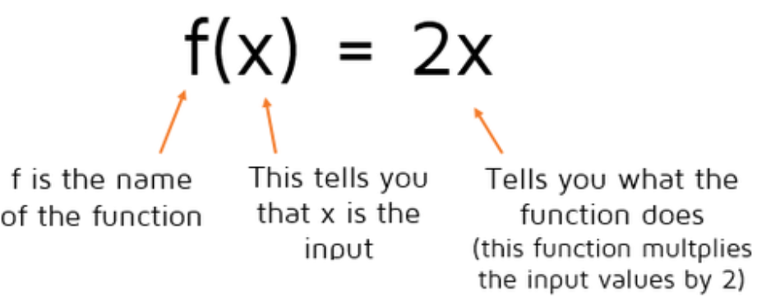
Exponential Function | Exponential functions are used to model growth and decay such as bacteria, population, interest, and depreciation. | $$f\left(x\right)=a{\left(b\right)}^{x}$$  $$a=$$initial value  $$b=$$multiplier  The multiplier is calculated from the rate, r.  Growth Factor: $$b=1+r$$  Decay Factor: $$b=1−r$$
Key Features of Exponential Graphs | The graph of an exponential function may model growth or decay and shows a quick increase or decrease. | Exponential Growth:  As x increases, y increases  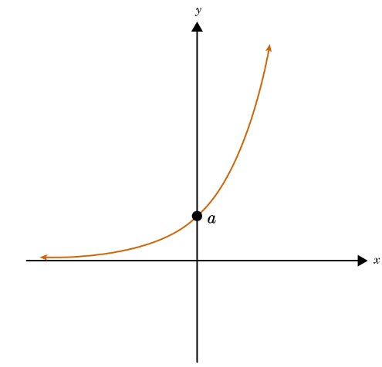  Exponential Decay:  As x increases, y decreases  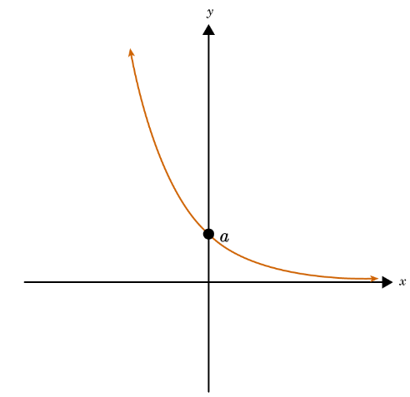  Key Features of Both:  - The y-intercept, a, must be greater than 0  - The x-values (domain) are from negative infinity to positive infinity (all real numbers)  - The y-values (range) must be greater than 0  - The graph will never touch the x-axis
Quadratic Equation | A quadratic equation is a two-degree polynomial that creates a parabola when graphed. | $$ax^{2}+bx+c=0$$  When represented as a function: $$f\left(x\right)=ax^{2}+bx+c$$
Key Features of a Parabola | When you plot points using a quadratic equation, the graph is a parabola. It is shaped like an upward or downward U.  There are four key parts of a parabola: the axis of symmetry, the vertex, the x-intercepts (zeros), and the y-intercept. | 