Algebra 1 Unit Test Guide

Functions & Their Graphs Unit Test

Item | Lesson Coverage | Objective | Mathematical Practice Standard | Lesson Page | Assessment Item
1 | Lesson 2: Relations & Functions | In this section, you will explain that a function is a specific type of relation that assigns each element of one set (the domain) to exactly one element of another set (the range). | Reason abstractly and quantitatively. | p. 2-7 | Use the image to answer the question.  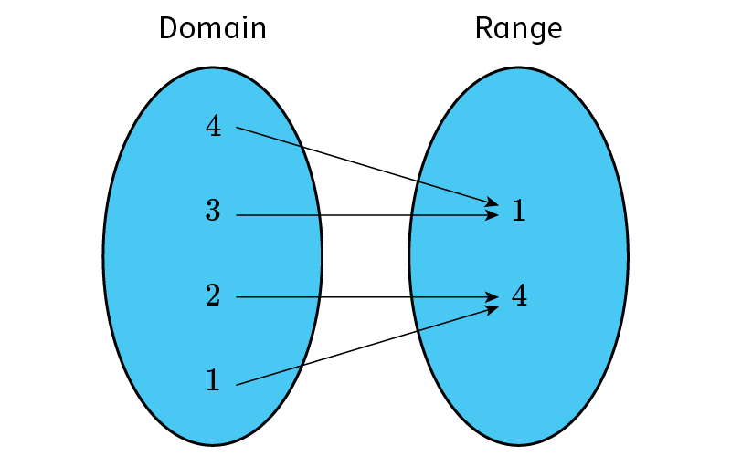  Based on the mapping diagram of the relation, determine which of the given options is accurate.  Option #1: The relation is a function.  Option #2: The relation is not a function.  Answer: 1
2 | Lesson 2: Relations & Functions | In this section, you will identify function and non-function relationships in a variety of representations. | Reason abstractly and quantitatively. | p. 9-16 | Use the image to answer the question.  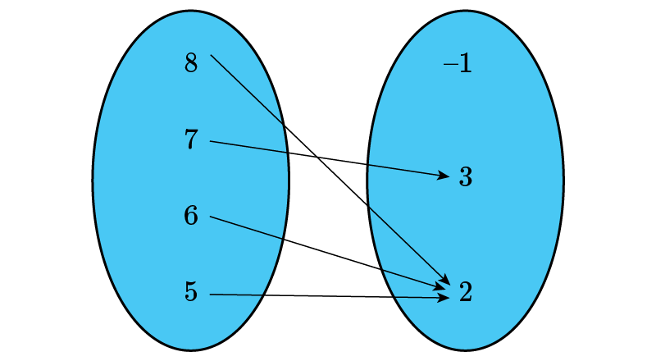  Determine whether the data in the diagram is a function and state the domain and range.  Answer: Yes, it is a function. The domain is the set {8,7,6,5}. The range is the set {−1,3,2}.
3 | Lesson 4: Naming, Evaluating, & Interpreting Functions | In this section, you will use function notation to describe a functional relationship between two quantities. | Reason abstractly and quantitatively. | p. 2-7 | Use the table to answer the question.  x y  0 3  1 3$\frac{1}{2}$  2 4  3 4$\frac{1}{2}$  Which of the following equations describes the function in the table using function notation?  Answer: $f\left(x\right)=\frac{1}{2}x+3$  Functions & Their Graphs Unit Test Item #3 - GeoGebra
4 | Lesson 4: Naming, Evaluating, & Interpreting Functions | In this section, you will evaluate functions for inputs in their domains. | Reason abstractly and quantitatively. | p. 9-13 | If $f\left(x\right)={(\frac{x}{8})}^{2}$, what is $f(-4)$?  Answer: $\frac{1}{4}$  Functions & Their Graphs Unit Test Item #4 - GeoGebra
5 | Lesson 4: Naming, Evaluating, & Interpreting Functions | In this section, you will interpret statements using function notation in terms of a context. | Reason abstractly and quantitatively. | p. 15-19 | Bacteria is known to grow exponentially. The function $B(h)=82{(1.25)}^{h}$ represents the number of bacteria, 𝐵(ℎ), as a function of hours, h. How many bacteria will there be after only $5\frac{1}{2}$ hours to the nearest bacteria? What is $B(5\frac{1}{2})$?  Answer: 280  Functions & Their Graphs Unit Test Item #5 - GeoGebra
6 | Lesson 5: Representing Functions | In this section, you will create input-output tables for a variety of function equations. | Reason abstractly and quantitatively. | p. 2-7 | Complete the input-output table for the function $f\left(x\right)={(x-2)}^{2}+3$.  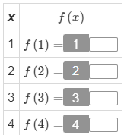  Answer:  - 4  - 3  - 4  - 7  Functions & Their Graphs Unit Test Item #6 - GeoGebra
7 | Lesson 5: Representing Functions | In this section, you will use input-output tables to create graphs of functions. | Reason abstractly and quantitatively. | p. 9-14 | Keylie is a freelance web designer. She charges her clients a $20 consulting fee plus $45 per hour worked. If they need images, Keylie charges an additional $15 fee for image research. Which graph accurately represents how much money Keylie will make if she has to work for 4, 6, 8, 10, and 12 hours for a client and has to find images?  Answer:  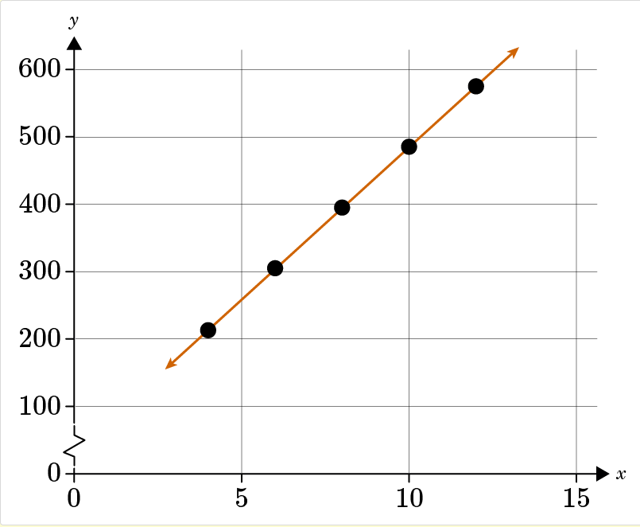Functions & Their Graphs Unit Test Item #7 - GeoGebra
8 | Lesson 5: Representing Functions | In this section, you will relate verbal, numeric, algebraic, and graphical representations of functions to each other. | Model with mathematics. | p. 16-19 | Use the image to answer the question.  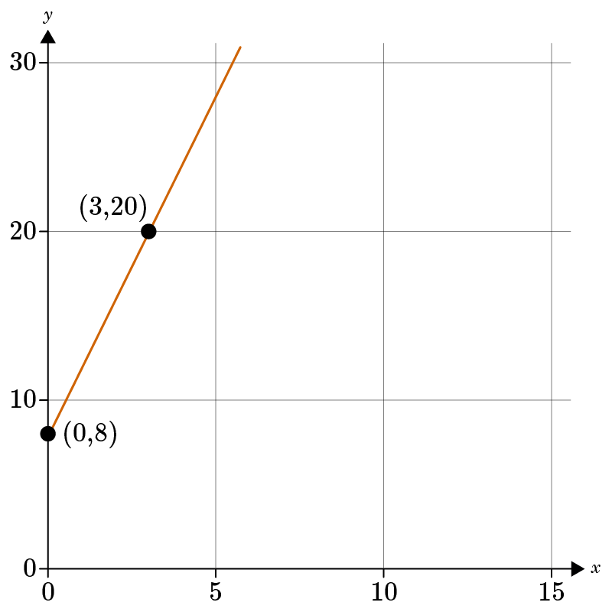  Colin charges a flat fee for babysitting plus an hourly fee. His total cost is represented on the graph. How can you represent this situation algebraically?  y = ___x+___  Answer: 4; 8
9 | Lesson 6: Linear Functions from Situations | In this section, you will define appropriate quantities, origin and scale of graphs of linear functions from real-world situations. | Model with mathematics. | p. 2-5 | Use the image to answer the question.  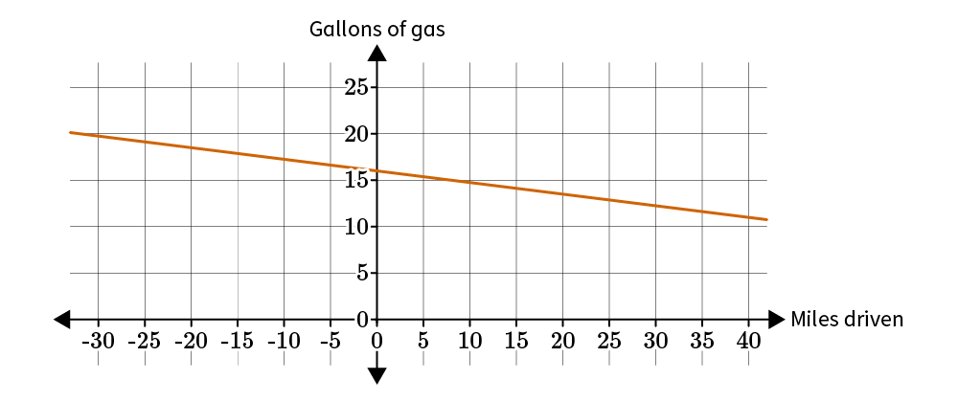  Steve made this graph to show how much gas was left in the gas tank of his truck as he drove. Did he use the appropriate scale for his axes? Enter 1 for yes or 2 for no.  Answer: 2
10 | Lesson 6: Linear Functions from Situations | In this section, you will plot points to create linear functions from situations. | Model with mathematics. | p. 7-12 | The city’s water company charges a fee of $20 a month in addition to a $0.25 per every gallon used. Using the function $c=0.25x+20$, where c is the total cost per month for water services and x is gallons used, which of the following points on the graph accurately represents a monthly usage of 1,200 gallons?  Answer: (1, 200, 320)  Functions & Their Graphs Unit Test Item #10 - GeoGebra
11 | Lesson 6: Linear Functions from Situations | In this section, you will interpret key features of linear function graphs in context. | Model with mathematics. | p. 14-17 | Use the image to answer the question.  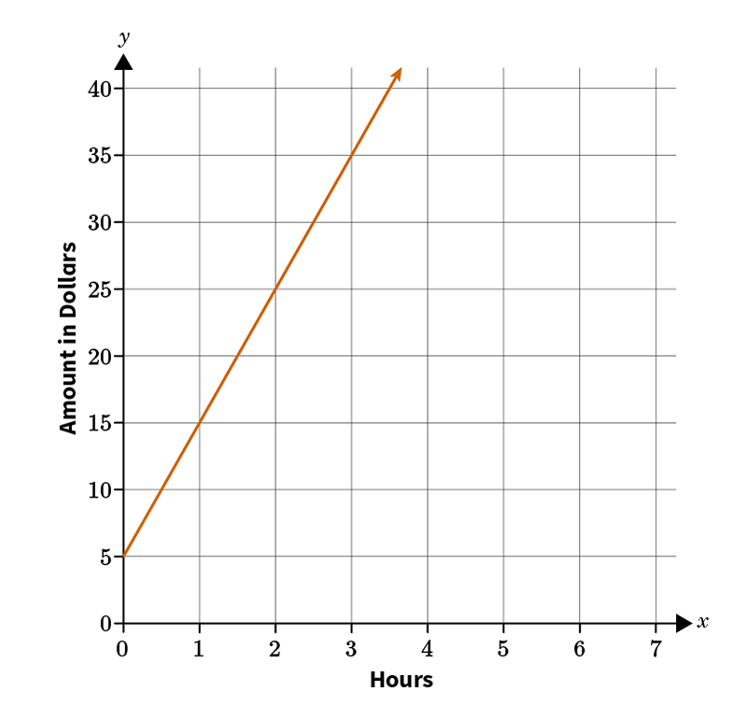  The graph illustrates how much Amanda makes watching her little cousins. Using the graph, predict how much Amanda will make if she watches them for seven hours.  Answer: $75
12 | Lesson 7: Piecewise Linear Functions from Situations | In this section, you will define appropriate quantities, origin and scale for graphs of piecewise linear functions when given different situations. | Model with mathematics. | p. 2-6 | A snowstorm took place during the weekend. Meteorologists tracked the total amount of snowfall for the storm. For the first 2 hours, it snowed at a rate of 1 inch per hour. The snow stopped for an hour and a half, then resumed at a rate of 1.5 inches per hour for the next 3 hours. Based on this information, what scale would work best for representing the data on the x-axis?  Answer: 0.5
13 | Lesson 7: Piecewise Linear Functions from Situations | In this section, based on different situations, you will plot points to create graphs of piecewise linear functions. | Model with mathematics. | p. 8-14 | A dog groomer charges her clients by the weight of the dog. The following piecewise function represents the total charge, f(𝑥), for a dog weighing x pounds.  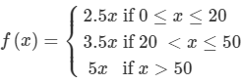  What would be the last point graphed on the first piece of the function, 𝑓(𝑥)=2.5𝑥?  Answer: (20, 50)  Functions & their Graphs Unit Test Item #13 - GeoGebra
14 | Lesson 7: Piecewise Linear Functions from Situations | In this section, you will interpret key features of piecewise linear function graphs in context. | Model with mathematics. | p. 16-20 | Use the image to answer the question.  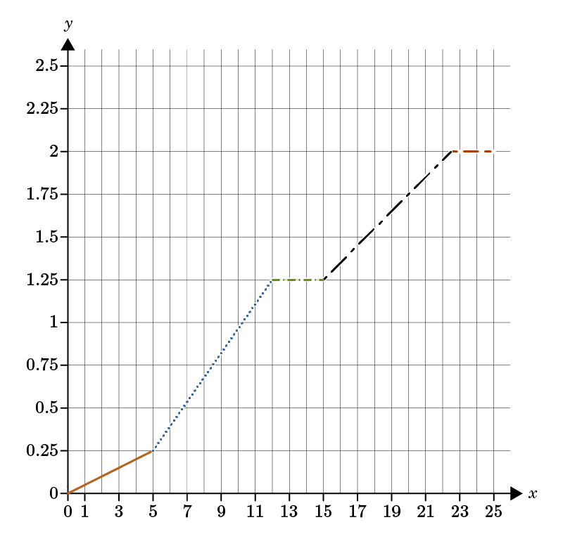  On Friday, Kaitlyn went to the park to work out. She started with a slow jog at a constant rate for five minutes. She then increased her speed to a faster, constant pace for seven minutes. She took a three-minute break, then ran for another 7.5 minutes at a constant pace to finish her two-mile run. She rested for the remainder of the time. During what domain interval will she reach 1.25 miles?  Answer: $12≤x≤15$
15 | Lesson 8: Exponential Functions from Situations | In this section, you will define appropriate quantities, origin, and scale for graphs of exponential functions from situations. | Model with mathematics. | p. 2-7 | A scientist is observing a particular species of bacteria growing in a petri dish. The number of bacteria can be represented by the equation $n(t)=50{(1.2)}^{t}$, where n is the number of bacteria after t hours. If the scientist checks the population in 4 hours, what would be an appropriate domain for the problem?  Option #1: $0≤t≤104$  Option #2: $0≤n≤104$  Option #3: $0≤t≤4$  Option #4: $0≤n≤4$  Answer: 3
16 | Lesson 8: Exponential Functions from Situations | In this section, you will plot points to create graphs of exponential functions from situations. | Model with mathematics. | p. 9-14 | Use the table to answer the question.  x 𝑓(𝑥)  0 32,000  1 29,440  2 27,048.80  3 ?  Sydney bought a new car for $32,000.00. If the car depreciates in value by 8% each year, the situation can be modeled by the equation $f(x)=32,000{(0.92)}^{x}$ .Complete the table to find the value of the car to the nearest cent after three years.  The value of the car after three years is $___.  Answer: 24,918.02  Functions & Their Graphs Unit Test item #16 - GeoGebra
17 | Lesson 8: Exponential Functions from Situations | In this section, you will interpret key features of exponential function graphs in context. | Model with mathematics. | p. 16-20 | Use the image to answer the question.  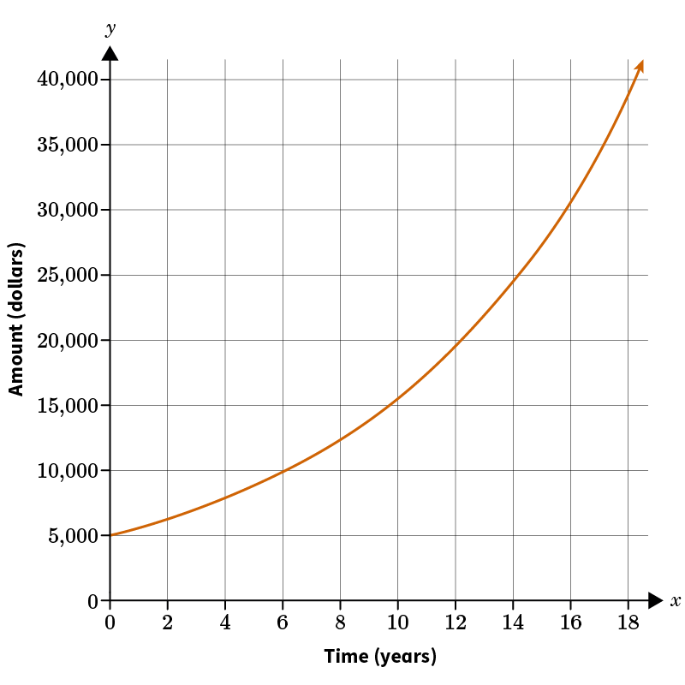  Lincoln’s parents invested $5,000 in a college savings account when he was born. If the account has a growth rate of 12%, the situation can be modeled by the equation $a(t)=5,000{(1.12)}^{t}$, where a is the amount after t years. Which one of the following statements is true about the graph of the function?  Option #1: As t increases, a increases slowly at first and then quickly.  Option $2: As t increases, a increases quickly at first and then slowly.  Option #3: As t increases, a decreases slowly at first and then quickly.  Option #4: As t increases, a decreases quickly at first and then slowly.  Option #___ is the true statement.  Answer: 1
18 | Lesson 9: Quadratic Functions from Situations | In this section, you will define appropriate quantities, origin and scale for graphs of quadratic functions from situations. | Model with mathematics. | p. 2-7 | Marilee is creating a garden in her yard. She needs to put up a fence to keep the animals out of it. She has 40 yards of fencing she can erect. This situation is modeled using the equation $A={-w}^{2}+20w$, where 𝐴 is the area of the fence and w is the width of the fence. Using the equation, what is domain when the maximum range is achieved?  Answer: 10 yards  Functions & Their Graphs Unit Test Item #18 - GeoGebra
19 | Lesson 9: Quadratic Functions from Situations | In this section, you will plot points to create graphs of quadratic functions from situations. | Model with mathematics. | p. 9-14 | A volleyball is served from a height of 6 feet with an initial velocity of 33 feet per second. The situation is modeled using the function $h=-6t^{2}+33t+6$, where h is the height in feet and t is time in seconds. Which of the following uses the function to correctly identify the corresponding y-values to the given x-values of 0, 1, 2, 3, and 4?  Answer: (0,6), (1,33), (2,48), (3,51) and (4,42)  Functions & Their Graphs Unit Test Item #19 - GeoGebra
20 | Lesson 9: Quadratic Functions from Situations | In this section, you will interpret key features of quadratic function graphs in context. | Model with mathematics. | p. 16-21 | Nora is creating a dog run in her backyard for her dog, Max. She has enough materials to create a run with a perimeter of 120 feet. This is represented by the function $A={-w}^{2}+60w$, where 𝐴 is the area of the run and w is the width. Which of the following best analyzes the meaning of the x-intercept?  Answer: The dog run must have a width between 0 and 60 feet.  Functions & Their Graphs Unit Test item #20 - GeoGebra
21 | Lesson 6: Linear Functions from Situations | In this section, you will interpret key features of linear function graphs in context. | Model with mathematics. | p. 14-17 | Use the image to answer the question.  Using this graph of a linear equation as an example, create a real-world situation that the graph could model. In 3–5 sentences, explain what the graph is modeling.  Answer: In this example, the student could explain that the graph models the relationship between the number of hours a person works as a dog walker and the amount of money they make. The y-intercept at (0,5) means there is a $5 appointment fee for hiring the dog walker. In addition to the appointment fee, the dog walker will make $10 for every hour spent working. If the dog walker works for one hour, they will earn $15. If they work for two hours, they will earn $25. They will earn $10 per hour for every additional hour worked.
22 | Lesson 8: Exponential Functions from Situations | In this section, you will interpret key features of exponential function graphs in context. | Model with mathematics. | p. 16-20 | Andrea invested $3,000 in an online currency. If the value of the currency increases at a rate of 14% per year, the situation can be modeled using the equation $A(t)=3,000{(1.14)}^{t}$, where 𝐴 is the amount in the investment after t years. In 3–5 sentences, identify the key features of the graph and interpret the meaning of the data.  Answer:  - As t increases, A increases slowly at first and then quickly.  - The y-intercept is greater than 0.  - The A-values are greater than 3,000.  - The amount in the investment continues to increase over time.  - The t-values are greater than or equal to 0.
23 | Lesson 9:  Quadratic Functions from Situations | In this section, you will interpret key features of quadratic function graphs in context. | Model with mathematics. | p. 16-21 | Quadratic functions can be used to describe the rate at which an object will fall and predict when it will land or how high it may go. Create a quadratic function using the function $y=-16t^{2}$ to help predict when an object will return to the ground from being kicked, dropped, or thrown. In 3–5 sentences, describe the scenario in which you will use the function. Write the complete function and explain the meaning of the variable t and the constant value.  Answer: Student answers should include a scenario and explanation such as the following:  Letti kicked a rock off a ledge that was 25 feet above the ground. To determine the time in seconds that it takes the rock to fall to the ground, the function used would be $y=-16t^{2}+25$. The variable t represents the amount of time, in seconds, that it takes the rock to fall to the ground. The constant value of 25 represents the starting height of the rock, in feet, before it is kicked off the ledge.

