- Unit 8 Lesson 1: Americas to 1500
- Americas to 1500 Introduction

Timeline:
- Pre-1500 Periods and Civilizations
1. Preclassic Period (2000 BCE - 250 CE)
- Olmec Civilization (2000 BCE - 400 BCE)
- Known as the "mother culture" of Mesoamerica.
- Created colossal head sculptures and practiced early forms of writing and calendar systems.

2. Classic Period (250 CE - 900 CE)
- Mayan Civilization (250 CE - 900 CE)
- Developed advanced astronomy, mathematics, and writing systems.
- Significant cities: Tikal, Teotihuacán, and Copán.
- Utilized a city-state political structure with long-distance trade networks.

3. Postclassic Period (900 CE - 1500 CE)
- Aztec Civilization (1325 CE - 1521 CE)
- Known for their capital city Tenochtitlan and the Triple Alliance.
- Advanced agricultural techniques, including chinampa field systems.
- Notable for decentralized political structures and their emphasis on warfare in religion.

- Andean Time Periods and Civilizations
1. Pre-Inca Period
- Chavin Culture (900 BCE - 200 BCE)
- Recognized for their influence on later Andean civilizations, characterized by unique temple art styles.

2. Inca Period (1438 CE - 1533 CE)
- Inca Empire (1438 CE - 1533 CE)
- Known for extensive networks of roads and cities such as Machu Picchu and Cusco.
- Developed terrace farming, quipu record-keeping, and an effective centralized political structure.

- Interactions and Impacts
- Cultural and Technological Exchanges
- Both the Aztec and Inca civilizations had significant cultural and technological achievements that influenced each other and neighboring societies.

- Impact of European Conquest
- Spanish Conquest (1500s)
- Diseases like smallpox drastically reduced Indigenous populations.
- Conquistadors like Hernán Cortés and Francisco Pizarro played crucial roles in the fall of the Aztec and Inca Empires.
- European colonialism led to the destruction and alteration of significant Indigenous cultural and architectural sites.

- Landmark Events in the Fall of Civilizations
1. Aztec Empire Fall
- Hernán Cortés arrives in 1519.
- Fall of Tenochtitlan in 1521 due to alliances, disease, and superior weaponry.

2. Inca Empire Fall
- Francisco Pizarro's conquest beginning in 1532.
- Capture and execution of Emperor Atahualpa in 1533.

- Key Features and Adaptations
- Mesoamerican Adaptations
- Water sources, topography, and climate largely influenced their agricultural and architectural practices.
- Extensive use of trade routes and city sophistication.

- Andean Adaptations
- Terrace farming to maximize agricultural output in mountainous regions.
- Advanced understanding of astronomy and science developed from interactions with their environment.

- Key Figures and Artifacts
- Olmec Colossal Heads: Monumental sculptures highlighting their artistic and cultural advancements.
- Mayan Codices and Astronomical Records: Demonstrating their complex societal structure and scientific knowledge.
- Aztec Tenochtitlán and Art: Showcase of urban planning, religious structures, and conquests.
- Incan Road Systems and Machu Picchu: Representation of their engineering prowess and social organization.

This timeline gives a clear and interesting look at the histories of early American civilizations before Europeans arrived and changed everything. Starting with the Olmec's important early culture and going up to the sudden changes caused by the Spanish conquerors, each period and civilization played a special role in the history of the Americas before European colonization.

- Unit 8 Lesson 2: Geography and Early Civilizations
- The World of Mesoamerican and South American Civilizations

Objective 1: Identify the locations of major Mesoamerican and South American civilizations, including the Olmec, Zapotec, Chavin, Maya, Aztec, and Inca.

Essential Question: In what areas of Mesoamerica and South America were major civilizations, including the Olmec, Zapotec, Chavin, Maya, Aztec, and Inca, located?

Key Words:
1. Mesoamerica: The region extending from central Mexico to Central America
2. Andean: Relating to the Andes mountains and surrounding regions
3. Indigenous: Originating or occurring naturally in a particular place
4. Topography: The arrangement of the natural and artificial physical features of an area
5. Civilization: An advanced state of human society with complex social, political, and cultural systems

Big Ideas:
- Mesoamerican civilizations included the Olmec, Zapotec, Maya, and Aztec
- South American Andean civilizations included the Chavin and Inca
- Geographical features like mountains, rivers, and coastlines influenced the development of these civilizations
- Each civilization adapted to its unique environment, developing distinct agricultural practices and societal structures
- Trade and cultural exchange occurred between civilizations, despite geographical barriers
- The rise and fall of these civilizations were often linked to environmental factors and resource management
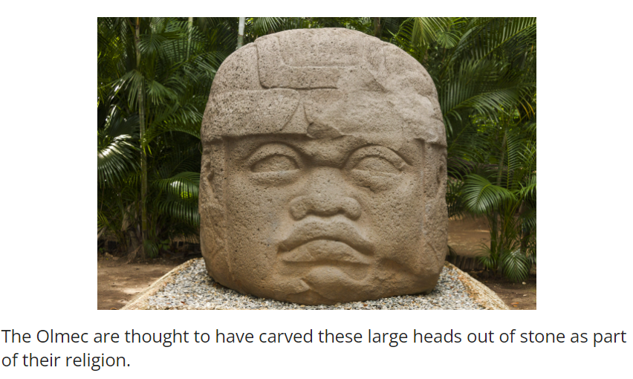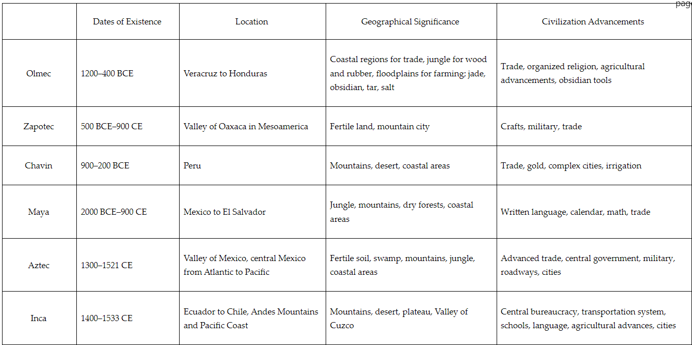

Check-In Questions:
1. Complete the table by filling in one similarity between the Inca and the Aztec civilizations and one difference for each of them in the labeled boxes.

Answer:
Similar Characteristic: Large populations, central cities, environmental obstacles made it difficult to centralize authority, advanced trading systems, created roadways
Characteristic Unique to Aztec: Geography was jungle, system of tribute based on force
Characteristic Unique to Inca: Geography was mountains and desert, system of tribute based on cooperation, more advanced communication system

2. List two geographical features that Mesoamerican civilizations had to overcome.

Answer: Mesoamerican civilizations were challenged by mountains in the south, jungles in the east, desert areas, and floodplains.

Practice Questions:
1. What did Mesoamerican and South American religions have in common?

Answer: Religion was based on nature and the environment. Gods were tied to animals and the sun. Worship revolved around things such as the stars and the growing seasons.

2. What is one geographical obstacle that would have made trade between the Zapotec and Chavin difficult?

Answer: The geography between the Zapotec in Mesoamerica and the Chavin in Peru would have made it very difficult for people to travel and trade. There are mountains, jungle, and desert separating them.

- Geography's Influence on the Development of Civilizations

Objective 2: Compare and contrast the geographical locations of Mesoamerican and Andean South American civilizations.

Essential Question: How was the development of civilizations in Mesoamerica and South America dependent on their location and geography?

Key Words:
1. Geography: The study of physical features of the Earth and its atmosphere
2. Topography: The arrangement of the natural and artificial physical features of an area
3. Climate: The weather conditions prevailing in an area over a long period
4. Irrigation: The supply of water to land or crops to help growth
5. Terrace farming: A method of farming whereby steep slopes are cut into a series of successively receding flat surfaces

Big Ideas:
- Geography influenced the development of civilizations in Mesoamerica and South America
- Waterways played a crucial role in the growth of these civilizations, facilitating trade and transportation
- Topography and climate affected agricultural practices, settlement patterns, and trade routes
- Mesoamerican civilizations dealt with diverse landscapes including jungles, mountains, and coastal areas
- Andean civilizations adapted to high altitudes, steep terrain, and varied climate zones
- Both regions developed advanced agricultural techniques to overcome environmental challenges
- The control of water resources was crucial for the success of these civilizations 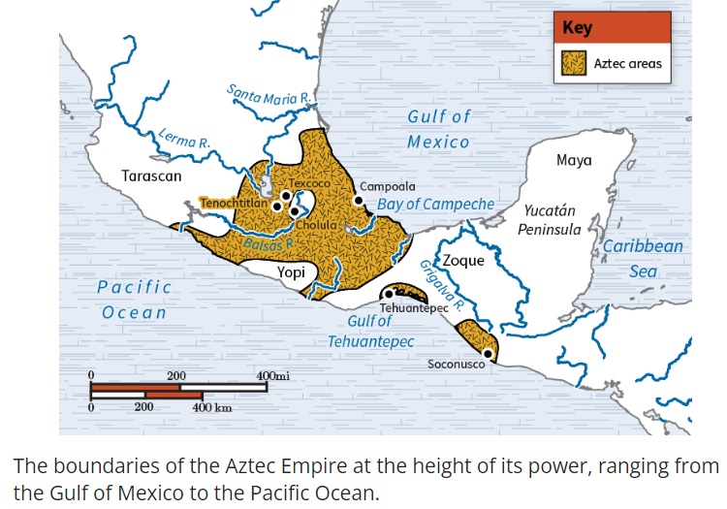

Check-In Questions:
1. Complete the chart by listing one obstacle for each category based on the location of the civilizations.

Answer:
Mesoamerican Civilizations:
Waterways: Flooding, too much rainfall
Topography: Swamp, jungle, mountains
Climate: Hot, humid, dry, flood seasons

Andean South American Civilizations:
Waterways: Access to rivers, dry
Topography: Mountains, desert
Climate: Dry, high altitude, cold, broad temperature ranges

2. List two ways that Mesoamerican and South American civilizations adapted to their topography.

Answer: Terrace farming, irrigation systems, canals, trade, found food sources suited for their area

Practice Questions:
1. Explain the role of the Inca civilization's government in allowing them to adapt to the topographical challenges of their location.

Answer: The Inca government was centralized under one ruler, but there were bureaucracies that organized regional public works projects. Communities worked as cooperatives to build irrigation systems, develop terraced fields, produce food, and build roadways. The government was structured so that the regions were directed to improve their settlements by working together.

2. Describe what terraced fields are and why they were beneficial.

Answer: Terraced fields are created by carving flat areas out of the sides of mountains or hills that resemble steps. These flat fields make it easier for farmers to cultivate the land in a steep area. They made previously useless land farmable so societies could grow crops.

- Olmec, Zapotec, and Chavin Civilizations

Objective 3: List the key features of the Olmec, Zapotec, and Chavin civilizations in Mesoamerica and South America using primary and secondary artifacts.

Essential Question: How do Olmec, Zapotec, and Chavin civilizations' artifacts demonstrate global interdependence in early Mesoamerica and South America?

Key Words:
1. Artifacts: Objects made by human beings, typically of cultural or historical interest
2. Polytheistic: The belief in or worship of more than one god
3. Cosmo-magical: Relating to beliefs that combine cosmic and magical elements
4. Zoomorphic: Having or representing animal forms or gods of animal form
5. Anthropomorphic: Having human characteristics or depicting humans

Big Ideas:
- Olmec, Zapotec, and Chavin civilizations had similar religious beliefs and practices, often centered on nature and the environment
- Art and artifacts reflect the environment, beliefs, and social structures of these civilizations
- Trade and cultural exchange may have occurred between these civilizations, as evidenced by similarities in artistic styles and motifs
- Each civilization developed unique artistic traditions while sharing some common themes and symbols
- Religious and political power were often intertwined, as reflected in monumental architecture and ceremonial objects
- The use of local materials in art and architecture demonstrates how these civilizations adapted to their environments
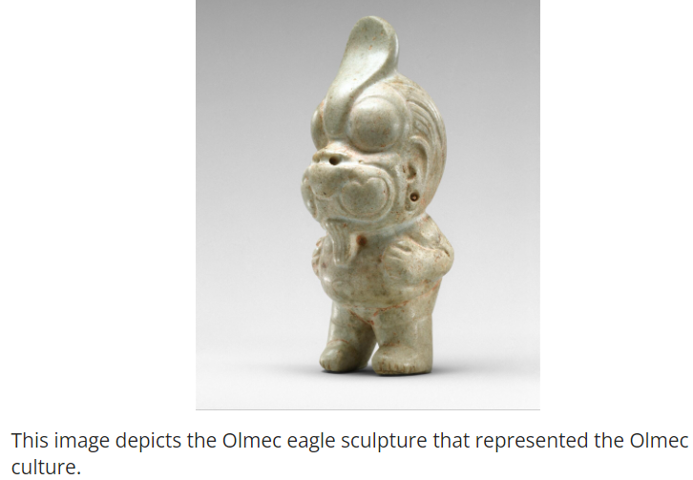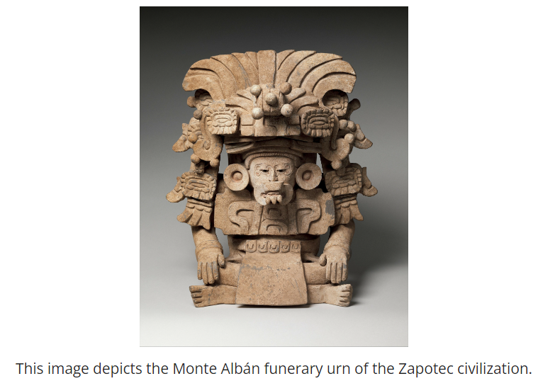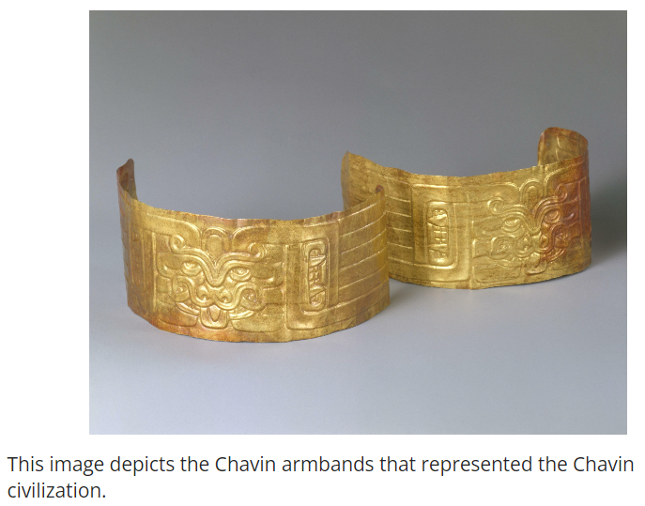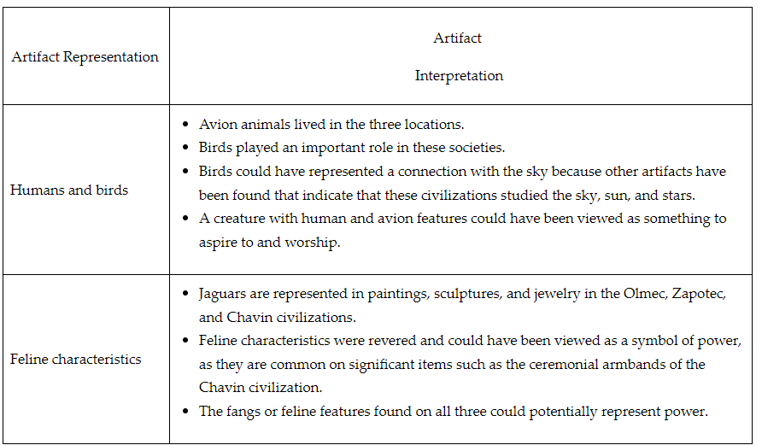

Check-In Questions:
1. Briefly explain one common representation or feature found on all three of the artifacts discussed in this lesson and its connection to the civilizations' belief systems.

Answer: Each artifact has a representation of a bird, human, or feline. The bird could represent the ability to fly, the desire to reach the sky, and power. Combined with human features, it could mean that the civilization felt that humans aspired to be free, and it could represent a higher power. The fangs or feline features found on all three also could represent power.

2. How is the environment and location of each civilization reflected in the artifacts?

Answer: The materials used in the artifacts were found in each civilization's location. The subject matter also reflected the wild birds and jaguars that would have been found in both Mesoamerica and South America.

Practice Questions:
1. Conduct research online to find another Olmec, Zapotec, and Chavin artifact. Analyze and evaluate the artifact to list the key features for each artifact found. Create a chart to record your observations. Then use the chart you created to identify the similarities among the artifacts. What might this tell you about these civilizations?

(Students should create a chart and analyze artifacts. The answer will vary based on their research.)

2. Using the artifacts you researched in Question 1, compare one artifact from the lesson (the Olmec eagle, Monte Albán funerary urn, or Chavin gold armbands) with one of the artifacts you found in your research from different civilizations. Construct a chart to list the key features of each artifact. Then, use your observations to list the similarities and differences of each artifact.

(Students should create a comparison chart. The answer will vary based on their research and chosen artifacts.)

- The Olmec Civilization (1200-400 BCE)

Objective 4: Summarize how the Olmec Empire ruled their empire and interacted with the environment from 1200 BCE to 400 BCE.

Essential Question: What role did the environment play in the rise and fall of the Olmec Empire?

Key Words:
1. Floodplains: Flat land areas adjacent to a river that are subject to flooding
2. Chinampas: Artificial islands created as a system of agriculture
3. Slash-and-burn agriculture: A farming method involving clearing land by burning vegetation
4. Seismic: Relating to earthquakes or other vibrations of the earth
5. Colossal heads: Massive stone sculptures of human heads created by the Olmec

Big Ideas:
- The Olmec adapted to their environment through innovative agricultural techniques such as chinampas and slash-and-burn agriculture
- Olmec culture and religion were heavily influenced by their environment, as seen in their art and artifacts
- Environmental factors likely contributed to both the rise and fall of the Olmec Empire
- The Olmec developed a complex social and political structure, with an elite class controlling resources and trade
- Olmec art and architecture, including the colossal heads, demonstrate advanced technological and artistic skills
- The Olmec civilization had far-reaching influence, with its cultural and religious practices influencing later Mesoamerican civilizations
- Trade played a crucial role in the Olmec economy, facilitated by their strategic location near rivers and the coast

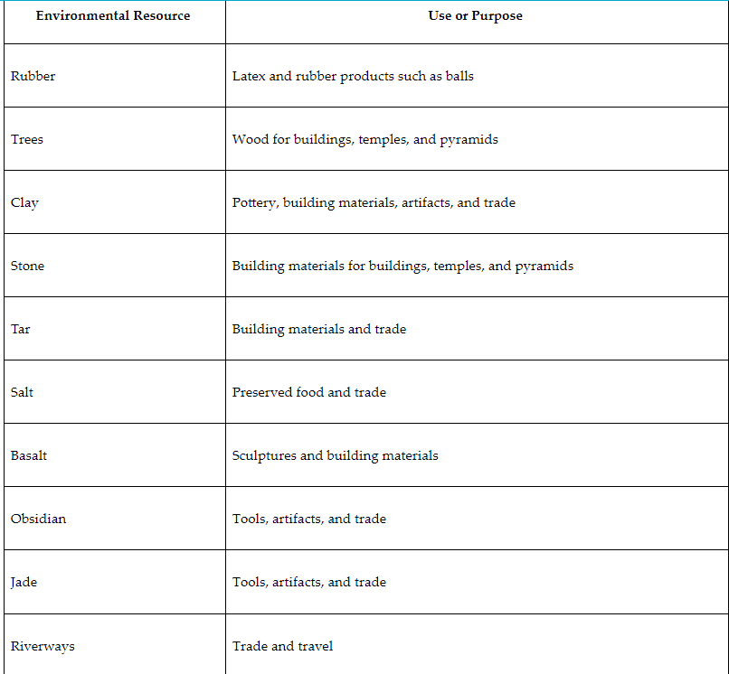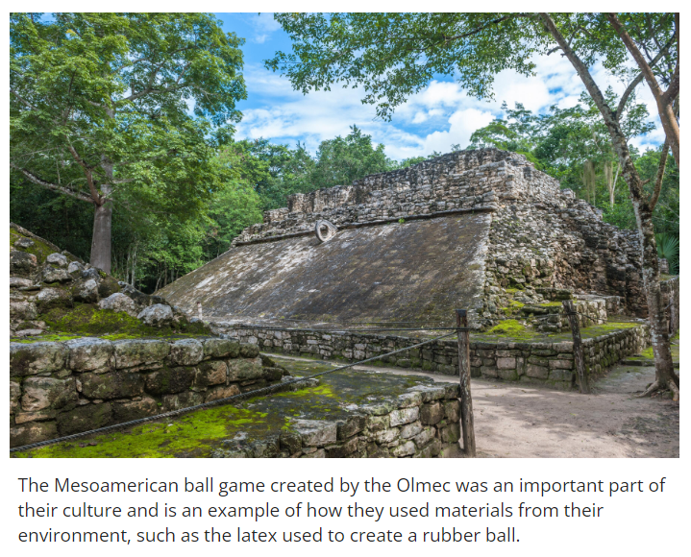
Check-In Questions:
1. What is the significance of the large Olmec heads?

Answer: The Olmec heads represent:
- the ability of the Olmec to transport large stones long distances
- a belief system centered around the human form
- artisan abilities to create such detailed sculptures with limited tools
- the environmental resources available at the time

2. Name two ways that the Olmec adapted to their environment.

Answer: The Olmec built irrigation and canal systems to channel water to their fields and away from the populated areas; developed slash-and-burn agriculture to create farmland; developed the chinampa for fields in swampy areas; created goods from the resources available to them such as basalt building stone; and created a trade system using the riverways.

Practice Questions:
1. Summarize the rise and fall of the Olmec Empire by creating a timeline describing significant events and artifacts influenced in the Olmec civilization.

Answer: (Students should create a timeline including key events such as the beginning of the civilization in 1200 BCE, the establishment of capitals, creation of major artifacts, and the decline around 400 BCE.)

2. Research an Olmec agricultural invention. Summarize the invention and explain how the Olmec farming development continues to be used today.

Answer: (Students should research and describe an Olmec agricultural invention, such as chinampas or slash-and-burn agriculture, and explain its modern applications

- Unit 8 Lesson 3: The Mayan Empire
- Mayan Rise and Rule

Objective 1: Summarize the rise and rule of the Mayan empire, including its city-state political structure, using multiple perspectives of the same or similar historical events.

Essential Question: How did the Mayan Empire rise to power?

Key Words:
1. Yucatán: Region in southern Mexico where Mayan civilization developed
2. City-states: Independent political units that made up the Mayan Empire
3. Nacom: Military leader in Mayan city-states
4. Codices: Ancient Mayan books providing historical information
5. Dresden Codex: One of the oldest surviving pre-Columbian documents

Big Ideas:
- The Mayan Empire consisted of interconnected city-states rather than a centralized government
- Mayan civilization had roots dating back to the Olmec culture around 2600 BCE
- City-states like Teotihuacán, Tikal, and Copán were centers of Mayan culture and power
- Mayan leaders derived their authority from political and religious connections
- Primary sources like the Dresden Codex provide valuable insights into Mayan society

Check-In Questions:
1. What sources do historians consult for multiple perspectives on Mayan history?
Answer: They use Spanish accounts but have moved toward using primary Mayan sources, such as the Dresden Codex.

2. How did Mayan kings wield political power?
Answer: They formed close relationships with wealthy nobles and claimed to derive power from the gods.

Practice Questions:
1. How did Mayan city-states change over time?
Answer: They went from being ruled locally and independently to being ruled by people with political and religious power.

2. How were city-states in the Mayan Empire connected?
Answer: They were connected through trade networks and political alliances.

- Mayan Cities and Trade

Objective 2: Show the extent and operation of the Mayan civilization, including three important cities and the patterns of long-distance trade.

Essential Question: How does the formation of cities and trade networks contribute to the development of civilizations?

Key Words:
1. Mesoamerica: Cultural region extending from central Mexico to Central America
2. Step terrace: Agricultural technique of cutting steps into hillsides for farming
3. Long-distance trade: Exchange of goods over extensive geographical areas
4. Teotihuacán: Major Mayan city-state and religious center
5. Obsidian: Volcanic glass highly valued in Mayan trade

Big Ideas:
- Mayan civilization stretched across a vast area with a population of around 10 million
- Important city-states included Teotihuacán, Tikal, and Copán
- Mayan trade networks extended to the Caribbean and Gulf of Mexico
- Cities served as centers of culture, religion, and economic activity
- Archaeological evidence has changed historians' understanding of Mayan civilization
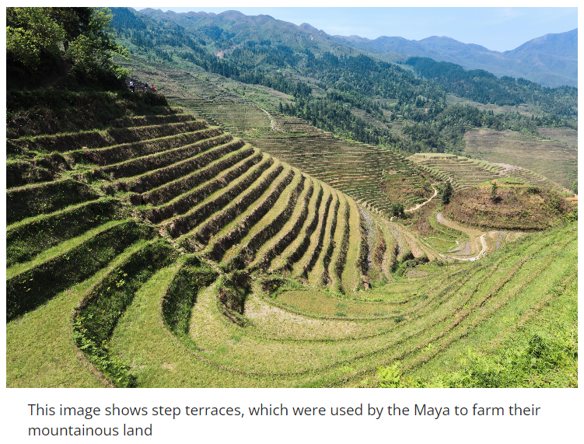

Check-In Questions:
1. Describe trade routes in Mayan civilization.
Answer: Trade routes across the Mayan civilization were expansive. They stretched across Mesoamerica and into the Caribbean and along the Gulf Coast.

2. Assess the article "Cultural Exchange in Ancient Mexico." How does it show the complexity of Mayan civilization?
Answer: Mayan city-states were complex. Archaeological evidence shows that they had an advanced understanding of mathematics and astronomy. They built expansive trade routes that contributed to their city-states' wealth.

Practice Questions:
1. Use information about Mayan buildings to argue that Mayan cities were advanced for their time.
Answer: The ruins of temples, terraces, palaces, and even apartments are still around in many Mayan cities. These buildings' longevity show how advanced they were for the time.

2. How can you use information about Mayan trade networks from this section to explain how global interdependence has shaped the world?
Answer: Mayan city-states built economies dependent on trade with other societies outside their region. They traded goods like gold, jade, and obsidian as far as the Caribbean and the Gulf Coast of Mexico.

- The Maya

Objective 3: Explain the ways in which the Maya manipulated and adapted to the environment, including their developments in science, astronomy, and technology.

Essential Question: How do humans adapt to their environments?

Key Words:
1. Slash and burn agriculture: Technique of clearing land by cutting and burning vegetation
2. Step terrace farming: Method of creating flat surfaces on hillsides for agriculture
3. Mayan calendar: Complex timekeeping system developed by the Maya
4. Obsidian tools: Sharp implements made from volcanic glass
5. Chichén Itzá: Important Mayan pyramid in Mexico

Big Ideas:
- Maya adapted to diverse environments through innovative agricultural techniques
- They developed advanced water management systems, including reservoirs and cisterns
- Mayan mathematics and astronomy were highly sophisticated
- They used local materials and advanced engineering to build long-lasting structures
- Astronomy played a crucial role in Mayan religion and agriculture
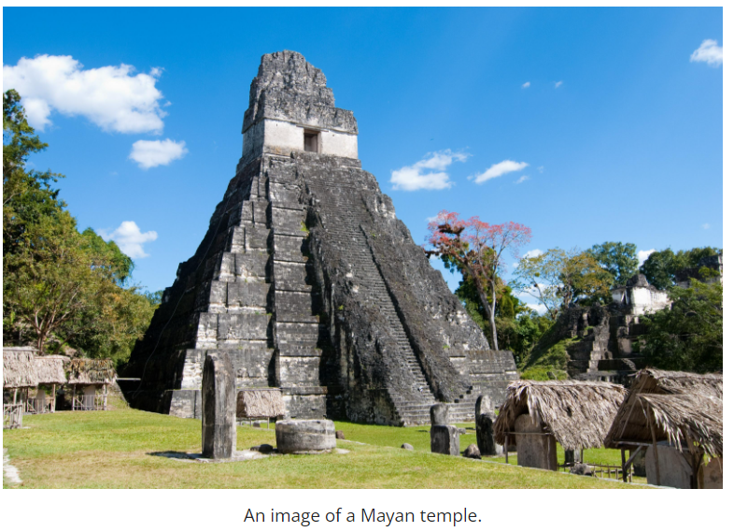
Check-In Questions:
1. How did slash and burn agriculture manipulate the productivity of the land?
Answer: It gave fields time to remain fallow to maintain their productivity.

2. Summarize advancements in mathematics that allowed the Maya to make long-term plans and coordinate major construction projects.
Answer: The Maya created a written number system that included the concept of zero. Their use of complex geometry made it possible for them to plan, design, and create roads, bridges, and buildings, some of which still remain today.

3. Summarize Mayan understanding of astronomy, and how it contributed to their manipulation of the environment.
Answer: The Maya used their understanding of astronomy and mathematics to create a 365-day calendar system and used it to predict the climate and rainfall, which were important to agriculture. This calendar tracked the movements and positions of stars, planets, and other celestial bodies accurately within 19 minutes over the course of a year.

Practice Questions:
1. How did the Maya manipulate their environment?
Answer: They used slash and burn agriculture and step terraces to farm more effectively.

2. How could step terraces be used as an example of the Maya adapting the environment?
Answer: They cut steps into the earth in order to farm more easily in mountainous areas.

- Theories on Mayan Collapse

Objective 4: Compare theories on the collapse of the Mayan Empire.

Essential Question: How do civilizations decline?

Key Words:
1. Overpopulation: Condition where population exceeds the environment's capacity to support it
2. Environmental degradation: Deterioration of the environment through depletion of resources
3. Mayan classical period: Era of Mayan civilization from about 250-900 CE
4. Climate change: Long-term alteration in global or regional climate patterns
5. Deforestation: Clearing of forests on a large scale

Big Ideas:
- The decline of Mayan civilization was gradual, not sudden
- Three main theories explain the Mayan collapse: warfare, overpopulation, and environmental degradation
- Increased warfare may have led to social and economic instability
- Population growth may have strained resources, especially during droughts
- Environmental degradation, including deforestation, may have exacerbated climate issues
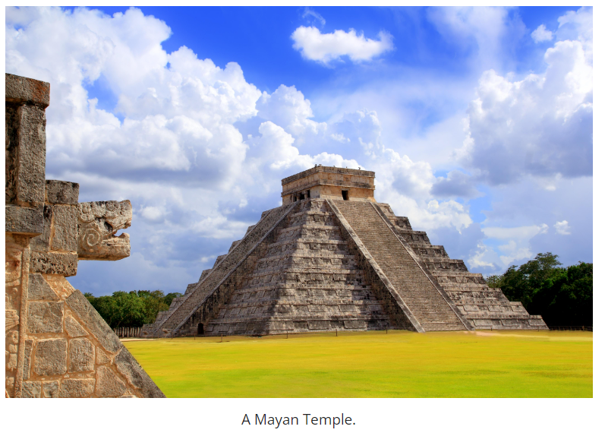
Check-In Questions:
1. What did historians first believe caused the Mayan civilization to decline?
Answer: Natural disasters

2. What evidence supports the overpopulation theory?
Answer: Droughts that hit many Mayan cities caused famines and large populations could no longer be supported by the environment.

Practice Questions:
1. Which theory do you believe provides the most compelling evidence for the decline of Mayan civilization? Use evidence from this section to defend your answer.
Answer: (Sample) The environmental degradation theory has the strongest evidence. It takes evidence from the overpopulation theory, the droughts and famine, and builds off of it. From this it argues that these problems were caused by the degradation of the environment through deforestation.

2. How can historians interact effectively with one another when comparing two theories?
Answer: By building on each other's research and evidence.

- Unit 8 Lesson 4: The Aztec Empire
- From Migrants to Mighty Empire

Objective 1: Summarize how the Aztec Empire rose and expanded.

Essential Question: How did the Aztecs create a powerful empire?

Key Words:
1. Migrants: People who move from one place to another
2. Valley of Mexico: Area in central Mexico where the Aztecs settled
3. Tenochtitlan: Capital city of the Aztec Empire
4. Triple Alliance: Coalition formed by the Mexica, Tetzcoco, and Tlacopan
5. Tribute: Payment made by conquered peoples to the Aztec Empire

Big Ideas:
- The Aztecs began as a migrant group called the Mexica
- They settled on an island in Lake Texcoco, founding Tenochtitlan in 1325
- The Aztecs formed the Triple Alliance in 1428, marking the start of their empire
- Through military conquest and alliances, the empire expanded rapidly
- By the early 16th century, the Aztec Empire controlled most of central Mexico
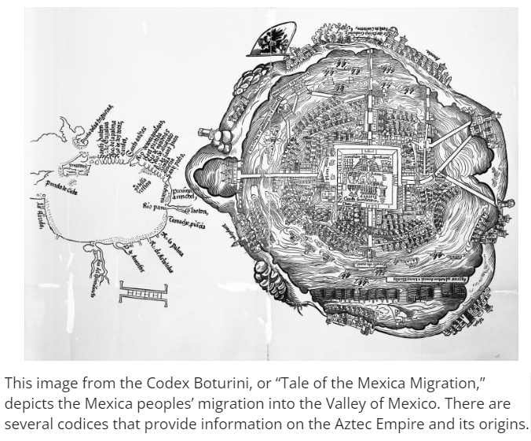
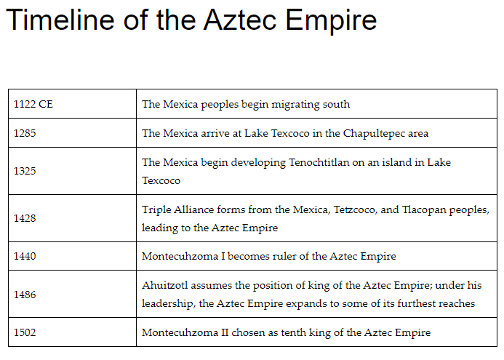
Check-In Questions:
1. Describe the role of the Mexica in creating the Aztec Empire.
Answer: This migrating group of people eventually settled in Lake Texcoco and formed alliances with two other groups in the area. The Triple Alliance, as it was known, led to the rise of the Aztec Empire, headed by Mexica leaders.

2. What was Tenochtitlan?
Answer: Tenochtitlan was a city built by the Mexica; it became the capital of the Aztec Empire.

Practice Questions:
1. How does the Codex Azcatitlan depict the history of the Aztec Empire?
Answer: The codex shows the migration of the Mexica people, their activities and games, and the development of the empire over time, including the arrival of the Spanish.

2. What were some key features of Aztec religion?
Answer: Religion was very important to the Aztecs. They had many gods, numerous priests, and many temples. They organized their religious beliefs around rituals and ceremonies, including human sacrifices.

- Growing Power, Growing Territory

Objective 2: Show the extent of the Aztec Empire and how it operated through its base at Tenochtitlan and alliances with neighboring tributary states.

Essential Question: Why do empires seek to expand their territory?

Key Words:
1. Causeways: Raised roads across water or low ground
2. Aqueducts: Systems for conveying water from distant sources
3. Templo Mayor: Main temple complex in Tenochtitlan
4. Tribute system: Method of collecting resources from conquered territories
5. Flower wars: Pre-arranged conflicts to demonstrate Aztec power

Big Ideas:
- Tenochtitlan was a large, sophisticated city and the center of the Aztec Empire
- The Aztec Empire expanded through conquest and alliances
- Conquered territories were required to pay tribute to the empire
- The empire was organized into provinces with local leadership maintained
- Flower wars were used to demonstrate Aztec power and gather sacrificial captives
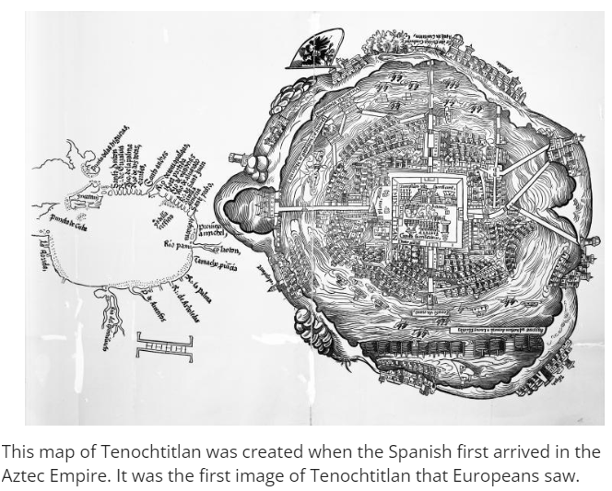

Check-In Questions:
1. What is the connection between the Triple Alliance and the Aztec Empire?
Answer: The Triple Alliance marked the start of the Aztec Empire.

2. Describe the significance of Tenochtitlan in the Aztec Empire.
Answer: Tenochtitlan was not only a large city and the capital of the empire, but its architecture and layout showcased the empire's strength and values.

Practice Questions:
1. Compare the extent of the Aztec Empire to that of the Roman Empire.
Answer: The Aztec Empire covered a large area but was contained in what is today one country. The Roman Empire, at its largest, included territory on three different continents.

2. Why did the Aztecs appoint specific towns to manage tributes to the empire?
Answer: By assigning this role to specific towns, the Aztecs allowed some local power structure to remain, reinforcing Aztec control while maintaining local leadership.

- Mastering Land and Water

Objective 3: Explain how Aztecs manipulated and adapted to the environment, including major ideas in architectural engineering and astronomy.

Essential Question: Why did the Aztec manipulate and adapt to the environment?

Key Words:
1. Chinampas: Artificial agricultural islands created in shallow lakes
2. Terraces: Flat areas cut into hillsides for farming
3. Irrigation: Systems for supplying water to crops
4. Horticulturalists: Experts in plant cultivation
5. Astronomical bodies: Celestial objects observed for timekeeping and navigation

Big Ideas:
- The Aztecs settled in a challenging environment and developed innovative solutions
- They created complex agricultural systems, including chinampas and terraces
- Aztec astronomy was highly advanced, used for timekeeping and agriculture
- They developed sophisticated engineering techniques for building in marshy areas
- The Aztec calendar was more accurate than European calendars of the time
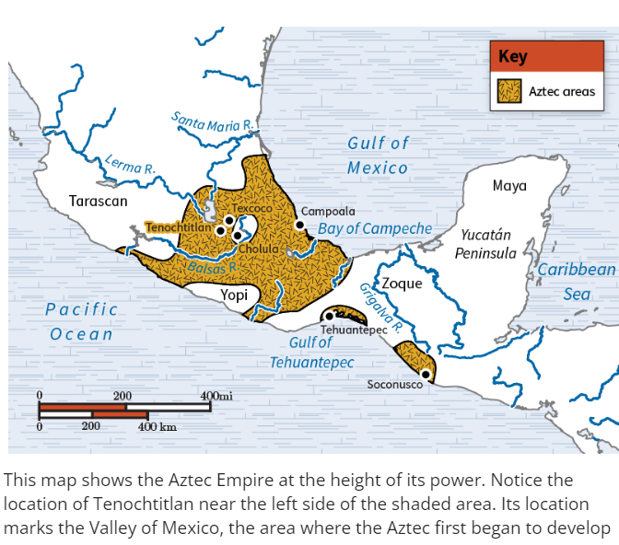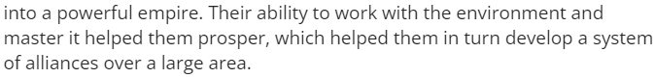

Check-In Questions:
1. Where did the Mexica people settle and develop the city of Tenochtitlan?
Answer: The Valley of Mexico

2. What were two different roles related to agriculture in the Aztec Empire?
Answer: Farmers, who planted and grew crops, and horticulturalists, who were experts on different types of plants and seeds and the land being cultivated.

3. Explain the major ideas in architectural engineering that developed in the Aztec civilizations.
Answer: The Aztecs created massive buildings despite soft soil, using stone foundations and support piles. They created a running water system, constructed aqueducts and canals, and developed chinampas for agriculture.

Practice Questions:
1. Why was irrigation an important strategy in Aztec agriculture?
Answer: Irrigation made it possible to get water to crops in areas with less ideal weather conditions, allowing for food production across the empire.

2. How did Aztec society reflect their adaptation to the environment?
Answer: The specialized roles of farmers and horticulturalists show how the Aztecs adapted to their environment, recognizing the need for both practical farming skills and expert knowledge of plants and land cultivation.

3. What were the major ideas and techniques in astronomy and mathematics that developed in the Aztec civilization?
Answer: Aztecs used complex mathematical equations based on astronomical observations for navigation and to create accurate calendars. They observed celestial bodies, adjusted their calendar for the true length of the year, and used astronomy for religious and agricultural purposes.

- The Most Powerful Empire in the World

Objective 4: Summarize the ways in which the Aztec Empire was ruled.

Essential Question: Why did the Aztecs use multiple methods to rule their empire?

Key Words:
1. Huey tlatoani: The Aztec emperor or "great speaker"
2. Tlatoani: Local ruler of a city-state within the Aztec Empire
3. Huitzilopochtli: Main Aztec god of war and the sun
4. Flower wars: Ritualized conflicts used to demonstrate power and obtain sacrificial captives
5. Decentralized government: System allowing local control under central authority

Big Ideas:
- The Aztec Empire was ruled by an emperor (huey tlatoani) chosen from nobility
- Local city-states maintained some autonomy under their own rulers (tlatoani)
- Religion played a crucial role in Aztec governance and warfare
- Human sacrifice was an important part of Aztec religious and political practice
- The empire used a decentralized system to manage its vast territory
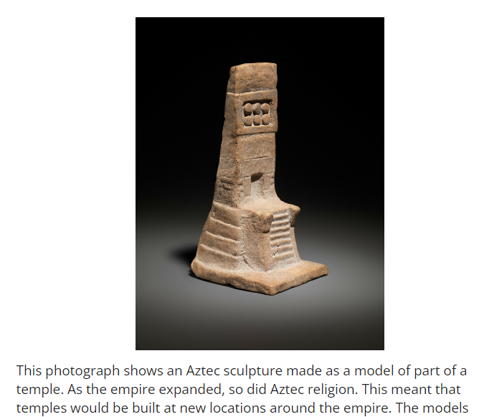

Check-In Questions:
1. Who was the most powerful person in the Aztec Empire?
Answer: The emperor, also known as the huey tlatoani

2. What was the Triple Alliance?
Answer: The Triple Alliance was an arrangement between the Aztecs and two other city-states to eliminate another powerful state; once this was done, they worked together to create the Aztec Empire.

Practice Questions:
1. Why did the Aztec Empire use a decentralized government to organize itself?
Answer: By letting city-states within the empire govern themselves, the city-states might be more content than having to be controlled by an outside power who tried to take over their city directly.

2. How does understanding the context of Aztec ritual human sacrifice help us better understand the Aztec Empire?
Answer: It helps us see that human sacrifice was a structured system based on defined religious beliefs and practices. Contextualizing Aztec human sacrifice helps us understand that their society, religion, and government operated in complex ways, even if the practice is considered problematic today.

- Unit 8 Lesson 5: The Inca Empire
- Rise of the Inca Empire

Objective 1: Summarize the rise and expansion of the Inca Empire.

Essential Question: How did the Aztecs create a powerful empire?

Key Words:
1. Inca Empire: The largest pre-Columbian empire in America, centered in the Andes
2. Quipu: Knotted cords used by the Inca for record-keeping
3. Sapa Inca: The emperor of the Inca Empire
4. Mit'a: Labor system used by the Inca for public works
5. Vertical archipelago: System of using different elevations for diverse agriculture

Big Ideas:
- The Inca Empire developed in the Andes Mountains rather than along river valleys
- At its height, the empire had a population of over 12 million people
- The Inca built upon cultural connections of previous Andean civilizations
- Rapid expansion in the 1400s led to incorporation of diverse communities
- The Inca used quipu for record-keeping as they lacked a formal writing system
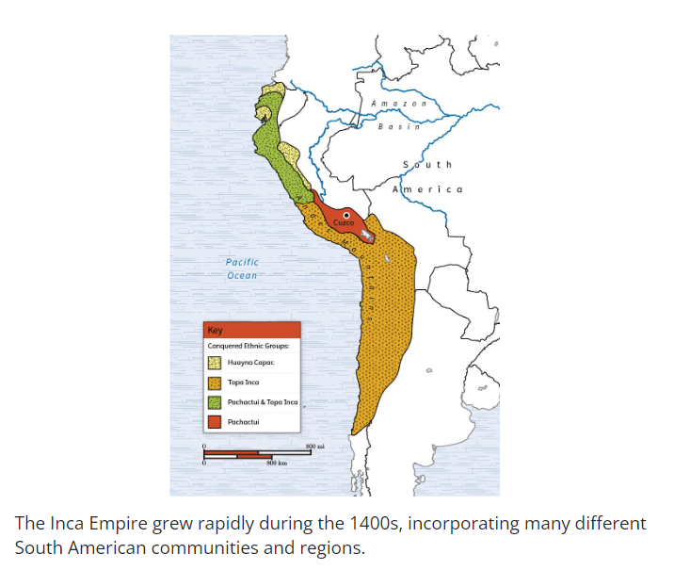
Check-In Questions:
1. What was the capital of the Inca Empire?
Answer: Cuzco

2. What is mit'a?
Answer: The labor system the Inca used to mobilize troops and workers for public service.

Practice Questions:
1. Explain how geography affected the Inca Empire differently than other societies.
Answer: The Inca Empire developed in the Andes Mountains, while other major civilizations were first founded along river valleys. The mountains presented unique geographical challenges that made it difficult to unite the various communities found throughout the range.

2. Explain some of the challenges historians face when trying to learn about the expansion of the Inca Empire.
Answer: The Inca Empire never developed a formal writing system; historians must use numerical records found in quipu, as well as oral traditions that emphasize mythology, and second-hand accounts written by the Spanish conquerors.

- Connecting the Inca Empire

Objective 2: Show the effect of infrastructure and city-building projects on the Inca Empire.

Essential Question: How did a sophisticated road system allow the Inca to expand and administer their empire?

Key Words:
1. Chasquis: Inca relay runners who delivered messages
2. Tambo: Relay stations along Inca roads
3. Machu Picchu: Famous Inca city built high in the Andes Mountains
4. Terrace farming: Agricultural technique used by the Inca on mountain slopes
5. Vertical archipelago: Inca system of using different elevations for diverse agriculture

Big Ideas:
- The Inca built an extensive road system covering about 25,000 miles
- Roads connected diverse geographic and ethnic regions of the empire
- The Inca used innovative techniques to build roads and bridges in challenging terrain
- Chasquis ran between tambo stations to deliver messages quickly across the empire
- Cities like Cuzco and Machu Picchu were connected by the road system
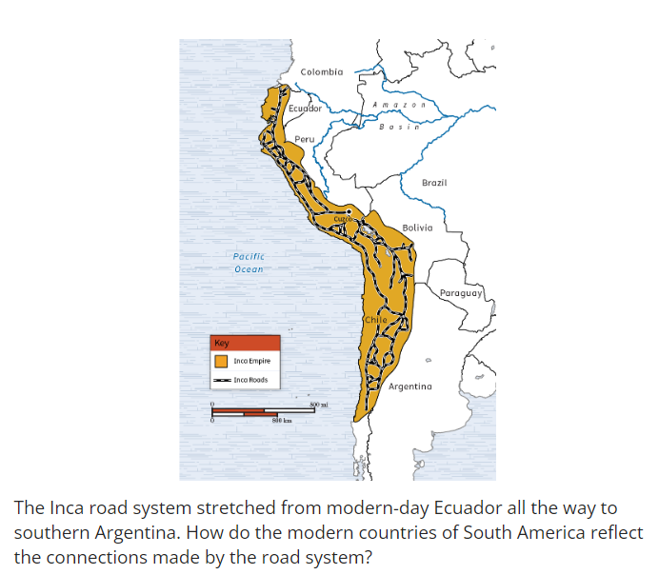

Check-In Questions:
1. How did people in the city of Machu Picchu sustain themselves?
Answer: Trade and terraced farming

2. What common language did the Inca use to promote unity within the empire?
Answer: Quechua

Practice Questions:
1. Compare the Inca road system to modern highway systems like the U.S. interstate system or German Autobahn.
Answer: The U.S. interstate system and the German Autobahn both connect major cities to each other for efficient travel and trade, just like the Inca road system.

2. Explain how the Inca used the chasquis system for communication.
Answer: The Inca used a relay system to communicate across long distances. In this system, messengers, called chasquis, ran between a series of stations, called tambo. They carried messages as well as long conch shells, used to alert the next runner that they were near.

- Adapting to the Andes

Objective 3: Explain how the Incas manipulated and adapted to their environment, including their use of terrace farming and developments in science, astronomy, and technology.

Essential Question: How did geography affect the Inca development of science, technology, and agriculture?

Key Words:
1. Terrace farming: Agricultural technique used on mountainsides
2. Ch'arki: Inca method of preserving meat by drying and freezing
3. Quipu: Knotted cords used for record keeping and calculations
4. Huacas: Inca religious shrines used for astronomical observations
5. Yupana: Inca counting board used for mathematical calculations

Big Ideas:
- The Inca adapted to different elevations using the vertical archipelago system
- Terrace farming allowed cultivation on steep mountain slopes
- The Inca developed unique food preservation techniques like ch'arki
- Quipu were used for complex record keeping and mathematical calculations
- Astronomy played a significant role in Inca religion and architecture


Check-In Questions:
1. What did the Inca use to keep records instead of written language?
Answer: Knotted cords called quipu

2. What was the importance of the mit'a system in the Inca Empire?
Answer: People in the Inca Empire worked for the empire for a period of time to construct roads and to provide food for the community.

3. Summarize what Inca construction and the use of the yupana and quipu reveal about major ideas in Inca mathematics.
Answer: Inca construction reveals a complex understanding of geometry. The use of the yupana and quipu show that the Inca used a decimal system much like our way of counting and that they used zeros in their mathematics.

Practice Questions:
1. Describe how the Inca method of record keeping is unique compared to other early civilizations in the world.
Answer: The Inca did not develop a system of writing, such as those found in Mesopotamia and Egypt. Instead, they used knotted strings of varying colors and lengths, called quipu, to record important information.

2. Explain how the geography of the Andes Mountains affected the agricultural methods used by the Inca.
Answer: The Andes Mountains had many different elevations. To make use of the space, they developed terraced agriculture. This form of farming allowed for the development of different types of crops. Crops at higher elevations were protected, and water could drain down to lower elevations as a form of irrigation.

3. Summarize the importance of astronomy in the Inca Empire.
Answer: There is archaeological evidence that the Inca built devices to measure and observe the sun and stars. Inca cities and other structures were built around astronomical phenomena such as equinoxes and solstices. We also know that the Inca ordered their day-to-day lives using an accurate solar calendar.

- Ruling the Inca Empire

Objective 4: Summarize the methods of rule in the Inca Empire.

Essential Question: How did the Inca Empire govern a geographically large territory with a diverse population?

Key Words:
1. Sapa Inca: The divine ruler of the Inca Empire
2. Suyu: Administrative districts of the Inca Empire
3. Ayllu: Local communities that organized daily life for Inca people
4. Mitma: Forced relocation of non-ethnic Incans within the empire
5. Quechua: Language family promoted by the Inca to unify the empire

Big Ideas:
- The Sapa Inca was the divine ruler with absolute authority
- The empire was divided into four administrative districts (suyus)
- Local communities (ayllus) organized daily life and labor
- Forced relocation (mitma) was used to control conquered populations
- The Inca promoted Quechua as a common language to unify diverse peoples
- Mit'a labor system and communal storehouses were used instead of currency
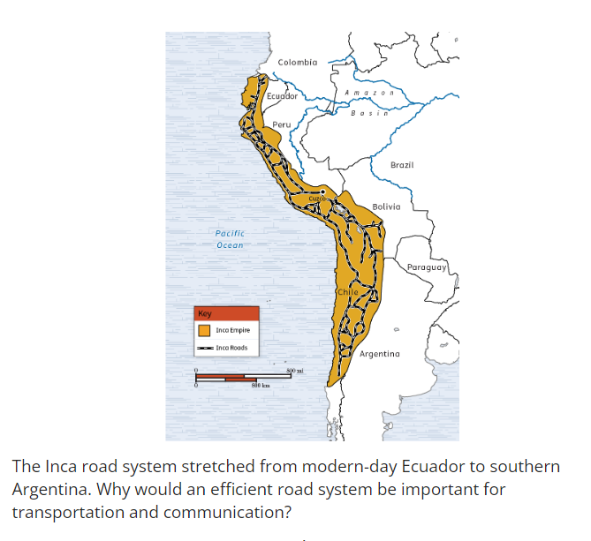
Check-In Questions:
1. What language system did Inca leaders promote to help unify the empire?
Answer: Quechua

2. What role did chasquis play in the Inca communication system?
Answer: Chasquis were messengers trained to run long distances, and they were educated to read quipus. They ran from station to station, transferring important information in a relay to different parts of the empire.

Practice Questions:
1. Using evidence from the Spanish conquistador's account, explain what role quipus served in the Inca economy.
Answer: Quipus were used to conduct a yearly census to identify people who were in poverty, as well as births, deaths, and lists of who could be used for mit'a labor.

2. Using evidence from the Spanish conquistador's account, explain how the Inca used storehouses to ensure economic equality.
Answer: Everyone was required to work to pay tribute to the storehouses. During lean years, the storehouses were open to everyone, not just the rich and powerful. This ensured economic equality because people were not treated differently just because of their social status.

- Unit 8 Lesson 6: Early Civilizations Interactions and Influences
- Changes and Continuity in Early Mesoamerican Civilizations

Objective 1: Investigate the cultural, political, technological, and economic changes and continuities between the Olmec and Mayan civilizations.

Essential Question: How did the economy, politics, culture, and technology stay the same or change between the Olmec and the Maya?

Key Terms:
1. Mesoamerica: The cultural region extending from central Mexico to Central America.
2. Slash and burn agriculture: A farming method where vegetation is cut down and burned to clear land for cultivation.
3. City-states: Independent political units consisting of a city and its surrounding territory.
4. Bloodletting: The ritualistic practice of drawing blood from oneself as an offering to the gods.
5. Hieroglyphics: A system of writing using pictures or symbols to represent words or sounds.

Big Ideas:
• The Olmec (1200-400 BCE) and Maya (1800 BCE-250 CE) were early Mesoamerican civilizations based on farming.
• Both used slash and burn agriculture and corn as a key crop.
• Both were organized as city-states ruled by kings/elites.
• Both played a ritual ballgame called tlachtli.
• Both developed writing systems, calendars, and the concept of zero.
• The Maya built larger, more ceremonial cities and more complex pyramids than the Olmec.
• The Maya developed more advanced astronomy and math than the Olmec.
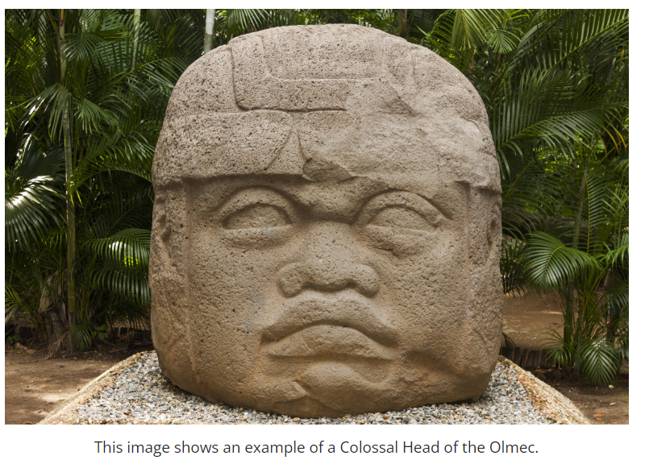

Check-In Questions:
1. How did the Olmec politically organize themselves?
Answer: As city-states

2. What was the name of the ritual ballgame played by the Olmec and Maya?
Answer: Tlachtli

Practice Questions:
1. How did the Mayan cities differ from the Olmec?
Answer: The Mayan cities were bigger, were built on a grander scale, and were the center of religious, commercial, and bureaucratic power for each city-state.

2. Explain why the development of the number zero was important for the Olmec and Maya.
Answer: The number zero was important for tracking days in a calendar. As well, it was helpful in calculating sums which could be used for counting population, tribute, trade, and crops.

- Aztec and Inca Interactions

Objective 2: Explain the ways in which the Aztec and Inca empires interacted culturally, politically, and economically with other American civilizations and societies.

Essential Question: How did the Aztec and Inca interact politically, economically, and culturally?

Key Terms:
1. Triple Alliance: A political and military coalition formed by the Aztec city-states of Tenochtitlan, Texcoco, and Tlacopan.
2. Tribute: Goods or services paid by conquered peoples to their conquerors.
3. Pochteca: Aztec long-distance traders who also acted as spies for the empire.
4. Ayllu: An Incan community structure based on extended family groups.
5. Mit'a: A labor tax system used by the Inca, requiring able-bodied people to work for the empire.

Big Ideas:
• The Aztec formed the Triple Alliance to gain political control over an 80,000 square mile area.
• The Inca expanded to control over 2,500 miles and 16 million people.
• Both empires demanded tribute from conquered peoples.
• The Aztec allowed local rule in exchange for tribute, while the Inca used the ayllu system.
• Both empires built extensive road networks for trade and communication.
• Both spread their language, religion, and customs to conquered peoples.


Check-In Questions:
1. How did the Aztec keep a watchful eye on parts of their empire?
Answer: They used the pochteca to spy on parts of the empire.

2. How did the Inca teach conquered people their culture?
Answer: They taught them their local language, Quechua.

Practice Questions:
1. Create a table that explains how the Aztec carried out their political, economic, and social relations with neighboring societies.
Answer:
Political: Used military conquest to capture 80,000 miles of land; Formed alliances with conquered people; Created Triple Alliance system; Allowed local rulers to govern their own regions but demanded tribute.
Economic: Connected capital Tenochtitlan with raised roads and canals; Tenochtitlan contained a large market with agricultural trade; Pochteca traveled for goods and gathered intelligence.
Cultural: Worshipped sun god Huitzilopochtli; Engaged in human sacrifice; Used enslaved people and tribute for labor and sacrifice; Waged frequent warfare.

2. Create a table that explains how the Inca carried out their political, economic, and social relations with neighboring societies.
Answer:
Political: Ruled using ayllu organized into units of 10; Relied on local rulers but demanded tribute; Established administrative centers with standardized government buildings.
Economic: Required mit'a labor; Developed extensive road network; Ensured food distribution to those who couldn't work; Used quipu accounting system.
Cultural: Created schools to teach Incan culture; Required use of Quechua language; Used clothing patterns to identify social groups; Developed elaborate religious calendar.

- Impact of Aztec and Inca on Environment and Cultures

Objective 3: Analyze the impact of the Aztec and Inca empires on the environment and culture of Mesoamerica and South America.

Essential Question: How did the Aztec and Inca empires impact the environment and cultures of Mesoamerica and South America?

Key Terms:
1. Chinampas: Artificial islands created by the Aztecs for agriculture in shallow lake beds.
2. Terrace farming: An agricultural technique using level surfaces cut into hillsides to maximize arable land and irrigation.
3. Nahuatl: The language spoken by the Aztecs, still used by some indigenous people in Mexico today.
4. Quechua: The main language of the Inca Empire, still spoken widely in the Andean region.
5. Ashlar: A masonry technique using finely cut and fitted stone blocks without mortar.

Big Ideas:
• The Aztec built chinampas (floating islands) for agriculture in Lake Texcoco.
• The Inca developed terrace farming in mountainous terrain.
• Both empires built extensive road networks and irrigation systems.
• The Aztec spread the Nahuatl language, while the Inca spread Quechua.
• Both empires impacted local cultures through religion and social organization.
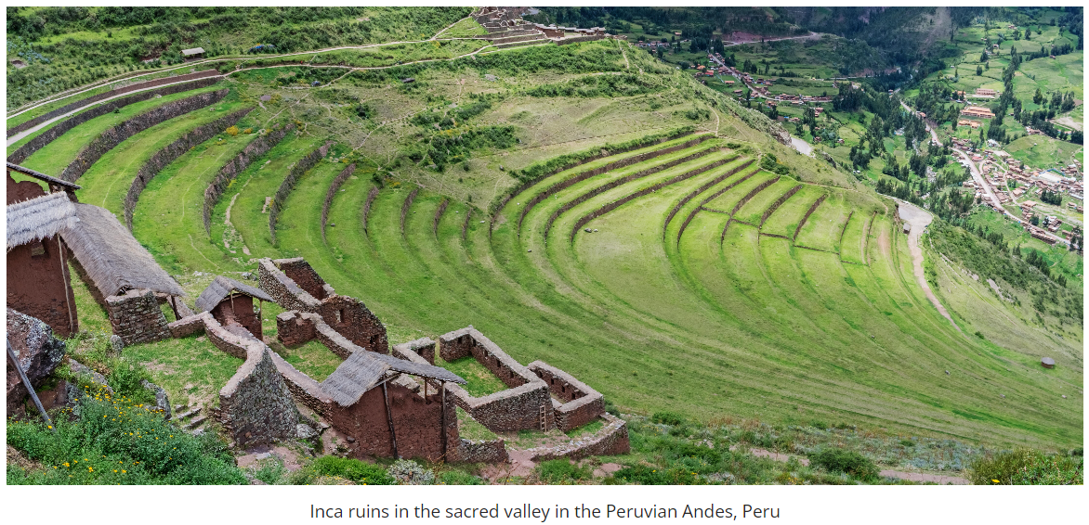
Check-In Questions:
1. How did the Aztec impact the environment to grow food?
Answer: They created chinampas to grow food in the lakes.

2. How did the Inca impact the environment to grow food?
Answer: They developed terrace farming in mountainous terrain.

Practice Questions:
1. Search online for information about chinampas. Write a statement about how the chinampa technology is being used today. What evidence did you find?
Answer: Chinampa technology is currently being adapted for sustainable urban agriculture. Evidence shows it's being used in projects like floating gardens in Mexico City to improve food security and in eco-friendly urban planning in cities like Chicago and New York. Some modern interpretations include rooftop gardens and vertical farming techniques inspired by the chinampa system.

2. How did the Inca use religion to culturally manage their empire?
Answer: Conquered people adopted the Incan religion and participated in Inca religious ceremonies.

- Earlier South American Civilizations

Objective 4: Investigate the influence of the earlier South American civilizations on the Inca Empire.

Essential Question: How did earlier South American civilizations impact the Inca Empire?

Key Terms:
1. Chavín: An early Andean civilization known for its religious and artistic influence.
2. Quipu: A record-keeping system using knotted cords to represent numerical and other data.
3. Chasqui: Inca relay messengers who ran along the empire's extensive road network.
4. Wari: A pre-Incan civilization known for its urban planning and terrace agriculture.
5. Chicha: A fermented corn beer traditionally consumed in Andean cultures.

Big Ideas:
• The Chavín, Caral, Chimu, and Wari civilizations predated the Inca in South America.
• These civilizations developed agricultural techniques, architectural styles, and religious practices that influenced the Inca.
• The quipu record-keeping system may have originated with the Caral.
• The Wari likely developed terrace farming before the Inca.
• The Inca adopted and adapted many practices from these earlier civilizations.
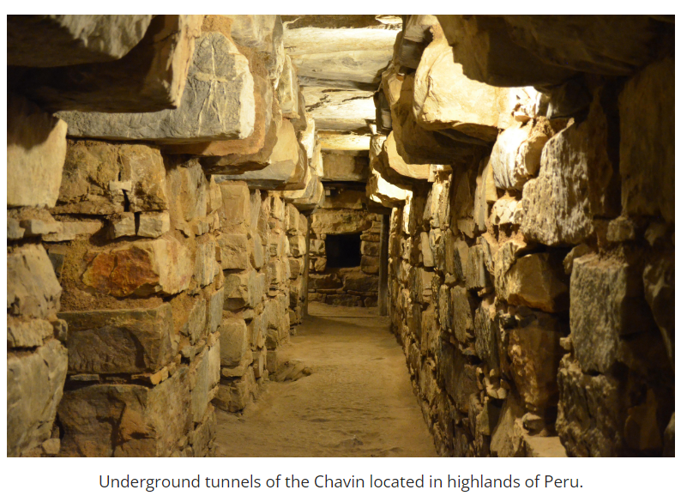

Check-In Questions:
1. What message system did the Inca build based on the Chimu?
Answer: Chasqui
2. Who were the original terrace farmers in the region prior to the Inca?
Answer: The Wari

Practice Questions:
1. Search online to solve the problem of whether the quipu developed by the Caral is the earliest quipu before the Inca. What evidence did you find?
Sample Answer: Recent archaeological evidence suggests that quipu-like devices were indeed used by the Caral civilization, dating back to around 3000 BCE. Excavations at the Caral site have uncovered knotted textiles that resemble early forms of quipu. This evidence indicates that the concept of using knotted cords for record-keeping predates the Inca by several thousand years, though the Inca likely developed and refined the system.

2. Search online for more information about the quipu and how it works. How did the quipu solve the problem of communication for cultures with no formal writing system? What evidence did you find?
Sample Answer: The quipu solved communication problems by using a complex system of knots, colors, and cord placement to record information. Evidence shows that different knot types represented different numbers, while cord colors and placement indicated categories of information. This allowed for recording of numerical data, historical events, and even narratives. Archaeological finds and Spanish colonial accounts provide evidence of quipu use for census data, tax records, and historical narratives.

3. Why do you think it is important to study the influence of earlier South American civilizations on the Inca Empire?
Sample Answer: Studying earlier South American civilizations is crucial for understanding the development of the Inca Empire. It helps us recognize that the Inca built upon and adapted existing technologies, agricultural practices, and cultural elements. This knowledge provides a more complete picture of South American history, highlights the interconnectedness of ancient cultures, and helps us appreciate the complexity and sophistication of pre-Columbian civilizations. It also challenges the notion that advanced civilizations appeared suddenly, showing instead a long process of cultural and technological evolution in the region.

- Unit 8 Lesson 7: Impact of European Conquest
- Old World Diseases in the New World

Objective 1: Investigate how the introduction of Eurasian diseases such as smallpox impacted Indigenous American populations.

Essential Question: How has global interdependence shaped the world?

Key Terms:
1. Columbian Exchange: The intentional and unintentional exchange of goods, plants, animals, and microbes between the Old and New Worlds after 1492.
2. Immunity: The body's ability to resist or fight off a particular infection or toxin.
3. Smallpox: A highly contagious viral disease that was devastating to Indigenous populations.
4. Wampum: Beads made from shells, used as currency and for ceremonial purposes by some Indigenous peoples.
5. Encomienda system: A labor system where Spanish colonists were granted land and Indigenous laborers.

Big Ideas:
• The Columbian Exchange led to the spread of Old World diseases to the Americas.
• Indigenous populations lacked immunity to these diseases, causing devastating effects.
• Disease contributed to the rapid conquest of Indigenous empires by European colonizers.
• The spread of disease led to significant demographic and social changes in Indigenous societies.
• Europeans interpreted disease outbreaks differently from Indigenous peoples.
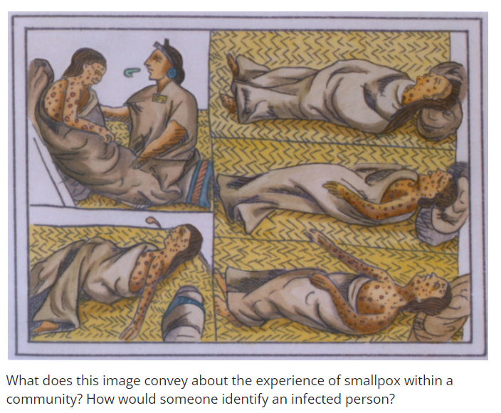
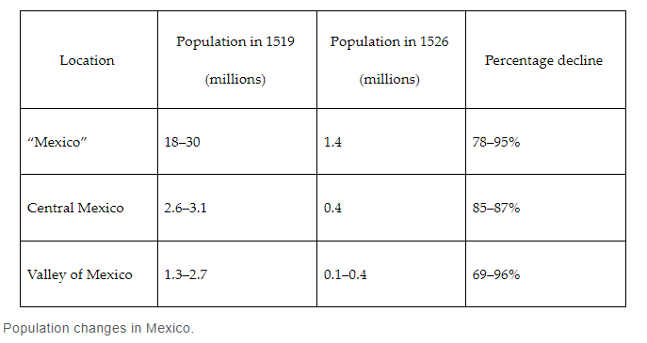

Check-In Questions:
1. Name one disease that Europeans brought from the Old World to the New World.
Answer: Any of the following: smallpox, influenza, malaria, typhus, measles, whooping cough, and typhus

2. How did smallpox lead to the successful Spanish takeover of Tenochtitlán?
Answer: Smallpox spread like wildfire, weakened the Aztec armies, and contributed to the Aztec's enemies' decision to side with the Spanish conquistadors.

Practice Questions:
1. How does the lack of immunity determine the severity of an illness?
Answer: Immunity is based on a community's exposure to disease, which would lead to the creation of antibodies. Without exposure to disease, as the Americas lacked, a community is vulnerable.

2. How well did Europeans and Indigenous peoples understand the spread of Eurasian diseases?
Answer: The Europeans understood that Indigenous peoples were ill by the time they encountered and conquered them, and the Indigenous peoples understood the Europeans brought an illness with them.

- Impacts of Conquering

Objective 2: Draw comparisons between the cultural and physical conditions of the Aztec and Inca Empires before and after Spanish conquest.

Essential Question: How did the Spanish conquistadors' goals and methods of conquest physically reshape the former Aztec and Inca Empires?

Key Terms:
1. Chinampas: Artificial islands built by the Aztecs for agriculture in shallow lakes.
2. Codex Mendoza: A colonial-era manuscript recording Aztec history and culture.
3. Mita system: An Incan labor system adapted by the Spanish for mining.
4. Hacienda system: A system of large land grants used for agriculture and ranching in Spanish America.
5. UNESCO World Heritage site: Places of cultural, historical, or scientific significance protected by international treaties.

Big Ideas:
• Spanish conquest led to the destruction and transformation of Aztec and Inca cities.
• The Spanish built their colonial cities on top of Indigenous urban centers.
• Spanish economic activities, such as mining and cattle ranching, significantly altered the landscape.
• Deforestation was a major consequence of Spanish colonial industries.
• The physical changes imposed by the Spanish fundamentally altered the relationship between Indigenous peoples and their environment.
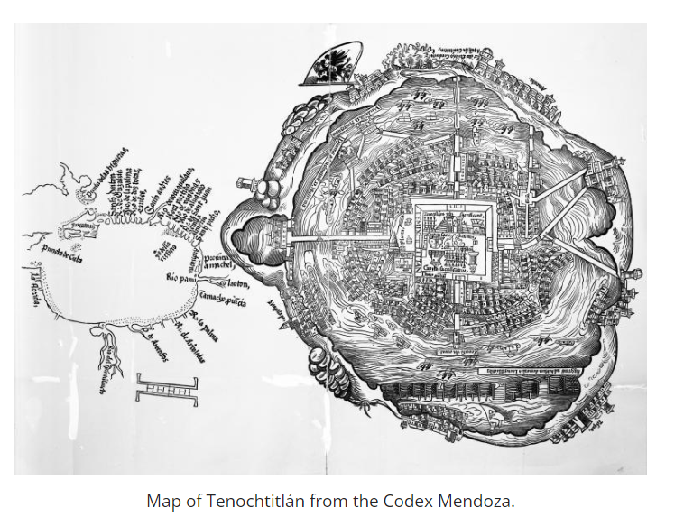
Check-In Questions:
1. Name two cities that Spanish colonists built on top of Indigenous city remains.
Answer: Tenochtitlán (Mexico City) and Cuzco

2. Name two Spanish industries that had a significant environmental impact on the rural landscape.
Answer: Mining (silver), cattle ranching, and/or sugar mills

Practice Questions:
1. Take the initiative to self-direct through the Museum of Cusco's website to its collections. What artifacts tell a story about the Incans?
Answer: Shells, silver, or native animals such as the alpaca.

2. Take the initiative to self-direct through the UNESCO World Heritage site's interactive map. What other sites are being protected as evidence of Indigenous peoples or the Spanish colonial legacy?
Answer: Antigua Guatemala, which is evidence of the first city planning attempts in Latin America, or the city of Quito, which was also built on top of Incan city remains.

- Impacts on the Inca and Aztec Empires

Objective 3: Explain the immediate and long-term impacts of Spanish conquests, such as those of Hernán Cortés and Francisco Pizarro, in the New World.

Essential Question: What are the immediate and long-term impacts of European conquest on the Inca and Aztec Empires, and how did this contribute to an ongoing dependence between the Old World and New World?

Key Terms:
1. Encomiendas: Land grants given to Spanish conquistadors, including rights to Indigenous labor.
2. Hernán Cortés: Spanish conquistador who led the conquest of the Aztec Empire.
3. Francisco Pizarro: Spanish conquistador who conquered the Inca Empire.
4. Codices: Traditional pictorial records of Mesoamerican cultures.
5. Monotheistic: Believing in or worshipping only one god.

Big Ideas:
• Spanish conquests led to immediate impacts such as enslavement, forced labor, and cultural changes.
• Long-term impacts included further colonization, environmental changes, and economic transformation.
• The conquest of the Aztec and Inca Empires led to massive influxes of gold and silver to Spain.
• Spanish colonization set precedents for other European imperial efforts in the Americas.
• The conquests created an ongoing economic and cultural dependence between the Old and New Worlds.
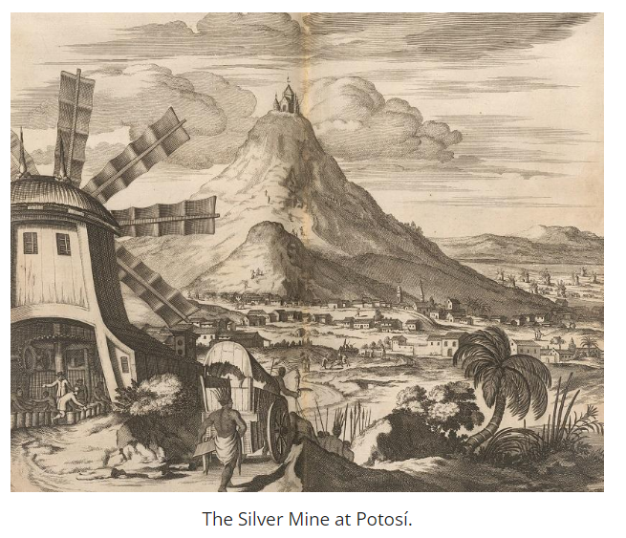
Check-In Questions:
1. What is one immediate impact of Spanish conquests?
Answer: Death from fighting; death from disease; rise in colonial pursuits; or destruction of Indigenous cities and culture.

2. What is one long-term impact of Spanish conquests?
Answer: Environmental changes; European control of American wealth; America's increased role in the global economy; or ongoing colonialization.

Practice Questions:
1. What was the role of Spanish conquistador Hernán Cortés in the fall of the Aztec Empire?
Answer: Hernán Cortés left his encomienda and led the conquest that resulted in the conquering of the Aztec capital, Tenochtitlán. He killed the Aztec leader.

2. What is the role of Francisco Pizarro in the fall of the Inca Empire?
Answer: Francisco Pizarro was inspired by Hernán Cortés and asked the Spanish government for their help in conquering more territory inland around modern day Peru. He tricked the Inca leader, Atahuallpa, to meet with him and then killed him. From there, Pizarro conquered Cuzco and other important locations and peoples within the Inca Empire.

- Unit 8 Lesson 8: The Fall of the Aztec and Inca Empires
- Spanish Conquest

Objective 1: Summarize the circumstances that made it possible for the Spanish to conquer the Aztec and Inca peoples.

Essential Question: Why were the Spaniards able to conquer the Aztec and Inca so quickly?

Key Terms:
1. Empire: A group of territories or peoples under a single sovereign authority
2. Indigenous peoples: Original inhabitants of a region
3. Alliance system: Political agreements between different groups
4. Panaqa: Ruling group in the Inca Empire
5. Conquistadors: Spanish explorers, military officers and soldiers who led expeditions to the Americas

Big Ideas:
• The Spanish used alliances with oppressed indigenous groups to help conquer the Aztec and Inca
• Advanced military technology and horses gave the Spanish an advantage in battle
• European diseases decimated indigenous populations, weakening their ability to resist
• The internal conflicts within the Aztec and Inca empires made them vulnerable to conquest
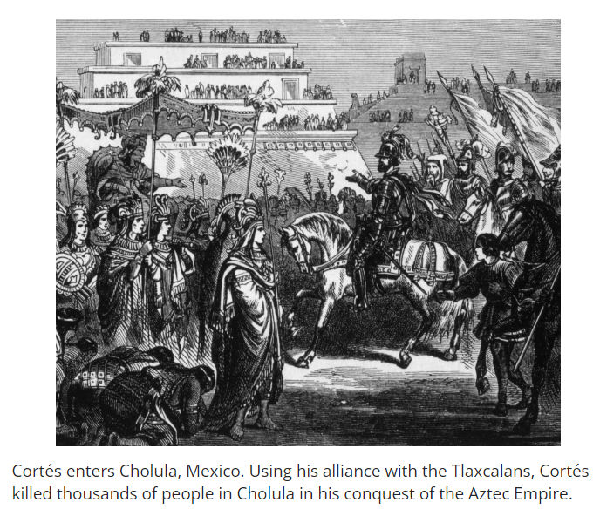
Check-In Questions:
1. What practices were causing unrest in the Inca Empire before Pizarro arrived?
Answer: The Inca taxed land throughout the empire, imprisoned family members of governing officials to force allegiance to the empire, and made people in conquered territories follow the Incan religion.

2. How did the introduction of diseases by the Europeans aid in the conquest of the New World?
Answer: The Aztec and the Inca did not have natural immunity to European diseases, so these diseases acted as a form of biological warfare, weakening indigenous populations.

Practice Questions:
1. How did the alliance system help Pizarro gain power to battle against and defeat the Inca?
Answer: After Pizarro defeated Atahualpa, the indigenous people gave him supplies that had been stored for the Inca. These additional provisions helped Pizarro gain power and eventually beat the Inca.

2. Explain how Malinche, the enslaved girl whom Cortés received as a gift, was beneficial in helping the Spaniard form relationships with Indigenous people that would later be useful in his overthrow of the Aztec.
Answer: Malinche was born in the Americas and spoke indigenous languages. She could converse with local people, making them comfortable sharing important information with her. This information later helped the Spanish in their conquest.

- Welcome Friends or Possible Foes?

Objective 2: Explain the perspectives of the Aztec and Inca on the arrival of the Spanish conquistadors in their empires.

Essential Question: How did the perspectives of the Aztec and Inca differ from those of the Spanish conquistadors?

Key Terms:
1. Montezuma: Aztec ruler at the time of Spanish arrival
2. Hernán Cortés: Spanish conquistador who led the conquest of the Aztec Empire
3. Pedro de Alvarado: Spanish conquistador left in charge of Tenochtitlan by Cortés
4. Atahuallpa: Ruler of the Inca Empire at the time of Spanish arrival
5. Francisco Pizarro: Spanish conquistador who led the conquest of the Inca Empire

Big Ideas:
• Both the Aztec and Inca initially welcomed the Spanish, not realizing their intentions
• The Aztec believed Cortés might be the return of their god Quetzalcoatl
• Montezuma's strategy of appeasing the Spanish with gifts backfired
• The Inca were overconfident due to their large army and agreed to meet with Pizarro
• Both empires quickly learned the Spanish intended to conquer them

Check-In Questions:
1. Describe Montezuma's intended outcome by offering gifts to Cortés at the initial meeting between the Aztec and the Spaniards.
Answer: Montezuma thought the gifts would placate the Europeans and give the Aztec an opportunity to study the potential invaders.

2. Which Spaniard attacked the Aztec, leading to a revolt?
Answer: Pedro de Alvarado

Practice Questions:
1. Describe what you think the Inca's thought process was when they gave the Spanish the ransom to free Atahuallpa, even after watching the Europeans kill thousands of Inca people.
Answer: The Inca probably thought that by freely giving their riches to the Spanish, their leader would be spared.

2. Explain why you think the initial meetings of the Spaniards with the Aztec and Inca transpired differently.
Answer: When the Aztec met with Cortés, the meeting was to size up the Spanish army, placate them, and offer gifts to steer them away. The initial meeting with the Inca was different; Pizarro had no intent of negotiation and was there to conquer the Inca.

- Events Leading to the Fall of the Aztec and Inca Empires

Objective 3: Investigate factors that led to the fall of the Aztec and Inca Empires.

Essential Question: How did internal and external factors contribute to the fall of the Aztec and Inca Empires?

Key Terms:
1. New World: Term used by Europeans to describe the Americas
2. Empires: Large territories or number of territories under a single authority
3. Smallpox: Highly contagious viral disease introduced by Europeans
4. Iron Age: Period characterized by the widespread use of iron or steel
5. Macuahuitl: Wooden club with obsidian blades used by Aztecs

Big Ideas:
• Both empires struggled to maintain control over their vast territories
• European diseases like smallpox decimated indigenous populations
• The Spanish had superior weapons technology, including steel and gunpowder
• Internal conflicts and civil wars weakened both empires before Spanish arrival
• The combination of internal and external factors led to the rapid fall of both empires
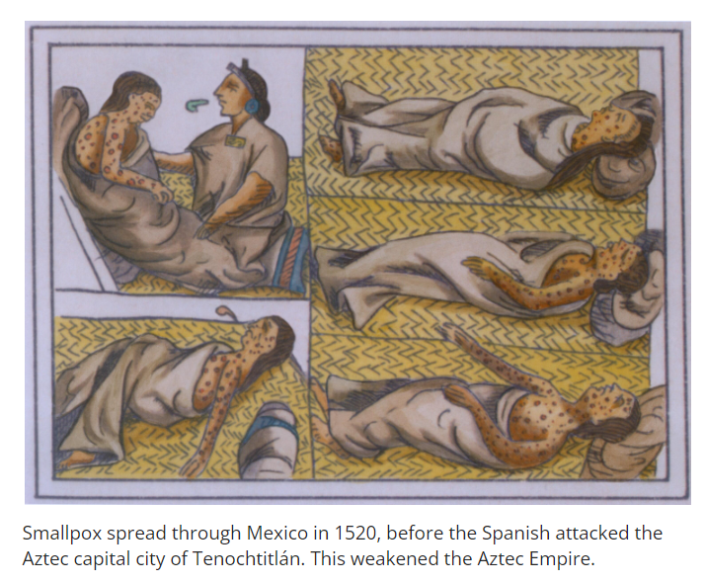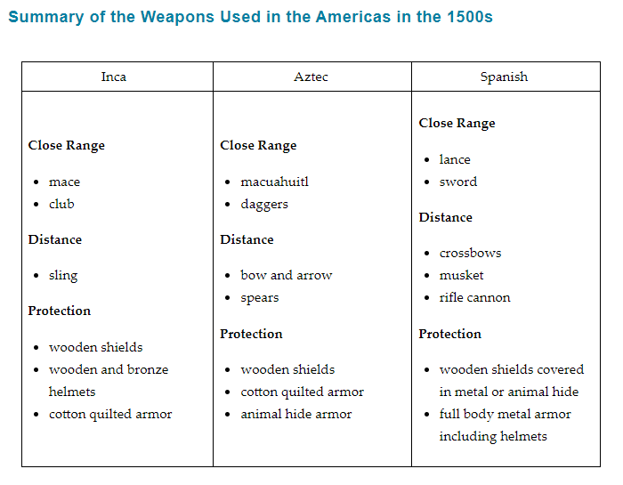
Check-In Questions:
1. What invisible weapons led to the decline of both the Aztec and Inca Empires before the Spanish attacked?
Answer: European diseases like smallpox

2. What types of weapons did the Incan army use?
Answer: Spears, slings, and clubs

Practice Questions:
1. How did their efforts to grow their empire contribute to the fall of the Aztec Empire?
Answer: As the Aztec Empire grew, it became more unstable. People in new territories often rebelled. New soldiers in the Aztec army were not as loyal, which made the empire more vulnerable to attack from the outside. The Maya saw the Aztec as a threat and helped the Spanish.

2. Search online for information about smallpox and write 2-4 sentences about the effects of smallpox on the indigenous peoples of the New World.
Answer: Smallpox is an infectious disease caused by the variola virus, which was common in Europe. The indigenous people of the New World had no immunity to smallpox. Some historians estimate that up to 20 million people died across the Americas in the generations after the Europeans arrived.

