- Unit 7 Lesson 1: Medieval-Renaissance Europe
- Medieval-Renaissance Europe Introduction
Timeline:

- 476 CE: Fall of the Western Roman Empire
- Beginning of the Early Middle Ages

- c. 500-1000 CE: Development of Feudal System in Europe

- 800 CE: Charlemagne crowned as Holy Roman Emperor

- 1066: Norman Conquest of England (Battle of Hastings)

- 1095-1291: The Crusades

- 1215: Magna Carta signed in England

- 1337-1453: Hundred Years' War between England and France

- 1347-1351: The Black Death ravages Europe

- c. 1350-1600: The Renaissance
- 1440s: Johannes Gutenberg invents the printing press
- Late 1400s-early 1500s: High Renaissance in Italy (Leonardo da Vinci, Michelangelo, Raphael)

- 1517: Martin Luther posts 95 Theses, beginning the Protestant Reformation

- 1534: Henry VIII establishes Church of England, starting the English Reformation

- 1545-1563: Council of Trent (Catholic Counter-Reformation)

- c. 1550-1700: The Scientific Revolution
- 1543: Nicolaus Copernicus publishes heliocentric theory
- 1610: Galileo Galilei publishes observations supporting heliocentrism
- 1687: Isaac Newton publishes Principia Mathematica

**This timeline provides a chronological overview of the major events and periods covered in the unit, from the fall of the Western Roman Empire through the Scientific Revolution.
Objective: Introduce the key concepts and time periods covered in the Medieval-Renaissance Europe unit.

Essential Question: What is the enduring impact of the European Renaissance on modern societies?

Key Terms:
1. Feudal system: The political and economic system in medieval Europe based on the holding of land in exchange for service or labor.
2. Middle Ages: The period in European history from the fall of the Roman Empire to the Renaissance.
3. Renaissance: A period of cultural rebirth and artistic innovation in Europe from the 14th to 17th centuries.
4. Crusades: A series of religious wars between Christians and Muslims over control of holy sites in the Middle East.
5. Scientific Revolution: A period of major scientific discoveries and advances, particularly in astronomy and physics, during the 16th and 17th centuries.

Big Ideas:
• The unit covers the development of Europe from the fall of the Roman Empire through the Renaissance
• Key topics include the feudal system, role of the Catholic Church, Crusades, and Black Death
• The Renaissance marked a period of significant cultural and intellectual changes
• The Scientific Revolution brought major advances in science and technology
• Ideas developed during this period still impact modern societies
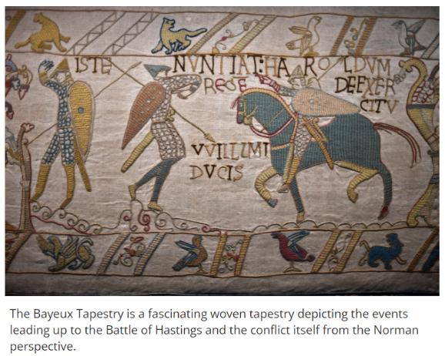

Check-In:
1. What two important movements are highlighted as following the Middle Ages?
Answer: The Renaissance and the Scientific Revolution

2. What provided stability to European lives during the Middle Ages?
Answer: The Catholic Church

Practice:
1. Describe two ways the Renaissance impacted European society.
Answer: The Renaissance was marked by cultural and artistic advancements. It also led to intellectual developments and changes in how people viewed the world and themselves.

2. How did interactions with other societies influence changes in Europe during the Middle Ages?
Answer: Interactions with other societies, notably during the Crusades to the Middle East, exposed Europeans to new ideas and cultures. This led to faster changes and paved the way for movements like the Renaissance and Scientific Revolution.

- Unit 7 Lesson 2: Feudal System
- Western European Civilization is Established

Objective 1: In this section, you will examine how the feudal system developed by studying the medieval social hierarchy system, the role of the Church, and the changes in property ownership.

Essential Question: How did Western Europe develop during the Middle Ages to have its own cultural identity in spite of the political division caused by the feudal system?

Key Terms:
1. Postclassical: The period after the fall of the Roman Empire
2. Serfs: Peasant farmers who worked the land in exchange for protection
3. Feudalism: A hierarchical system based on land ownership and military service
4. Roman Empire: The empire that previously unified Western Europe
5. Three-field system: An agricultural method that improved crop rotation and yields

Big Ideas:
• The fall of the Roman Empire led to a lack of central authority in Western Europe
• The manorial system developed, creating self-sufficient estates
• Feudalism created a hierarchical power structure based on land ownership
• The Catholic Church provided cultural unity despite political divisions
• Technological advancements, often from Asia, improved agricultural productivity

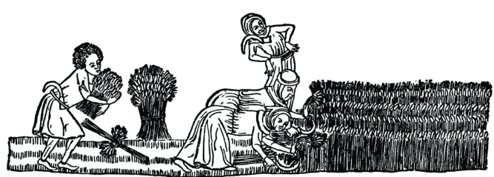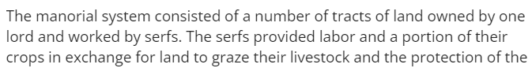

Check-In Questions:
1. How did the concept of private property emerge?
Answer: With the decline of empires, military leaders and mounted soldiers took control of large tracts of land. They became landlords, managing the properties. This land was hereditary. Sometimes it was granted by a king in exchange for military and economic support and allegiance.

2. Describe the role serfs played in the Western European feudal system.
Answer: Serfs were the agricultural workers on a landowner's manor. They labored in the fields as well as in the castle in exchange for protection and access to land from the lord.

Practice Questions:
1. Why was it so difficult for medieval Europe to unify after the fall of the Roman Empire?
Answer: Sample answer: Without the centralized authority of Rome and its military, regions split apart and manorialism created self-sufficient mini-kingdoms with a landowning lord offering protection to farm laborers in exchange for a percentage of their crops. Latin was the only common language and was only used by the Church and educated people. Local languages made it difficult for larger regions to unify.

2. What was a result of improved agricultural technology on the lives of the serfs?
Answer: Sample answer: With improved technology, serfs were able to plant more crops, more efficiently and produce more food, which resulted in an increase in population. Economic activity increased and there were shifts in roles because fewer people were needed to grow more crops.

- Introduction to Manorialism

Objective 2: In this section, you will describe the hierarchical nature of the manor system by interpreting information from charts and tables depicting the medieval class system.

Essential Question: How did the manor system develop and organize society in medieval Europe?

Key Terms:
1. Hierarchical: A system organized by ranks or orders
2. Lords: Landowners who controlled manors
3. Manorialism: An economic system based on the manor and dependent on agriculture
4. Fiefs: Land granted by a lord to a vassal in exchange for military service
5. Chivalry: The medieval knightly system with its religious, moral, and social code

Big Ideas:
• Manorialism developed after the fall of the Roman Empire due to political unrest
• The manor system was self-contained and based on a hierarchical structure
• Lords provided protection in exchange for labor and crops from serfs
• Knights and vassals served lords in exchange for land and status
• The Church played a significant role in reinforcing the manorial system

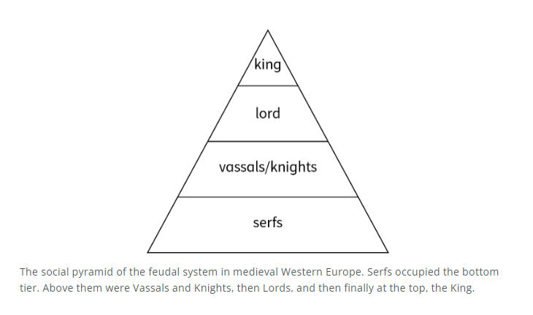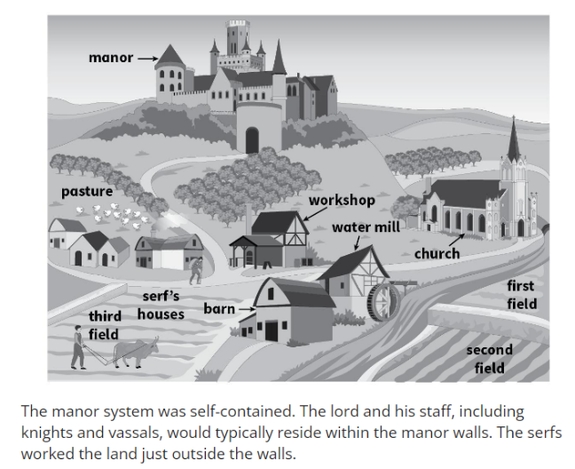
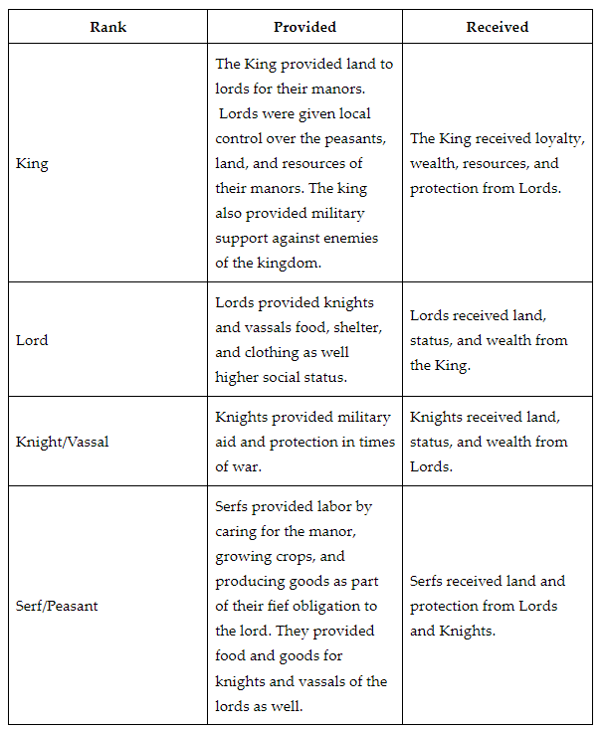

Check-In Questions:
1. Describe the role of knights in the manor system hierarchy.
Answer: Sample answer: Knights were the armed military of the manor. They protected the lord, the serfs, and the manor. Their job included enforcing law and order as well as protection.

2. Give one example of a technology from Asia that helped improve agriculture in Western Europe during the Middle Ages.
Answer: Sample answer: Answers could include the three-field system, moldboard plow, horse collar, or improved forging technology.

Practice Questions:
1. Complete the table examining the reciprocal relationships between different groups in the feudal system's social hierarchy.
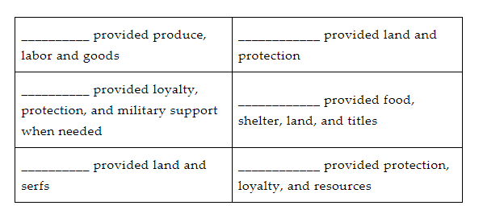
Answer: 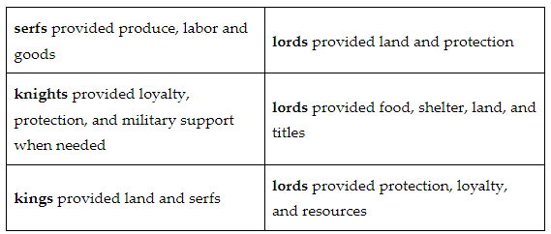

2. Describe the role of the knight's code of chivalry.
Answer: Sample answer: The code of chivalry was a code of conduct for knight behavior. It was a list of rules for how to behave, worship, fight, and advance in society.

- Feudalism's Success in Europe

Objective 3: In this section, you will use the provided primary source document, representing multiple perspectives on life in the French feudal system, to analyze how the political, social, and economic needs for order and structure were met during the Middle Ages.

Essential Question: How did feudalism create a sense of order, safety, and organization for Western European people during the Middle Ages and set the stage for the Renaissance?

Key Terms:
1. Fiefs: Land granted by a lord to a vassal in exchange for military service
2. Hierarchy: A system of organization with higher and lower levels
3. Homage: A public ceremony in which a vassal pledged loyalty to his lord
4. Abbey: A monastery or convent under the leadership of an abbot or abbess
5. Excommunicate: To officially exclude someone from participation in the Church

Big Ideas:
• Feudalism provided a system of authority based on obligation and loyalty
• The Church played a central role in feudal contracts and enforcement
• The feudal system benefited different social classes in various ways
• The Truce of God was an attempt by the Church to limit violence
• Feudalism's rigidity and inequality eventually led to social changes
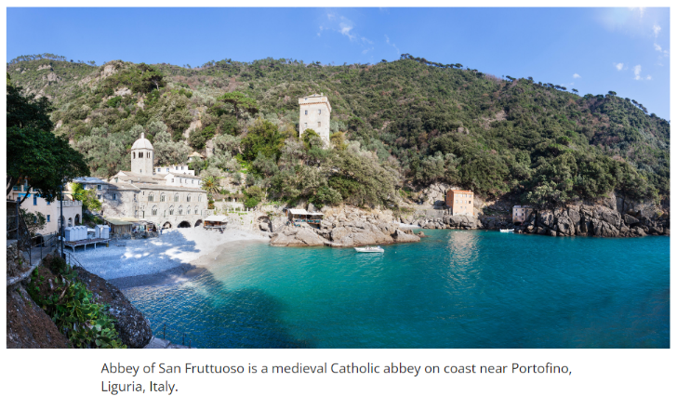

Check-In Questions:
1. What was the purpose of the Truce of God?
Answer: Sample answer: The Truce of God was established by a council of French provincial bishops who wanted to create peace among different territories. They designated certain days to be days of peace, and any conflict on those days was punished by penalties such as excommunication or having land taken away.

2. Briefly describe the unbalanced power relationship in a fiefdom.
Answer: Sample answer: Whoever was granted a fief typically had specific obligations that they agreed to, whereas the lord, king, or Church had more vague duties. There were specific penalties for breaking fief obligations for serfs and vassals, but not for lords.

Practice Questions:
1. Analyze the quote from a "Ceremony of Doing Homage and Swearing Fealty" and write 2–3 sentences about what role the Church played in homage.
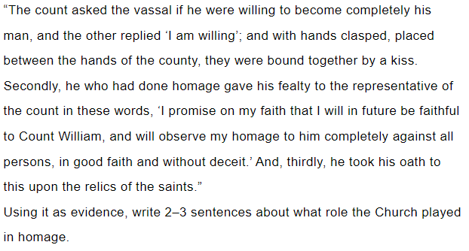
2. Why was feudalism unable to produce peace in Europe?
Answer: Sample answer: The feudal system was based on numerous small, self-governing territories that were frequently at conflict with one another, creating disorder.

- Compare Causes and Effects of the Middle Ages on Europe

Objective 4: In this section, you will compare the roles of feudalism and Christianity and the impact of diseases and climate on European culture during the Middle Ages and how they impacted the development of the Renaissance.

Essential Question: How do feudalism, the Catholic Church, disease, and climate impact the Middle Ages, the Renaissance, and modern-day European culture?

Key Terms:
1. Hierarchical: Arranged in order of rank or importance
2. Renaissance: A period of cultural rebirth and artistic innovation in Europe
3. Knights: Mounted warriors who served lords in exchange for land
4. Crusades: Religious wars fought between Christians and Muslims over holy sites
5. Bubonic plague: A deadly disease that decimated Europe's population in the 14th century

Big Ideas:
• Feudalism and the Church created a hierarchical structure in medieval society
• The Crusades exposed Europeans to new ideas and technologies
• The bubonic plague led to significant social and economic changes
• Climate changes affected agricultural production and population growth
• These factors collectively contributed to the development of the Renaissance
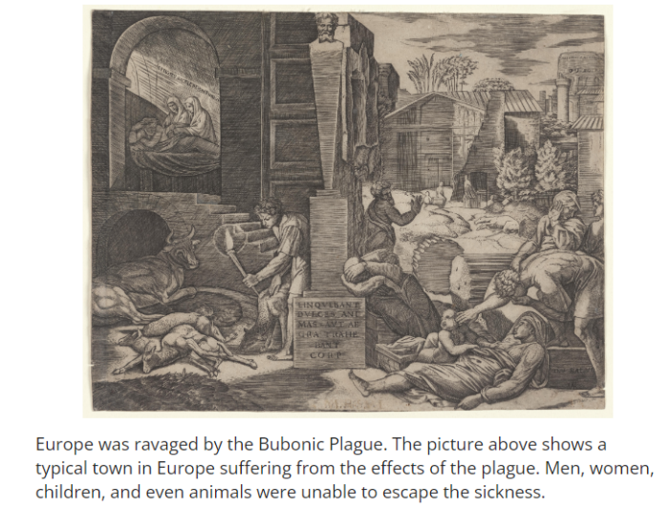

Check-In Questions:
1. What was an intellectual ideal from the Greeks and Romans that experienced renewed interest during the Renaissance?
Answer: Sample answer: Intellectual ideals such as individualism, equality, and representational government such as republics, derived from classical Greek and Roman literature, experienced a surge in popularity.

2. How did the Crusades and exposure to Middle Eastern culture impact the European feudal system during the Middle Ages?
Answer: Sample answer: Crusaders from Europe came into contact with new ideas, technologies, and goods that they brought back when they returned home. New technologies improved crops and food production, which made farms more productive and efficient. Interaction with the Islamic world also renewed interest in intellectualism, and soldiers returned with ideas questioning the existing feudal political and economic system.

Practice Questions:
1. Compare the rise of city-states to the rise of the Renaissance.
Answer: Sample answer: With a growing demand for goods from outside of Europe, trade increased, and city-states formed in trading centers. They had their own political systems, and their economies grew with trade. Trade included both goods and ideas, which resulted in a renewed interest in the classics. The interest in ancient Greece and Rome, combined with wealthy merchant patronage, brought about the Renaissance.

2. Explain how the bubonic plague impacted changes in medieval politics due to the drastic reduction in population numbers.
Answer: Sample answer: As the plague took its toll on the population, workforce numbers fell and labor was in demand. This meant that workers could demand higher wages and had economic and social opportunities that had not been available during the structure of feudalism. There was a rise in social mobility and individualism.

- Unit 7 Lesson 3: National States and Monarchies
- Power Expands, Contracts, and Evolves

Objective 1: In this section, you will evaluate how power and authority has changed and expanded from the fall of the Western Roman Empire to the emergence of nation-states, providing appropriately cited evidence.

Essential Question: How has power and authority evolved since the fall of the Western Roman Empire?

Key Terms:
1. Centralized: Concentrated power in a single authority
2. Decentralized: Power distributed among many local authorities
3. Feudalism: System of political and social organization based on land ownership
4. Nation-states: Sovereign states whose citizens share a common national identity
5. Regent: Person who rules temporarily when the monarch is incapacitated

Big Ideas:
• Power in Europe shifted from centralized (Roman Empire) to decentralized (feudalism) and back to centralized (nation-states)
• The Catholic Church gained power as the Western Roman Empire declined
• Feudalism developed as a system of protection and land management
• Nation-states emerged as powerful lords consolidated their authority
• The Byzantine Empire continued as a centralized power in the East until 1453
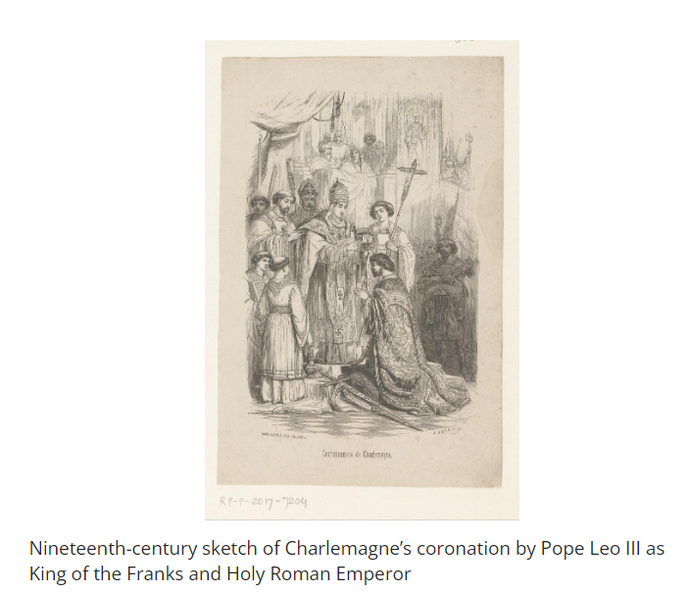

Check-In Questions:
1. Cite two examples that show how power and authority changed and expanded after the fall of Western Rome.
Answer: Sample answers: The Byzantine Empire in the east continued to be a centralized power; Feudalism developed; Carolingians centralized power; The Holy Roman Empire was created; The development of the European nation-state also represented centralized power, albeit not on the scale of former empires; The Papal States formed.

2. Name the power structure that developed as lords centralized authority, which created a sense of national identity.
Answer: nation-state

Practice Questions:
1. Using evidence from the section, fill in the chart to show the ways power and authority changed from 500 to 1500 CE.
Answer: 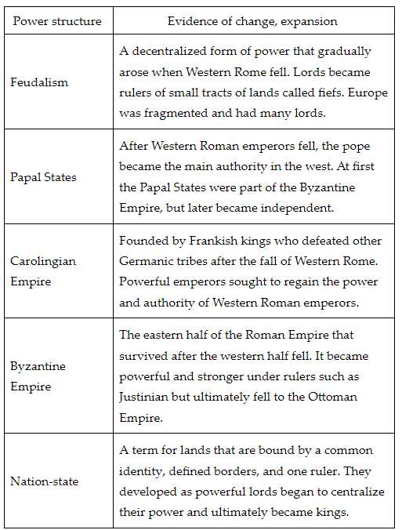

2. Fill in the timeline that marks important changes to the Byzantine Empire's power.
Answer:
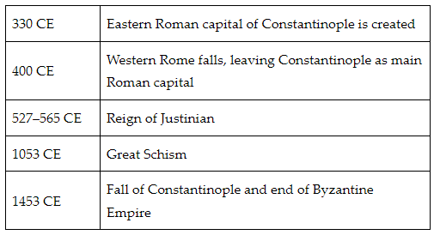

- From Wars and Kings to Diplomacy and Parliament

Objective 2: In this section, you will describe the development of England as a nation-state, including the role of William the Conqueror and developments in England's constitutional and legal history.

Essential Question: How did legal and constitutional developments help England become a nation-state?

Key Terms:
1. Nation-state: A sovereign state whose citizens share a common national identity
2. Indigenous: Native to a particular place
3. Constitutional monarchy: A system of government where the monarch's power is limited by law
4. Feudalism: System of political and social organization based on land ownership
5. Legislative Parliament: A body that makes laws for a nation

Big Ideas:
• England developed from a collection of diverse peoples into a unified nation-state
• William the Conqueror established Norman rule and expanded legal documentation
• The Magna Carta limited the king's power and established Parliament
• A series of legal documents formed England's unwritten constitution
• Parliament gradually gained more power, limiting the monarch's authority
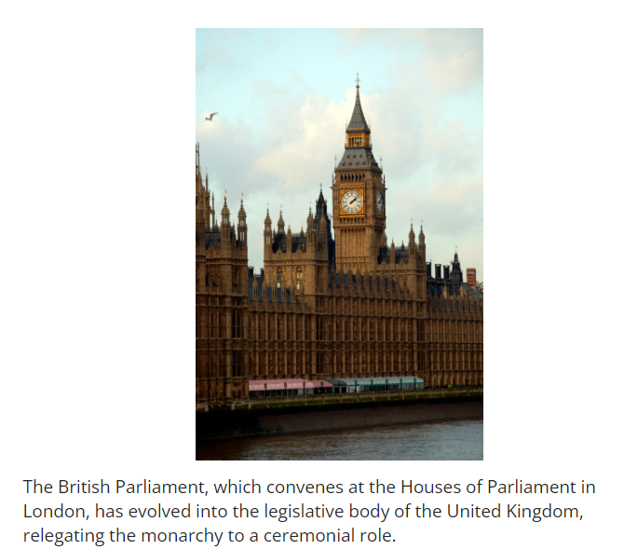

Check-In Questions:
1. How did William the Conqueror add to England's constitutional and legal history?
Answer: by instituting codified laws and a census

2. Name and describe two legal documents that contributed to what we now call the "Constitution of the Crown."
Answer: Sample answer: Student answers may include any two of the following: Doomsday Book: a census and accounting document; Statutes of William the Conqueror: penalties for crimes; Magna Carta: put limits on king's power and established a parliament; Provisions of Oxford: rules for how Parliament would operate; Petition of Right: more rights for citizens.

Practice Questions:
1. Create a timeline of important moments in England's constitutional and legal history.
Answer:
1. Anglo-Saxons set cultural norms for literacy
2. Battle of Hastings
3. William the Conqueror expands constitutional and legal documents
4. King John becomes king and continues wars
5. Nobles force King John to sign the Magna Carta
6. Parliament is created
7. Provisions of Oxford
8. Petition of Right

2. Think about how power structures such as feudalism gradually gave way to legal documents and precedents that now define England's constitutional history. Why do you think this happened?
Answer: Sample answer: Feudal lords who were successful in protecting people from Viking and Dane attacks became the most powerful. One example of this is the lords of Wessex, who eventually became the first kings. As security was established, the protection needs that feudalism met were no longer needed. Additionally, as kings continued to abuse their power, nobles and lords demanded more rights. These rights eventually led to documents such as the Magna Carta that would lead to the decline of monarchal power in England.

- Maps as Windows into the Past

Objective 3: In this section, you will identify key geographic features and borders of the kingdoms and feudal societies of England, France, Rome, the Netherlands, Russia, and Spain by using maps.

Essential Question: How can maps transport us to the European medieval world?

Key Terms:
1. Feudalism: System of political and social organization based on land ownership
2. Nation-states: Sovereign states whose citizens share a common national identity
3. Duchies: Territories ruled by a duke or duchess
4. Confederation: A union of partially self-governing states under a central government
5. Fiefdoms: Lands held by a lord and worked by serfs in the feudal system

Big Ideas:
• Medieval Europe was more politically fragmented than modern Europe
• Geographic features often defined political borders
• England and France were among the first to develop as nation-states
• The Holy Roman Empire was a loose confederation of territories
• Russia's geography, including permafrost, influenced its development 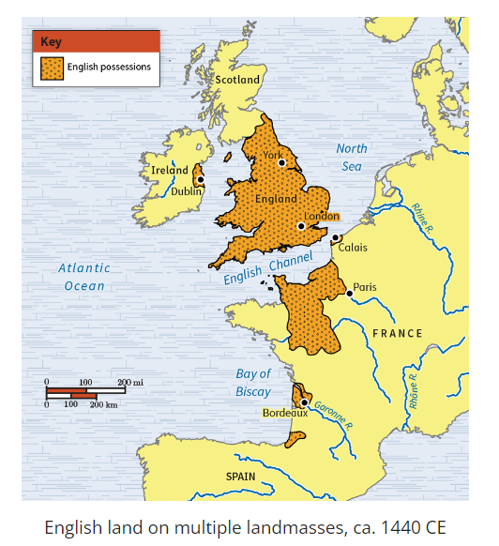 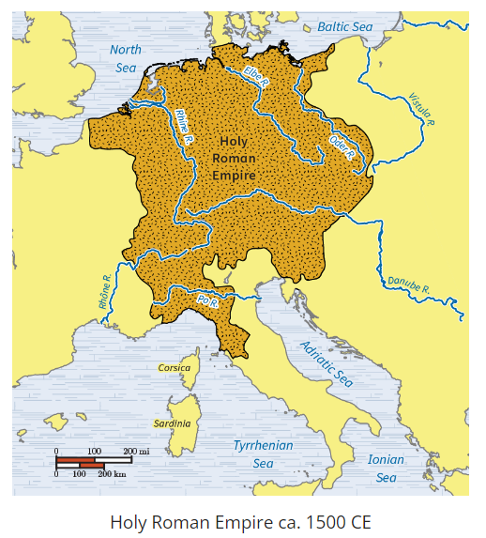 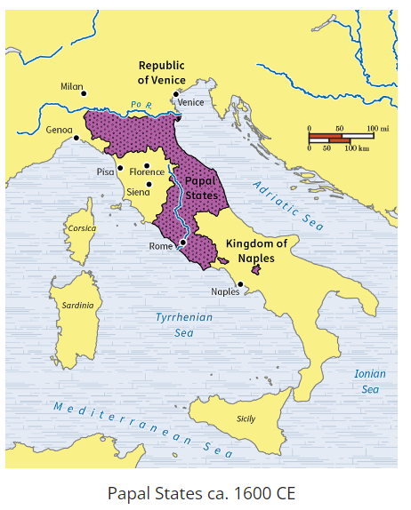 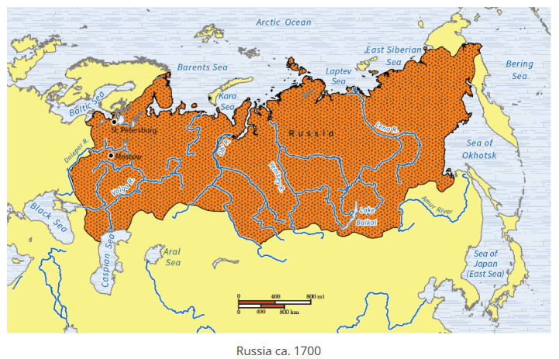

Check-In Questions:
1. Which geographic feature most significantly contributed to medieval England's borders?
Answer: oceans

2. The extensive layer of frozen dirt that was a key geographic feature of Russia was called what?
Answer: permafrost

Practice Questions:
- Select England, France, or Spain and sketch a map. Below your sketch, give a brief summary of key geographic features.
Answer:
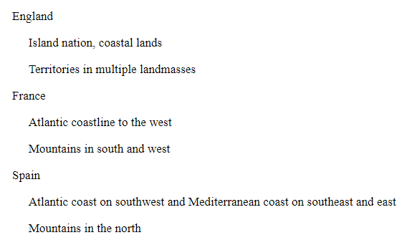

- Select Papal States, Russia, Netherlands, or Holy Roman Empire and sketch a map. Below your sketch, give a brief summary of key geographic features.
Answer:
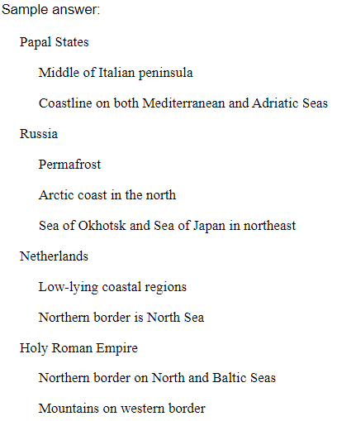

- "Europe" Begins

Objective 4: In this section, you will explain the importance of Charlemagne, the feudal monarchies, and the nation-states that emerged from them.

Essential Question: How was Charlemagne's rule impacted by feudalism?

Key Terms:
1. Decentralized: Power distributed among many local authorities
2. Centralized: Concentrated power in a single authority
3. Nation-state: A sovereign state whose citizens share a common national identity
4. Tithe: A portion of produce or income paid to support the church or landowner
5. Feudalism: System of political and social organization based on land ownership

Big Ideas:
• Charlemagne unified much of Europe and formalized the feudal system
• Feudalism developed as a way to provide order and protection after Rome's fall
• Charlemagne instituted reforms in education, arts, and administration
• After Charlemagne's death, feudal monarchies became the dominant power structure
• Nation-states eventually emerged from powerful feudal monarchies

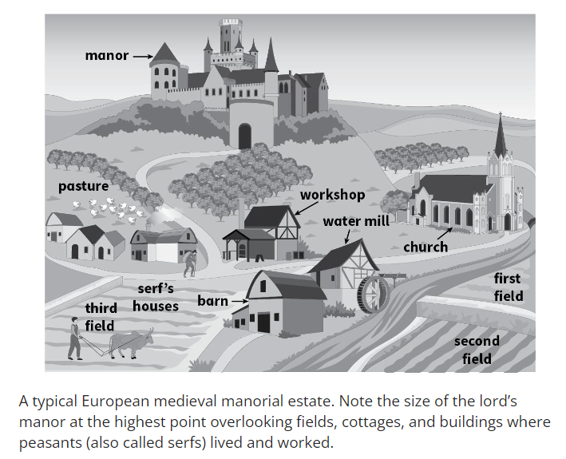

Check-In Questions:
1. Define feudalism.
Answer: a political and social system of decentralized power during the Middle Ages

2. Name two important reforms of Charlemagne.
Answer: reconquered former Roman territories and unified his empire by adopting a universal currency

Practice Questions:
1. In your journal, use the shape of a triangle to draw a sketch that explains the power structure of feudal monarchies.
Answer:
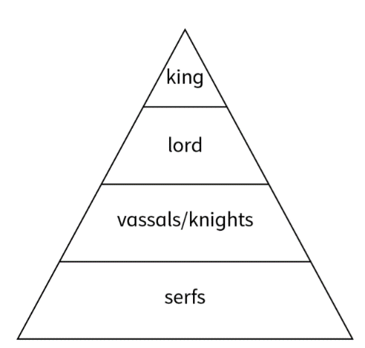

2. What are three adjectives that describe how you might feel on a daily basis as a peasant living on a feudal monarch's manor?
Answer: Sample answer: sore, powerless, tired

- Unit 7 Lesson 4: The Church and the Crusades
- The Catholic Church Power during the Crusades

Objective 1: Examine the role of the Catholic Church in Medieval Europe, including its role in the Crusades.

Essential Question: How did the Catholic Church attempt to unify Europe during events of the Middle Ages?

Key Terms:
1. Papal supremacy: The claim that the pope's authority is higher than any secular leader
2. Canon law: The set of laws established by the Catholic Church
3. Simony: The practice of selling church office positions
4. Friars: Monks who traveled to preach rather than staying in monasteries
5. Crusades: A series of religious wars launched by the Catholic Church to reclaim Jerusalem

Big Ideas:
• The Catholic Church gained significant power in Medieval Europe, claiming authority higher than secular leaders
• The Church established its own laws (canon law) and court system
• Reform movements like the Cluniac Reforms aimed to address corruption in the Church
• The Crusades were a series of holy wars launched by the Church to reclaim Jerusalem
• The Crusades had wide-ranging impacts on European society, trade, and culture
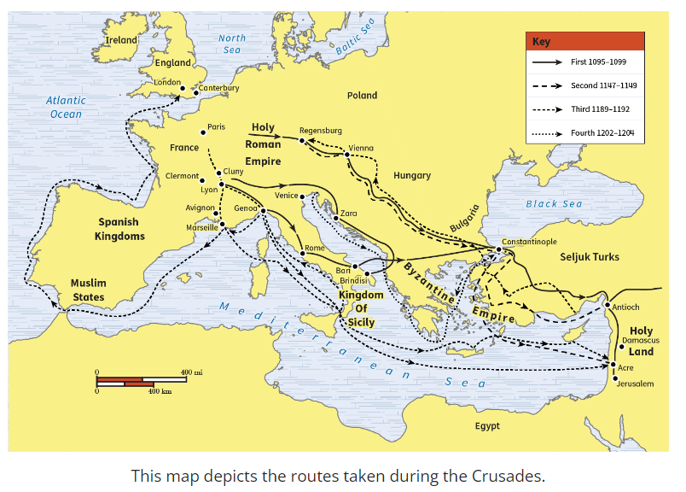

Check-In Questions:
1. What organization did St. Francis of Assisi begin?
Answer: The Franciscan friars

2. What agreement was reached with the Concordat of Worms?
Answer: The Church would have authority to appoint bishops without secular interference; the government would be able to assign fiefs.

Practice Questions:
1. Research the modern-day Catholic Church. Look for examples of Cluniac reforms that are still in practice today.
Answer: Sample answer: Priests are still asked to take vows of poverty and chastity; they are not allowed to marry; simony is still prohibited; the Church still chooses its officials.

2. Construct a chart or Venn diagram to compare and contrast Pope Gregory VII and Pope Innocent III.
Answer: Sample answer:
Gregory VII:
- Banned lay investiture
- Excommunicated King Henry IV
Both:
- Had conflicts with secular rulers
- Excommunicated kings
Innocent III:
- Launched Crusade against Albigensians
- Claimed superiority over all rulers

- Medieval Monastic Life

Objective 2: Explain how monasteries and convents became centers of community life and political power.

Essential Question: In a world full of governments, how did church branches such as monasteries and convents gain political and economic influence?

Key Terms:
1. Monasteries: Religious communities where monks live and work
2. Convents: Religious communities where nuns live and work
3. Benedictine Rule: A set of guidelines written by Benedict to organize monastic life
4. Tithes: A portion of income given to the church, often one-tenth
5. Aristocracy: The upper class in society, often nobility

Big Ideas:
• Monasteries and convents provided education, healthcare, and spiritual guidance to local communities
• They became centers of learning and preserved important texts
• As they gained wealth and land from donations, they grew in political and economic power
• Monasteries and convents often provided educated people for government positions
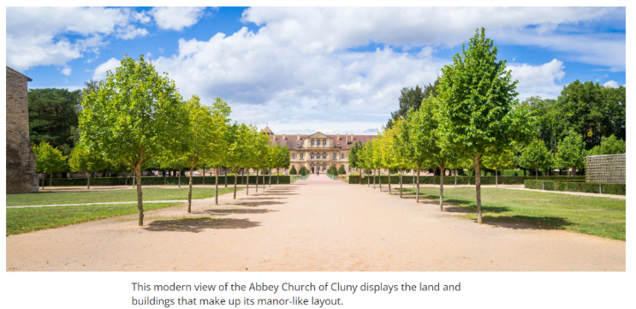
Check-In Questions:
1. What was Saint Francis of Assisi best known for?
Answer: Forming the Franciscan Order

2. Outline two ways in which monasteries and convents influenced medieval life.
Answer: They provided education for local communities, and they provided educated monks and nuns for local government jobs.

Practice Questions:
1. Go online and research the Franciscans and Dominicans. Make a Venn diagram comparing and contrasting these two influential groups.
Answer: Sample Venn diagram:
Dominicans: Founded by St. Dominic, Formed in 1216, Focused on education of faith
Both: 13th century reform organizations in the Catholic Church
Franciscans: Founded by St. Francis, Formed in 1209-1210, Focused on achieving humility

2. Research the monastery of Monte Cassino in Italy. Explain what occurred that destroyed it and why it is still important to this day.
Answer: It was destroyed multiple times during wars, including World War II. It remains important as one of the few territorial abbeys still related to the Catholic Church, preserving its history.

- Impact of the Crusades

Objective 3: Articulate the causes and effects of the Crusades on European and Islamic culture.

Essential Question: What impact did the Crusades have on European and Islamic cultures?

Key Terms:
1. Crusades: A series of religious wars launched by Western European Christians to reclaim holy lands from Muslims
2. Byzantine Empire: The eastern portion of the Roman Empire that continued after the fall of Rome
3. Umayyad Dynasty: The first great Muslim dynasty to rule the Islamic Empire
4. Abbasid Dynasty: The second major Muslim dynasty that succeeded the Umayyads
5. Great Schism of 1054: The formal split between the Roman Catholic and Eastern Orthodox Churches

Big Ideas:
• The Crusades were rooted in longstanding religious differences between Christians and Muslims
• They were a reaction to centuries of territorial changes in Southwest Asia
• The Crusades had long-lasting effects on both Europe and Southwest Asia
• They led to increased trade and cultural exchange between Europe and the Middle East
• The Crusades strengthened the power of the Roman Catholic Church in Europe
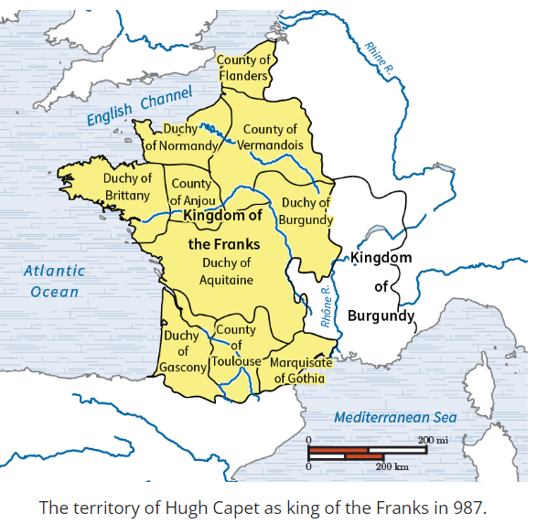

Check-In Questions:
1. What was the code of chivalry?
Answer: The code of chivalry was a set of rules that knights were required to follow to maintain their knighthood.

2. What role did Urban II have in the Crusades?
Answer: His speech at the Council of Clermont in 1095 began the events of the First Crusade.

Practice Questions:
1. Describe the most important result of the First Crusade to Western Christians.
Answer: The most important result of the First Crusade to Western Christians was the recapturing of the Holy Lands from Islam by Christians.

2. Create a table outlining four causes and effects of the Crusades on Europe.
Answer:
Sample table:
Cause: Muslim growth in the Byzantine Empire
Effect: Pope Urban II's speech at the Council of Clermont

Cause: Desire to expand Italian commercial power
Effect: Italy supported the Crusades with ships to move crusaders

Cause: Urban's Crusade in 1095
Effect: Christians recaptured lands in Palestine and Jerusalem

Cause: Muslims recapture much of what was lost in the First Crusade
Effect: Muslim influence spreads into modern-day Turkey

- Religious Conflicts with Wider Results

Objective 4: Identify the cultural and religious causes of the Crusades, as well as their consequences for Europe and Southwest Asia.

Essential Question: Why did the Crusades happen, and how did they affect Europe and Southwest Asia?

Key Terms:
1. Crusades: Religious wars launched by Western European Christians against Muslims in the Holy Land
2. Roman Catholic Church: The Christian church based in Rome, led by the Pope
3. Eastern Orthodox Church: The Christian church that split from the Roman Catholic Church in 1054
4. Indulgence: A remission of punishment for sins, granted by the Catholic Church
5. Sequencing: Putting historical events in chronological order

Big Ideas:
• The Crusades were driven by religious ideals but had political and economic motivations
• They connected the Mediterranean world in new ways through conflict and trade
• The Crusades strengthened the Roman Catholic Church across Europe
• They led to population changes in Europe and damage to communities in Southwest Asia
• The Crusades created new opportunities for trade and diplomacy
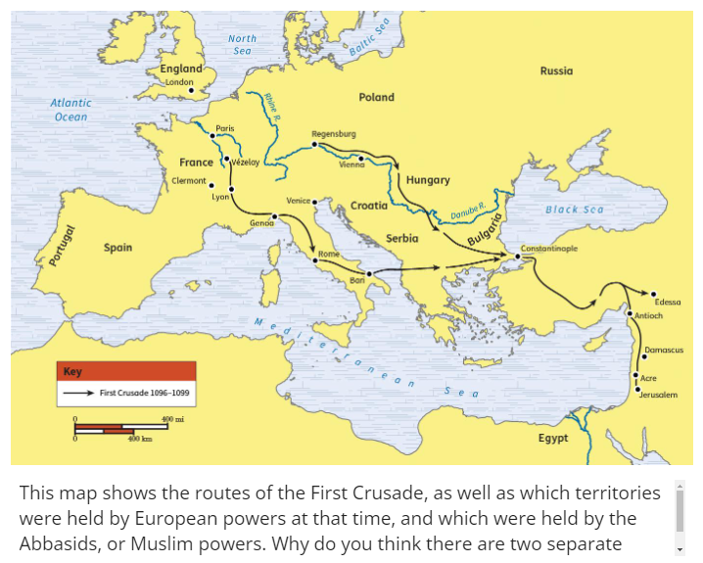

Check-In Questions:
1. What was one cause of the First Crusade?
Answer: Pope Urban II wanted to take Jerusalem back from Muslims. He wanted to bring the Eastern Orthodox Church and Roman Catholic Church back together.

2. Why was Jerusalem so important to European Christians?
Answer: They considered it a holy city.

Practice Questions:
1. How did the Crusades interconnect the Mediterranean region again?
Answer: The Crusades led to greater trade across the Mediterranean region. There were new opportunities for traders because of the constant movement between Europe and Southwest Asia. Some Christians also moved to Southwest Asia when the crusader states were created.

2. Use the table of Crusades provided in the lesson to outline the causes and effects of at least three Crusades.

Sample answer:
First Crusade (1096-1099):
Cause: Pope Urban II's call to retake Jerusalem
Effect: Christians captured Jerusalem and created crusader states

Second Crusade (1147-1149):
Cause: Muslims took the crusader state County of Edessa in 1144
Effect: Christians failed to advance past Damascus, Muslims won

Third Crusade (1189-1192):
Cause: Muslims retook Jerusalem
Effect: Christians failed to retake Jerusalem, but Saladin allowed Christian pilgrimages

- Unit 7 Lesson 5: Medieval Life and Times
- From Warlords to Holy Roman Empires

Objective 1: Examine primary sources from the medieval period to observe and summarize how northern European peoples promoted unity in Europe.

Essential Question: How did the culture of the Germanic tribes influence the development of Europe during the medieval period?

Key Terms:
1. Greco-Roman: Relating to the cultures of ancient Greece and Rome
2. Germanic tribes: Groups that inhabited northern Europe after the fall of Rome
3. Salic Law: A legal code established by Clovis that influenced inheritance laws
4. Feudalism: A social system based on holding land in exchange for service
5. Inculturation: The adaptation of Christian teachings to a non-Christian culture

Big Ideas:
• After Rome's fall, Germanic tribes competed for power in northern Europe
• Clovis unified much of France and Germany, converting to Christianity and establishing Salic Law
• The Carolingian dynasty, especially Charlemagne, spread Christianity and Roman ideals
• Otto I was crowned Holy Roman Emperor, strengthening ties with the Catholic Church
• The Heliand, a Saxon retelling of Jesus' story, helped spread Christianity among Germanic peoples
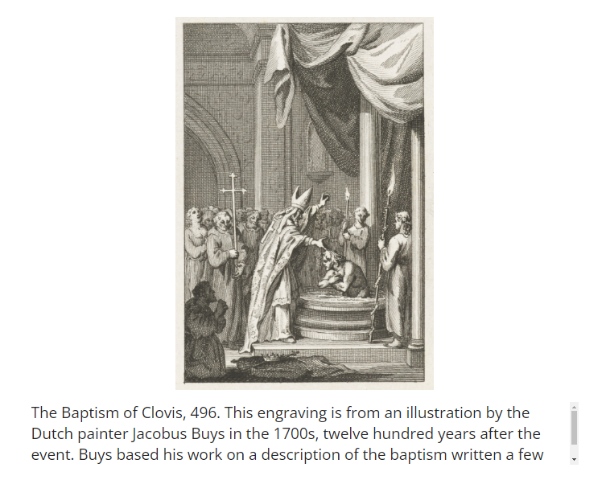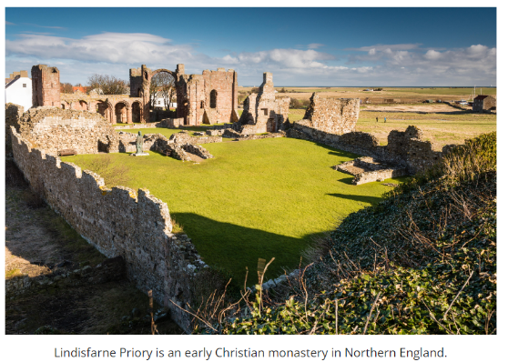

Check-In Questions:
1. How were warlords chosen in the early medieval period?
Answer: Warlords were elected by a group of warriors.

2. Under what ruler was Salic Law first codified?
Answer: The Salic Law was first codified under Clovis, King of the Franks, of the Merovingian dynasty.

Practice Questions:
1. How did Germanic laws of inheritance, as described in the Salic Law, affect European culture?
Answer: Women were prevented from inheriting land in much of Europe. In some cases, women were also kept from inheriting titles.

2. How does the Heliand demonstrate the practice of inculturation?
Answer: The poem teaches the story of Jesus by putting it in the context of the local Saxon warrior culture.

- Key Figures

Objective 2: Identify the achievements of key figures from the medieval period using primary sources.

Essential Question: What did key figures in medieval culture seek to achieve?

Key Terms:
1. Simony: The buying and selling of church offices
2. Clerical celibacy: The practice of priests remaining unmarried
3. Papal supremacy: The belief that the pope's authority is above all others
4. Investiture: The ceremony of appointing bishops
5. Renaissance: The period of cultural rebirth following the Middle Ages

Big Ideas:
• Charlemagne expanded his empire and promoted education and learning
• Pope Gregory VII pushed for church reforms and claimed papal supremacy
• The conflict between Pope Gregory VII and Emperor Henry IV highlighted tensions between church and state
• Giotto di Bondone introduced more realistic techniques in painting, foreshadowing Renaissance art
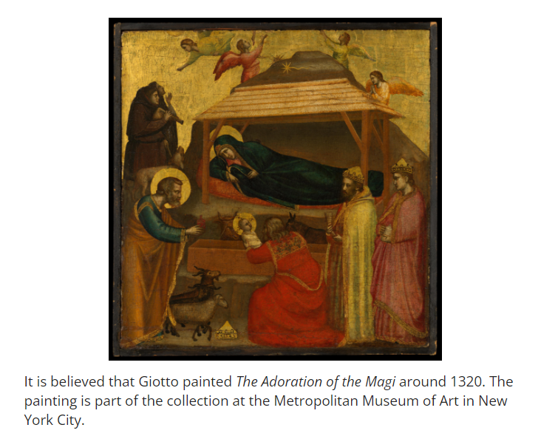
Check-In Questions:
1. What made Henry IV refuse to go along with Pope Gregory VII's reforms?
Answer: The reforms were upsetting to powerful Church leaders in Henry IV's empire. He needed their support to protect his empire against rivals.

2. How is Giotto di Bondone's style of painting different from other paintings from the medieval period?
Answer: There is more attention to realism in Giotto's work. He creates a sense of depth and shows more emotion in the facial expressions of his subjects.

Practice Questions:
1. List four things about Charlemagne that tell us he valued education.
Answer: He learned to speak other languages; He attended liberal arts lectures; He studied rhetoric and logic; He tried to learn to write.

2. Summarize some of Pope Gregory VII's main arguments for papal supremacy.
Answer: The Church is concerned with morality, but rulers are not bound to being moral. A bad king might choose wicked bishops. The Church has the power to excommunicate kings; therefore, the Church should be more powerful than those kings.

- The Black Death

Objective 3: Describe the Black Death and its effects on European society.

Essential Question: What impact did the Black Death have on medieval Europe?

Key Terms:
1. Bubonic plague: A bacterial infection spread by fleas and rodents
2. Black Death: The devastating epidemic of bubonic plague in 14th century Europe
3. Anti-Semitism: Prejudice against Jewish people
4. Sepsis: A life-threatening condition caused by the body's response to infection
5. Little Ice Age: A period of cooling temperatures that may have contributed to the plague's spread

Big Ideas:
• The Black Death killed about one-third of Europe's population in the 14th century
• The disease was spread by fleas on rodents and lice on humans
• Cities were hit hardest due to overcrowding and poor sanitation
• The plague led to increased religious fervor and anti-Semitic violence
• Some communities practiced early forms of quarantine to slow the spread
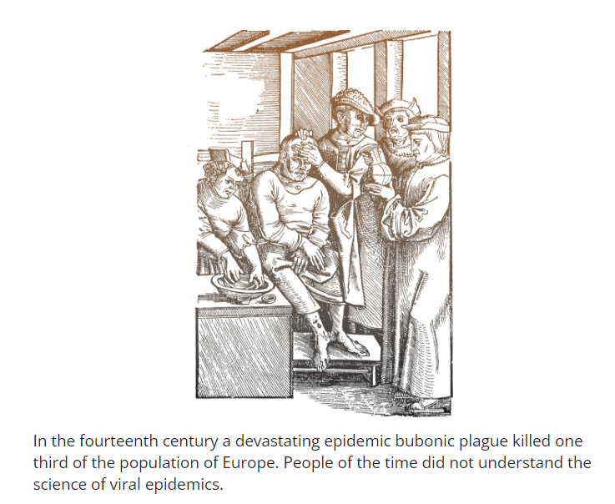
Check-In Questions:
1. What caused the spread of the bubonic plague?
Answer: Bacteria carried by fleas on rodents and lice on humans. These insects would get the bacteria from one infected animal or person and transfer it to another.

2. In what way did the plague result in a slowdown of trade?
Answer: Trade slowed as borders closed and visitors to towns were quarantined.

Practice Questions:
1. Describe how the Little Ice Age may have contributed to the Black Death.
Answer: Lowered temperatures, reduced harvests and increased rains led to a population that was ill-nourished and weak. These people may have been immunocompromised, which would make them more likely to become ill.

2. Why would an outbreak in disease make anti-Semitic violence more frequent?
Answer: Jewish people were already the target of religious prejudice and resented for their economic success. As Christian religious intensity rose in response to the plague, the persecution of Jewish people became more extreme.

- The Middle Ages Come to an End

Objective 4: Summarize some of the factors that led to the end of medieval Europe, including the Crusades, the Black Death, and the Hundred Years' War.

Essential Question: What caused the European Middle Ages to come to an end?

Key Terms:
1. Crusades: Religious wars launched by European Christians against Muslims in the Holy Land
2. Renaissance: The period of cultural rebirth following the Middle Ages
3. Hundred Years' War: A series of conflicts between England and France from 1337 to 1453
4. Inquisition: An institution established by the Catholic Church to combat heresy
5. Peasants' Revolt: An uprising in England in 1381 demanding social and economic reforms

Big Ideas:
• The transition from the Middle Ages to the Renaissance was gradual
• The Crusades brought new trade goods, knowledge, and cultural exchange to Europe
• The Black Death destabilized the feudal system by creating a labor shortage
• The Hundred Years' War contributed to the development of national identities in England and France
• These events collectively led to social, economic, and political changes that marked the end of the medieval period
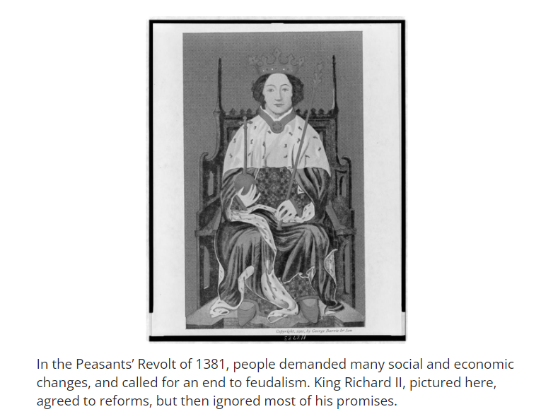

Check-In Questions:
1. What did the Crusaders bring back to Europe?
Answer: Crusaders brought home trade goods like spices, lemons, and pistachio nuts, as well as scholarly works from the Classical period.

2. What started the Hundred Years' War?
Answer: Edward III of England claimed the French throne.

Practice Questions:
1. Describe how the Crusades contributed to the transition from the Middle Ages to the Renaissance in Europe.
Answer: The Crusaders brought back new trade goods and stories of travel, which made more people want to travel. They also brought back texts from the Classical period, which had been lost in Europe. These encouraged new scholarship.

2. Describe the impact the Black Death and the Hundred Years' War had on the feudal system in England.
Answer: The Black Death created a labor shortage and the Hundred Years' War led to greater taxes. The result was that people demanded lower taxes and an end to feudalism, which eventually happened over time.

