- Unit 7 Lesson 1: Medieval-Renaissance Europe (Continued)
- Unit 7 Lesson 6: Renaissance
- The Impact of the Renaissance

Objective 1: In this section, you will use timelines to summarize how the causes and effects of the Renaissance led to the growth of Europe.

Essential Question: Why was the Renaissance so influential on Europe?

Key Terms:
1. Renaissance: French word for "rebirth," an era in European history from 1340 to 1620.
2. Middle Ages: The period between around 500 CE to around 1400 CE.
3. Humanism: A philosophy that focuses on the study of human beings and their society, politics, religion, and culture.
4. Patron: A person who finances the works of Renaissance artists.
5. Heliocentric model: A model of the universe with the sun at its center.

Big Ideas:
• The Renaissance bridged medieval and early modern Europe, marked by growth in states and culture.
• It was caused by factors like the translation of Greek and Roman texts, the creation of the printing press, and patronage of artists.
• The Renaissance led to advancements in art, science, and exploration.
• Humanist ideas influenced Renaissance thinkers and artists.
• New inventions and discoveries, like the printing press and heliocentric model, challenged traditional thought.
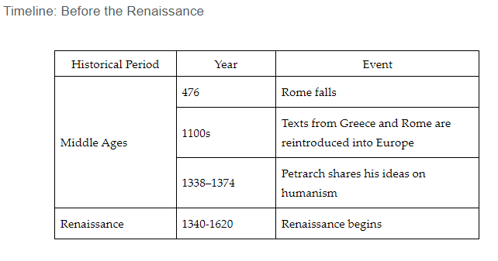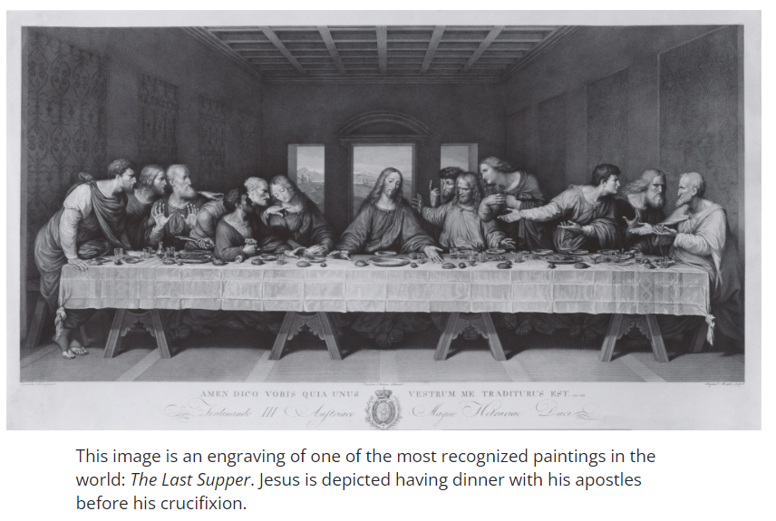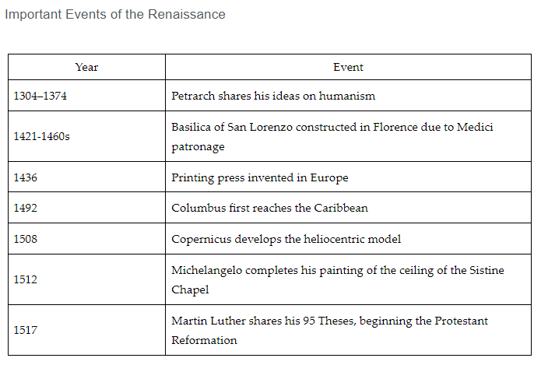

Check-In Questions:
1. What does Renaissance translate to from French? How is this term used in historical context?
Answer: It translates to "rebirth." It refers to the "rebirth" of the study of science and the creation and of an appreciation for art after the Middle Ages.

2. When did the Renaissance begin?
Answer: around 1400 CE

Practice Questions:
1. Summarize how inventions during the Renaissance led to the growth of Europe.
Answer: Sample answer: Inventions such as firearms, the magnetic compass, and the printing press put Europe on equal footing with other civilizations. During the Middle Ages, scientific growth was slow. These inventions were used in Asia for many centuries before Europeans began to use them during the Renaissance. They made it easier to compete with these other civilizations.

2. Summarize how Petrarch influenced the Renaissance using the timeline from this section.
Answer: Sample answer: Petrarch introduced the concept of humanism. He emphasized the study of the humanities and using ideas and influences from Greek and Roman thinkers.

- Humanism Launches a Revolution in Education during the Renaissance

Objective 2: In this section, you will analyze the concept of humanism and how it shaped events and developments during the Renaissance.

Essential Question: How did the concept of humanism shape events and developments during the European Renaissance?

Key Terms:
1. Humanism: An intellectual movement that led to changes in how people viewed themselves and the world.
2. Classical: Referring to works from ancient Greece and Rome.
3. Secular: Subjects not related to religion.
4. Studia humanitatis: The humanities, including history, politics, literature, philosophy, and rhetoric.
5. Individualism: A social principle stressing personality, independence, and self-reliance.

Big Ideas:
• Humanism began in Italy in the fourteenth century and spread throughout Europe.
• Humanists studied classical works to gain a stronger understanding of their own times.
• The movement focused on secular subjects rather than religion.
• Humanists believed education improved society and encouraged rulers to study humanities.
• Humanism emphasized individualism and celebrated the beauty of the human body.
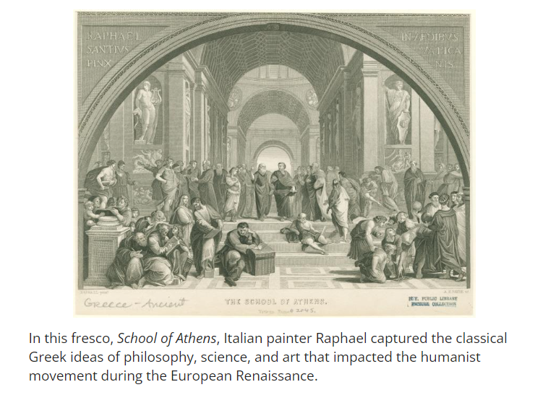

Check-In Questions:
1. Which Italian scholar and poet is known as the "Father of Humanism"?
Answer: Francesco Petrarch

2. Which novel written by Sir Thomas More described an ideal society whose citizens worked together for the common good?
Answer: Utopia

3. Explain how the relationship between Christianity and Humanism influenced political developments.
Answer: Sample answer: Humanism combined the study of Greek and Roman classics with that of early Christian writings. Instead of focusing on faith and the afterlife, humanism focused on the secular world, the study of the humanities, and individualism. Some of the Humanist's writings sparked the beginnings of future reformations.

Practice Questions:
1. Search online for websites that provide detailed descriptions of Raphael's School of Athens. Evaluate how this work of art supported the values important to humanism.

2. Search online to learn more about Christine de Pizan and other women who were humanist writers during the Renaissance. Evaluate this information to determine how their experiences and writings differed from those of male humanists from their era.

- Artists Define and Immortalize the Renaissance

Objective 3: In this section, you will use a world history lens to identify key artists and their achievements in the Renaissance.

Essential Question: Who were some of the key artists from the Renaissance and how did they promote this movement through their works?

Key Terms:
1. High Renaissance: Time period from approximately 1490 to 1530 that resulted in the production of the most exceptional works of art, sculpture, and architecture.
2. Sfumato: An artistic technique that takes its name from the Italian word for "smoke," used to create a blurred background effect.
3. Renaissance man: A person with expertise in multiple areas, including art, science, and engineering.
4. Fresco: A technique of mural painting executed upon freshly laid lime plaster.
5. Paragone: A Renaissance debate about whether painting or sculpture was the supreme art form.

Big Ideas:
• Leonardo da Vinci and Michelangelo were key figures of the High Renaissance.
• These artists were true "Renaissance men" with interests beyond just art.
• Leonardo's works included paintings like The Last Supper and Mona Lisa, as well as scientific sketches and inventions.
• Michelangelo created sculptures like David and painted the Sistine Chapel ceiling.
• The Renaissance saw advancements in artistic techniques and the elevation of artists' status in society.
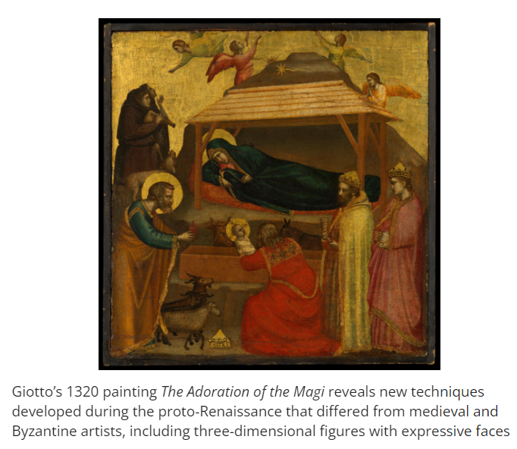
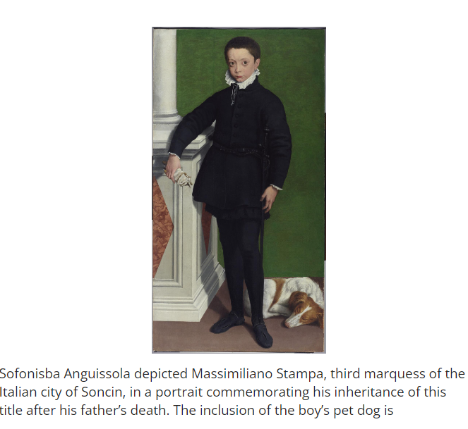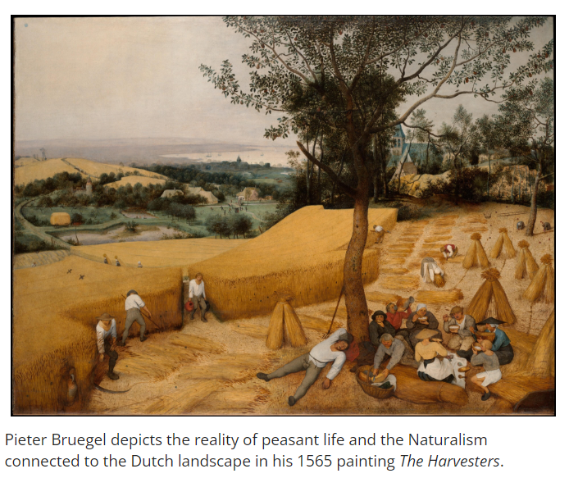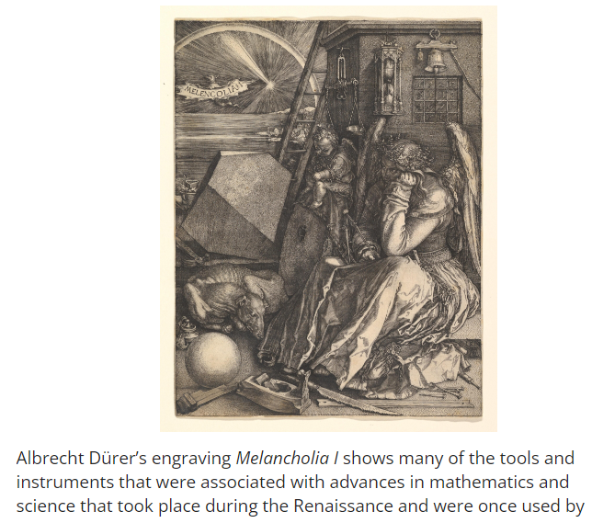

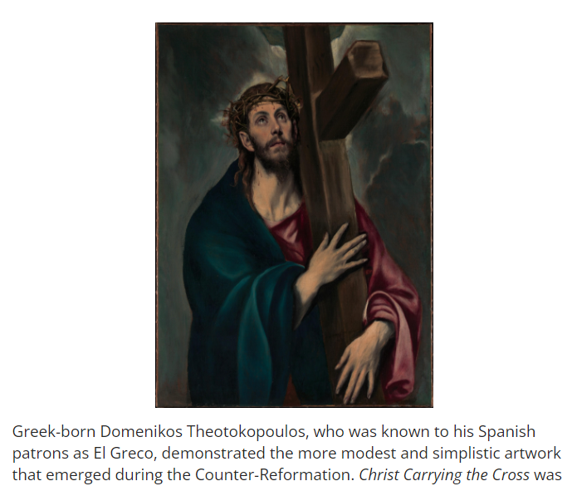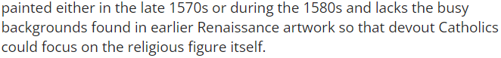

Check-In Questions:
1. Which artist from the proto-Renaissance period is known as the "Father of European painting"?
Answer: Giotto

2. Who was the leading woman artist of the Renaissance era?
Answer: Sofonisba Anguissola

3. How do the arts reflect the culture of the time that they were created?
Answer: Sample answer: Artist Jan van Eyck detailed portrayals of ordinary townspeople as well as religious figures in a movement known as Realism. The writer William Shakespeare included the themes of power, politics, and corruption in his dramas.

4. How can the arts transcend the cultures in which they were created to convey universal themes?
Answer: Sample answer: The musical influence of Vincenzo Galilei contributed to Baroque era music and the use of music to influence the emotions of the listener.

Practice Questions:
1. Place the appropriate description from the answer bank next to the Renaissance art movement that was most closely associated with it.
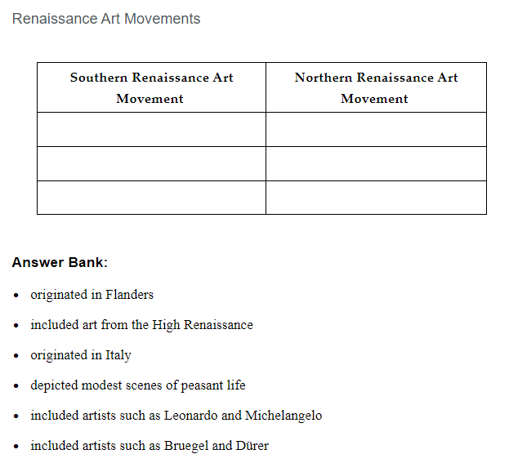
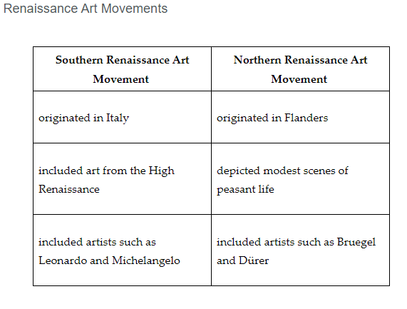
- How does Sofonisba Anguissola's painting The Game of Chess differ from other works of art from the Renaissance era?
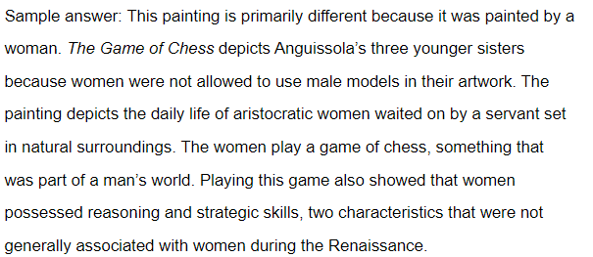

- The Renaissance: A Rediscovery of Classical Ideas and Learning

Objective 4: In this section, you will describe the intellectual developments and advances in technology that took place during the Renaissance in Italy and Northern Europe.

Essential Question: What impacts did intellectual developments and advancements in technology have on Italy and Northern European societies?

Key Terms:
1. Astrolabe: An instrument used to measure latitude at sea, first developed by ancient Greeks and improved by Arabs.
2. Caravel: A vessel with both square and triangular sails, developed by Portuguese sailors.
3. Geocentric theory: The belief that Earth was the center of the universe.
4. Heliocentric theory: The theory that the sun is at the center of the universe, with Earth and other planets revolving around it.
5. Scientific method: A multistep process of discovery used to confirm findings and prove or disprove a hypothesis.

Big Ideas:
• The Renaissance saw advancements in navigation technology, leading to European exploration.
• The printing press, invented by Johannes Gutenberg in 1456, revolutionized the spread of knowledge.
• New scientific theories, like Copernicus' heliocentric model, challenged traditional views.
• The scientific method evolved, leading to a revolution in thinking and intellectual experimentation.
• These developments had significant impacts on European society, religion, and global exploration.
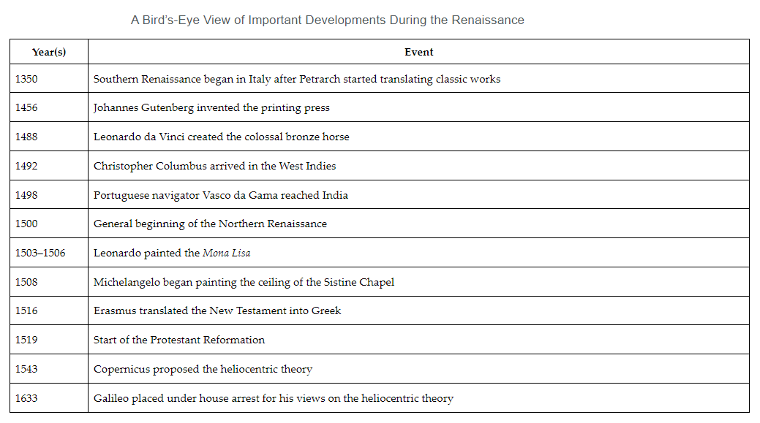
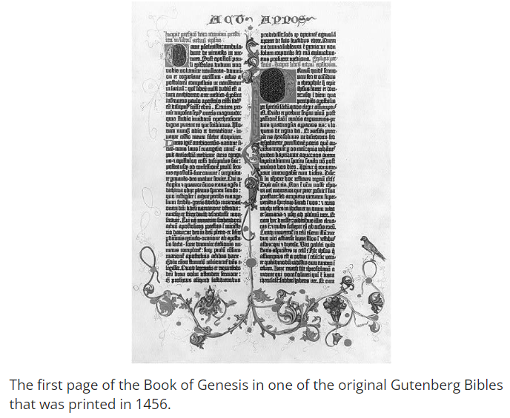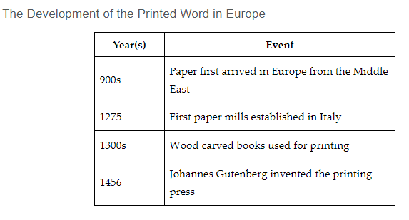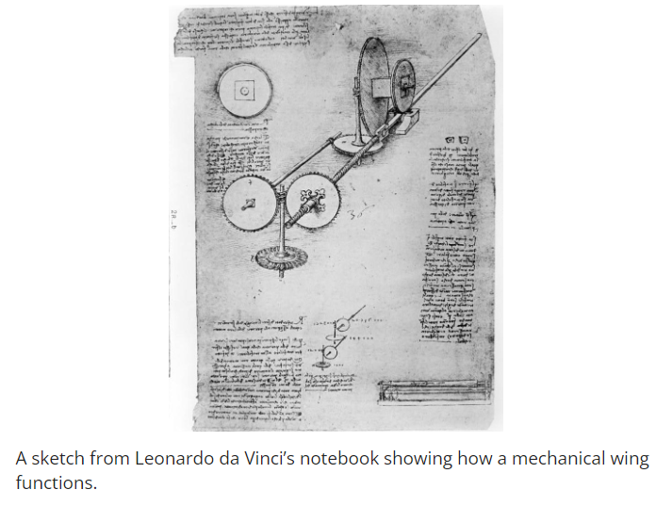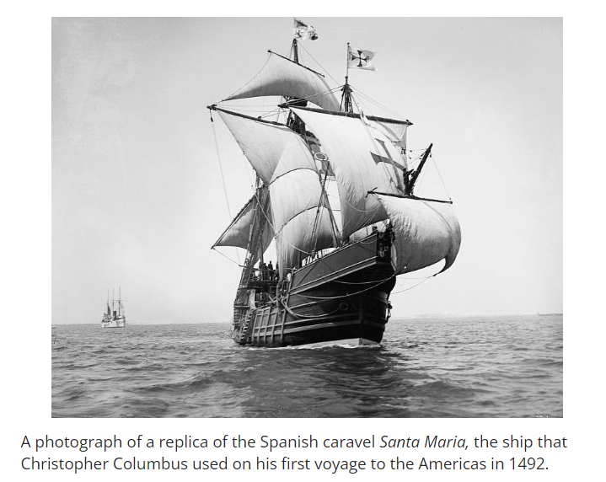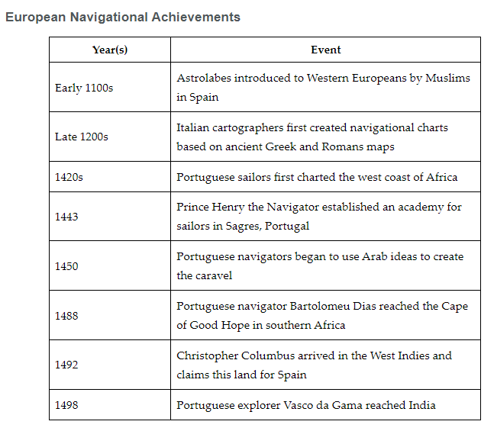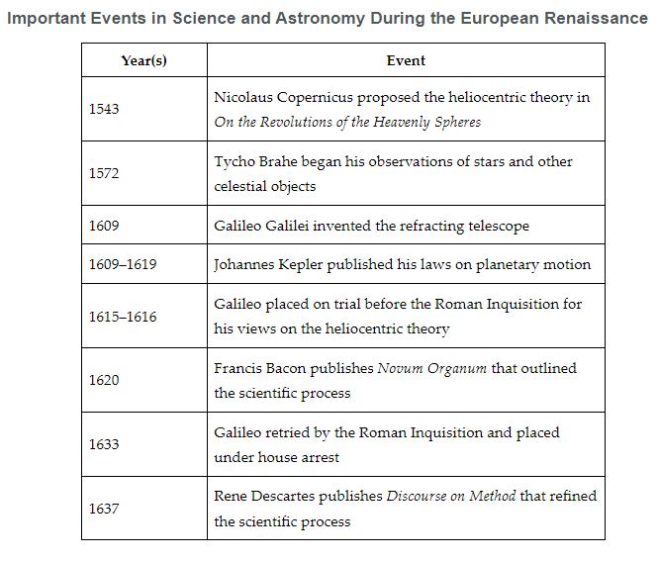

Check-In Questions:
1. How did the printing press impact Italian and Northern European societies?
Answer: Sample answer: The printing press increased the number of books that were available for reading. The higher number of books and the quick process that it took to print them made books more affordable. This helped advance knowledge and new ideas to a greater number of Europeans. Printing also influenced religious ideas and led to the religious turmoil resulting from the Protestant Reformation.

2. Which Renaissance scientist first theorized that the sun, rather than Earth, was at the center of the universe?
Answer: Nicolaus Copernicus

Practice Questions:
1. Leonardo da Vinci and Michelangelo were two of the key figures in Renaissance debate known as paragone. The central argument in this debate was whether painting or sculpture was the supreme form of art. Conduct an online search of paintings and sculptures done by Leonardo and Michelangelo. Describe whether the painting or sculpture is a supreme form of art and explain why you would classify the painting or sculpture as a supreme style of Renaissance art.
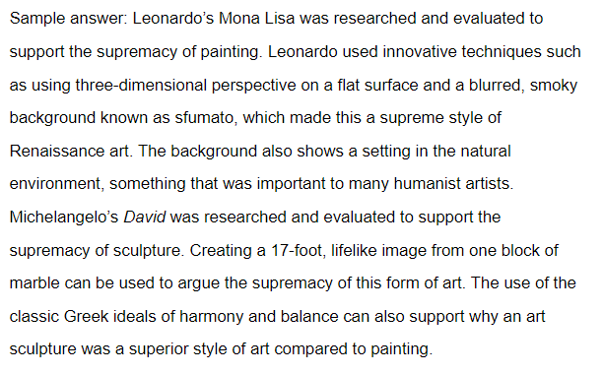
2. Imagine you were living during the Renaissance era. What type of intellectual or technological advancement would you create or invent? Design and develop a blueprint sketch of your idea. Describe whether your creation is an intellectual development or a technological advancement. In the description, include a rationale for the invention and how it would help improve society.
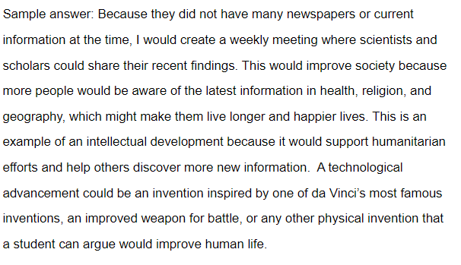

- Unit 7 Lesson 7: Reformation
- Rethinking Religion

Objective 1: Describe both the origins of the Protestant Reformation and the main people involved in it.

Essential Question: Why do major shifts in religious belief happen?

Key Terms:
1. Sacraments: Religious rites in the Catholic Church
2. Pope: Leader of the Catholic Church
3. Secular: Non-religious
4. Mass: Catholic religious service
5. Tithe: Contribution to the church from income

Big Ideas:
• The Catholic Church had significant authority in Europe in the early 16th century
• Concerns about Church practices and corruption led to calls for reform
• Martin Luther's 95 Theses in 1517 sparked the Protestant Reformation
• The printing press helped spread new religious ideas quickly
• Other reformers like John Calvin emerged with different Protestant beliefs

Check-In Questions:
1. What role did the Roman Catholic Church play in most Europeans' lives by the sixteenth century?
Answer: Most Europeans practiced Catholicism and organized their lives around the sacraments and other religious practices the Church offered.

2. What was Martin Luther's goal in circulating his Ninety-Five Theses?
Answer: He wanted to draw attention to what he saw as problems with the Catholic Church, in hopes of leading to eventual reform.

Practice Questions:
1. Most challenges facing the Roman Catholic Church in the fourteenth and fifteenth centuries primarily affected Church and political leaders at that time. Given what you have learned, what were some of the long-term impacts Europeans encountered because of these challenges?

Answer: Sample answer: The relocation of the pope and the later Western Schism suggested that the pope and the Church were not perfect. One long-term impact of these events was that scholars began to question the Church's ideas on a deeper level, as well as suggesting areas for potential reform.

2. In Germany and across Europe, Luther's ideas led to greater change. Hypothesize why this happened.

Answer: Sample answer: As more people began to question the Church's authority and ideas, people started having other new ideas as well. Luther's views became one among many, including Erasmus's views and other leaders. Additionally, outside of the Church, people even used Luther's ideas to help them fight for political change, such as during the Peasants' War of 1525.

- A World of Printed Words

Objective 2: Examine how the printing press and printed books influenced Europe and the new availability of the Bible.

Essential Question: Why did the printing press have such a lasting influence on Europe?

Key Terms:
1. Middle Ages: Medieval period in European history
2. Print culture: Culture centered around printed materials
3. Literacy: Ability to read and write
4. Illuminated manuscript: Hand-decorated book from medieval times
5. Censor: Suppress or prohibit publishing of certain materials

Big Ideas:
• Books were rare and expensive before the printing press
• Gutenberg's movable type printing press revolutionized book production
• Printed materials became cheaper and more widely available
• The Bible could be more easily translated and distributed
• Print culture helped spread new ideas during the Reformation and Renaissance
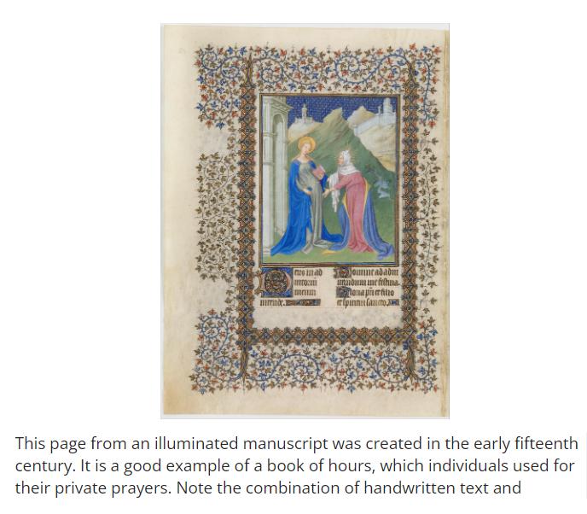

Check-In Questions:
1. What made books more expensive before Gutenberg's printing press?
Answer: Books had to be made by hand, which meant they took a lot of time to make and they were expensive as a result.

2. How did the Bible become more accessible after Gutenberg's printing press?
Answer: Sample answer: It was easier to print copies of the Bible, but more importantly, it was easier to print translations of the Bible as more and more scholars accessed and translated it into common languages.

Practice Questions:
1. Hypothesize why literacy rates did not rise quickly after the movable type printing press was developed.

Answer: Sample answer: Although it was easier to access documents in writing, and even though these documents and books were cheaper, this did not mean that people had learned to read. Books still cost money, and people in the lowest classes likely did not have the funds to purchase books, which also might have made it less likely that they would need or want to learn how to read.

2. One scholar has argued that a high demand for books shows that a culture values reading and learning. To what extent do you think this was true in Europe in the sixteenth century?

Answer: Sample answer: This seems mostly true because if there was a good demand for books, that suggests that people wanted to read them and learn from them. However, literacy rates were still not very high. But lower literacy rates don't necessarily mean people do not want to learn; it just means they haven't learned yet. People could still find others who were able to read to them and then learn information that way.

- Challenging the Catholic Church

Objective 3: Summarize the main ideas of the Protestant Reformation.

Essential Question: Why did Europeans challenge the Catholic Church to demand reform?

Key Terms:
1. Protestant Reformation: 16th century religious movement challenging Catholic Church authority
2. Indulgence: Document sold by the Church to reduce time in purgatory
3. 95 Theses: Martin Luther's criticisms of Church practices
4. Predestination: Calvinist belief that salvation is predetermined by God
5. Anglican Church: Church of England separate from Catholic Church

Big Ideas:
• The Catholic Church faced accusations of corruption and misuse of power
• Martin Luther challenged Church practices like the sale of indulgences
• The printing press helped spread Protestant ideas quickly
• John Calvin developed influential Protestant theology including predestination
• Other Protestant movements emerged like Anglicanism and Anabaptists
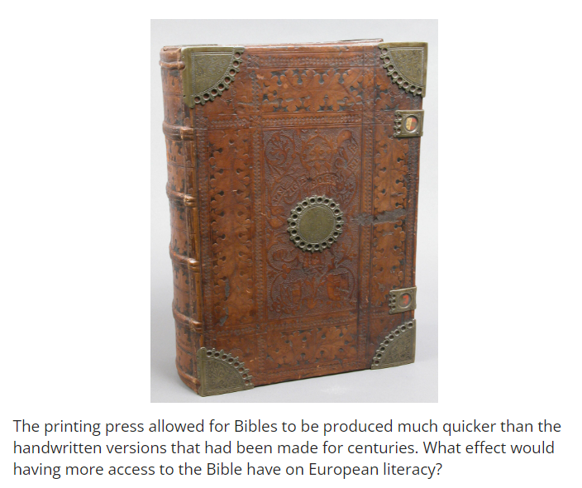
Check-In Questions:
1. Describe an example of the Catholic Church's corruption in the sixteenth century.
Answer: Sample answer: Officials within the Catholic Church were given jobs because of relatives or political ties rather than because they were the best qualified.

2. Describe the purpose of indulgences in the Catholic Church.
Answer: Sample answer: A method of raising money for the Church, indulgences allowed people to pay money in order to lessen future time spent in purgatory for themselves or their family members.

Practice Questions:
1. Create a table summarizing the ways in which Catholic, Lutheran, and Calvinist views of salvation differ.

Answer: Sample answer:
Catholics believed that salvation was achieved through good works
Lutherans believed that faith alone was enough to receive salvation
Calvinists believed that people are predestined for either heaven or hell

2. Why was the printing press important to the Protestant Reformation?

Answer: Sample answer: The printing press allowed for new ideas like Luther's 95 Theses to spread quickly rather than relying on handwritten copies. The rapid spread of information allowed Luther and his followers to tap into concerns about Church practices that were already swelling in various communities, which helped the Protestant movement gain momentum.

- The Catholic Church's Response to the Reformation

Objective 4: Interpret the Catholic Church's response to the Reformation at the Council of Trent.

Essential Question: How does the Catholic Church's reaction to the Reformation reflect the norms and values of the time period?

Key Terms:
1. Counter-Reformation: Catholic Church's response to the Protestant Reformation
2. Council of Trent: Meeting of Catholic leaders to address Protestant challenges
3. Doctrine: Set of beliefs held and taught by a church
4. Jesuits: Catholic religious order founded to defend the faith
5. Index of Forbidden Books: List of books banned by the Catholic Church

Big Ideas:
• The Catholic Church initially tried to suppress Protestant ideas
• The Council of Trent reaffirmed core Catholic teachings
• Reforms were made to address some Protestant criticisms
• New religious orders like the Jesuits were established
• The Church increased control over education, art and literature
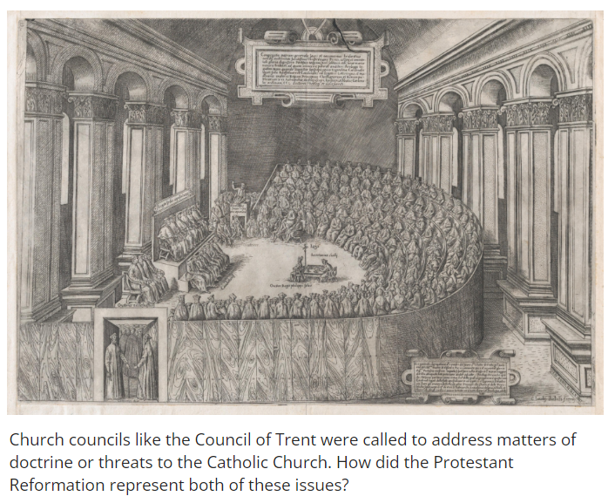

Check-In Questions:
1. Describe a criticism made by Protestants against the Catholic Church.
Answer: Sample answer: Protestants believed that faith alone was enough to get into heaven and that good works were unnecessary.

2. What is the purpose of an ecumenical council like the Council of Trent?
Answer: Sample answer: Ecumenical councils bring together Church leaders to address questions of doctrine or heresy, to ensure everyone is practicing Catholicism in the same way.

Practice Questions:
1. The Council of Trent produced a series of decrees in response to the Protestant Reformation. Read the Decree Concerning Indulgences (1563) and explain how it reaffirms core teachings of the Roman Catholic Church.

Answer: Sample answer: The Protestant Reformation wanted to reject the selling of indulgences, but the Council of Trent reaffirmed them as an important part of the Catholic Church and just sought to limit their abuses.

2. The Catholic Reformation saw the creation of new religious orders, such as the Jesuits. Read the excerpt from the papal bull Regimini militantis Ecclesiae (1540) which created the Jesuit order. Explain how it reflects the norms and values of the 16th century?

Answer: Sample answer: The sixteenth century saw the Church placing a lot of emphasis on the authority of the Pope and his power over the Christian world. The excerpt shows how the Church emphasizes this authority within the Church but also how people should follow the orders of the Pope without question.

- Unit 7 Lesson 8: Reformation Impact
- The Protestant Reformation: Religious Arguments and Tensions Between Many

Objective 1: Explain the causes and impact of the Reformation, highlighting the arguments of and tensions between religious and secular authorities, reformers and doctrines, and the English Reformation and the Counter-Reformation.

Essential Question: How did numerous arguments and tensions among political and religious officials in Europe lead to the Protestant Reformation and the global effects resulting from it?

Key Terms:
1. Protestant Reformation: A movement in the 16th century aimed at reforming the Catholic Church which resulted in the creation of Protestant churches.
2. Indulgence: A practice where the Church offered forgiveness for sins in exchange for money or good deeds.
3. Excommunicate: Official exclusion from participation in the sacraments and services of the Christian Church.
4. Papal bull: An official edict issued by the Pope.
5. Heresy: Belief or opinion contrary to orthodox religious doctrine.

Big Ideas:
- Causes of the Reformation: Corruption within the Catholic Church and political unrest led to the Reformation.
- Martin Luther's Role: Luther challenged the Church’s practices with his 95 Theses and used the printing press to spread his ideas.
- Rise of Non-Catholic Churches: Religious conflicts led to the rise of Protestant churches and further religious fragmentation in Europe.
- Response from the Catholic Church: The Counter-Reformation was the Church’s effort to reform itself and counter the spread of Protestantism.
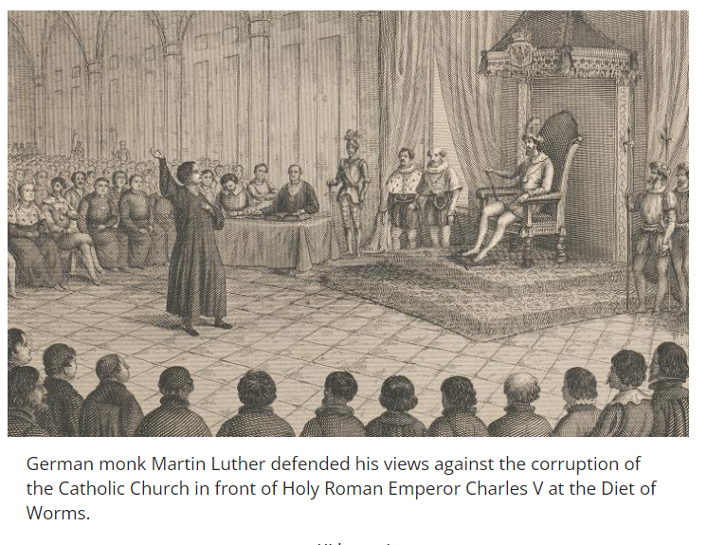
Check-In:
1. What was the name of the assembly where Martin Luther defended his religious views to Holy Roman Emperor Charles V?
- Answer: The Diet of Worms.

2. What was the movement in England that temporarily reinstated Catholicism as the official state religion?
- Answer: The Marian Reformation.

Practice:
1. 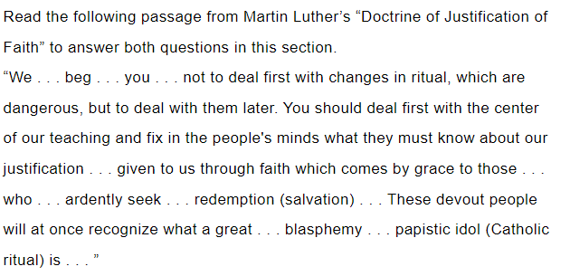Using effective reasoning, determine what Martin Luther argued was the most important issue that Catholic officials needed to do to reform the Church.
- Answer: Address the issue that salvation could only be achieved through faith alone.

2. According to Luther’s reasoning, what will the people be able to do once the Church addresses his concerns with Catholic doctrine?
- Answer: The faithful will abandon Catholic rituals once they realize that they can achieve salvation through faith.

- The Catholic Reformation: A Vigorous Response to the Growing Protestant Challenge

Objective 2: Summarize the political role of the Catholic Reformation, citing evidence of its role in continuity and change within early modern society.

Essential Question: How did the political impact of the Catholic Reformation promote continuity and change in early modern society?

Key Terms:
1. Counter-Reformation: The period of Catholic revival initiated in response to the Protestant Reformation.
2. Council of Trent: A council of the Roman Catholic Church convened to address reform and secure reconciliation with Protestants.
3. Indulgences: Remissions of the temporal punishment due for sins after absolution.
4. Inquisitions: Judicial institutions of the Church aimed at combating heresy.
5. Index of Forbidden Books: A list of books prohibited by the Catholic Church to prevent the spread of heretical ideas.

Big Ideas:
- Council of Trent: Addressed church abuses and reaffirmed core Catholic doctrines; banned the sale of indulgences.
- Educational Reforms: Establishment of seminaries for priest training.
- Inquisitions: The Roman and Spanish Inquisitions were established to combat Protestantism and preserve Catholic doctrine.
- Global Impact: The Counter-Reformation resulted in the renewal of missionary work and the establishment of new religious orders like the Jesuits.
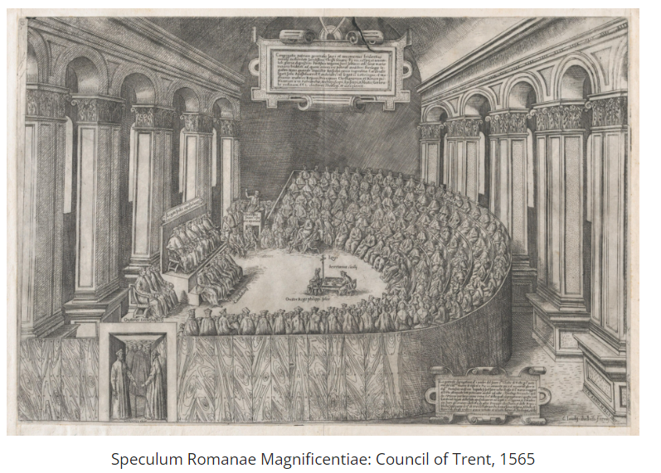
Check-In:
1. What was another name for the Catholic Reformation?
- Answer: The Counter-Reformation.

2. Who founded the Jesuit order of religious missionaries?
- Answer: Ignatius of Loyola.

Practice:
1. 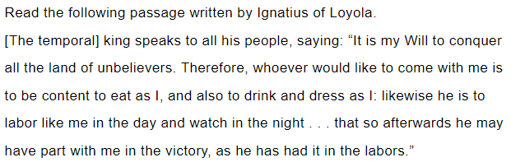How did Loyola’s Jesuits apply the ideas from "The Call of the King" during the Catholic Reformation?
- Answer: Jesuits were missionaries who spread Catholicism through parts of Europe and the newly discovered colonies in the Americas, Africa, and Asia.

2. Summarize recent book censorship proposals in the United States and the reasons behind them.
- Answer: Censorship of books is taking place in various parts of the country due to opinions about race, depiction of religion, or sexual content. Some believe students should not be exposed to certain ideas reflected in these books.

- Reformations Spark Religious and Political Strife in Europe

Objective 3: Analyze the impact of the Protestant Reformation on Europe by addressing religious conflicts within larger social, economic, artistic, and political developments.

Essential Question: How did religious conflicts between Protestants and Catholics and the religious ideas of Martin Luther and John Calvin impact social, economic, and political developments in Europe during the Protestant Reformation?

Key Terms:
1. Peace of Augsburg: An agreement allowing each German prince to decide the religion of his land.
2. Thirty Years’ War: A devastating war in Europe triggered by religious conflict.
3. Calvinism: A branch of Protestantism founded by John Calvin emphasizing predestination and a strict sense of morality.
4. Defenestration of Prague: An act that started the Thirty Years’ War when Protestant nobles threw two Catholic officials out a window.
5. Peace of Westphalia: The treaty that ended the Thirty Years’ War in 1648.

Big Ideas:
- Political Authority: Martin Luther’s and John Calvin’s ideas on secular and heavenly kingdoms influenced rulers to lead religious reforms.
- Religious Wars: The Protestant Reformation led to numerous conflicts, including the Thirty Years’ War, which devastated Central Europe.
- Economic Impact: The wars caused massive destruction but also led to economic changes and the rise of the Protestant work ethic.
- Art and Culture: The Reformation influenced changes in visual arts, literature, and music by spreading Protestant ideas and promoting literacy.
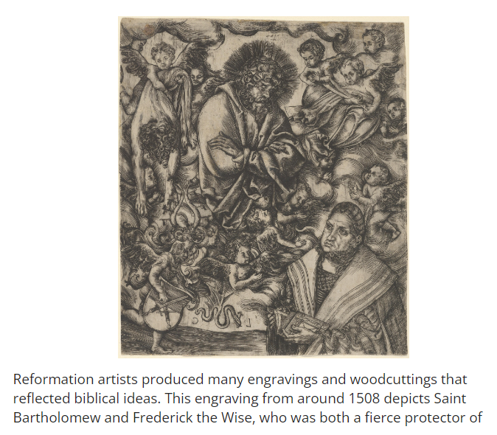
Check-In:
1. What incident led to the beginning of the Thirty Years’ War in 1618?
- Answer: The Defenestration of Prague.

2. The pamphlet Malleus Maleficarum dealt with which subject during the Protestant Reformation?
- Answer: Witchcraft.

Practice:
1. How did Martin Luther use the ideas of heavenly and secular kingdoms to convince German princes in the Holy Roman Empire to lead the reformation of the Catholic Church in their homelands?
- Answer: Luther stated that God ruled the entire world, which was divided into an earthly and a heavenly kingdom. Secular rulers had no authority in spiritual affairs, and the Church had no right to interfere in secular affairs. Luther charged the princes with leading the reformation within their territories.

2. How did Martin Luther’s and John Calvin’s teachings influence the framers of the U.S. Constitution in creating the Establishment Clause?
- Answer: Both Luther and Calvin believed in the separation of church and state, which supported the idea of clear separation that became the basis for the Establishment Clause.

- The English Reformation: A Religious and Political Power Struggle

Objective 4: Describe how Henry VIII and Elizabeth I used the English Reformation to break away from the Catholic Church and transform their nation into a Protestant state.

Essential Question: What actions did Henry VIII and Elizabeth I take to strengthen and preserve Protestantism during the English Reformation?

Key Terms:
1. Tudor Dynasty: The ruling family of England from 1485 to 1603.
2. English Reformation: The process of England breaking away from the authority of the Pope and the Roman Catholic Church.
3. Act of Supremacy: The act of Parliament that declared the king as the head of the Church of England.
4. Book of Common Prayer: The Anglican service book introduced during the English Reformation.
5. Elizabethan Settlement: The laws and policies by Elizabeth I to establish a middle way between Roman Catholicism and Protestantism in England.

Big Ideas:
- Henry VIII's Break with Rome: Motivated by political and personal reasons, Henry VIII broke away from the Catholic Church, establishing the Church of England.
- The Act of Supremacy: Formally named Henry as the head of the Church of England.
- Elizabeth I’s Reign: Elizabeth I adopted policies to balance Protestant and Catholic practices, ensuring stability and the continuation of Protestantism in England.
- Political Challenges: Elizabeth faced opposition from Catholic monarchs and nobles, as well as threats from the Spanish Armada.

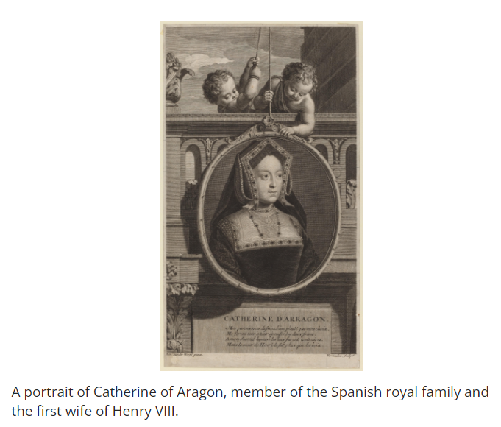

Check-In:
1. What was the purpose of the Act of Supremacy?
- Answer: It established the Church of England and named the English monarch as the head of this Church.

2. Which Tudor monarch temporarily restored Catholicism to England?
- Answer: Mary I.

Practice:
- Place the appropriate event next to the name of the English monarch who was most closely associated with it.
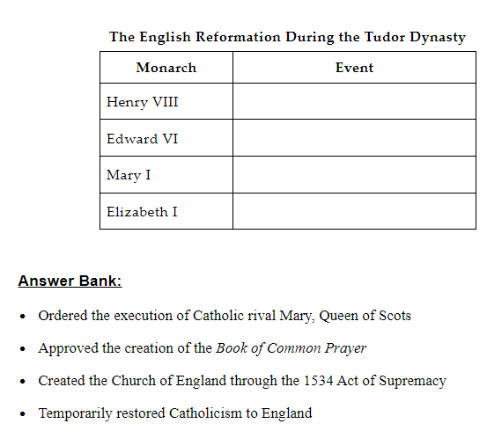

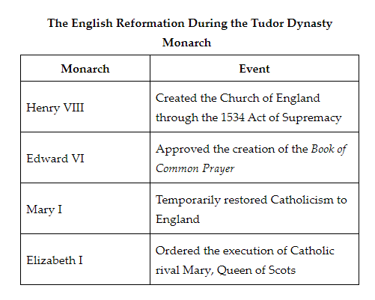
2. Describe how Elizabeth I attempted to work out a compromise between English Protestants and Catholics through the Elizabethan settlement.
- Answer: The Elizabethan settlement restored the Book of Common Prayer, revised to be acceptable to Catholics, and used English in Church services. It maintained Catholic rituals and the hierarchy of bishops in the Church of England.

- Unit 7 Lesson 9: Reformation Impact Discussion
Objective: Analyze the causes and consequences of the Reformation and Counter-Reformation, focusing on political, social changes, and their effects on women and religious minorities.

Essential Question: To what extent did the Reformation amount to a major turning point in history?

Key Terms:
1. Reformation: A 16th-century religious movement that led to the establishment of Protestant churches and significant changes in Christian practices.
2. Counter-Reformation: The Catholic Church's response to the Reformation, aimed at reforming internal practices and combating Protestantism.
3. Lutheranism: A branch of Protestant Christianity founded on the teachings of Martin Luther.
4. Calvinism: A branch of Protestantism founded by John Calvin, emphasizing predestination and a strict moral code.
5. Anglicanism: A branch of Protestantism that developed in England, initiated by the Church's break from the Roman Catholic Church under Henry VIII.

Big Ideas:
- Political and Social Changes: The Reformation brought about significant political and social changes, including the redistribution of power, the rise of new religious denominations, and shifts in social norms.
- Impact on Women and Minorities: The Reformation had various impacts on women and religious minorities, changing their roles and social standings in different regions.
- Debating the Turning Point: There is an ongoing historical debate about whether the Reformation was a major turning point in history, with arguments on both sides.

Check-In:
1. What were some of the major political changes brought about by the Reformation?
- Answer: The redistribution of power away from the Catholic Church, the rise of Protestant states, and increased political autonomy for certain regions.

2. How did the Reformation impact women and religious minorities?
- Answer: The roles and social standings of women and religious minorities shifted; women had varying experiences depending on the region and denomination, and religious minorities faced both persecution and new opportunities for religious freedom in different areas.

Practice:
1. To what extent was the Reformation a major turning point in history? Include evidence from at least two different sources.
- Answer: The Reformation was a significant turning point in history for several reasons. It led to the establishment of Protestant denominations, which changed the religious landscape of Europe. It also caused political power shifts, such as the reduction of the Catholic Church’s influence and the rise of nation-states. Moreover, it had a profound social impact, promoting individual freedoms and altering societal norms. On the other hand, some areas did not experience dramatic changes, and certain social structures remained intact, suggesting that while the Reformation was transformative, its effects were not uniform across all aspects of life.

2. Participate in a discussion and respond to two classmates' posts. What new perspectives did you gain from their viewpoints?
- Sample Answer: Through the discussion, I gained a deeper understanding of how the Reformation's impact varied across different regions. One classmate highlighted the significant changes in political governance in Northern Europe, while another noted the limited impact on rural areas where traditional practices persisted. These perspectives underscored the complexity of the Reformation's legacy.

Discussion Preparation:
- Be Prepared: Read the assigned articles and gather supporting evidence for your arguments.
- Support Ideas: Use meaningful text evidence to back up your points.
- Connect Questions to Broader Themes: Pose and respond to questions that link the discussion to larger historical themes and ideas.
- Respect Diverse Perspectives: Respond thoughtfully and respectfully to your peers' viewpoints.

Discussion Guidelines and Rubric:
- Guidelines: Understand the criteria you'll be graded on, such as preparation, evidence support, posing and responding to questions, and respecting diverse perspectives.
- Rubric: Check the specific components that will be graded, which may include the quality of your arguments, use of evidence, engagement in the discussion, and ability to respect and thoughtfully respond to others.

Discussion Prompt:
- Prompt: Historians debate as to whether the Reformation amounted to a major turning point in history. Use your knowledge of the Reformation to think like a historian to analyze its impact on politics and society. What aspects of life changed the most during the Reformation? What areas of life at the time were least impacted by the Reformation?
- Evidence Table:
-Evidence Supporting the Reformation as a Turning Point: Changes in religious authority, political power shifts, rise of denominationalism, effects on individual freedoms, etc.
-Evidence Refuting the Reformation as a Turning Point: Persistence of certain social structures, continuation of traditional practices in some regions, limited impact on rural areas, etc.

- Unit 7 Lesson 11: Scientific Advances
- Ideas from the Middle Ages and the Renaissance

Objective 1: Describe how ideas from the Middle Ages and the Renaissance led to the Scientific Revolution.

Essential Question: How did ideas from the Middle Ages and the Renaissance lead to the Scientific Revolution?

Key Terms:
1. Scientific Revolution: A period of great scientific advancements spanning the 16th to 18th centuries.
2. Universities: Educational institutions that preserved and expanded knowledge through teaching and research.
3. Humanism: An intellectual movement that focused on human potential and achievements.
4. Secular: Non-religious; worldly rather than spiritual.
5. Printing Press: An invention by Johannes Gutenberg that allowed for mass production of books.

Big Ideas:
- Medieval Universities: Preserved ancient texts and provided education in liberal arts, setting the foundation for the Scientific Revolution.
- Renaissance Humanism: Shifted focus from collective religious teachings to individual achievements, encouraging the study of ancient Greek and Roman texts.
- Innovation and Dissemination: The printing press played a critical role in spreading new ideas and ancient texts, leading to increased knowledge and intellectual exchanges.
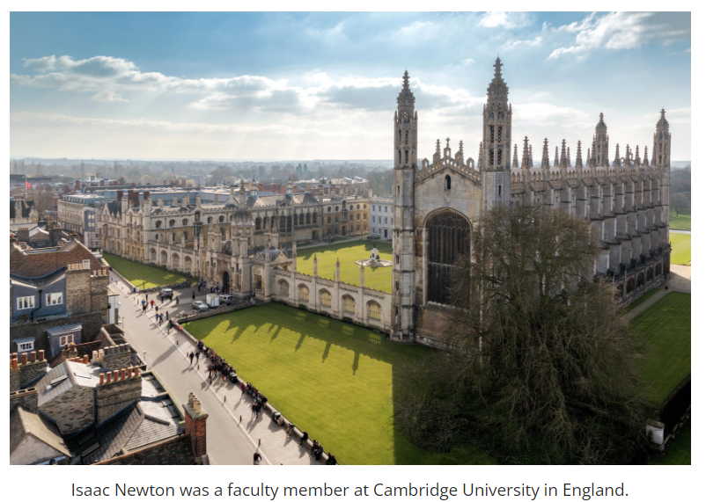
Check-In:
1. What ancient civilization did people in the Middle Ages and Renaissance study?
- Answer: Greece

2. What caused learning to stop again in the Middle Ages?
- Answer: The bubonic plague (Black Death)

Practice:
1. How did the printing press influence the Scientific Revolution?
- Answer: It allowed the spreading of new ideas and gave scholars access to ancient texts.

2. How did humanism change education?
- Answer: Humanism led people to focus on the individual and seek a more well-rounded education.

- Changing European Culture through the Scientific Revolution

Objective 2: Explain the major achievements in the Scientific Revolution and how they impacted European culture.

Essential Question: How did the major achievements of the Scientific Revolution impact European culture?

Key Terms:
1. Heliocentric System: The theory that the sun is the center of the solar system.
2. Law of Gravity: Newton’s theory that explains the force of attraction between objects.
3. Scientific Method: A systematic approach to research and experimentation.
4. Empiricism: The theory that knowledge comes from sensory experience and observation.
5. Rationalism: The belief in reason and logic as the primary source of knowledge.

Big Ideas:
- Scientific Discoveries: Major achievements like the heliocentric system and the law of gravity challenged traditional views and led to new technologies and political changes.
- Political Impact: The diminishing power of the Catholic Church and the rise of powerful monarchies who supported scientific research.
- Cultural Shifts: A move from faith-based knowledge to evidence-based reasoning, changing societal values and beliefs.

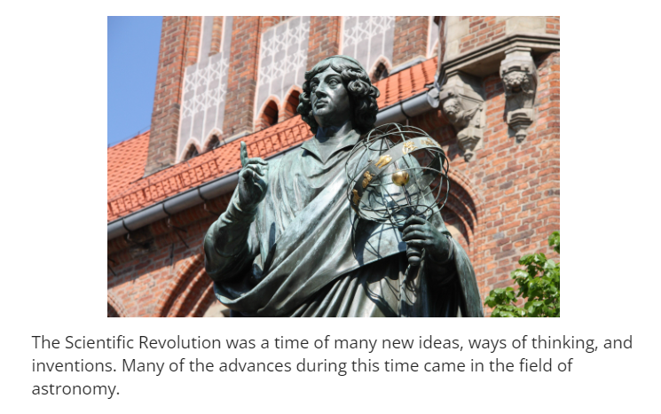
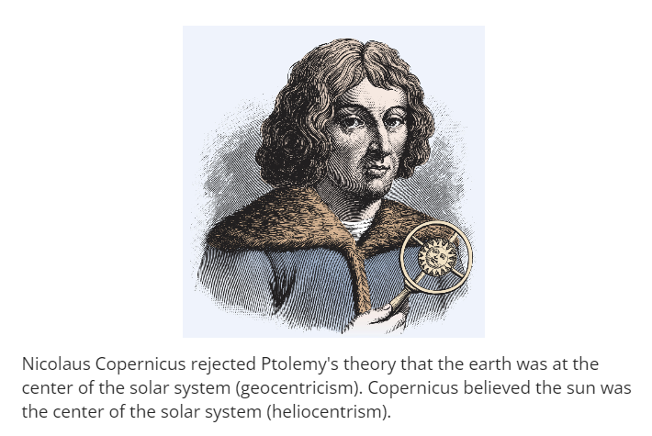
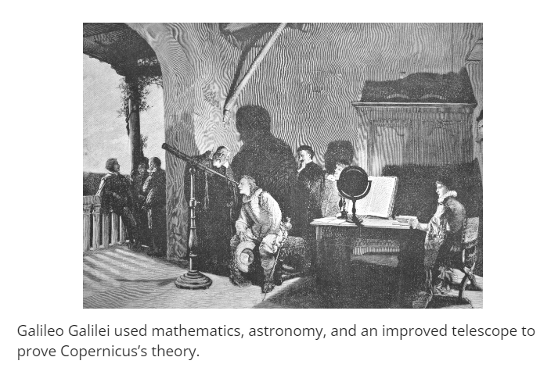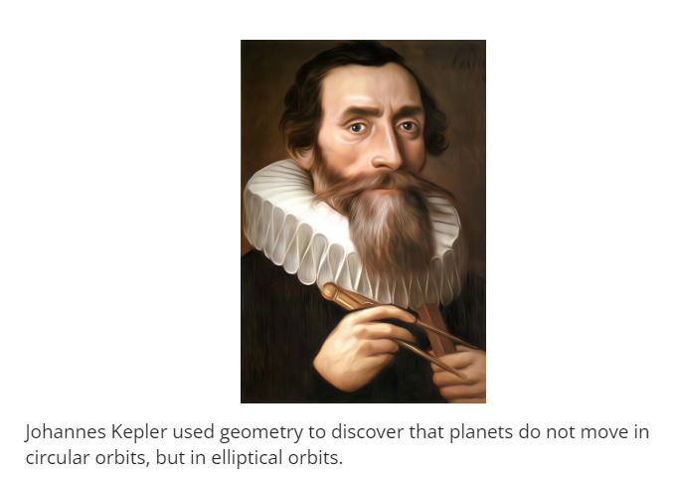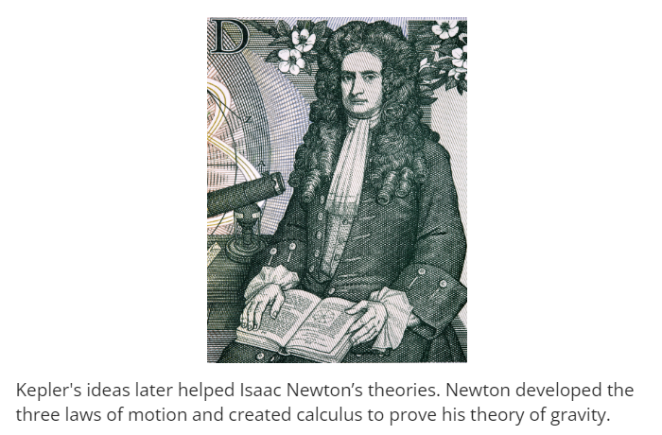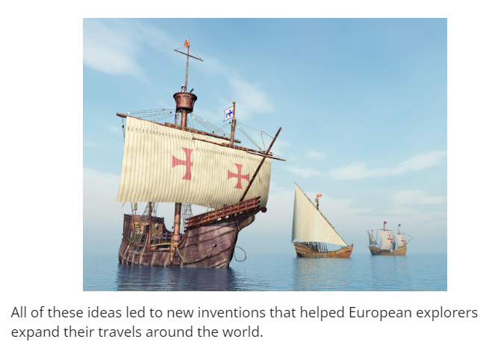
Check-In:
1. What idea did Copernicus challenge?
- Answer: Ptolemy's geocentric system

2. Before the Scientific Revolution, what had provided knowledge to people?
- Answer: Religion/the church

Practice:
1. What is an example of monarchs wanting to support the Scientific Revolution?
- Answer: Stipends for scientists to continue their work, the Royal Society of London for Improving Natural Knowledge, or the French Academy of Sciences.

2. Create a list with 3 major achievements of the Scientific Revolution and their impacts.
- Answer:
- Copernicus discovered the heliocentric theory and challenged a widely held belief (geocentrism).
- Galileo proved Copernicus’ theory of the heliocentric universe was correct and was threatened with execution from the Catholic Church.
- Bacon created the scientific method, which caused people to examine facts and perform experiments.

- Challenging the Norm

Objective 3: Describe the major technological and scientific contributions of individuals such as Copernicus, Galileo, Kepler, Newton, Descartes, and Bacon, and how time and place shaped their ideas during the Renaissance.

Essential Question: How did time and place shape the advancements and technology made during the Renaissance?

Key Terms:
1. Heliocentrism: The theory that the sun is the center of the universe.
2. Geocentrism: The belief that the Earth is the center of the universe.
3. Scientific Method: A systematic approach to research and experimentation.
4. Aristotelianism: A philosophy based on the teachings of Aristotle, emphasizing deductive logic.
5. Cartesian Geometry: A form of geometry that links algebra and Euclidean geometry, developed by René Descartes.

Big Ideas:
- Astronomical Discoveries: Copernicus, Galileo, and Kepler made significant advancements in understanding the solar system, challenging the geocentric model.
- Laws of Motion and Gravity: Newton built on previous work to create his laws of motion and theory of gravity, transforming our understanding of physical forces.
- Scientific Method: Bacon and Descartes promoted new ways of acquiring knowledge through observation, experimentation, and reasoning.
- Cultural Context: The time period’s emphasis on learning and the printing press enabled rapid dissemination of scientific ideas.
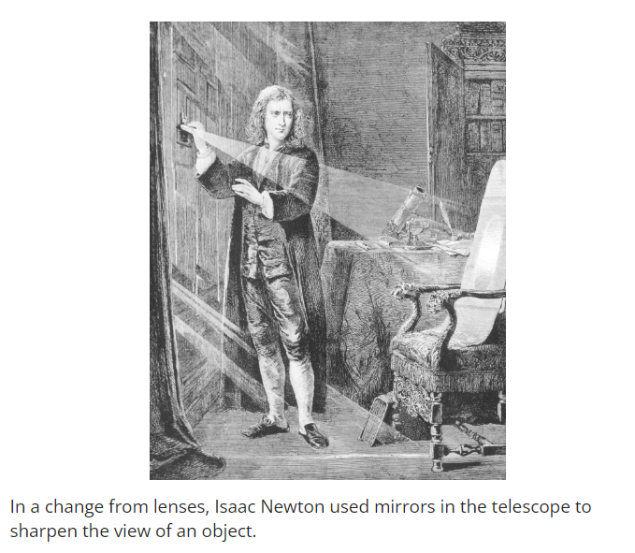

Check-In:
1. What method of learning was replaced by the scientific method?
- Answer: Aristotelianism

2. Which two scientists made improvements to the telescope?
- Answer: Galileo and Newton

Practice:
1. How did the time period impact scientific advancements?
- Answer: Following the invention of the printing press, scientists were able to publish and read each other’s work. Mass production of books and papers allowed for the spread of ideas and innovation.

2. Why were Copernicus’s findings considered radical for the time?
- Answer: Copernicus went against the church, which had accepted the geocentric system.

- The Lasting Impact of the Scientific Revolution

Objective 4: Explain how information and technology from the Scientific Revolution was able to influence society.

Essential Question: How did the Scientific Revolution influence society?

Key Terms:
1. Enlightenment: An intellectual movement that emphasized reason, individualism, and skepticism of traditional authority.
2. Scientific Method: A systematic approach to research and experimentation.
3. Natural Philosophy: The study of the natural world that evolved into modern science.
4. Empiricism: The theory that knowledge comes from sensory experience and observation.
5. Rationalism: The belief in reason and logic as the primary source of knowledge.

Big Ideas:
- Path to Enlightenment: The Scientific Revolution led to the Enlightenment, where thinkers applied scientific methods to society, government, and human nature, pushing for rationalism and individualism.
- Women in Science: Women like Maria Kirch, Margaret Cavendish, and Emilie du Châtelet made significant contributions to science, often against societal norms that undervalued their work.
- Social Change: The new emphasis on evidence-based knowledge undermined the authority of traditional institutions like the Catholic Church and led to revolutions and reforms.
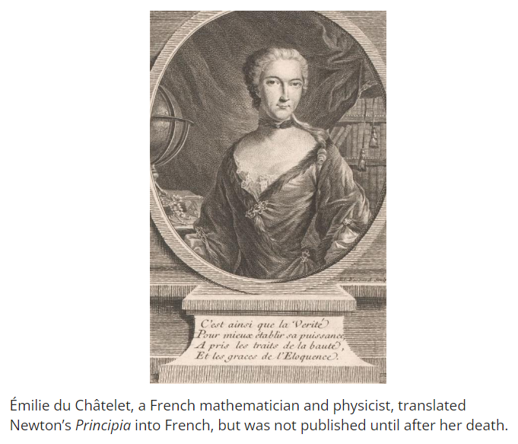

Check-In:
1. Who was the first woman hired as a professor by a European university? Was she allowed to teach?
- Answer: Laura Bassi, an Italian physicist, was hired at the University of Bologna but she was not allowed to teach.

2. Why weren’t women allowed to put their names on their published works?
- Answer: Women were considered inferior and not as intelligent as men.

Practice:
1. Create a timeline of five key achievements of women scientists of the time.
- Answer:
- 1570s – Sophia Brahe works with Tycho Brahe on calculations that Kepler would use to determine the elliptical movements of planets.
- 1650 – Maria Cunitz writes Urania Propitia, which simplified Kepler’s calculations.
- 1667 – Margaret Cavendish is the first woman to visit the Royal Society of London.
- 1702 – Maria Kirch is the first woman to discover a comet.
- 1732 – Laura Bassi becomes the first female professor at a European university.
- 1756 – Émilie du Châtelet’s translation with notes on Newton’s Principia is published posthumously.

2. How did the Scientific Revolution pave the way for the Enlightenment?
- Answer: The creation of the scientific method led thinkers to apply this way of learning about the world to society. The quest for truth, reason, and rationalism took over the teachings of the Catholic Church, leading to significant societal changes.

- Unit 7 Lesson 12: Renaissance Art & Architecture
- Introduction to the Renaissance

Objective 1: Identify various influences on Renaissance art, architecture, and literature.

Essential Question: In what ways were Renaissance art, architecture, and literature influenced by Classical, Byzantine, Islamic, and Western European styles?

Key Terms:
1. Classical: Relating to ancient Greek and Roman culture.
2. Byzantine: Style characterized by the use of bright colors and gilding, originating from the Eastern Roman Empire.
3. Islamic: Influences including advances in science and mathematics from the Islamic world.
4. Western European: Traditions and styles from Western Europe, including Gothic architecture and advancements in naturalism.
5. Social Mobility: The ability for individuals and families to move up the social hierarchy, which increased during the Renaissance.

Big Ideas:
- Regional Centers: The Italian Renaissance centered in Florence, while the Northern Renaissance spread across several cities like London, Paris, and Antwerp.
- Artistic Patronage: Wealthy families, especially the Medici, financed artists, which was a shift from church-led commissions.
- Art Influences: Italian Renaissance art adopted Byzantine colors and gilding, and classical focus on the human form. Northern Renaissance art was influenced by Western European naturalism.
- Architectural Influences: Renaissance architecture drew heavily from classical Roman buildings and incorporated naturalism and plain styles from Western European domestic architecture.
- Literature Influences: Renaissance literature was shaped by classical philosophy, humanism, and Islamic scientific perspectives.
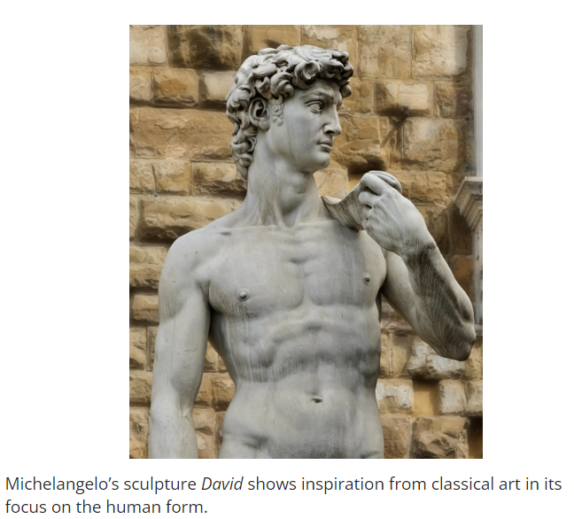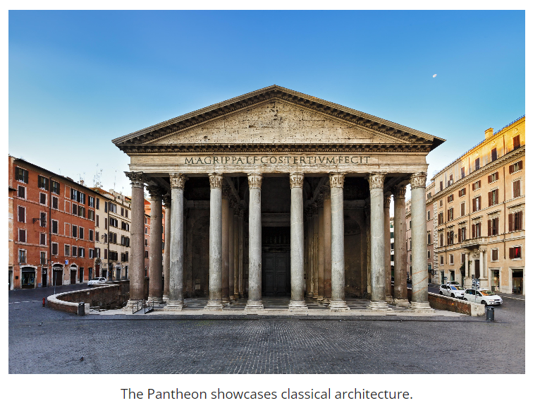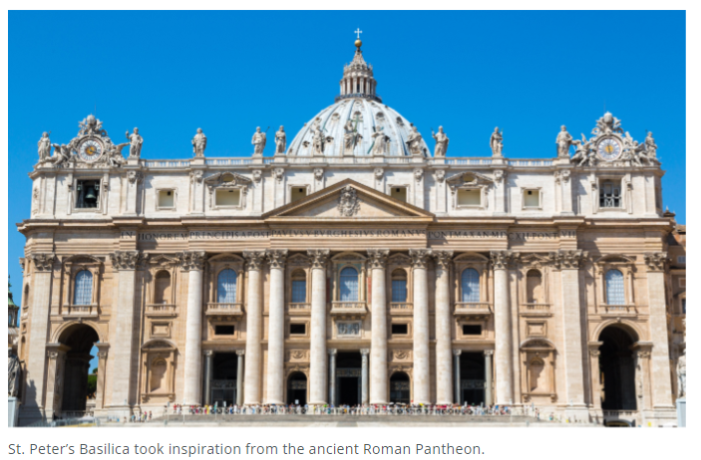

Check-In:
1. What role did the Medici family play in Renaissance art?
- Answer: The Medici were art patrons.

2. What philosophy placed human beings at the center of the universe?
- Answer: Humanism

Practice:
1. How did classical art influence Renaissance art?
- Answer: Classical art focused on the human form, which influenced Renaissance art to depict human anatomy realistically.

2. How did Byzantine art influence Italian Renaissance art?
- Answer: Byzantine art included the use of bright colors and gilding, which influenced Italian Renaissance art.

- Introduction to Renaissance Literature

Objective 2: Analyze how literature shaped events and developments during the Renaissance.

Essential Question: How did literature foster new ways of humanistic thinking that shaped events and developments during the Renaissance?

Key Terms:
1. Printing Press: An invention by Johannes Gutenberg that revolutionized the production of books.
2. Vernacular Language: The common spoken languages of the time, such as English, French, Italian, and German.
3. Reputable Sources: Information written by experts without errors or biases.
4. Humanism: An intellectual movement focusing on human potential and achievements.
5. Grammar Schools: Schools in England that focused on teaching subjects in the humanities.

Big Ideas:
- Printing Press Impact: Made books more accessible, increased literacy, and allowed literature to spread more widely.
- Use of Vernacular: Books were written in common languages, making them accessible to a larger audience beyond scholars.
- Humanism in Literature: Humanism shifted focus from religious guidance to the human experience, influencing education and social thought.
- Spread of Ideas: Humanism and literature contributed to changes in politics, art, and everyday life, encouraging independent thinking.
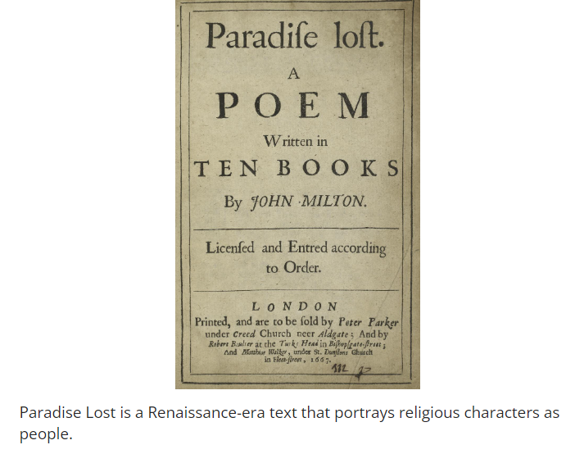

Check-In:
1. English, French, Italian, and German are examples of what type of language?
- Answer: Vernacular language

2. Before the invention of the printing press, how were books mainly produced?
- Answer: Books were produced by writing them out by hand.

Practice:
1. Search online for a reputable source on Shakespeare. Write a statement about how you know this is a reputable source. Include the link.
- Sample answer: The source I chose is a resource called "The Complete Works of William Shakespeare." It is reputable because it includes detailed information from experts on Shakespeare's life and works. [Link]

2. Using the source you found, evaluate the information contained by summarizing it.
- Sample answer: This source contains links to all of Shakespeare’s published writing. He wrote plays and poetry, and his works are widely studied for their contribution to literature and the evolving English language.

- The Shift from Medieval to Renaissance Art

Objective 3: Investigate the changes from medieval to Renaissance art using primary sources.

Essential Question: How can we use primary sources to investigate the changes from medieval to Renaissance art?

Key Terms:
1. Medieval: Relating to the Middle Ages, often marked by Christian religious art.
2. Christian: Gothic style that prevailed before the Renaissance, focusing on religious themes.
3. Perspective: Technique used to represent three-dimensional objects on a two-dimensional surface accurately.
4. Humanism: The cultural and intellectual movement that emphasized human potential and achievements.
5. Primary Sources: Original materials from the time period being studied.

Big Ideas:
- Medieval to Renaissance Transition: Primary sources like paintings show a shift from flat, religious-focused art to more three-dimensional, human-centered works.
- Use of Perspective: Renaissance art incorporated techniques like perspective to create depth and realism.
- Artistic Themes: While medieval art focused on Christian themes, Renaissance art explored human anatomy and the human experience.
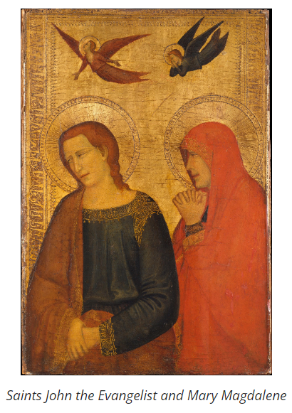
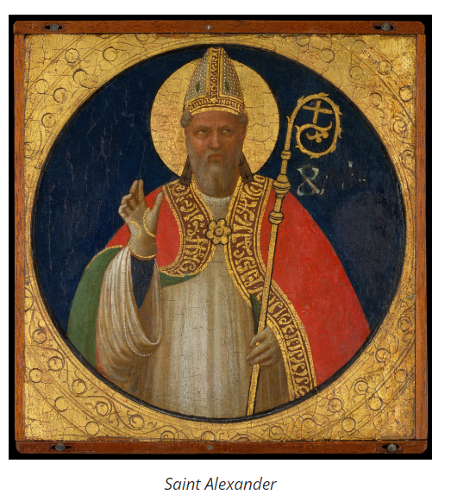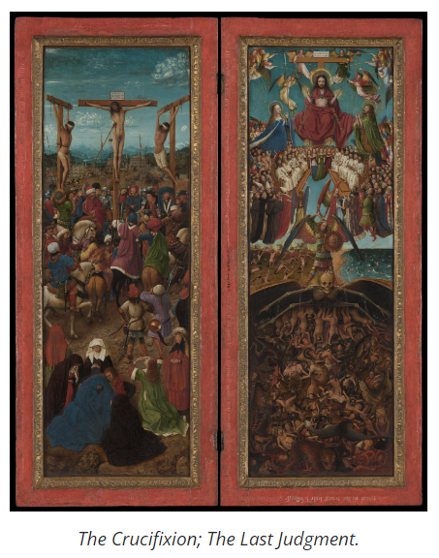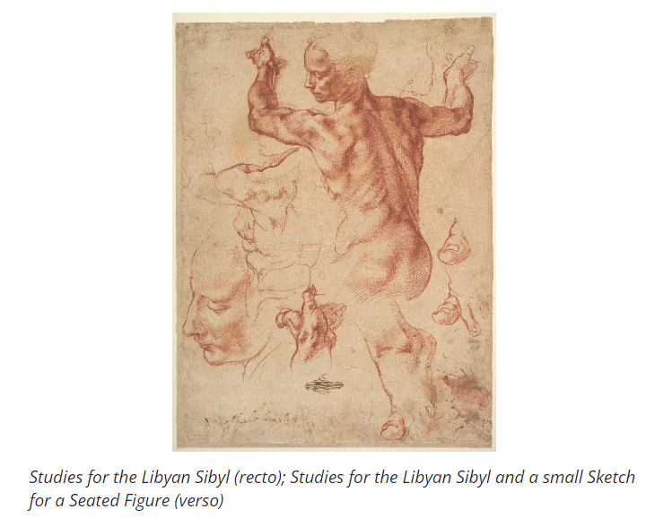
Check-In:
1. What demonstrates the use of perspective in art?
- Answer: The use of depth, making figures look three-dimensional.

2. How did the choice of subject matter change from medieval to Renaissance art?
- Answer: Medieval art focused on Christian religious figures, while Renaissance art focused on the human body.

Practice:
1. Search for a piece of medieval art. Write a statement explaining the aspects of medieval art present in the piece.
- Sample answer: The piece of art I chose is the "Leaf from a Beatus Manuscript: Christ in Majesty with Angels and the Angel of God Directs Saint John to Write the Book of Revelation" ca. 1180. The aspects of medieval art present in this piece are the focus on Christian religious figures and the lack of perspective.

2. Search for a piece of Renaissance art. Write a statement explaining the aspects of Renaissance art present in the piece.
- Sample answer: The piece of art I chose is "The Musicians" by Caravaggio. The aspects of Renaissance art present in this piece are the focus on the human body and the use of perspective.

- Introduction to the Artistic Impact of the Renaissance

Objective 4: Explain the impact of the artists of the European Renaissance on modern societies.

Essential Question: What was the impact of the artists of the European Renaissance on modern societies?

Key Terms:
1. Humanism: A Renaissance cultural movement that turned away from medieval scholasticism and revived interest in ancient Greek and Roman thought.
2. Perspective: An art technique for creating an illusion of three-dimensionality on a flat surface.
3. Patronage: Financial support given by patrons to artists.
4. Ethics: Moral principles that govern a person's behavior.
5. Realism: The attempt to represent subject matter truthfully, without artificiality.

Big Ideas:
- Influence of Humanism: Humanism's focus on the human form and human experience influenced art, politics, and science, shaping modern thought and practice.
- Use of Perspective: Renaissance artists used perspective to create realistic art, influencing modern artistic techniques.
- Patronage: Wealthy families like the Medicis supported artists, allowing them to focus on their work full-time. This practice continues to influence how art is created and funded in modern societies.
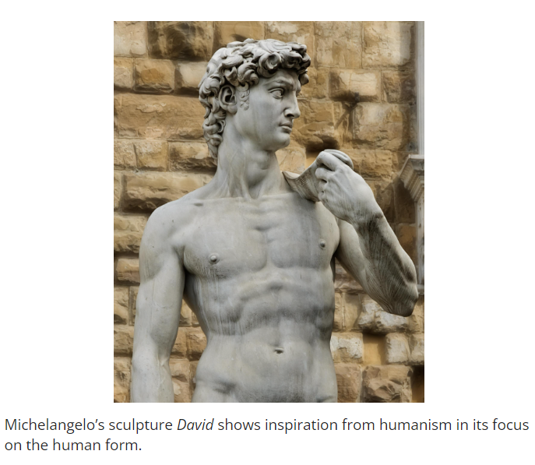
Check-In:
1. Why were many Italian Renaissance painters able to dedicate their lives to art?
- Answer: Because of patronage by a wealthy family.

2. Renaissance art focused less on religious subjects than medieval art did, and more on what?
- Answer: The human form.

Practice:
1. Explain how the influence of Renaissance art’s move toward incorporating perspective is still felt in modern societies.
- Sample answer: Modern artists still often create lifelike work using perspective. This technique is fundamental in creating realistic representations in various forms of art today.

2. Where is a focus on the importance of humanity seen in modern societies?
- Sample answer: In politics and science, where human rights and ethical considerations are central to decision-making and policy development.

