- Unit 6 Lesson 1: Dynastic Empires Introduction
- Dynastic Empires: Introduction
Timeline:
- Nomadic Origins and Mongol Empire (1206-1368 CE)
- Genghis Khan's rise and leadership in building the Mongol Empire.
- Mongol conquests and the geographical expansion of their empire.
- European contacts with the Mongols and their effects on Europe.

Impact of Mongol Rule
- Long-term effects of Mongol rule on conquered territories in Afro-Eurasia.
- Division of the Mongol Empire into four khanates: Golden Horde (Russia), Ilkhanate (Persia), Yuan Dynasty (China).
- Overextension and fragmentation leading to the collapse of the Mongol Empire.
- Effects of the Bubonic plague on the Mongols and their conquered lands.

Post-Mongol Empires
- Disintegration of the Mongol Empire and its impact on conquered societies.
- Comparison of Mongol influence on the Ming and Russian Empires.

- Ming Dynasty (1368-1644 CE)
- Ming Dynasty's cultural and economic connections with China, Japan, India, and East Africa during Zheng He's voyages.
- Role of Ming China in the global economy in the 16th and 17th centuries.
- Fall of the Ming Empire due to overextension, famine, inflation, rebellions, and the rise of the Manchu.

Qing Dynasty and Trade Systems
- Establishment of the Canton System by the Qing Empire and European reactions.

Russian Empire Expansion
- Russian methods of imperial expansion from Moscow, including the role of the Cossacks and gunpowder weaponry.
- Political control in Russia, focusing on the tsar, boyars, religious conversion to Orthodox Christianity, and the yasak tribute system.

Medieval Japan
- Economic and cultural ideas from medieval Japan relative to that period.
- Social classes in Japan's feudal system, including shogun, daimyo, samurai, and peasants.

- Global Trade and Maritime Empires (15th-17th Centuries)
- Geographic origin of silk, spices, cotton, and porcelain.
- Maritime voyages of Christopher Columbus (1492) and Vasco da Gama (1497-1498) driven by European demand for Asian goods.
- Impact of the trade of Asian luxury goods and silver on Asia, Africa, America, and Europe.
- Disruption of Indian Ocean trade by the Portuguese entry into the trade network.
- Differences between European maritime empires (e.g., Portuguese) and Asian land-based empires (e.g., Russian, Ottoman Turks).

Economic and Political Impact of Trade
- Methods of expansion and control used by the Portuguese in the Indian Ocean trading post empire and the practice of armed trade.
- Economic and political impact of global trade on Western Europe.
- Effect of European maritime trade with Asia on overland trade routes controlled by the Ottoman Empire.

- Dynastic Empires: Introduction

Objective: Understand the rise and fall of dynastic empires, their cultural achievements, and the interactions between various empires.

Essential Question: How are cultural achievements defined?

Key Terms:
1. Cultural Diffusion: The spread of cultural beliefs and social activities from one group to another.
2. Nomadic: Moving from one place to another rather than living in one place all the time.
3. Dynastic Empire: Empires ruled by members of the same family over generations.
4. Astrolabe: An ancient tool used by astronomers and navigators to measure the position of the stars.
5. Primary Sources: Original documents or evidence from the time being studied.

Big Ideas:
- Understanding Cultural Achievements: Cultural achievements are defined by what different empires accomplished in areas like art, science, and technology.
- Rise and Conquest: Examining the rise of the Mongol Empire under Genghis Khan and its enormous expansion through conquests.
- Trade and Interaction: Trade facilitated cultural exchanges and interactions between different empires, such as Zheng He’s voyages during the Ming Dynasty that connected China, Japan, India, and East Africa.
- Technological Advancements: Innovations like gunpowder weaponry enabled the expansion of empires, such as Russian expansion into Siberia.
- Legacy and Influence: The lasting impacts of dynastic empires continue to shape present-day societies and cultures, like Japan's feudal structure and samurai class. 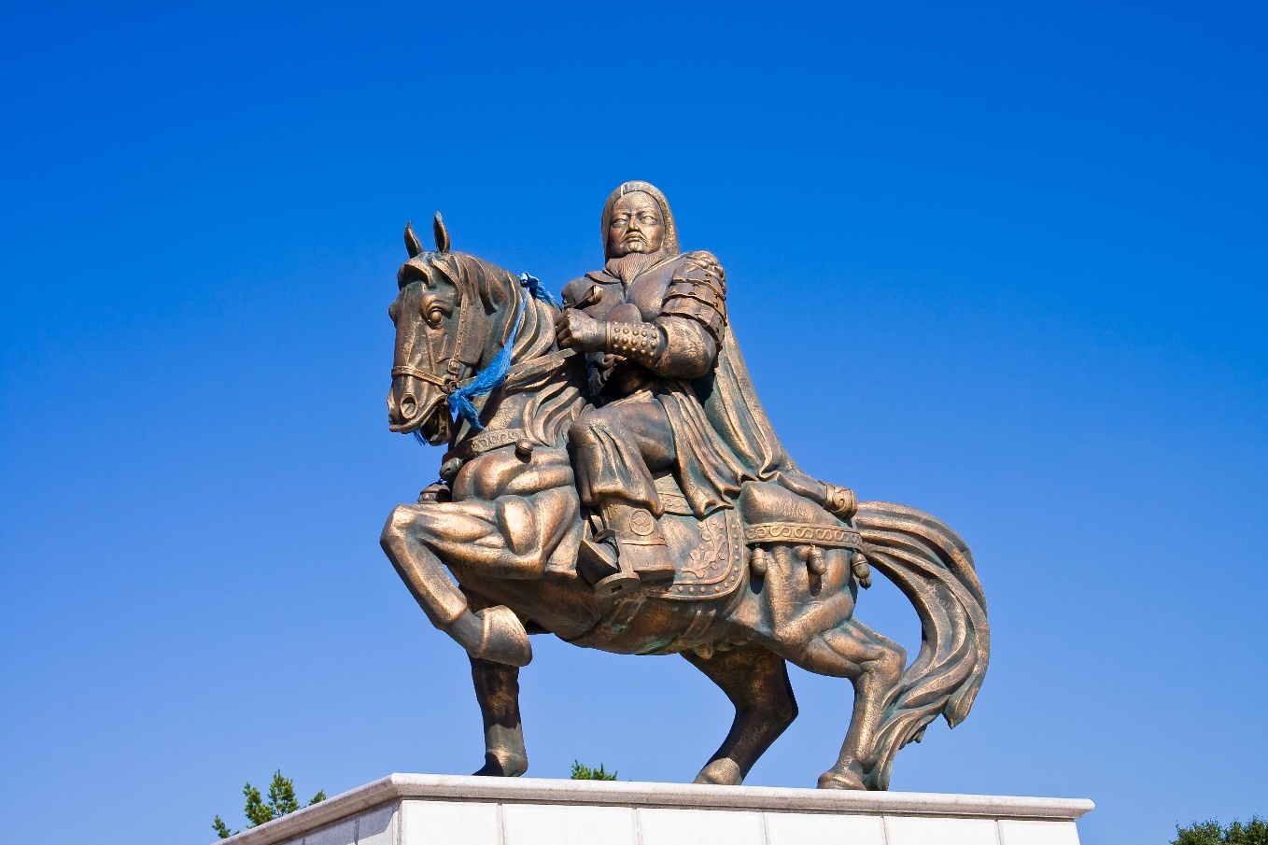

Check-In Questions:
1. How are cultural achievements defined?
- Answer: Cultural achievements are defined by what different empires accomplished in areas like art, science, and technology.
2. What role did technological advancements like the astrolabe play in the expansion of dynastic empires?
- Answer: Technological advancements like the astrolabe helped navigators measure the position of stars, aiding in expeditions and maritime trade, which facilitated the expansion of empires.

Practice Questions:
1. What was the significance of Genghis Khan's conquests in establishing the Mongol Empire?
- Answer: Genghis Khan's conquests were significant in establishing a vast Mongol Empire that stretched from the Caspian Sea to the Sea of Japan, showcasing the power and influence of the Mongol rule.
2. How did trade influence cultural interactions during the Ming Dynasty?
- Answer: Trade, exemplified by Zheng He's voyages, created cultural and economic connections between China, Japan, India, and East Africa, leading to the exchange of goods, ideas, and technology.

- Unit 6 Lesson 2: The Mongols
- Genghis Khan and the Mongol Empire

Objective 1: Identify the origins of Chinggis (Genghis) Khan and how he built the Mongol Empire, using historical inquiry and analytical processes to determine interpretations of his contributions.

Essential Question: What were Genghis Khan's contributions to the building of the Mongol Empire?

Key Terms:
1. Historical Inquiry: The process of locating and analyzing multiple sources to answer historical questions.
2. Primary Sources: Historical records created by people who experienced events firsthand.
3. Secondary Sources: Historical records created by people who did not experience events firsthand.
4. Tobchi'an: Also known as "The Secret History of the Mongols," a primary source about Mongol history.
5. Cavalry: Soldiers who fight on horseback.

Big Ideas:
- Historical inquiry involves developing questions, finding sources, and analyzing information to understand historical events.
- Genghis Khan united Mongol tribes and created a vast empire through military conquest.
- The Mongol Empire stretched from the Sea of Japan to the Caspian Sea.
- Genghis Khan's contributions to the Mongol Empire are viewed both positively and negatively by different sources.
- Positive contributions include developing a writing system, creating laws, and promoting religious tolerance. 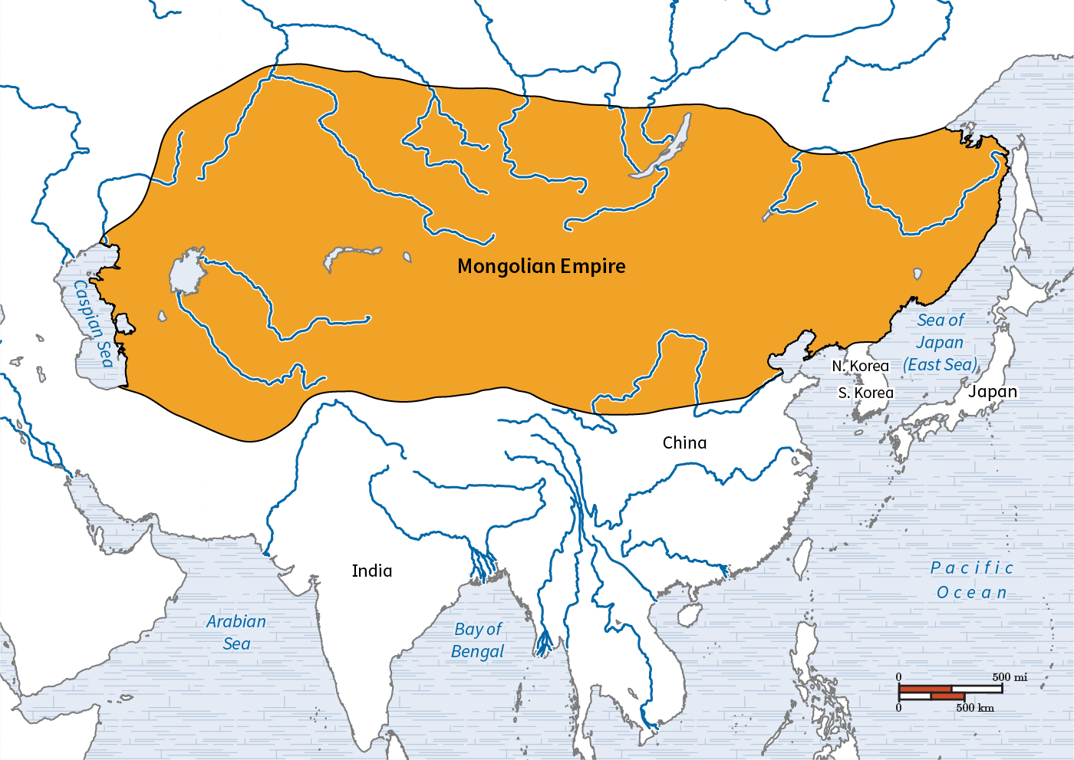

Check-In Questions:
1. What is the first step of a historical inquiry?
- Answer: Developing broad and specific questions.
2. What do historians do when they use analytical processes in historical inquiry?
- Answer: Historians compare evidence from multiple sources, consider cause-and-effect relationships, make generalizations, and determine a solution or possible answer to their questions.
3. What factors contributed to Genghis Khan's invasion of neighboring lands?
- Answer: A change in climate, a desire for wealth and power, a rivalry with China, and a desire to bring Asia under a single ruler contributed to the Mongol invasions.

Practice Questions:
1. Explain some of the positive contributions Genghis Khan made in the development of the Mongol Empire.
- Answer: Some positive contributions include: developing a Mongolian writing system, creating the Mongolian Code of Law, unifying the Silk Road, developing the first international postal service, creating a meritocratic military, offering religious tolerance, facilitating trade between Asia, the Middle East, and Europe, and supporting ethnic diversity.
2. Explain examples of bias that can be found in primary sources about the contributions of Genghis Khan in the development of the Mongol Empire.
- Answer: Primary sources such as "The Secret History of the Mongols," written by Mongol scholars, may be overly positive about Genghis Khan's contributions, while sources written by those he conquered may offer more negative accounts of Khan's role in building the empire.

- Geography and the Development of the Mongolian Empire

Objective 2: Identify the areas the Mongols conquered, using a variety of tools to determine the relationship between geography and the historical development of the Mongols.

Essential Question: What is the relationship between geography and the historical development of the Mongols?

Key Terms:
1. Human Geography: The study of how humans interact with their environment.
2. Physical Geography: The study of Earth's natural processes and patterns.
3. Thematic Map: A map that shows geographic patterns about a particular topic.
4. Steppes: Dry, grassy plains suitable for raising herd animals.
5. Nomadic: Moving from place to place in search of food and resources.

Big Ideas:
- Geography played a crucial role in the development and expansion of the Mongol Empire.
- The steppes of Mongolia led to a nomadic lifestyle and skilled horsemanship, which were advantageous in warfare.
- Being landlocked, the Mongols became experts at land-based conquest but never developed naval power.
- The Silk Road, controlled by the Mongols, greatly influenced international trade and the empire's wealth.
- Mongol conquests had significant impacts on population and economic development in conquered territories.

Check-In Questions:
1. Which geographic tool shows the geographic patterns about a particular topic?
- Answer: A thematic map
2. Which geographic tool uses a line to connect data points?
- Answer: A line graph
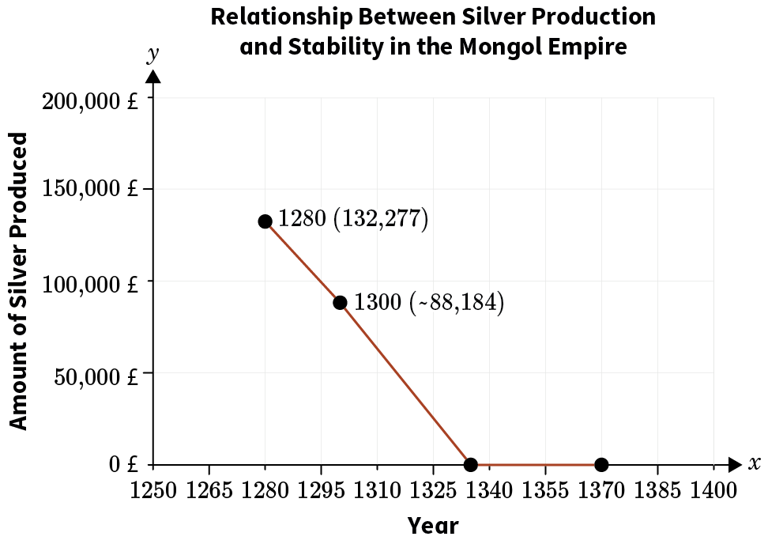

Practice Questions:
1. Explain how the physical geography of Mongolia impacted the development of the Mongol Empire.
- Answer: The steppes of Mongolia led to the people becoming both nomadic and expert horse riders. These skills were of great use to their army when conquering other lands, as they could move quickly over large territories without requiring much in the way of supplies. Being landlocked, the Mongols became skilled land-based soldiers but did not develop naval warfare capabilities, leading to their empire expanding only over land in Asia, Europe, and the Middle East.
2. Explain the impact the Mongol Empire had on world trade.
- Answer: By controlling the entire Silk Road trading route in the 1200s and 1300s, the Mongol Empire greatly influenced the world economy. When there was peace in the empire, worldwide trading increased; when there was conflict in the empire, worldwide trading decreased. This impact can be demonstrated by silver production in Europe, which fluctuated based on the stability of the Mongol Empire.

- The Mongols' Impact on Europe

Objective 3: Describe the effects of Mongol contact with Europeans, using evidence from a variety of sources.

Essential Question: What were Europeans' perspectives on the impact of the Mongol Empire?
Key Terms:
1. Golden Horde: The western part of the Mongol Empire that invaded Eastern Europe.
2. Cavalry: Soldiers who fight on horseback.
3. Siege Warfare: A military strategy to capture a fortified place by surrounding it.
4. Silk Road: An ancient network of trade routes connecting East and West.
5. Historical Inquiry: The process of investigating historical questions using various sources.

Big Ideas:
- The Mongol Empire's expansion brought them into frequent contact with Europeans.
- European perspectives on Mongol impact varied widely, from positive to extremely negative.
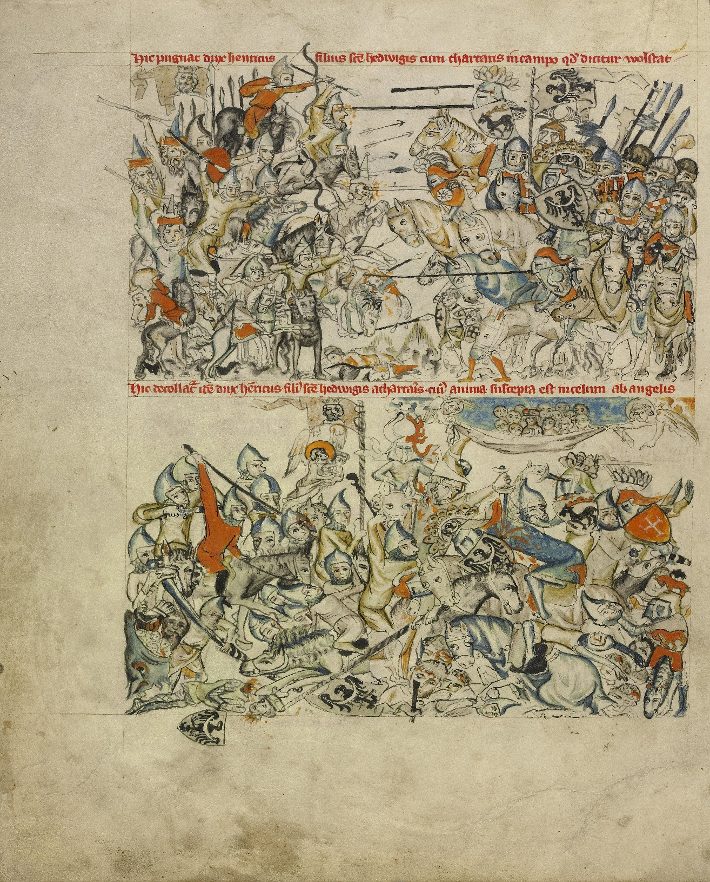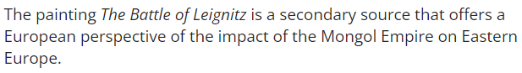
- Positive views focused on increased trade and cultural exchange along the Silk Road.
- Negative views emphasized the brutality of Mongol conquests and their devastating effects on Eastern European cities.
- Primary and secondary sources offer different insights into European-Mongol interactions.

Check-In Questions:
1. What is an example of a primary source of information about European interaction with the Mongol Empire?
- Answer: The writings of Marco Polo, written during his time in China at the court of Mongol leader Kublai Khan.
2. What is an example of a secondary source of information about European interaction with the Mongol Empire?
- Answer: Textbooks, images, maps, films, and paintings are all examples of secondary sources, developed many years after the rise and fall of the Mongol Empire.

Practice Questions:
1. Explain some of the positive contributions Western Europeans wrote about regarding the effects of interactions with the Mongol Empire.
- Answer: Some positive contributions noted include the development and unification of the Silk Road, the creation of the first international postal service, and the support of communication and trade between Asia, the Middle East, and Europe.
2. Explain the main focus of negative portrayals of interactions with the Mongol Empire by Europeans.
- Answer: Many sources describing the negative impacts of the Mongol Empire focus on the death and destruction caused by the Mongol conquest of Eastern Europe, including the devastation of cities and the slaughter of populations.

- The Mongol Empire’s Impact on Europe

Objective 4: Analyze the long-term effects the Mongols had on conquered territories in Asia, Europe, and the Middle East using evidence from a variety of sources.

Essential Question: What were the long-term impacts on the territories the Mongols conquered?

Key Terms:
1. Yuan Dynasty: The Mongol-led dynasty that ruled China from 1271 to 1368.
2. Ilkhanate: The Mongol khanate that ruled Persia (modern Iran) from 1256 to 1335.
3. Cultural Diffusion: The spread of cultural practices from one society to another.
4. Autocratic: Relating to a system of government by one person with absolute power.
5. Mughal Empire: An empire in India founded by descendants of the Mongols.

Big Ideas:
- The Mongol Empire had varying long-term impacts on different conquered territories.
- In China, Mongol rule led to increased trade and cultural exchange, but had limited impact on language and governance.
- In Persia, Mongol rulers adopted Islam and local customs, leading to a blending of cultures.
- Russia experienced significant linguistic, religious, and political changes due to Mongol rule.
- The Mughal Empire in India, founded by Mongol descendants, had lasting impacts on architecture, governance, and cultural integration. 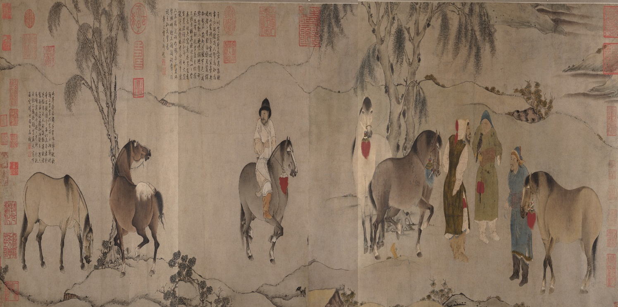 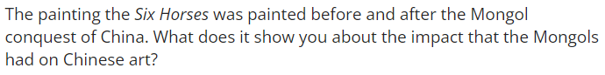 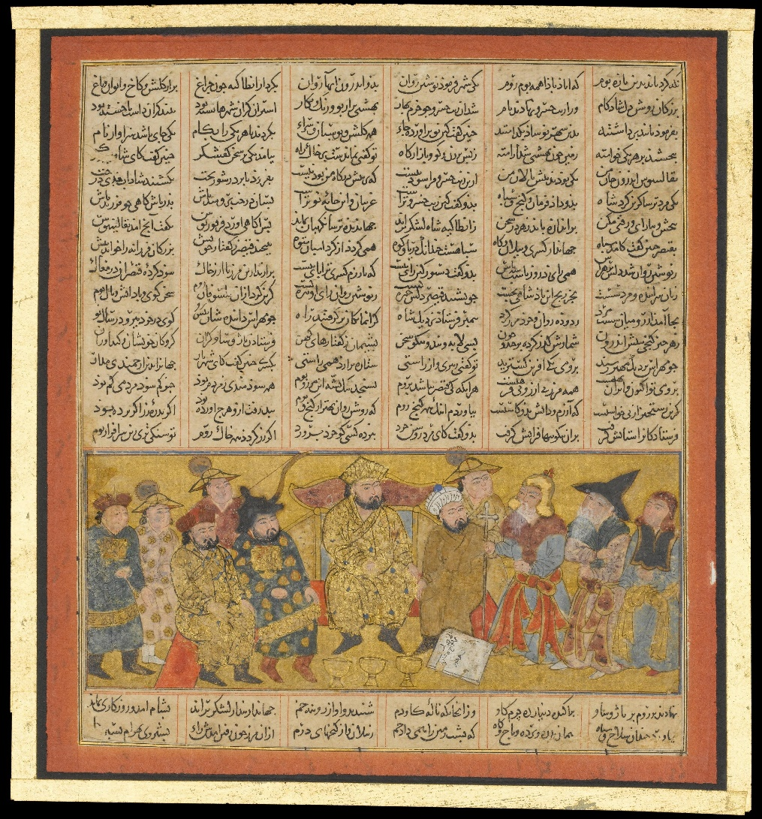 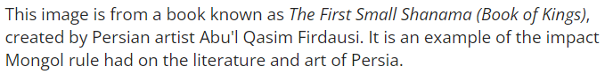 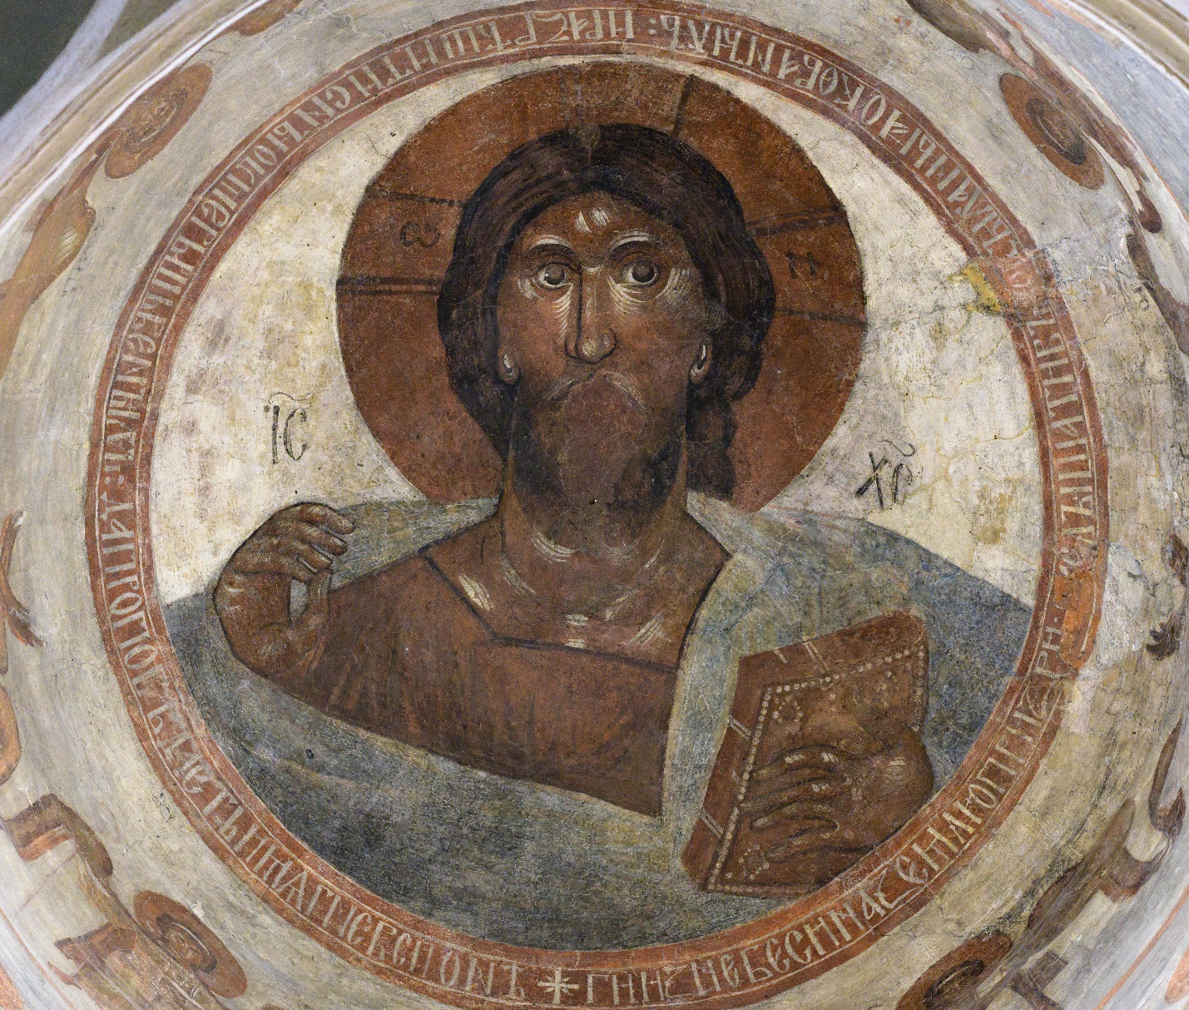 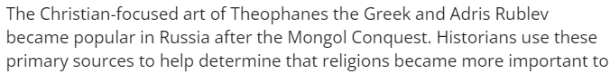 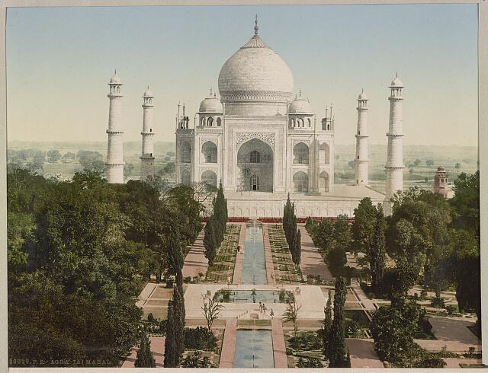 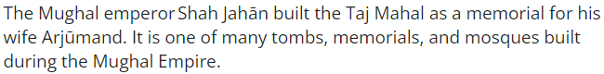

Check-In Questions:
1. What is the name of the world history book that shows the long-term impact of the Mongolian culture on Persia?
- Answer: Jāmiʿ al-tawārīkh
2. Mongol Emperor Öljeitü's conversion to which religion led to its long-term stability in Persia?
- Answer: Islam

Practice Questions:
1. Use research to locate 2–3 sources describing the impact of Mongol occupation on Russia. Analyze your sources to determine some of the long-term effects of the Mongol Empire on Russia.
- Answer: Some long-term effects include: the adoption of Mongolian words in the Russian language, the rise in importance of the Russian Orthodox Church, the growing significance of Moscow, the development of the Russian census and postal service, and the decline of the viche governmental system in favor of a more authoritative system.
2. Use research to locate 2–3 sources describing the impact of Mongol occupation on China. Analyze your sources to determine some of the long-term effects of the Mongol Empire on China.
- Answer: Long-term effects include: the rise in trade, the development of Chinese drama and literature, conflicts among Tibetan Buddhist and Chinese Buddhist and Daoist religions, and more authoritative approaches by future Chinese leaders.
3. Use research to locate two to three sources describing the impact of Mongol influence on India. Analyze your sources to determine some of the long-term effects of the Mughal Empire on India.
- Answer: Long-term effects include: unification of India under a single government, tradition of multicultural governance, major construction projects that have lasted for centuries, improved trade between various regions, and increased openness to the West.

- Unit 6 Lesson 3: Fall of the Mongols
- Dividing the Mongol Empire

Objective 1: Investigate why the Mongol Empire was divided into four khanates and how Mongol rule affected each using primary and secondary sources.

Essential Question: How did Mongol khanates come to reflect the people they governed?

Key Terms:
1. Khanates: Separate regions of the Mongol Empire ruled by different leaders.
2. Abbasid Caliphate: Islamic empire ended by Mongol conquest.
3. Mandate of Heaven: Chinese belief in the divine right to rule.
4. Silk Road: Ancient trade route connecting East and West.
5. Bureaucracy: System of government administration.

Big Ideas:
- The Mongol Empire was divided into four khanates due to leadership disputes.
- Each khanate (Yuan Dynasty, Golden Horde, Ilkhanate, Chagatai Khanate) adapted to local cultures differently.
- The Yuan Dynasty in China promoted trade and created a social hierarchy favoring Mongols.
- Khanates maintained some Mongol traditions while adopting local customs and religions.
- Historical sources, both primary and secondary, help in understanding the complex narrative of the Mongol Empire.
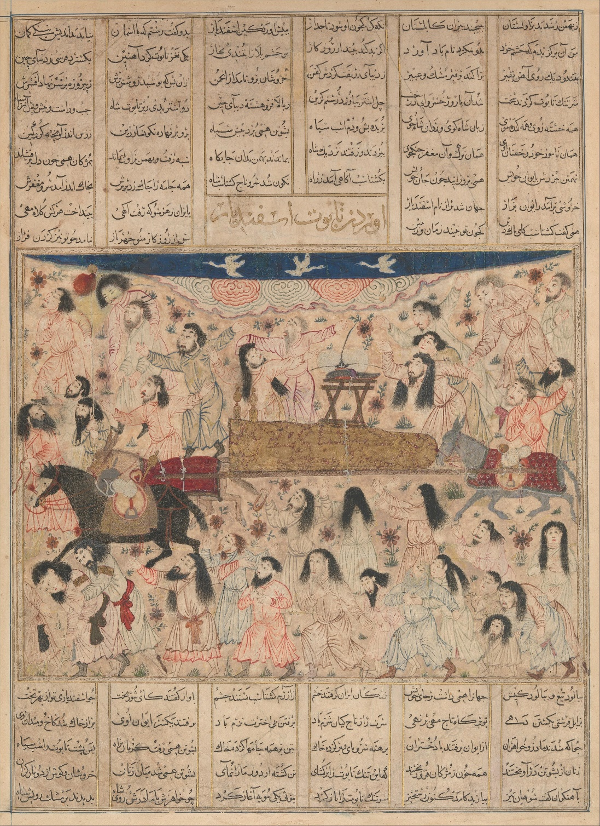

Check-In Questions:
1. Why was the Mongol Empire divided?
- Answer: Fights between Genghis Khan's grandsons over who should be the leader eventually divided the empire.
2. How many khanates were created after the division of the Mongol Empire?
- Answer: Four

Practice Questions:
1. Explain how the image of the pommel plate demonstrates how the Mongols combined their cultural customs with the Persians.
- Answer: The image shows the use of horses, which was an important part of Mongol nomadic society. The pommel is also used on a horse saddle. It incorporates Persian and Muslim designs, such as the intricate metal work and the Arabic writing around the edges of the pommel.
2. Using the article "From Genghis to Kublai," explain why Genghis Khan uses the analogy of a stone falling into deep water when speaking about the khurultai.
- Answer: The quotation means that if someone did not attend the khurultai to select a new leader, their influence in the empire would decrease like a stone falling into deep water.

- Collapse of the Mongol Empire

Objective 2: Analyze how overextension and fragmentation led to the collapse of the Mongol Empire.

Essential Question: How did the overextension and fragmentation of the Mongol Empire lead to its collapse?

Key Terms:
1. Overextension: Expanding beyond the ability to effectively control.
2. Fragmentation: Breaking into separate parts.
3. Red Turban Rebellion: Uprising against Mongol rule in China.
4. Bubonic Plague: Deadly disease that spread through the Mongol Empire.
5. Timurid Dynasty: Empire founded by Timur, claiming Mongol descent.

Big Ideas:
- The vast size of the Mongol Empire made it difficult to govern effectively.
- Internal disputes over leadership weakened the empire.
- External threats and diseases like the bubonic plague contributed to the collapse.
- Each khanate faced unique challenges that led to its eventual downfall.
- The collapse of the Mongol Empire had lasting impacts on the regions it once controlled. 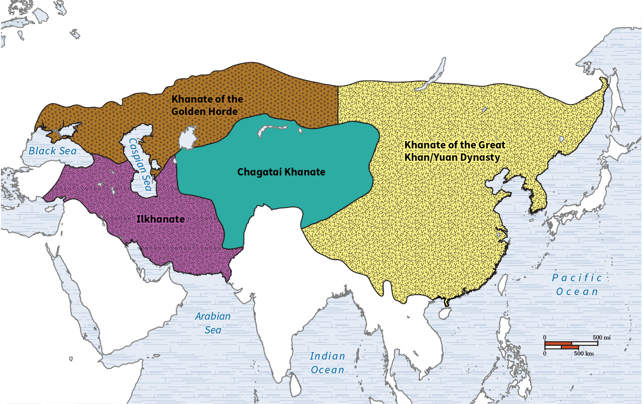 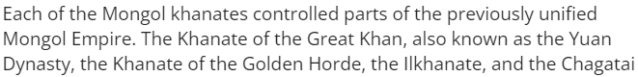

Check-In Questions:
1. How many khanates were created after the division of the Mongol Empire?
- Answer: Four
2. What disease helped to hasten the collapse of the Mongol khanates?
- Answer: The bubonic plague

Practice Questions:
1. How did family disputes lead to the fall of the Mongol Empire?
- Answer: Disputes between Genghis Khan's grandsons over who should lead the Mongol Empire weakened the empire and eventually led to its division. These disputes continued within the four khanates, further weakening the Mongols in the face of rival empires and internal threats.
2. How would the size of the Mongol Empire have impacted its ability to govern?
- Answer: Because the Mongol Empire was so large, it was incredibly diverse politically, ethnically, culturally, and religiously. This made governing a challenge because no one policy could be effective over so many different areas.

- The Mongol Empire and Disease

Objective 3: Describe how diseases, particularly the bubonic plague, affected the Mongols and the land they conquered.

Essential Question: How did the Mongol Empire spread disease?

Key Terms:
1. Pax Mongolica: Period of peace and stability under Mongol rule.
2. Bubonic Plague: Deadly disease spread by fleas and rats.
3. Black Death: Name for the bubonic plague epidemic of the 1300s.
4. Quarantine: Isolation to prevent the spread of disease.
5. Yersinia pestis: Scientific name for the bacteria causing bubonic plague.

Big Ideas:
- The Pax Mongolica allowed for increased trade and travel, but also facilitated disease spread.
- The bubonic plague, or Black Death, devastated populations across the Mongol Empire and beyond.
- Trade routes, especially the Silk Road, played a crucial role in spreading the disease.
- The plague weakened Mongol control and contributed to the empire's collapse.
- The Black Death had long-lasting social and economic impacts on affected regions.

Check-In Questions:
1. How did the bubonic plague spread along the Silk Road?
- Answer: Through fleas known as Yersinia pestis
2. How did the Mongol Empire promote trade across Eurasia?
- Answer: The Mongols ensured safe travel through the various Mongol territories.

Practice Questions:
1. How did the Silk Road help promote the spread of the Black Death across Eurasia?
- Answer: The Mongol Empire made trade more efficient and safer by controlling passage along the Silk Road. Well-populated towns lined the routes, and trade ships passed frequently through every port. This allowed for previously isolated diseases, including the bubonic plague, to spread much faster as fleas and rats moved with merchants to large urban centers and major trading posts.
2. Why did the Black Death help to cause the political collapse of the Golden Horde, Ilkhanate, and Yuan Dynasty?
- Answer: These Mongol groups had conquered foreign territories, and they needed to show strength to maintain political control. The Black Death weakened their alliances and damaged their economic success, making it easier for them to be overthrown.

- Mongol Disintegration and Conquered Peoples

Objective 4: Analyze the impact that the disintegration of the Mongol Empire had on conquered societies.

Essential Question: What effect did the disintegration of the Mongol khanates have on conquered societies?

Key Terms:
1. Tsar: Title for Russian monarchs.
2. Sufism: Mystical branch of Islam.
3. Ming Dynasty: Chinese dynasty that replaced the Mongol Yuan Dynasty.
4. Silk Road: Ancient trade route connecting East and West.
5. Eastern Orthodox Church: Major branch of Christianity prevalent in Russia.

Big Ideas:
- The fall of the Mongol Empire led to the rise of new powers in conquered territories.
- In Russia, the city of Moscow (Muscovy) emerged as a center of power.
- The collapse of the Yuan Dynasty in China led to the rise of the Ming Dynasty and changes in social structure.
- In the former Ilkhanate, Persian customs and officials helped maintain stability after Mongol rule.
- Religious changes, such as the spread of Sufism in Persia and the strengthening of the Eastern Orthodox Church in Russia, were lasting impacts of Mongol rule. 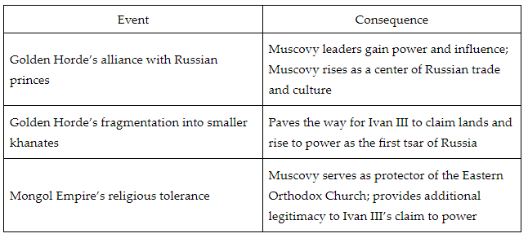

Check-In Questions:
1. Which dynasty overthrew the Yuan Dynasty to take control of China?
- Answer: The Ming Dynasty
2. Why did Muscovy emerge as the center of Russian society during and after Mongol rule?
- Answer: Muscovy leaders made alliances with the Mongols. This allowed them to increase their economic and political power at the expense of other states in the area.

Practice Questions:
1. Compare the responses of the conquered societies that lived in each area following the collapse of the Yuan Dynasty and the Golden Horde.
- Answer: As the Yuan Dynasty fell, the Ming Dynasty rose to replace it. Ming leaders returned to the style of government that existed in the region before the Mongols invaded. This switch gave the Han ethnic group the most power and reestablished the civil service examination in China. Following the collapse of the Golden Horde, Russians from Muscovy were well-placed to take power. They paved the way for Ivan III to gain control as Russia's first tsar.
2. How did the Ilkhanate continue to impact life in Southwest Asia even after that empire disintegrated?
- Answer: Since the Ilkhanate had kept Persian practices in place and included Persian officials in their government, there was a stable transition to smaller khanates run by ethnic Persians after the Ilkhanate collapsed. The Ilkhanate had also promoted Sufism, which resulted in its continued practice even after future rulers introduced Shi'a Islam to the Ilkhanate's former territory.

- Unit 6 Lesson 4: Mongol Influence Portfolio
- The Mongols Influence on the Ming and Russian Empires

Objective:
Analyze the similarities and differences of the Mongol influence on the Ming and Russian Empires using historical evidence from primary and secondary sources to create written, oral, and graphic forms of communication.
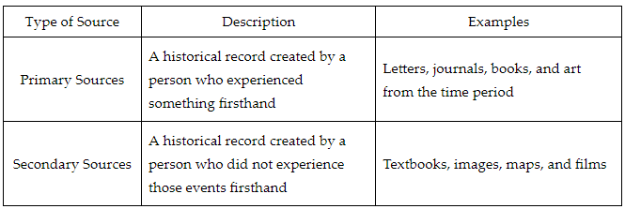
Essential Question:
Why were the Mongols so influential?

Key Terms:
1. Geopolitical: Related to politics, especially international relations, influenced by geographical factors.
2. Narrative: A story or account of events that provides a structured way to understand the past.
3. Perspective: Seeing things from other people's viewpoints, essential for understanding different historical experiences.
4. Symbolism: The use of symbols, images, or visuals to represent ideas or concepts.
5. Empathy: Understanding and sharing the feelings of others, crucial for relating to people from history.

Big Ideas:
- Influence on Art: The Mongols had a significant impact on the art of both the Ming and Russian Empires. Ming literature, plays, and porcelain art thrived while Russian art became centered on religious works.
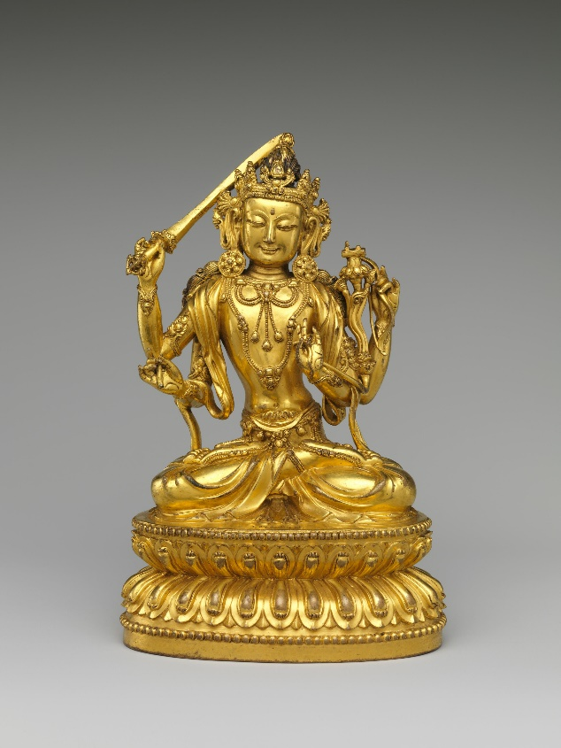
- Impact on Language: Mongolian language had little impact on the Chinese language but significantly influenced Russian, with many Mongolian words incorporated and cities named using Mongolian terms.
- Religious Tolerance: The Mongols were generally tolerant but caused lasting religious changes. Tibetan Buddhism influenced Ming emperors, whereas the Russian Orthodox Church became more centralized and influential after Mongol invasions.
- Government Structure: Both the Ming and Russian empires were influenced to adopt autocratic and totalitarian forms of governance, although the practical applications varied between the two.
- Economic Development: The Mongol trade routes greatly influenced the economic strategies of both empires, contributing to the prosperity of respective merchant classes.

Check-In:
1. Describe a similar influence the Mongols had on both the Ming and Russian Empires.
- Answer: The Mongols influenced the development of autocratic and totalitarian governments in both the Ming and Russian Empires.

2. Describe an influence the Mongols had on the Russian Empire that was not evident in the Ming Empire.
- Answer: The Mongols' impact on language was evident in the Russian Empire but not in the Ming Empire. Mongolian words were incorporated into Russian, and some cities were named using Mongolian terms.

Practice:
1. Think about the research question: “Why were the Mongols so influential on the Ming and Russian Empires?” Develop a plan that addresses how you will approach the research and manage the work to complete the project. Use the historical inquiry method to find at least three primary and secondary sources that discuss Mongol influence.
- Sample Answer: My plan involves setting goals for finding sources on Mongol influence, prioritizing primary sources like paintings, and secondary sources like history books. I'll allocate specific times for each task and use online databases to locate materials.

2. Use your research to analyze the similarities and differences of Mongol influence on the Ming and Russian Empires. What were the most interesting and important points? Develop a multimedia presentation that presents your research creatively.
- Sample Answer: My research revealed that while both empires adopted autocratic governments influenced by the Mongols, the Ming focused more on overseas trade whereas the Russians retained many Mongolian words in their language. The most interesting point was how religious tolerance differed: Tibetan Buddhism influenced Ming leaders, whereas the Russian Orthodox Church grew stronger and became a symbol of nationalism.

Topics Comparison Table:

Steps for Managing Your Project:
1. Develop a Plan: Brainstorm the approach, list required sources, and identify where to find them.
2. Set Realistic Goals: Create due dates and allocate time considering other commitments.
3. Manage Your Time: Use a planner to make a realistic schedule and stick to it.
4. Create a Backup Plan: Prepare for unexpected issues like power outages or internet problems.

- Unit 6 Lesson 5: Chinese Dynasties
- The Power of the Ming Dynasty

Objective 1: Examine the Ming Dynasty’s connections with nations in East Asia and around the Indian Ocean, using historical sources to infer cultural and economic ties.

Essential Question: How did the Ming Dynasty forge cultural and economic connections with other countries, particularly those in East Asia and around the Indian Ocean rim?

Key Terms:
1. Ming Dynasty: Ruled China from 1368 to 1644 CE, known for its expansive exploration and trading missions.
2. Zheng He: A famous Chinese explorer from the Ming Dynasty who led voyages showcasing China's power.
3. Tribute System: A practice where surrounding countries would give gifts to China in exchange for peace and protection.
4. Treasure Ships: Large, technologically advanced ships used by Zheng He during his voyages.
5. Diplomacy: Managing international relations, shown by how Zheng He handled issues in the countries he visited.

Big Ideas:
- Ming Dynasty Exploration: The Ming Dynasty was known for proactive diplomacy and expansive maritime exploration led by figures like Zheng He, who traveled extensively and brought back exotic goods and established diplomatic ties.
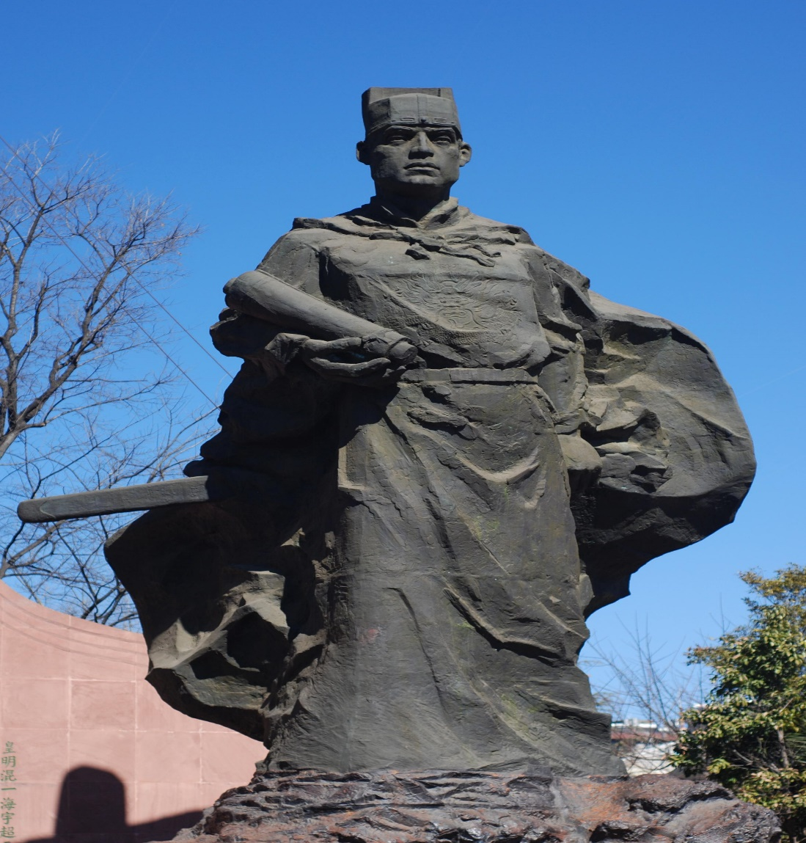
- Tribute System: Emperors like Yongle reintroduced a tribute system to assert China’s dominance and secure peace, involving nations like Japan and Vietnam.
- Economic and Cultural Exchanges: Zheng He’s voyages to places like Java, India, and East Africa established trade networks and cultural exchanges, demonstrated through goods traded and gifts exchanged.
- Diplomatic Missions: Zheng He handled local issues such as capturing pirates and supporting local leaders, reinforcing Chinese influence abroad.
- Visual and Material Evidence: Artifacts and inscriptions, such as those left in Malacca and Sri Lanka, provide evidence of the Ming Dynasty's interactions and influence.

Check-In:
1. Why did Emperor Yongle send Zheng He on expeditions?
- Answer: He wanted to show the world how powerful China was.

2. What is one way Zheng He interacted with people in the places his expeditions visited?
- Answer: Zheng He and his crews traded items from China; he handled diplomatic issues, such as capturing rogue pirates or supporting local rulers; and brought offerings for local religious sites.

Practice:
1. Using the information about Zheng He’s voyages, write a statement evaluating his journeys. What was the most significant impact his voyages had?
- Answer: Zheng He’s voyages showcased China's power through the size and technical innovation of their ships and their ability to conduct diplomacy and trade on a global scale. His voyages reinforced China's superiority and influence in the region and beyond.

2. Search online to find out what happened after Zheng He’s voyages ended. Write a statement about what happened in China after his death. What kind of information did you find?
- Answer: The Ming Dynasty stopped sending out large expeditions after Zheng He’s death. These journeys became viewed as too expensive, and even building the boats themselves was seen as too costly. The Chinese stopped traveling outside China and isolated themselves.

- Ming China: A World Leader Controlling Trade
Objective 2: Interpret the role that Ming China played in the global economy during the sixteenth and seventeenth centuries, as well as the impact that role had on China.

Essential Question: How did Ming China’s participation in the global economy affect the empire?

Key Terms:
1. Global Economy: Worldwide trade and economic system involving multiple countries.
2. Tribute: Gifts or payments made to a more powerful entity in exchange for peace or protection.
3. Porcelain: Fine ceramic material that was highly valued and widely traded.
4. Silver: A valuable traded commodity that became the primary currency for trade.
5. Isolation: A policy of remaining apart from the affairs or interests of other groups or countries.

Big Ideas:
- Ming Goods in Global Trade: The Ming Dynasty became a leader in global trade, exporting high-demand goods like porcelain, silk, and tea.
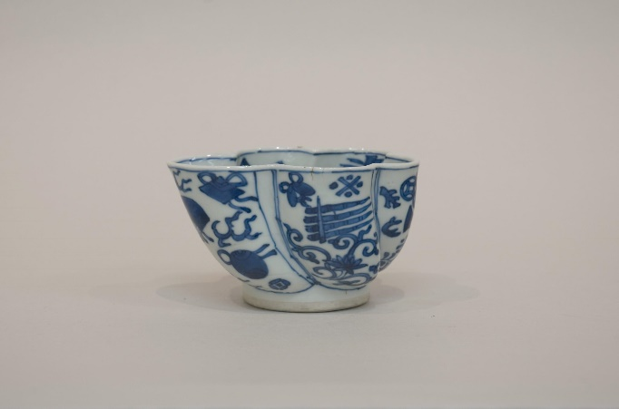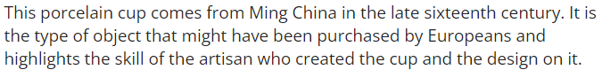
- Tribute to Trade Balance: While traditional tribute systems emphasized Chinese superiority, Europeans viewed trade as partnerships, leading to trade imbalances favoring China.
- Trade and Wealth: The demand for Chinese goods brought significant wealth to China, and the silver acquired through trade became a crucial part of the Chinese economy.
- Controlled Trade: Ming rulers controlled foreign trade strictly, seeing themselves as superior and cautiously limiting European access to their markets.
- Decline and Isolation: Post Zheng He's explorations, China's increasing inward focus led to a more isolated stance, limiting further global interaction.

Check-In:
1. What was the main way Ming Chinese authorities tried to control their role in the global economy?
- Answer: Ming China kept European traders at a distance.

2. How did Ming Chinese authorities view China in comparison with the rest of the world?
- Answer: Ming China considered itself superior to all other countries.

Practice:
1. Matteo Ricci drew a map that showed the Chinese all the continents in the world, with China at the center. How might this have affected Chinese people’s understanding of their place in the world?
- Answer: By seeing a visual representation of how China fit in with other continents, it might have helped the Chinese people see that the world was much larger beyond their country. It might have reinforced China's sense of power due to its central position but also made them realize they were one place among many.

2. What was one of the most significant ways in which participation in the global economy affected Ming China?
- Answer: Because the Chinese did not want European goods, silver became the primary item exchanged. Over time, silver became so valuable to the Chinese that they focused their currency around silver and began collecting taxes in silver. This increased demand for silver in Asia and changed the relationship between Japan and China, leading Japan to stop seeing China as superior.

- Factors of Failure

Objective 3: Interpret the reasons for the Ming Dynasty’s fall.

Essential Question: Why did the Ming Dynasty fall?

Key Terms:
1. Overextension: When an empire becomes too large or complex to maintain effectively.
2. Famine: Extreme scarcity of food, impacting populations’ health and stability.
3. Inflation: The increase in prices and the decrease in the value of money.
4. Rebellions: Uprisings or revolts against the ruling power.
5. Manchu: A group from northeastern China who eventually overtook the Ming Dynasty.

Big Ideas:
- Overextension: The expansion of the Ming Dynasty’s territories and government, coupled with costly military campaigns, stretched resources thin.
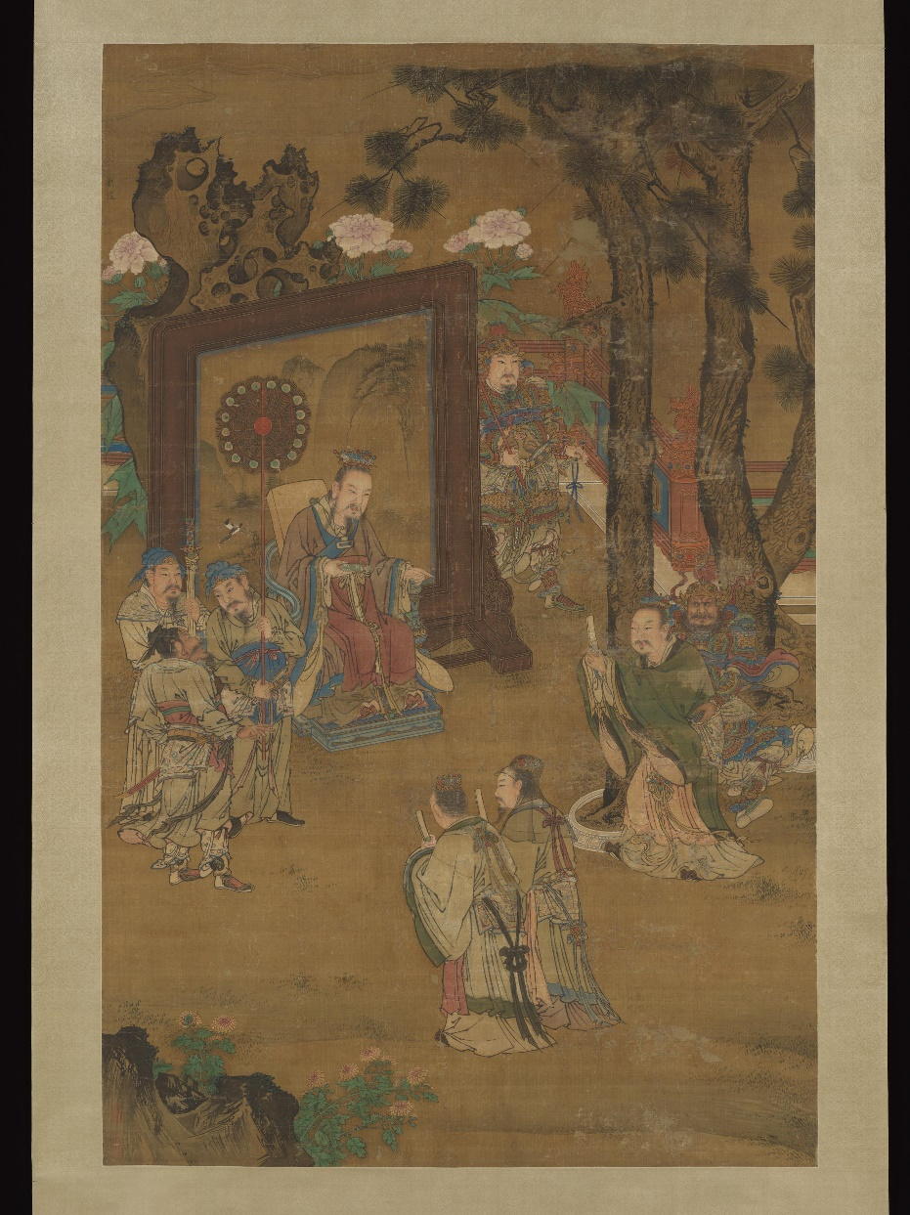
- Environmental Issues: Changes in climate and natural disasters, like the Little Ice Age and frequent typhoons, led to agricultural failures and famine.
- Government Corruption: Ineffective leadership and corruption among officials exacerbated inflation and social unrest.
- Rebellions: Internal dissatisfaction and external pressures, such as raids by the Mongols and attacks by the Manchus, weakened the empire.
- Manchu Conquest: The Manchus, taking advantage of the Ming Dynasty’s weakened state, ultimately overthrew the Ming to establish the Qing Dynasty.

Check-In:
1. What are some of the causes of the Ming Dynasty’s fall?
- Answer: There were both internal and external issues that affected the Ming. The empire faced attacks from outside forces such as the Mongols and the Manchus. Internally, government corruption, famines, and inflation caused significant problems, leading to rebellions and ultimately the dynasty's downfall.

2. Which groups of people threatened the Ming Dynasty in the sixteenth and seventeenth centuries?
- Answer: Japan, the Mongols, and the Manchus all attacked the Ming Dynasty at various times during these centuries.

Practice:
1. One of the factors that led to the decline of the Ming Dynasty was overextension. Can you interpret the information you have learned to explain how overextension affected the Ming Dynasty?
- Answer: It was expensive to maintain a larger, more complex government as the Ming Dynasty expanded the country’s borders. Keeping its borders secure was also expensive. When they had to send armies to fight the Mongols and other outside forces, this added to the financial burden on the empire.

2. Who were the Jurchen, and what do you think is most important about the role they played in the downfall of the Ming Dynasty?
- Answer: The Jurchen were a group that lived in Manchuria and followed the Ming rulers, sometimes protecting the Ming in special military units. However, efforts to strengthen and grow the Jurchen led them to eventually fight the Ming. Over time, the Jurchen became known as the Manchus, and after several decades of fighting, they established the new Qing Dynasty. What is most important about them is that they began as subjects of the Ming but eventually saw themselves as more powerful and overthrew the Ming to establish their own rule.

- The Canton System: Engaging the World

Objective 4: Explain why the Qing Dynasty established the Canton System and interpret Europeans’ reactions to the system.

Essential Question: Why did the Qing Dynasty establish the Canton System?

Key Terms:
1. Canton System: A system used by the Qing Dynasty to control foreign trade by restricting it to the port of Guangzhou (Canton).
2. Tributes: Payments or gifts given to a ruler, often as a sign of submission or allegiance.
3. Guangzhou: A port city in southern China that became the sole legal point of trade for foreigners under the Canton System.
4. Trade Imbalance: A situation where the value of imports and exports between two countries is unequal, often leading to economic tension.
5. Opium War: A conflict between China and Britain (1839-42; 1856-60) primarily over the British trade of opium in China and resulting in China opening more ports to British trade.

Big Ideas:
- Canton System Objectives: The Qing Dynasty formalized the Canton System to control foreign trade, maintain economic power, and limit European influence within China.
- Regulated Trade: The system confined all foreign trade to the port of Guangzhou under strict regulations, ensuring that the Qing government maintained control.
- European Frustrations: Western nations, particularly Britain, were frustrated by the limitations and sought to expand trade access and bypass restrictive regulations.
- Opium Trade and Conflict: The British began smuggling opium into China, leading to widespread addiction and tension, which eventually resulted in the Opium Wars.
- End of the Canton System: The Opium Wars forced China to open more ports to European trade, marking the end of the Canton System and diminishing Qing control over foreign trade.
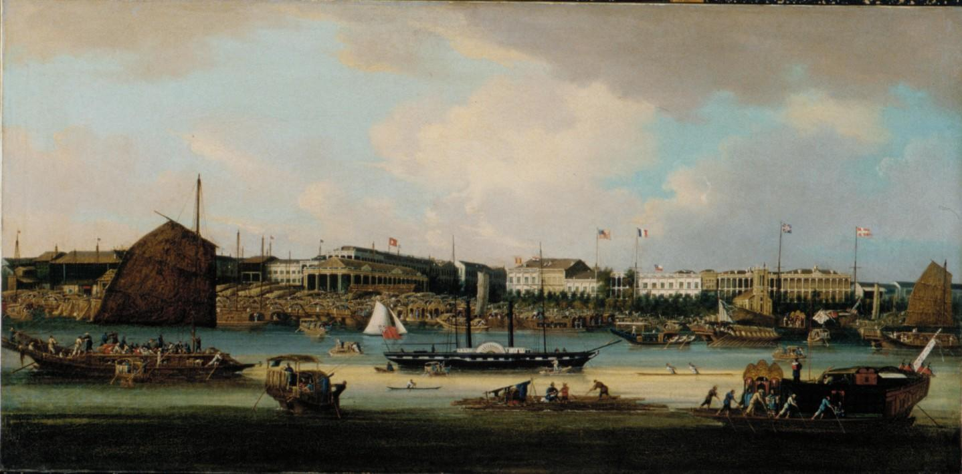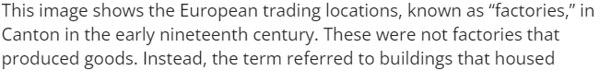

Check-In:
1. What was the Canton System?
- Answer: It was the system the Qing Dynasty used to control foreign trade. It limited Westerners’ trade access to the city of Guangzhou and included many regulations Westerners had to follow in order to trade their goods.

2. What did Westerners specifically not like about Chinese trading procedures?
- Answer: They wanted the Chinese to buy their own products from the West.

Practice:
1. Review the information you’ve just learned about the Canton System. Write a paragraph explaining what you think was the most significant reason why this system was created. Can you communicate your ideas clearly?
- Answer: The Chinese had a long history of being the most powerful country in Asia. The tribute system had helped them maintain their power because it made other countries formally recognize them as superior. The Canton System was a way to maintain power in a trading relationship with Western countries who did not see themselves as tributes that were less powerful than China.

2. Based on what you’ve learned about European responses to the Canton System, what do you see as an important turning point in the relationship between Europeans and the Qing Dynasty?
- Answer: An important turning point is when the British started finding ways to smuggle opium into China. They knew that opium was not allowed in China, but they also knew how popular it was. The Europeans wanted to find a way to trade something other than silver, and opium was the item that worked. Then, the conflict between the Europeans and the Qing Dynasty grew into war, which reduced the Qing Dynasty’s trading power from what it had previously been.

- Unit 6 Lesson 6: Russia and Japan
- Building a Russian Empire

Objective 1: Summarize how Russia began to expand as an empire.

Essential Question: How did Tsar Ivan IV expand Russia into an empire?

Key Terms:
1. Tsar: The emperor of Russia.
2. Ivan the Terrible: The first ruler to be called tsar, known for his significant territorial expansions.
3. Empire: A group of nations or regions ruled by one leader or government.
4. Streltsy: Soldiers in the Russian army who carried guns.
5. Cossacks: Members of a group of Russian warriors known for their military skill.

Big Ideas:
- Territorial Expansion: Ivan IV expanded Russia’s territory significantly, including key conquests such as Kazan, Astrakhan, and parts of Siberia.
- Use of Gunpowder: Ivan IV utilized gunpowder weapons, greatly advancing military capabilities.
- Economic Interests: Access to important trade routes and resources like fur motivated Russia’s expansion efforts.
- Military Pioneers: The Stroganovs and Cossacks played crucial roles in securing and settling Siberia.
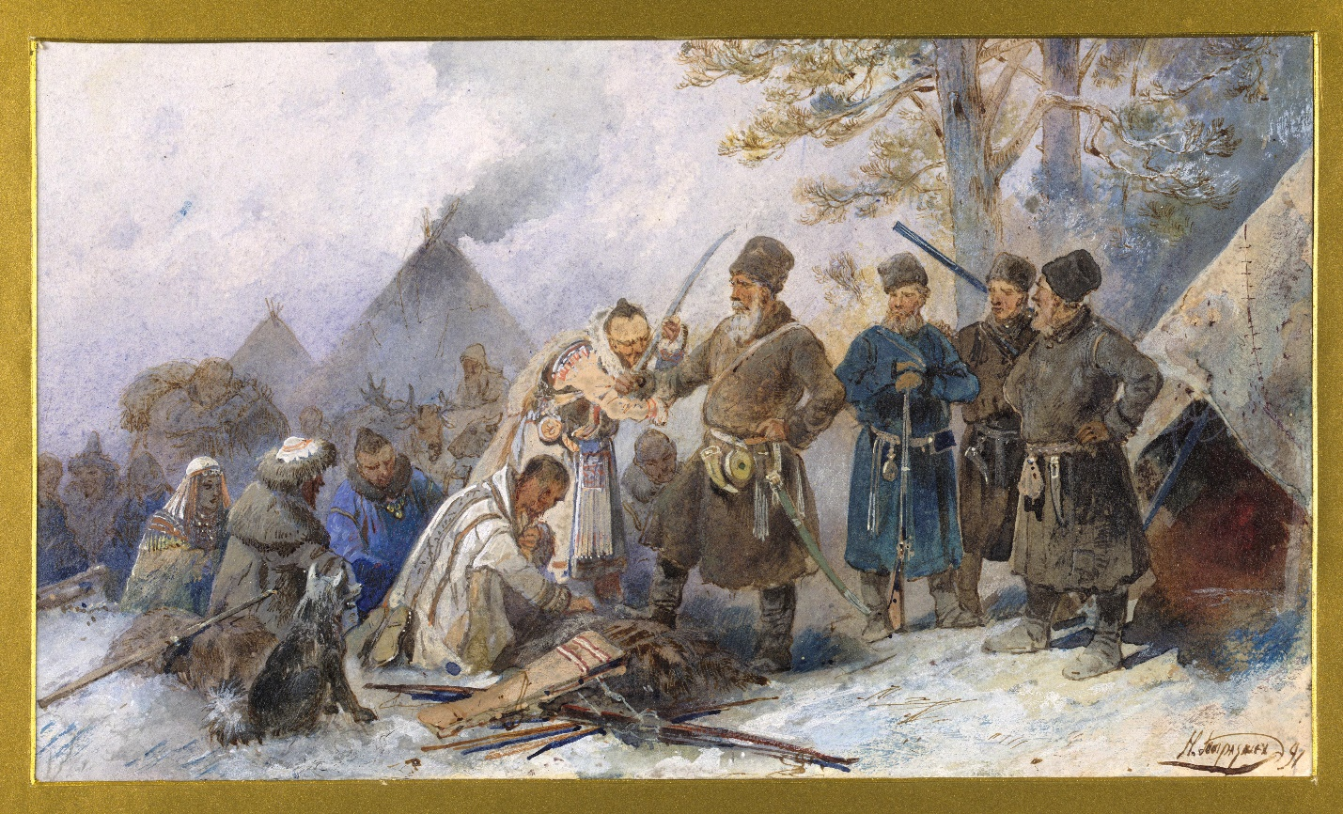

Check-In:
1. Which Russian ruler was the first to have the title “tsar”?
- Answer: Ivan IV.

2. What were the streltsy?
- Answer: Soldiers in the Russian army who carried guns.

Practice:
1. What role did weapons play in Ivan IV’s efforts to expand Russia?
- Answer: Ivan IV added the streltsy to make a standing army and used handheld guns for the first time. He also brought a firearms factory to Moscow, using Europeans who had the skills to help Russia create weapons. Ivan IV kept a large number of weapons that he used to attack places he wanted Russia to bring into its empire.

2. Why did Russians want to secure Siberia?
- Answer: They wanted access to natural resources in Siberia that could be used to make money, including fur.

- Managing an Empire of Multitudes

Objective 2: Investigate the methods of political control used in imperial Russia.

Essential Question: What methods did the Russian Empire use for political control, and what impact did these methods have on the country and its people?

Key Terms:
1. Tsar: The emperor of Russia, considered the ruler with ultimate authority.
2. Orthodox Christianity: The religion adopted by the Rus people and later the state religion of Russia, uniting the people culturally.
3. Boyars: High-ranking members of the Russian gentry, who often held significant political power.
4. Oprichnina: A policy introduced by Ivan IV to control and punish those who opposed him, giving him direct control over parts of Russia.
5. Yasak: A tribute or tax, often paid in fur, required from indigenous peoples and traders in Siberia.

Big Ideas:
- Religious Unification: Orthodox Christianity played a key role in uniting the Rus people under a common culture and supported the authority of the tsar.
- Centralized Government: Ivan IV centralized Russian government by reforming laws and creating assemblies that included church leaders.
- Aristocracy Control: The boyars were essential to governance but faced restrictions under Ivan IV’s rule to limit their power.
- Tribute Systems: Tributes, like the yasak tax, helped maintain control over new territories and provided revenue for the empire.
- Church and State Cooperation: Tsars often worked closely with the Russian Orthodox Church to reinforce their political authority. 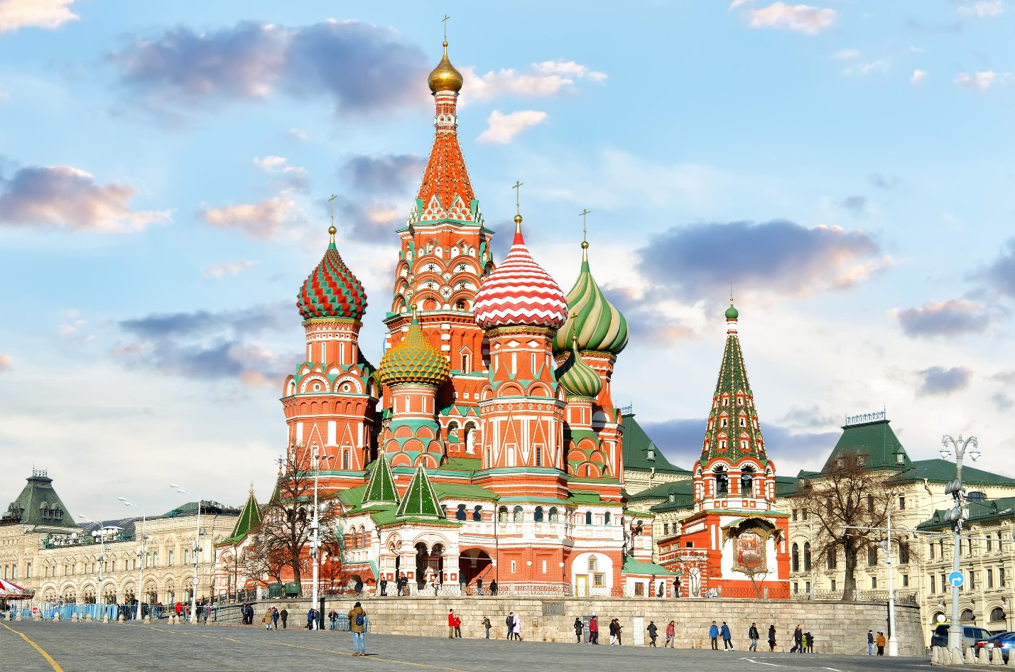 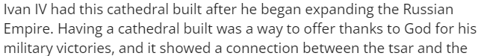

Check-In:
1. Who were the boyars?
- Answer: High-ranking members of the Russian gentry.

2. What was the purpose of yasak?
- Answer: To collect furs from Siberia as taxes from indigenous people and hunters/traders.

Practice:
1. Why was it beneficial for the tsar and the Russian Orthodox Christian Church to work together?
- Answer: When the tsar and Russian Orthodox Christian Church worked together, it increased the government’s political control over the empire. When the church supported the tsar’s government, it sent a message to the Russian people that God stood behind the tsar’s wishes.

2. Why did Ivan IV work to limit the power of the boyars during his rule?
- Answer: Before he became tsar, Ivan saw how the boyars tried to take power for themselves. During his reign, he wanted to ensure he was the most powerful person in Russia.

- A Portrait of Medieval Japan

Objective 3: Describe the economic and cultural ideas that stem from medieval Japan.

Essential Question: What economic and cultural ideas emerged in medieval Japan?

Key Terms:
1. Shogun: The military ruler of Japan who held the real power, despite the emperor being the symbolic figurehead.
2. Daimyo: Powerful landowners who often wielded significant authority within their territories.
3. Samurai: The warrior class in Japan known for their military skills and loyalty to the daimyo.
4. Zen Buddhism: A form of Buddhism focusing on meditation and self-reliance, popular among the samurai.
5. Chanoyu: The Japanese tea ceremony, developed as a formal cultural practice during the medieval period.

Big Ideas:
- Military Hierarchy: Japan was ruled by the shogun and supported by a network of warriors, including samurai and daimyo.
- Economic Growth: Agricultural advancements and new markets helped grow Japan’s economy, with increased trade and the use of coined money.
- Cultural Developments: New forms of Buddhism, visual arts, poetry, and theater emerged and thrived during this period.
- Guilds: Trade guilds helped protect merchants and artists, allowing them to develop monopolies and control markets.
- Cultural Practices: Practices like the tea ceremony and Zen Buddhism became integral to Japanese culture, particularly among the elite. 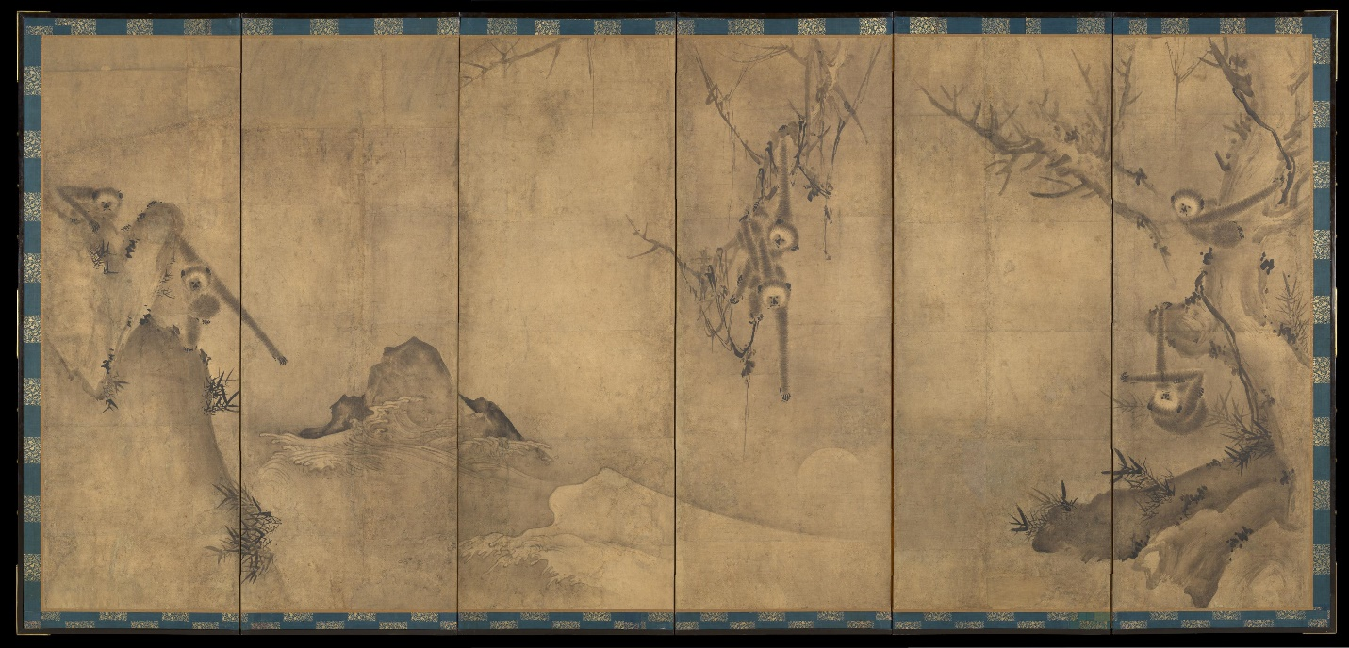 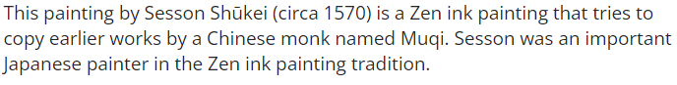

Check-In:
1. What new type of Buddhism was attractive to samurai in medieval Japan?
- Answer: Zen Buddhism.

2. What was one thing that expanded markets in medieval Japan?
- Answer: Agricultural advancements meant there were more agricultural products to sell; coins also made it easier to buy goods.

Practice:
1. Why were trade guilds helpful to merchants and artists?
- Answer: Guilds helped protect against competition. By forming guilds, merchants and artists could create monopolies that helped their businesses.

2. Why were the warrior classes interested in visual arts?
- Answer: The warrior classes, including the shogun, developed an interest in visual arts because they thought it showed that they were cultured. It was a way of competing with the emperor, to show that you did not need to be an emperor in order to have access to fine arts.

- A Hierarchy of Class Power
Objective 4: Summarize the different social classes of feudal Japan, using visual aids to organize the groups.

Essential Question: What social classes existed in feudal Japan?

Key Terms:
1. Feudalism: A social system in which lower classes served landowners, and a warrior class provided military support.
2. Hierarchy: A system in which people are ranked one above the other based on status or authority.
3. Emperor: The symbolic ruler of Japan, considered a religious figurehead.
4. Daimyo: Powerful landowners who often wielded significant authority within their territories.
5. Samurai: The warrior class in Japan known for their military skills and loyalty to the daimyo.

Big Ideas:
- Emperor and Shogun: The emperor was a symbolic figurehead, while the shogun held actual military and political power.
- Daimyo and Samurai: Daimyo were powerful landowners and warriors, while samurai served them with loyalty and military skill.
- Feudal Hierarchy: A rigid social hierarchy existed in feudal Japan, from the emperor and shogun down to peasants and merchants.
- Working Classes: Farmers, artisans, and merchants were crucial to the economy but held lower social status compared to the warrior class.
- Economic Basis: The land and its produce formed the economic basis of feudal Japan, with those owning land holding the most power. 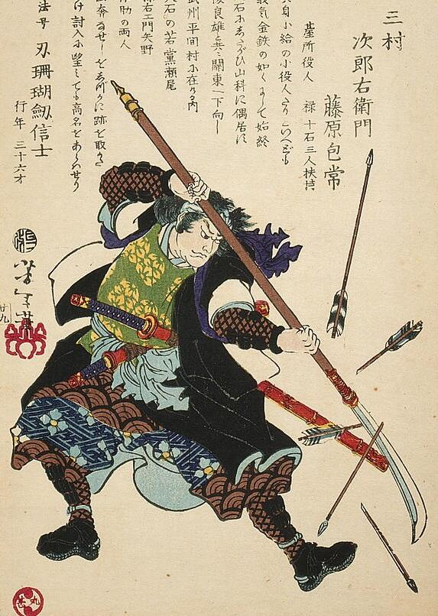 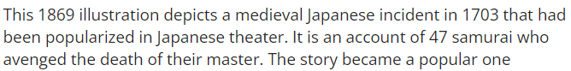

Check-In:
1. Which class typically had the most power in feudal Japan?
- Answer: The warrior class.

2. Why were merchants lowest in the social hierarchy?
- Answer: They did not produce things; they only sold other people’s goods for profit.

Practice:
1. Using what you have learned, construct a chart of feudal Japan’s social classes and rank them from the highest level of power to the lowest level of power. Include a brief description of each class.
- Sample answer:
- Shogun: Military ruler of Japan, most powerful.
- Emperor: Figurehead; lacked real power but was an important symbol and religious figure.
- Daimyo: Landowners who often held a lot of territory and political power to support the shogun.
- Samurai: Warriors who were loyal to the daimyo and supported them.
- Farmers/Peasants: Produced food for the country; essential but lower in status.
- Artisans: Produced important items for society, such as tools and clothing.
- Merchants: Often wealthy but valued least because they did not produce goods, just sold them.

2. Construct a diagram showing which social classes in feudal Japan were part of the warrior class and which were part of the non-warrior class.
- Sample answer:
- Warrior Class: Shogun, Daimyo, Samurai.
- Non-Warrior Class: Emperor, Farmers/Peasants, Artisans, Merchants.

- Unit 6 Lesson 7: Global Trade
- Origin of Luxury Trade Groups

Objective 1: Develop maps to show the geographic origin of silk, spices, cotton, and porcelain.

Essential Question: What are the geographic origins of silk, spices, cotton, and porcelain?

Key Terms:
1. Cartography: The art and technology of mapmaking.
2. Silk: A luxury fabric produced from the silk thread spun by silkworms, originating in China.
3. Spices: Flavorful plant parts such as cinnamon and nutmeg originating from Southeast Asia.
4. Cotton: A natural fiber that grows around the seeds of the cotton plant, originating in areas like the Indus River Valley in Asia and Mesoamerica.
5. Porcelain: A high-quality ceramic material originating in China.

Big Ideas:
- Geographic Origins: Silk and porcelain originated in China, while spices like cinnamon and nutmeg are native to Southeast Asia. Cotton grew widely in the Indus River Valley, Central America, and the Nile Basin in Africa.
- Historical Maps: Early maps, engraved on stone or wood, have evolved with advances like the printing press and navigational tools to modern digital maps created with computers.
- Climate Zones: Cotton thrives in regions 30 degrees north and south of the equator, establishing it in various parts of the world.
- Trade Importance: These luxury items became highly sought after, leading to flourishing trade routes that connected different civilizations. 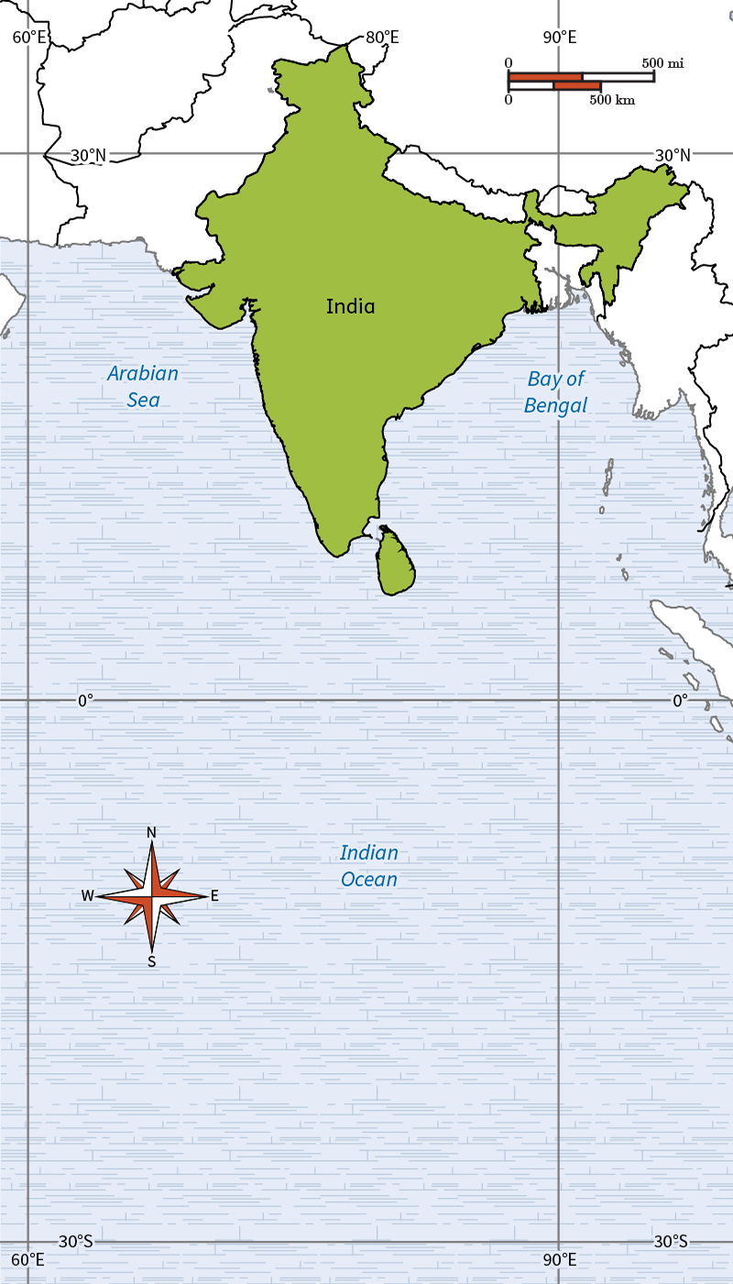 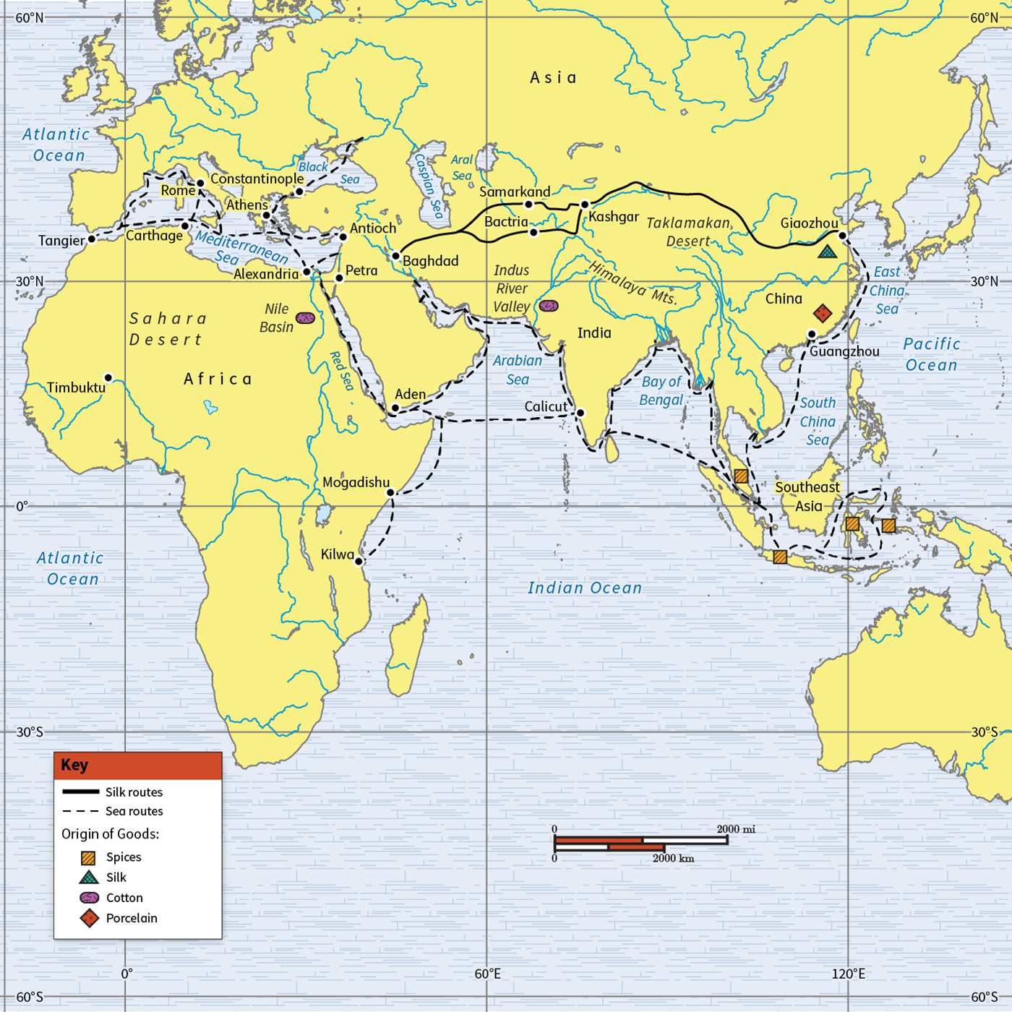

Check-In:
1. Where did silk and porcelain originate?
- Answer: China.

2. What is the term for the art and technology of mapmaking?
- Answer: Cartography.

Practice:
1. Develop two maps using different map-making technology to show trade routes for silk, spices, cotton, and porcelain between Asia, Europe, and Africa. For example, trace the trade routes on a paper map using a pencil and create a map using online interactive tools of regional climate in Asia. Analyze the two maps to explain where silk and spices originated. In 3-4 sentences, explain why silk and spices originated primarily in those areas of the world and why they were in such demand in Europe.
- Answer: Cotton and spices were available in China and Southeast Asia because these locations had the climate needed to produce these goods. Silk was only produced in China because it is where the special type of silkworm lived. Spices were harvested from plants grown in the warm, semi-tropical islands of Southeast Asia, which couldn't be grown in Europe.

2. Analyze the map created to determine why cotton was cheaper than silk cloth. In 3-4 sentences, explain why silk and spices were able to demand higher prices in Europe.
- Answer: Cotton was grown all around the world, but silk was only produced in China, limiting its supply. India was a main source of cotton for Asia and Europe. Since India was geographically closer to Europe than China, cotton was easier to get with fewer dangers for traders along the route.

- Motivating European Exploration

Objective 2: Summarize how the pivotal maritime voyages of Christopher Columbus in 1492 and Vasco da Gama in 1497–1498 were motivated by European demand for Asian luxury goods using maps with data sets (charts, tables, graphs) and/or readings.

Essential Question: What motivated Vasco da Gama and Christopher Columbus?

Key Terms:
1. Silk Road: A network of trade routes that connected Europe and Asia for trade in luxury goods.
2. Caravel: A small, fast ship used by the Portuguese and Spanish for exploration.
3. Maritime Exploration: Sea voyages undertaken by European explorers to discover new trading routes and territories.
4. Cartaz: A document issued by Portugal allowing merchants to trade in the Indian Ocean.
5. God, Gold, and Glory: The three main motivating factors behind European exploration.

Big Ideas:
- Exploring for Trade: Vasco da Gama and Christopher Columbus sought new routes to access Asian luxury goods like silk and spices.
- Portugal’s Strategy: Portugal's strategic advantage from its coastline, Prince Henry’s navigation schools, and the development of new ships led to successful explorations.
- Economic and Religious Motives: The European desire to find new wealth (gold), spread Christianity (God), and gain fame (glory) drove exploration efforts.
- Portuguese Success: Vasco da Gama found a route to India around Africa, allowing direct trade access, while Columbus’ voyage led to the discovery of the Americas. 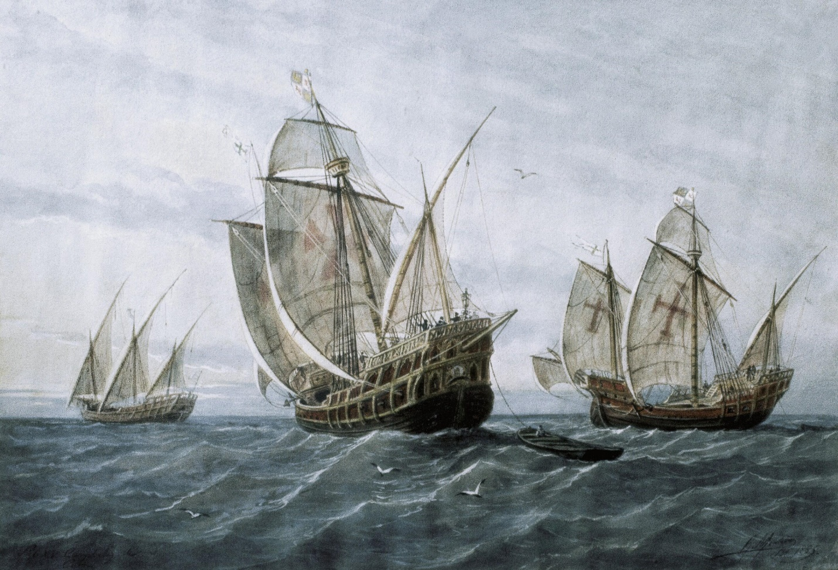

Check-In:
1. What are the three motivating factors that led to European exploration?
- Answer: Gold, God, and Glory.

2. What is one reason why Portugal was the leader in European exploration?
- Answer: Portugal was the leader because Prince Henry the Navigator started navigation schools where sailors learned to sail and read maps, and because of Portugal’s advantageous shoreline.

Practice:
1. Vasco da Gama and Christopher Columbus both created plans to acquire Asian luxury goods. Using the map, summarize how the pivotal maritime voyages of Christopher Columbus in 1492 and Vasco da Gama in 1497–1498 were motivated by the demand of Asian luxury goods. 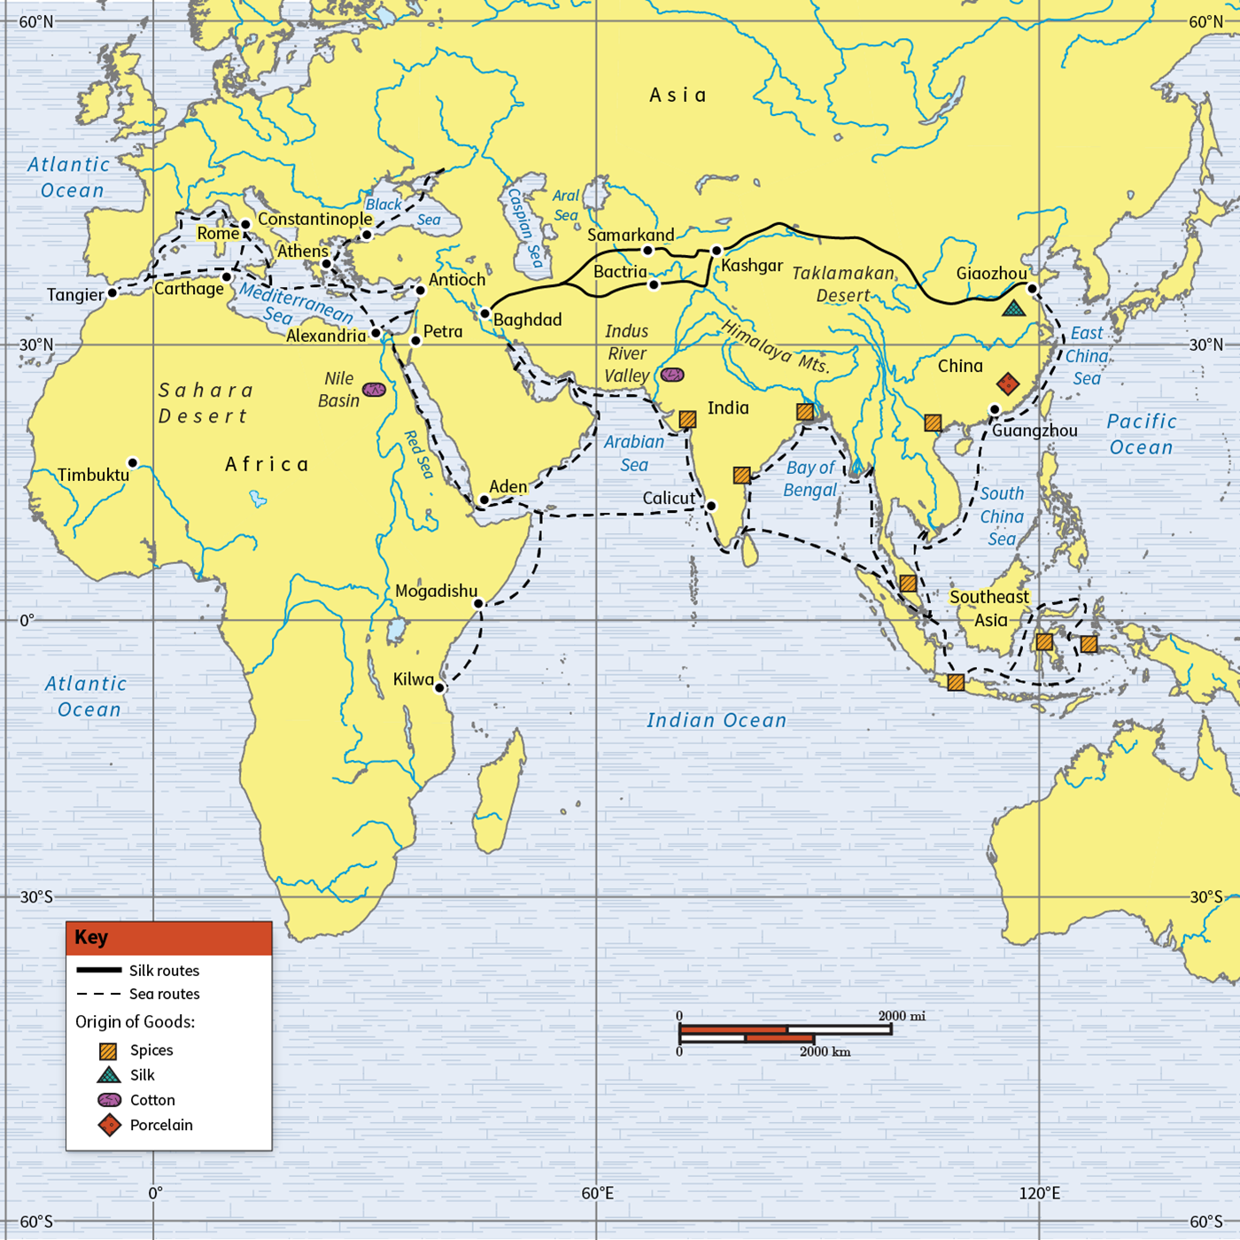
- Answer: Vasco da Gama wanted to acquire spices, tea, and silk directly, reducing costs by bypassing Arab middlemen. Columbus aimed to reach the Indies for spices, motivated by Spain's need for wealth and the desire to spread Christianity. Both voyages were driven by the demand for Asian luxury items, economic gain, and religious spread.

2. Using the summary and analysis of the map from Question 1, why do you think it was so difficult to sail around Africa?
- Answer: The seas in between continents, such as the Mediterranean Sea and Arabian Sea, were not connected by water. The large size and shape of Africa required explorers to travel far out to sea, navigating difficult and unknown waters, which made the journey challenging.

- Global Markets, Global Impact

Objective 3: Analyze the ways in which the exchange of Asian luxury goods and silver impacted economies in Asia, Africa, America, and Europe.

Essential Question: How did Asian luxury items and South American silver fundamentally alter global economies?

Key Terms:
1. Silk Road: The network of routes used for the trade of luxury goods between Asia and Europe.
2. Inflation: The decrease in the value of currency and the rise in prices due to a large influx of money, such as the silver from South America.
3. Mercantilism: An economic policy focused on maximizing exports and minimizing imports, often through the use of colonies.
4. Revenue: Income generated from trade or economic activity.
5. Caravan: A group of traders traveling together, often in desert regions like those in Africa.

Big Ideas:
- Luxury Goods Trade: The global exchange of luxury items like spices and silk from Asia significantly influenced European economies and social status symbols.
- Silver’s Impact: South American silver, particularly from mines in places like Potosí, flooded into Europe, creating immense wealth but also contributing to inflation.
- Colonial Expansion: European nations adopted mercantilism, setting up colonies to control resources, which further enriched Europe at the expense of colonized regions.
- African Trade Decline: Traditional trade routes in Africa declined due to new sea routes, leading to economic and social disruptions, including the trafficking of enslaved people.
- American Colonies: Indigenous American economies were destroyed, and their resources were extracted for European benefit, leading to long-term economic and humanitarian costs. 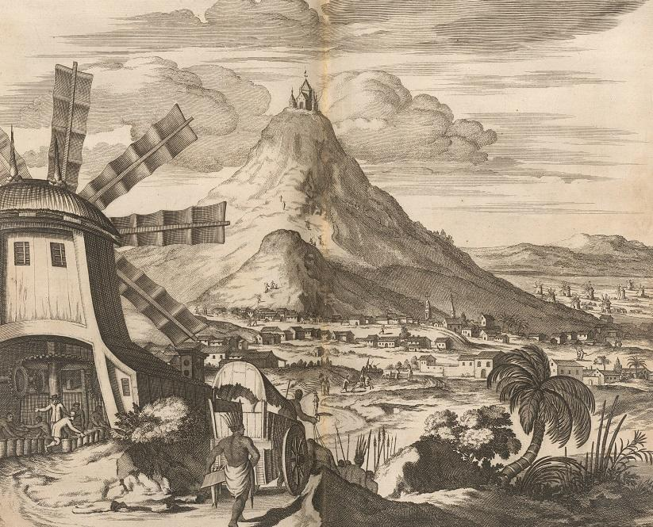 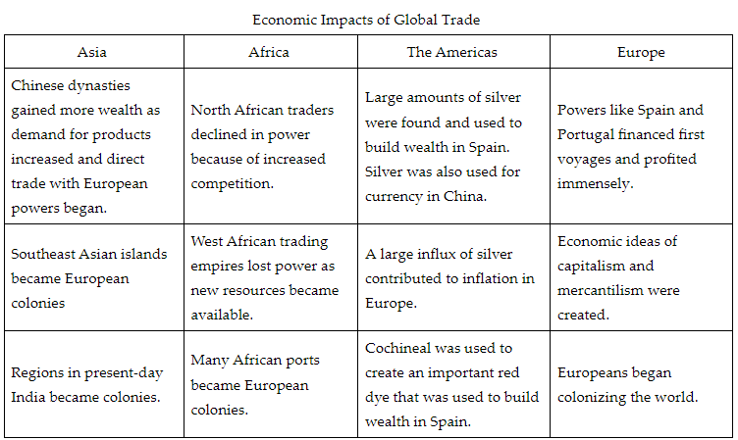

Check-In:
1. List the specific reasons why nation-states wanted to find direct access to India, Asia, and “The Spice Islands.”
- Answer:
- Nation-states wanted to find new routes to obtain Asian luxury goods like tea, spices, silk, jade, and porcelain.
- Nation-states wanted to avoid paying the Arab and Asian traders in order to get luxury items at lower prices.

2. Name one specific economic impact of global trade in the Americas and one specific impact of global trade in Africa.
- Answer:
- Americas: Large amounts of silver were taken out of South America, local economies disappeared, and the Americas became colonies of European powers.
- Africa: Raw materials were exported, many people were enslaved, coastal areas became colonies, North African traders faced competition, caravan routes decreased, and Western trading empires declined.

Practice:
1. Analyze how South American silver impacted two different economies.
- Answer: South American silver impacted Spain’s economy by generating immense wealth but also contributing to inflation in Europe. China imported silver from Spain and converted from paper currency to silver, impacting their economy positively by increasing wealth accumulation.

2. To what extent were European powers economically enriched through global trade while other regions were negatively impacted? Use evidence to reason effectively.
- Answer: European powers, like Spain and Portugal, were markedly enriched through global trade, gaining wealth from precious metals, new crops, raw materials, and the establishment of colonies. Meanwhile, other regions such as Africa, the Americas, and Southeast Asia were negatively impacted by resource extraction and oppression. However, China also benefited economically through trade with Europe, demonstrating varied impacts of global trade.

- Portugal Makes a Big Impact

Objective 4: Analyze the extent to which Portuguese entry into the Indian Ocean trade network in the fifteenth and sixteenth centuries disrupted earlier patterns of trade using primary and secondary sources.

Essential Question: How did Portugal impact the Indian Ocean trade network?

Key Terms:
1. Monopoly: Exclusive control over trade or production of a commodity.
2. Intermediary: An agent or third party that acts as a go-between in trade or business transactions.
3. Cartaz: A permit issued by Portugal that allowed merchants to trade in the Indian Ocean.
4. Caravel: A small, fast Portuguese ship used for exploration.
5. Religious Zeal: Intense devotion and enthusiasm for spreading a religion, often associated with violence in historical contexts.

Big Ideas:
- Shift of Power: Portugal disrupted existing trade patterns controlled by Muslim traders, Venetians, and Chinese by establishing direct sea routes to India and the Spice Islands.
- Economic Change: The influx of spices and luxury goods reduced prices in Europe, changing economic dynamics.
- Cartaz System: Portugal's implementation of the cartaz system forced all trading ships to purchase permits, legalizing Portuguese piracy.
- Colonial Expansion: Portugal’s success inspired other European powers to seek their own routes, intensifying colonial expansion and competition.
- Religious Influence: Portugal’s integration of Catholicism into trade practices marked a significant departure from the more tolerant trade relationships of previous Muslim traders. 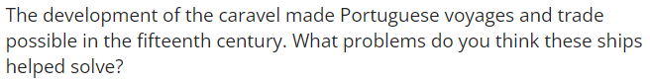

Check-In:
1. What problems did earlier patterns of trade cause for the Portuguese?
- Answer: Muslim traders from North Africa and the Middle East, the Chinese, and the Venetians controlled Indian Ocean trade, monopolizing routes and products and making it difficult for the Portuguese to access Asian luxury goods. The Ottoman and Egyptian empires only allowed Muslim traders to pass overland, creating a significant barrier for the Portuguese.

2. Evaluate the primary and secondary sources, then name two ways that the Portuguese changed earlier patterns of trade in the Indian Ocean.
- Answer: The Portuguese were the first European power in the Indian Ocean trade, and they established the cartaz system.

Practice:
1. Imagine you are an Indian resident of Calicut. Write a short journal entry that describes your first encounter with the Portuguese. Be sure to note the differences you notice compared to previous Muslim traders.
- Answer: Today was my first encounter with a European power in this port: the Portuguese. They had new, faster, lighter ships called caravels. They destroyed our city and made people convert to Catholicism. A lot of violence occurred today. There is also a new system of permits that all boats need to buy in order to allow them to trade here—all of this is new. All of this was so different than the Muslim traders we are used to seeing. They didn’t try to force us to convert and transactions were mostly peaceful. Also, there was no such thing as a permit to trade.

2. Make a chart that illustrates what the Indian Ocean trade network looked like before Portuguese involvement and after.
- Answer:
- Before Portuguese
- Powers: Muslim, Chinese, and Venetian traders
- Products: Spices, luxury goods
- Tools: Diplomacy, business negotiations
- Economic Impact: High prices set by Muslim traders and Venetians
- After Portuguese
- Powers: Portuguese, European powers
- Products: Spices, luxury goods
- Tools: Caravels, violence, religious zeal, permits
- Economic Impact: Lower prices set by Portuguese

- Unit 6 Lesson 8: Maritime Empires
- Expansion

Objective 1: In this section, you will compare the development of maritime empires, like the Portuguese Empires, with the development of land-based empires, like the Chinese, Russian, and Ottoman Empires, in the fifteenth and sixteenth centuries.

Essential Question: What led to the growth of maritime and land-based empires during the 1400s?

Key Terms:
1. Mercantilism: An economic theory that a country's power depends on its wealth, particularly in gold and silver.
2. Maritime empires: Empires built through naval power and control of sea trade routes.
3. Trading post empire: An empire that controls trade through a network of fortified trading stations rather than direct territorial control.
4. Colonization: The process of establishing control over a foreign territory and its people.
5. Joint-stock companies: Business entities where investors buy shares and share in profits and losses.

Big Ideas:
• The spice trade and fall of Constantinople led European nations to seek new trade routes
• Portugal established the first European maritime empire through exploration
• Land-based empires expanded through military conquest and direct control
• Maritime empires relied on trade, while land empires required significant infrastructure
• Both types of empires had to navigate ruling multiethnic populations 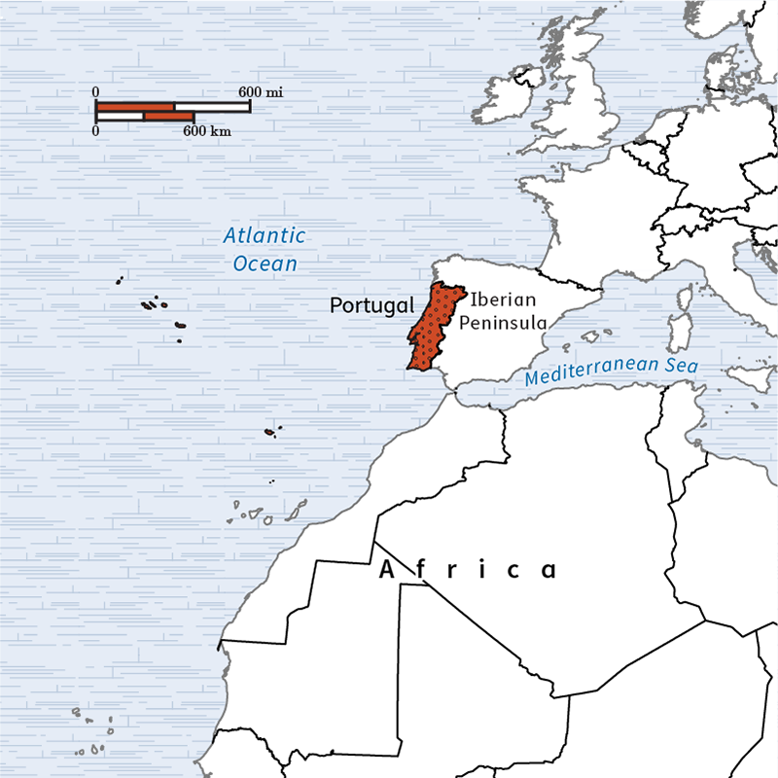 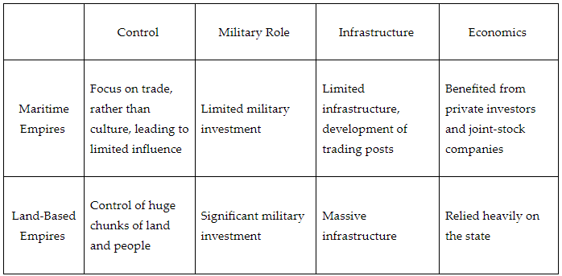

Check-In:
1. What are three land-based empires that expanded while the Portuguese explored and expanded into the Indian Ocean?
Answer: Any three from the following list: Ming China, Ottoman Empire, Russian Empire, and Mughal Empire

2. What does a trading post empire do?
Answer: A trading post empire asserts control over areas outside of its nation through control of trade rather than through direct colonization. They seek to control trade networks by establishing strategic trading centers.

Practice:
1. Describe why the Portuguese began to explore the Indian Ocean.
Answer: Sample answer: The Portuguese began to explore the Indian Ocean because they wanted to find a way to participate in and possibly control aspects of the spice trade after the Turks conquered Constantinople, signaling the end of the Byzantine Empire.

2. Describe a few cultural developments and achievements in expanding empires in the fifteenth and sixteenth centuries.
Answer: Sample answer: The Portuguese adopted and developed navigational techniques through technology, such as the astrolabe and caravel. Land-based empires developed in terms of exploration, architecture, arts, and sciences. The Ming Dynasty allowed for a period of overseas exploration under Admiral Zheng He. The Mughal Empire had long periods of religious tolerance and built the Taj Mahal; and the Ottoman Empire made a number of advances in the arts, sciences, architecture, and medicine.

- A Trading Post Empire

Objective 2: In this section, you will outline the causes and effects of the Portuguese maritime trading post empire in the Indian Ocean.

Essential Question: How did the Portuguese maritime trading post empire affect the peoples around the Indian Ocean?

Key Terms:
1. Trading post empire: An empire that controls trade through a network of fortified trading stations rather than direct territorial control.
2. Factories: Fortified trading posts established by European powers in foreign lands.
3. Armed trade: The use of military force to protect and enforce trade interests.
4. Monopoly: Exclusive control over a particular trade or commodity.
5. Assimilation: The process by which a minority group adopts the customs and attitudes of the prevailing culture.

Big Ideas:
• Portugal established trading posts and factories along the Indian Ocean coastlines
• The Portuguese used force to maintain control over trade routes
• Their empire focused on trade rather than territorial conquest
• Portuguese actions significantly impacted local cultures and economies
• The trading post model was later adopted by other European powers 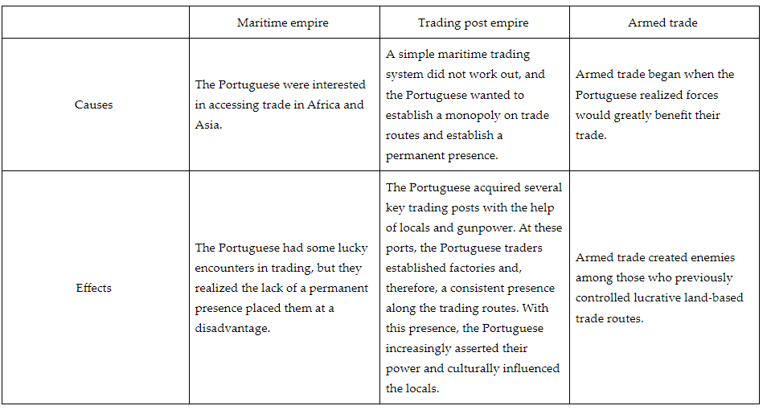

Check-In:
1. Name any three major Portuguese trading posts in the Indian Ocean.
Answer: Portuguese trading posts mentioned in this lesson include Sofala, Kilwa, Calicut, Goa, Macao, Canton, and Luanda.

2. What were the compounds the Portuguese established to maintain control of ports called?
Answer: factories

Practice:
1. Describe how the Portuguese were able to gain control of trade in the Indian Ocean.
Answer: Sample answer: The Portuguese used force and exploited local rivalries to take control of strategic ports and built factories to maintain control.

2. Describe the consequences of Portuguese influence in the Indian Ocean.
Answer: Sample answer: Portuguese trade increased the influence of Christianity in the Indian Ocean, established new forms of local administration within colonial holdings, and introduced some New World crops through the Columbian Exchange. However, they also caused destruction through attacks on other religions and cultures, military takeovers, and stifling local developments of industry, as colonies require the European nations and cannot be fully independent.

- The Dutch Lead

Objective 3: In this section, you will outline the economic and political impact of global trade on Western Europe through a primary source written by Josiah Child, a British investor in the East India Company and Royal Africa Company, and the cover images of Abraham de Bruyn’s volume.

Essential Question: How were the Dutch able to establish a trade empire in South and East Asia leading to the "Dutch Golden Age"?

Key Terms:
1. Dutch East India Company: A powerful Dutch trading company granted a monopoly on Asian trade.
2. Joint-stock company: A business entity where investors buy shares and share in profits and losses.
3. Dutch Golden Age: A period of great prosperity and cultural achievement in the Netherlands.
4. Monopoly: Exclusive control over a particular trade or commodity.
5. Commercial goods: Products bought and sold in trade.

Big Ideas:
• The Dutch established a trading post empire similar to the Portuguese model
• They formed the Dutch East India Company, a joint-stock company with significant powers
• The Dutch focused on key spices and inter-Asian trade
• Their success led to the "Dutch Golden Age," a period of prosperity and cultural achievement
• Dutch success inspired other European nations, like Britain, to follow their model 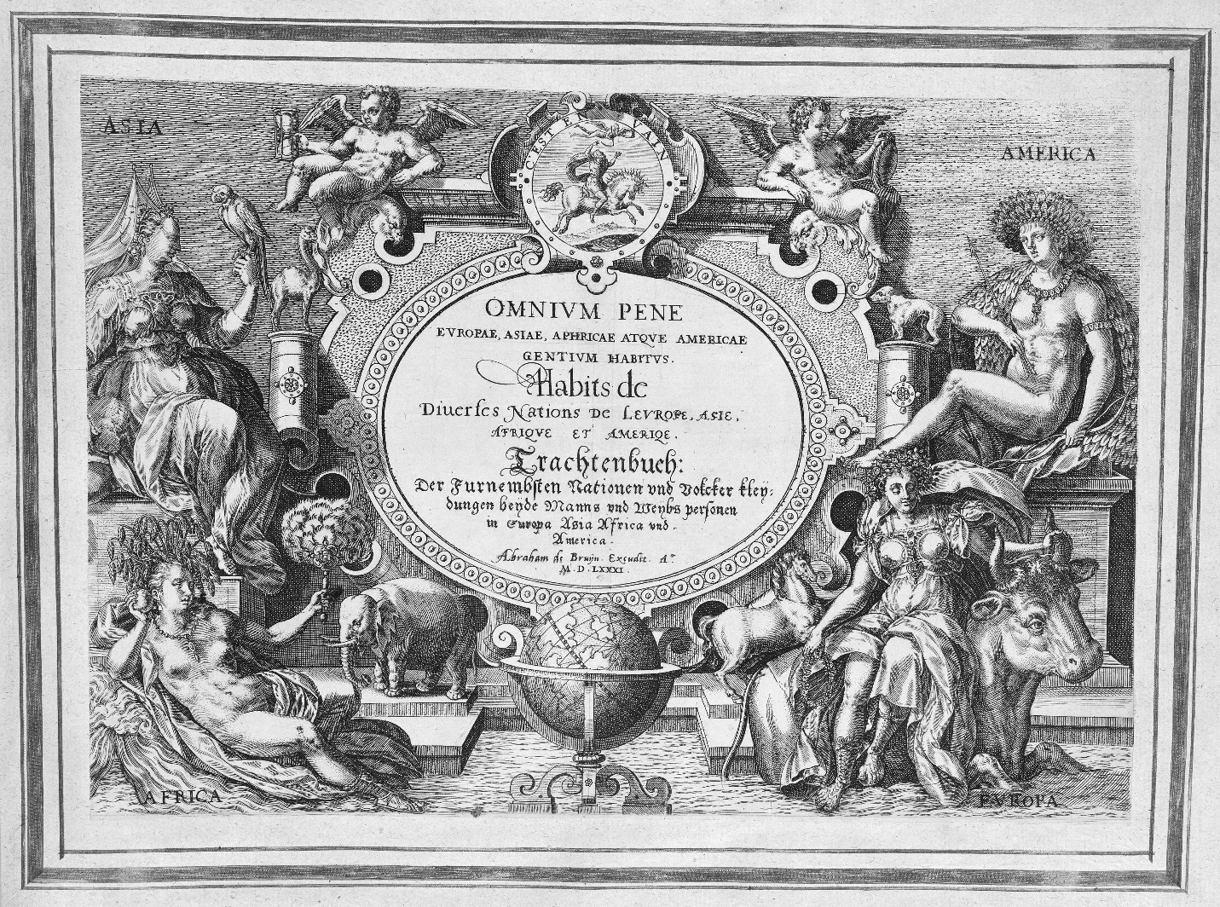 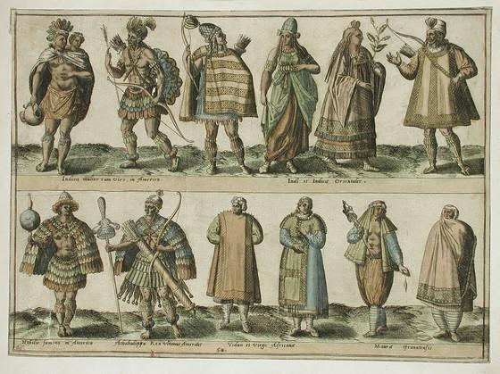 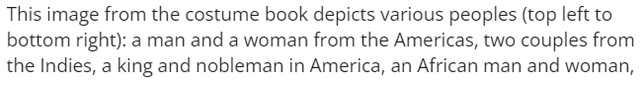 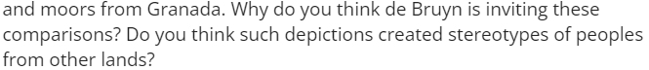

Check-In:
1. Between the British and Dutch, which nation was initially more successful in Asia?
Answer: The Dutch East India Company was more organized and able to form important trading partners in Asia, often by force.

2. What was Josiah Child's main request of the British government?
Answer: Josiah Child wanted the British government to lower interest rates.

Practice:
1. Describe why Josiah Child believed the Dutch East India Company was more successful than the British East India Company in 1668.
Answer: Sample answer: Child believed the Dutch East India Company was more successful because the Netherlands developed a culture around trade and the state helped investors and traders more in the form of faster courts, assistance in shipbuilding, quality regulation of goods, and lower interest rates.

2. Outline how the cover of Abraham de Bruyn's volume demonstrated a sense of hierarchy of continents.
Answer: Sample answer: On the cover page of Abraham de Bruyn's volume, an image depicts all four continents. Europa, or Europe, is depicted fully clothed and as a ruler. Asia is depicted as clothed, yet still exotic. Africa is depicted as naked but with key trading goods. America is depicted as naked with a feather headdress and cape.

- Investigating Shifts in Trading

Objective 4: In this section, you will investigate the impact of growing European engagement in direct maritime trade with Asia on overland trade routes controlled by the Ottoman Empire.

Essential Question: What factors led the Europeans to successfully dominate global trade?

Key Terms:
1. Circumnavigation: The act of sailing or traveling all the way around something, especially the world.
2. Paradigm shift: A fundamental change in approach or underlying assumptions.
3. Industrialization: The process of developing an economy based on large-scale industry.
4. Janissaries: Elite infantry units that formed the Ottoman Sultan's household troops and bodyguards.
5. Cross-cultural interactions: Exchanges between different cultures, including ideas, technologies, and practices.

Big Ideas:
• European explorations, like Magellan's circumnavigation, challenged traditional beliefs
• Scientific achievements and industrialization gave Europeans a competitive advantage
• The Ottoman Empire's military decline was partly due to failure to adopt new technologies
• Europeans learned from Ottoman mistakes and focused on innovation and industrialization
• Cross-cultural interactions facilitated European technological advancements
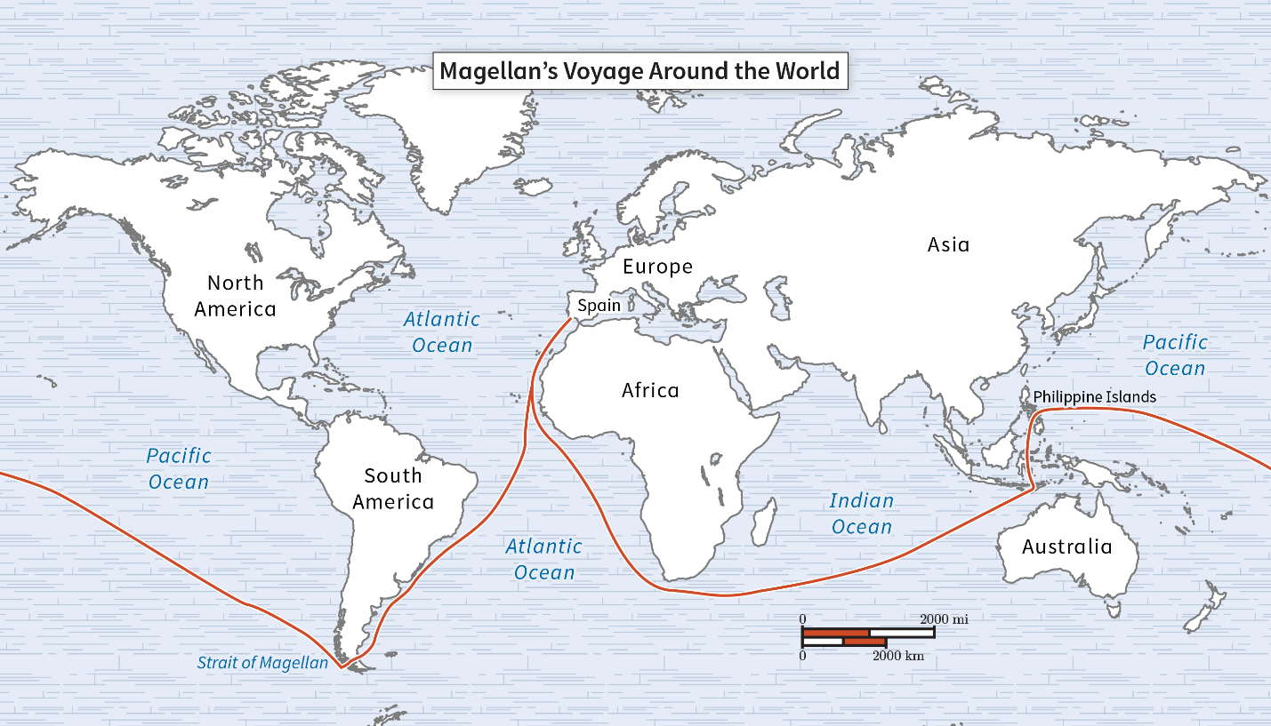
Check-In:
1. What are two cultural achievements, according to the Europeans, that placed them at an advantage in terms of trade?
Answer: The development of science and industrialization

2. Why did Sir William Eton believe the Janissaries were no longer useful to the Ottoman Empire?
Answer: The Janissaries refused to adapt to modern methods of warfare.

Practice:
1. Investigate Eton's survey for a plausible reason for the decline of the Ottoman Empire:
Answer: Sample answer: The Ottomans did not adopt and manufacture weapons. In addition, the Janissaries had considerable power yet held their countries back with their refusal to modernize their weaponry. Meanwhile, the Europeans were able to industrialize and train with firearms.

2. Investigate "Magellan's Voyage Round the World" (accessible on pages 42–48) for a struggle Magellan's crew faced in their successful attempt to circumnavigate the globe:
Answer: Sample answer: Magellan's crew faced a number of setbacks, from changing water routes to struggles obtaining supplies to pushback from Indigenous peoples they encountered. In addition, Magellan died in one of the skirmishes in the Philippines.

