- Unit 5 Lesson 1: Early Civilizations
- Africa to 1500: Introduction
Timeline:
7000 BCE:
- Early Agriculture Begins: Agriculture starts developing in various parts of Africa, leading to the establishment of farming villages.

3000 BCE:
- Rise of Ancient Egypt: Ancient Egypt emerges along the Nile River, becoming one of the first major civilizations.

1000 BCE:
- Emergence of Nubia: Nubia, located south of Egypt, begins to develop as a distinct civilization borrowing heavily from Egyptian culture but maintaining unique traits.

1000 CE:
- Rise of Sahel States: Powerful states begin to emerge in the Sahel region south of the Sahara Desert, utilizing their formidable cavalry and engaging in extensive caravan trade.
- Trade in Gold and Salt: Sahelian states grow wealthy by trading gold for salt and other goods through caravan routes across the Sahara Desert.

13th Century:
- Ghana Empire: The Ghana Empire dominates West Africa, thriving on wealth from trans-Saharan trade.
- Malaria and Other Diseases: In many parts of Africa, diseases such as malaria, yellow fever, and sleeping sickness make settlement difficult.

1350 CE:
- Kingdom of Mali: After the fall of Ghana, the Mali Empire rises to prominence under leaders like Mansa Musa, known for his pilgrimage to Mecca and immense wealth.

15th Century:
- Rise of Songhai: The Songhai Empire emerges as a dominant power in West Africa, continuing extensive trade networks and fostering cultural growth.

Throughout these periods, African civilizations are influenced by exchanges and interactions:
- Egypt's Interaction with Nubia: Egyptians expand southward into Nubia, leading to cultural exchanges and conflicts. Eventually, Nubia becomes strong enough to expel the Egyptians and even rule over Egypt for a time.
- Ethiopia Adopts Christianity: Influenced by Christian missionaries, Ethiopia becomes a center of Christianity in Africa.
- Islam Spreads to the Sahel: Muslim traders and missionaries introduce Islam to the Sahel region, significantly impacting local cultures and practices.
Objective 1: To understand the factors that contributed to the rise and fall of civilizations in Africa before 1500.
Essential Question: What factors contribute to the rise and fall of civilizations?
Key Terms:
1. Cavalry - Soldiers who fought on horseback.
2. Caravan - A group of traders traveling together across distances.
3. Sahara Desert - The largest desert in the world, located in northern Africa.
4. Nubia - An ancient region located along the Nile River, south of Egypt.
5. Migration - The movement of people from one place to another.

Big Ideas:
- Diverse Geography: Africa's diverse environments, like the Sahara Desert and fertile grasslands, influenced how societies developed. Where it was hard to live, like in areas with diseases such as malaria, yellow fever, and sleeping sickness, fewer people lived. But where the land was rich and good for farming, powerful civilizations grew.
- Trade and Wealth: Powerful states in the Sahel region south of the Sahara desert traded gold for salt and goods. These trades made them wealthy.
- Cultural Exchange: African civilizations like Nubia borrowed and learned from their neighbors, including Egypt. Nubia became strong enough to expel the Egyptians and even ruled over Egypt for a time while maintaining their unique culture.
- Diverse Development: Different regions developed their own ways of life. For example, the Sahel had strong cavalry armies, while the forested regions were known for their skilled craftsmen. 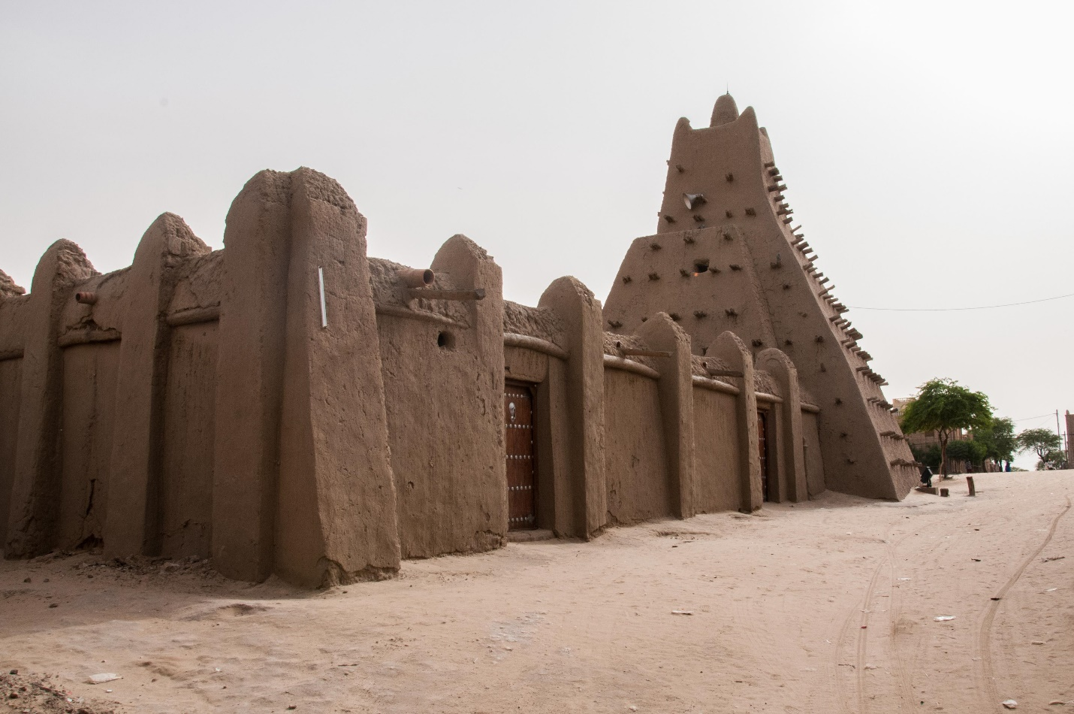 
Check-In Questions:
1. Why was the Sahara Desert important in the history of Africa?
- Answer: It influenced where civilizations could develop and was a key route for trade caravans.
2. What made the Sahel region powerful?
- Answer: Its formidable cavalry and wealth from the caravan trade across the Sahara.
Practice Questions:
1. How did the geography of Africa affect the civilizations that developed there?
- Answer: Diverse environments like deserts, fertile grasslands, and forested areas created different living conditions and resources, leading to varied societal developments.
2. What role did trade play in the development of African civilizations?
- Answer: Trade allowed civilizations to grow wealthy and powerful by exchanging valuable resources like gold and salt across large distances.
- Unit 5 Lesson 2: Physical Features and Migration Patterns
- Major Geographic Features of Africa

Objective 1: To analyze geographic features of Africa before 1500, including both physical and human characteristics that define regions.

Essential Question: What major geographic features define and differentiate the regions of Africa before 1500?

Key Terms:
1. Sahara Desert - The world’s largest desert located in northern Africa.
2. Nile River - The world’s second-longest river flowing through Eastern Africa.
3. Sahel - A transition zone between the Sahara Desert and savannas in West Africa.
4. Savannas - Grasslands with scattered trees.
5. Niger River - A major river in West Africa that supports many civilizations.

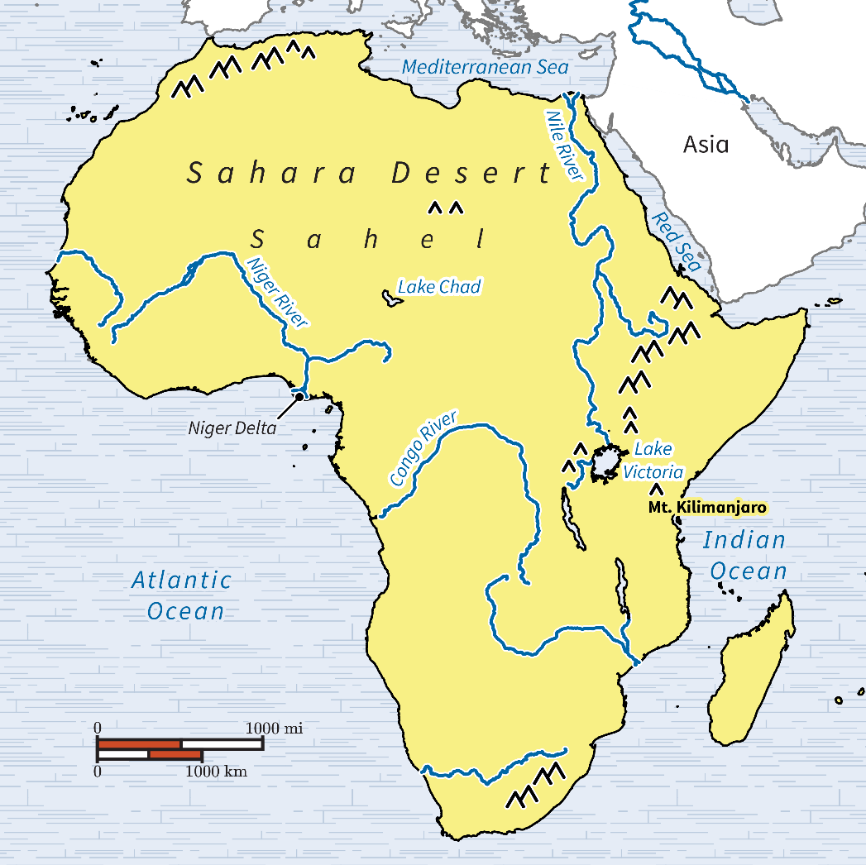

Big Ideas:
- Birthplace of Humans: Africa is where modern humans first appeared, and it is rich in both fertile lands and challenging environments.
- East Africa: Known for the Nile River Valley which supported ancient civilizations like Egypt. It also has the East African Rift System, fertile lands, and major water sources like Lake Victoria.
- West Africa: Known for the Sahel region and the Niger River Valley which supported powerful kingdoms like Ghana, Mali, and Songhai.
- Physical Features and Settlements: People settled in areas with water and fertile lands for agriculture. East Africa's Rift System, including Mount Kilimanjaro and Lake Victoria, and West Africa's Sahel and Niger Delta were key settlement areas.

Check-In Questions:
1. As of 2007, what is the longest river in the world?
- Answer: The Amazon.
2. What is the main source of water for the Nile River?
- Answer: Lake Victoria.

Practice Questions:
1. Looking at the map, which body of water is closest to the Ethiopian Highlands?
- Answer: The Red Sea.
2. Looking at the map, describe where the Niger River is located.
- Sample Answer: The Niger River is in the western part of Africa, under the Sahara Desert, and near the Atlantic Ocean.

- Changing the Cultural Landscape

Objective 2: To describe the reasons for the Bantu migration and the places where they migrated.

Essential Question: What are the reasons for the Bantu migration?

Key Terms:
1. Migration - Movement of people from one area to another.
2. Ironworking - Creating tools and weapons from iron.
3. Subsistence farming - Farming to meet the needs of a family.
4. Depletion - The reduction or exhaustion of resources.
5. Great Zimbabwe - A significant archaeological site and ancient city built by the Bantu.

Big Ideas:
- Origins of the Bantu: The Bantu people originated from southern West Africa (modern-day Nigeria and Cameroon) around 1000 BCE. They were skilled in ironworking and practiced subsistence farming.
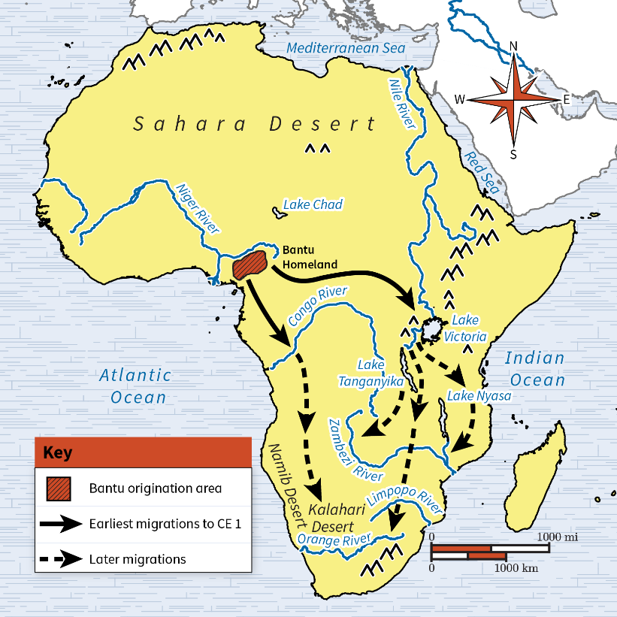
- The Bantu Migration: The Bantu migrated in multiple phases across Africa due to reasons like depletion of resources, overpopulation, and tribal conflicts. They spread their language, culture, and ironworking skills.
- Impact on Settlements: The Bantu migration led to the establishment of settled agriculture. They introduced crops like cereal grains and practices such as animal husbandry. Their movement created new cultural, economic, and political landscapes in Africa.
- Great Zimbabwe: The Shona people, an ethnic group of the Bantu, built Great Zimbabwe around 1100 CE, famous for its large walled structures, trade in precious goods, and influence on the region.

Check-In Questions:
1. From where did the Bantu originate?
- Answer: Modern-day areas of Nigeria and Cameroon.
2. How many languages are derived from the Bantu language?
- Answer: Around 500.

Practice Questions:
1. Why do historians think the Bantu decided to migrate?
- Sample Answer: The major theories include depletion of resources, overpopulation, tribal warfare, climate change affecting crops, and epidemics.
2. How do we know the Bantu migrated?
- Answer: Through the iron tools and pottery they left behind.

- Settled Agriculture

Objective 3: To explain how the Bantu migration contributed to settled agriculture in Africa.

Essential Question: How did the Bantu contribute to settled agriculture in Africa?

Key Terms:
1. Cereal grains - Types of grasses cultivated for their edible grains.
2. Animal husbandry - The science of breeding and caring for farm animals.
3. Subsistence farming - Farming to meet the needs of a family.
4. Migration - Movement of people from one area to another.
5. Cultural exchange - The exchange of ideas, customs, and technologies between cultures.

Big Ideas:
- Farming Techniques: The Bantu migration is responsible for spreading settled agriculture across Africa by introducing new crops like cereal grains and advanced farming techniques. 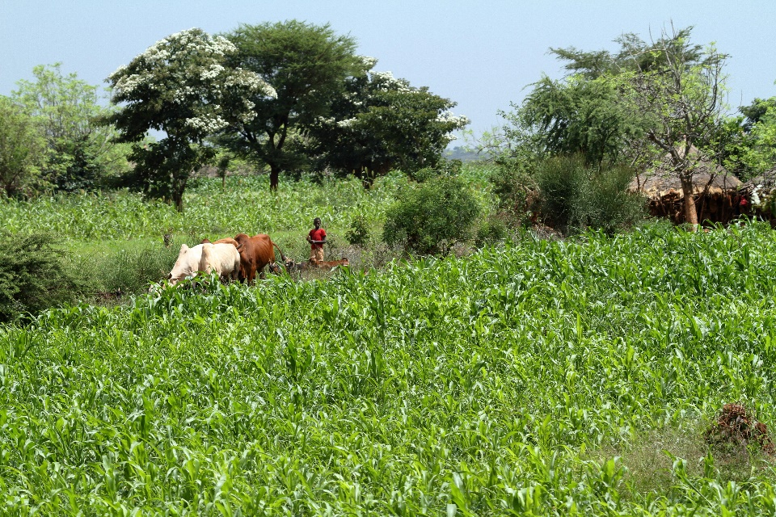
- Technological Advancements: The Bantu brought iron tools that improved agricultural efficiency and productivity.
- Culture and Skills Exchange: The Bantu’s interactions with local hunter-gatherer groups led to cultural exchanges, where they shared their knowledge of agriculture and ironworking.
- Formation of Villages and Cities: The spread of settled agriculture led to the growth of villages, which eventually developed into cities and kingdoms that engaged in trade and cultural activities.

Check-In Questions:
1. Who is responsible for settled agriculture in Africa?
- Answer: The Bantu.
2. From where did the Bantu people originate?
- Answer: Modern-day areas of Nigeria and Cameroon.

Practice Questions:
1. How did the Bantu migration impact the social and cultural characteristics of Africa?
- Sample Answer: The Bantu migration led to cultural blending, the spread of new farming techniques, and the establishment of settlements and trade networks.
2. What lasting impact did the Bantu migration have on Africa?
- Answer: The Bantu migration resulted in a widespread Bantu culture and language, advanced farming practices, and the development of societies that became influential in African history.
- Unit 5 Lesson 3: East and West African Societies
- East African Trade Empires

Objective 1: To identify the scope of influence of the East African empire of Axum and the Swahili city-states.

Essential Question: How did the location of the Axum Empire and the Swahili city-states impact their ability to grow in size and economic power?

Key Terms:
- Axum - An ancient kingdom in northeastern Africa that controlled trade from the Mediterranean to the Arabian Peninsula and the Indian Ocean. 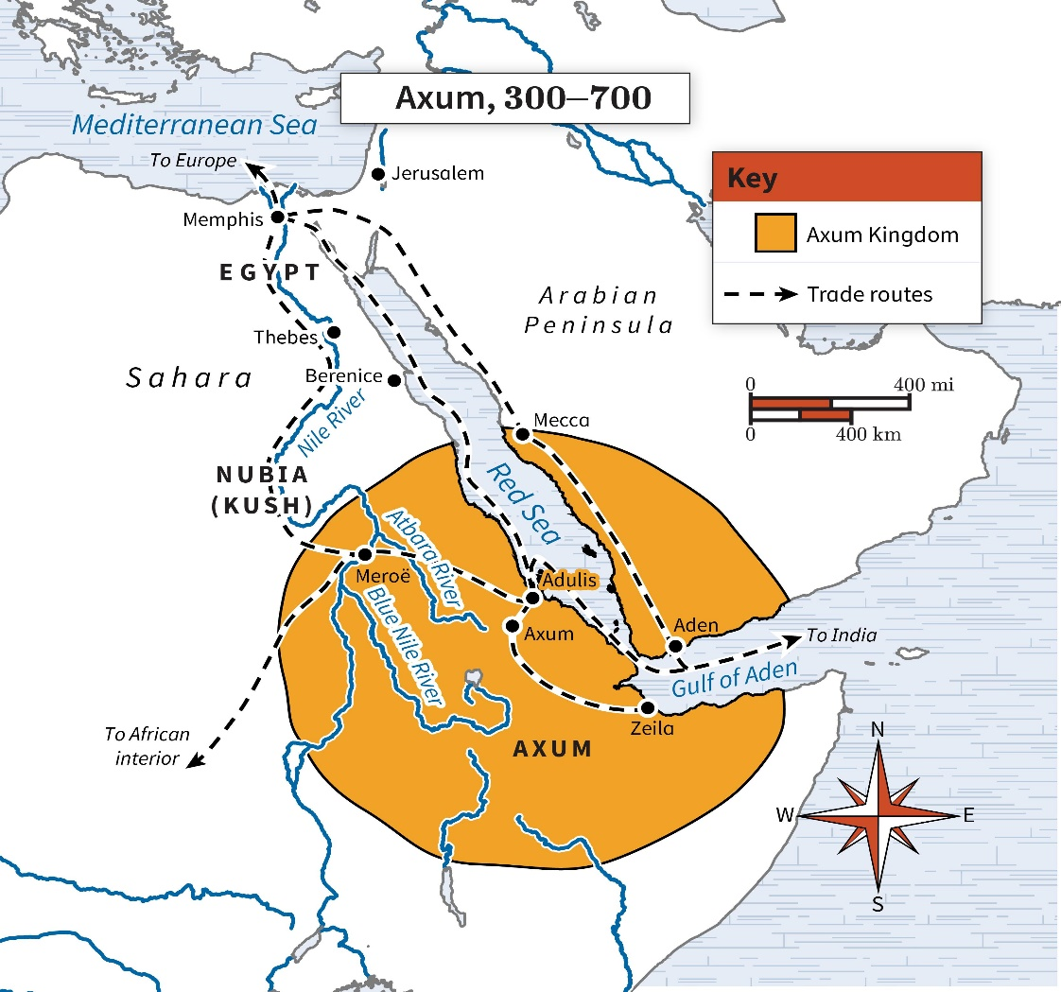 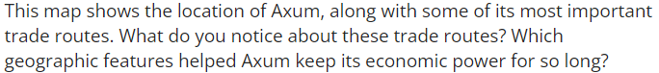

2. Swahili City-States - A collection of city-states along the Swahili Coast that controlled trade in the Indian Ocean from around 1100 CE into the sixteenth century.
3. Bab el-Mandeb Strait - The strait controlled by Axum that connected the Red Sea with the Gulf of Aden.
4. Swahili - A language that emerged from the mixing of Arabic and Bantu languages.
5. Indian Ocean - The ocean along which the Swahili city-states traded with other regions.

Big Ideas:
- Strategic Location: The location of Axum at the Bab el-Mandeb Strait provided an opportunity to control trade in and out of the Red Sea. This helped Axum grow economically and politically.
- Swahili Trade Network: The Swahili city-states thrived due to their strategic positioning along the Swahili Coast. This location made them easy to access for trade routes along the eastern coast of Africa and with regions around the Indian Ocean.
- Communication: The development of the Swahili language from Arabic and Bantu facilitated trade between different language groups around the Indian Ocean, promoting economic growth and cultural exchange.

Check-In Questions:
1. What geographic feature gave Axum an advantage?
- Answer: Bab el-Mandeb Strait.
2. The Swahili language emerged from mixing what two languages?
- Answer: Arabic and Bantu.

Practice Questions:
1. How did location influence Axum’s success as an empire?
- Sample Answer: Axum's strategic position at the Bab el-Mandeb Strait allowed it to control trade in and out of the Red Sea, which supported its economic growth and influence across the region.
2. What factors supported trade on the Swahili Coast?
- Sample Answer: Language and location supported trade on the Swahili Coast. The Swahili language provided a common communication method, and the positioning along the Indian Ocean facilitated easier and safer trade routes.

- Effects of Trade on Economies, Politics, and Culture

Objective 2: To describe the economic, political, and social developments in East Africa before 1500 using a provided source.

Essential Question: What factors contributed to the rise and fall of the Axum Empire and Swahili city-states?

Key Terms:
1. Trade Network - Systems that allowed for the exchange of goods and culture between East African societies and other regions.
2. Colonization - The process of establishing control over indigenous people and their lands by foreign powers.
3. Portuguese Invasion - The entry of Europeans into the Indian Ocean trade network, which disrupted existing trade routes of the Swahili city-states.
4. Decline - The loss of power, influence, and economic stability.
5. Stone Towns - Coastal cities built by the Swahili people that became prominent trading centers.

Big Ideas:
- Trade Dependence: Axum and the Swahili city-states' economies were deeply connected to trade. Economic success impacted political and social stability.
- Cultural Exchange: Through trade, cultural and linguistic exchange flourished, contributing to the unique social structures of East African societies.
- European Colonization: The arrival of Europeans, especially the Portuguese, disrupted Swahili trade networks and led to a decline in their power and influence.
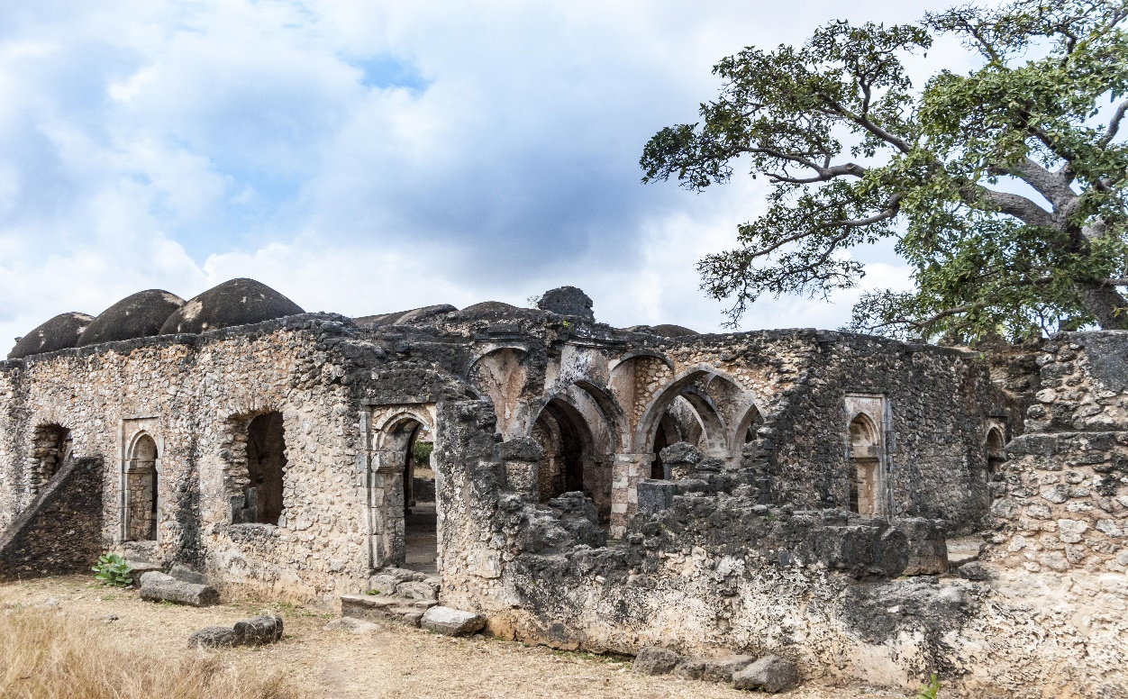

Check-In Questions:
1. When did the Swahili city-states lose influence and power?
- Answer: The end of the fifteenth century.
2. Who took over the trade of the former Axum Empire as it lost influence?
- Answer: Swahili city-states.

Practice Questions:
1. Describe the major factor that led to the end of the Swahili city-states.
- Sample Answer: The arrival of the Portuguese in the Indian Ocean disrupted the trade networks that were the basis of the Swahili city-states' power and influence.
2. What was a change that had a positive impact on trade for the Swahili city-states?
- Sample Answer: The fall of the Axum Empire created a trade vacuum that the Swahili city-states were able to fill, benefiting them economically.

- Sudanic Kingdoms of Ghana, Mali, and Songhai

Objective 3: To describe factors that contributed to the rise and fall of the Sudanic kingdoms of Ghana, Mali, and Songhai.

Essential Question: To what degree were the rise and decline of the West African kingdoms similar?

Key Terms:
1. Trans-Saharan Trade - Trade routes across the Sahara Desert that connected West African kingdoms with North Africa.
2. Taxation - Systems implemented by kingdoms to generate revenue from trade.
3. Mansa - The title of the ruler or king in the Mali Empire.
4. Bureaucracy - A system of government with appointed officials responsible for various administrative tasks.
5. Succession - The process of inheriting a title or position of power.

Big Ideas:
- Strategic Location: The strategic location of the Ghana Empire on trans-Saharan trade routes enhanced its economic power through the taxation of goods like gold and salt.
- Leadership and Organization: Effective leaders like Sundiata (Mali) and Askia Muhammad (Songhai) implemented systems that promoted economic and governmental efficiency.
- Religious Influence: Conversion to Islam played a critical role in government organization and cultural exchange, as seen in the reigns of Mansa Musa and Askia Muhammad.
- External Threats: The decline of these empires often resulted from external invasions, internal strife, and competition over control of trade routes.
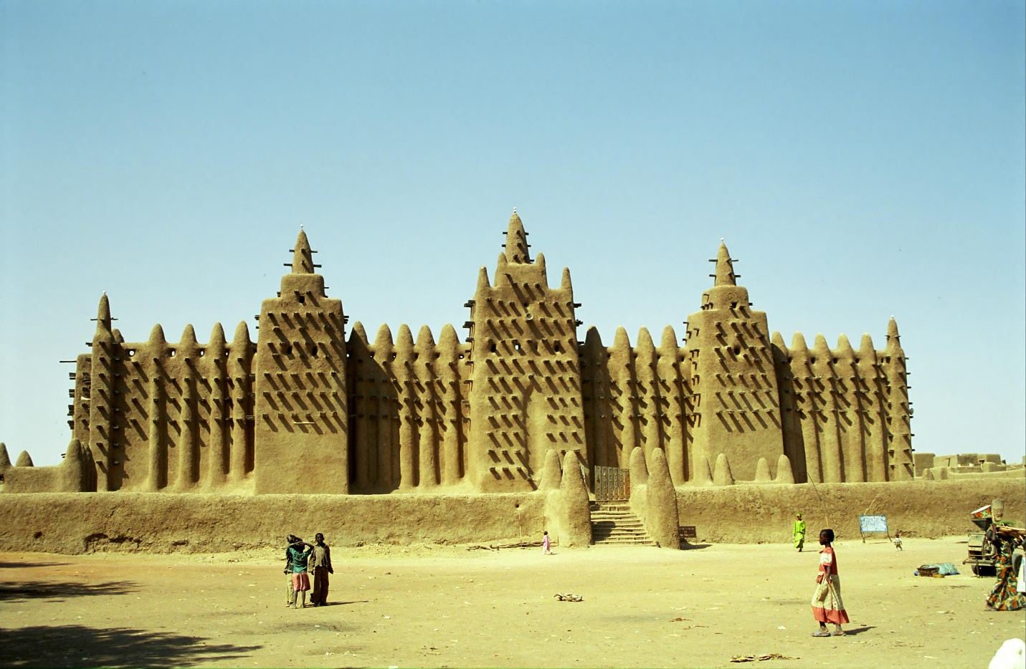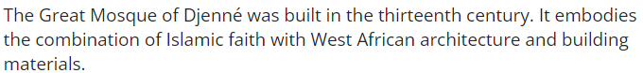

Check-In Questions:
1. Which ruler adopted policies supporting religious tolerance and freedom as a means to ensure peace across his large empire?
- Answer: Mansa Kankan Musa.
2. What method to raise revenue (money) did the West African empires have in common?
- Answer: Taxing trade.

Practice Questions:
1. How was the reign of Mansa Musa similar to Askia Muhammad’s reign?
- Sample Answer: Both leaders were Muslims who implemented government systems that enhanced the efficient rule over large empires.
2. Why might a ruler establish a bureaucracy or assign specific clans certain occupations?
- Sample Answer: Both a bureaucracy and assigning specific occupations to clans use the division of labor to increase efficiency and enable specialization.

- Achievements in West Africa

Objective 4: To explain the significance of key achievements of the civilizations of West Africa before European influence.

Essential Question: Why are achievements in West Africa prior to European influence still significant?

Key Terms:
1. Nok Culture - The earliest known culture in West Africa that produced iron tools and unique art styles.
2. Iron-Smelting - The process of extracting iron from ore, which the Nok people mastered, effectively skipping the Bronze Age.
3. Timbuktu - A renowned center of learning in Mali with substantial libraries and scholarly activity.
4. Original Art Styles - Artistic traditions unique to West Africa, exemplified by Nok sculptures.
5. Trans-Saharan Trade Network - Trade routes that connected West Africa to North Africa and beyond.

Big Ideas:
- Early Iron Use: The Nok culture's use of iron tools and production techniques bypassed the Bronze Age, demonstrating technological advancement.
- Centers of Learning: Timbuktu in Mali was a significant center of scholarship and trade, showcasing the intellectual and cultural achievements of West Africa.
- Recognition of Art: West Africa's original art styles have often been overlooked or mislabeled. Discoveries from Nok culture help validate the region's rich artistic heritage.
- Economic and Cultural Flourishing: The extensive trans-Saharan trade network enabled the exchange of goods, ideas, and cultural practices, contributing to the development of sophisticated societies.
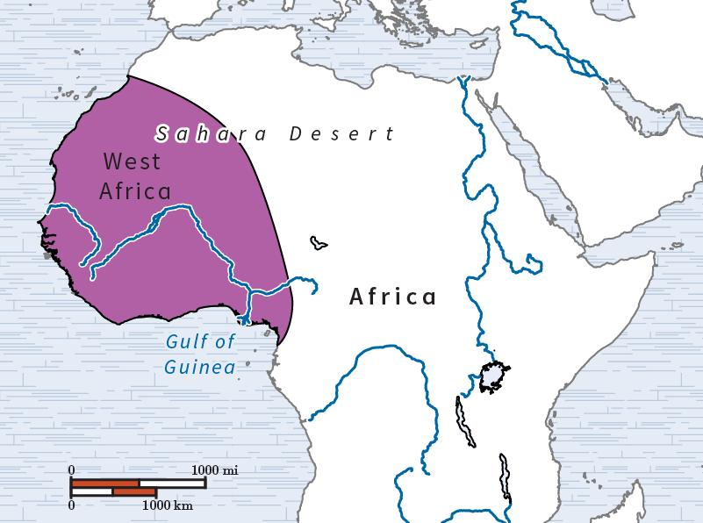

Check-In Questions:
1. What is significant about the Nok culture?
- Answer: It is the oldest known culture in West Africa, renowned for its original art styles and iron-smelting techniques.
2. Why is it important that an artistic ancestor has been discovered in West Africa?
- Answer: Finding an artistic ancestor proves that West African art styles originated in the region and were not merely copied from other cultures.

Practice Questions:
1. Search online for a map of West Africa. What geographical features separate the region from its neighbors?
- Sample Answer: The Sahara Desert separates West Africa from North Africa, and rivers that connect to the Gulf of Guinea often distinguish it from the interior of Africa. There are no hard borders, so not all maps show the exact same regions.
2. How does the idea of iron-smelting being an invention transplanted from elsewhere fit into the common narrative regarding accomplishments in West Africa?
- Sample Answer: Since West African achievements in art and architecture have been historically misattributed to other cultures, scholars might similarly underestimate the potential for iron-smelting to have been an indigenous innovation.

- Unit 5 Lesson 4: Africa and Trade
- Evaluating Trade

Objective 1: Explain the significant similarities and differences between trade patterns of the trans-Saharan trade route and the Indian Ocean basin.

Essential Question: In what ways did trade patterns of the Indian Ocean basin and the trans-Saharan trade route differ and resemble each other, and what was the cultural impact of both trade routes?

Key Terms:
1. Caravans: Groups of traders and their goods traveling together, especially across deserts.
2. Maritime: Related to the sea, especially in regard to seafaring commercial or military activity.
3. Dynasties: Successive ruling families or groups.
4. Cultural Diffusion: The spread of cultural beliefs and social activities from one group to another.
5. Conversion: Changing religion or beliefs, often influenced by interaction with different cultures.

Big Ideas:
- Trade Networks' Development: While the Indian Ocean basin facilitated maritime trade with goods like spices, porcelain, and silk, the trans-Saharan trade route enabled the exchange of gold and salt across vast deserts. 
- Cultural Exchange: Both routes were conduits for religions such as Islam and Buddhism. Trade along these routes didn’t only involve goods but also ideas and beliefs. This resulted in religious and cultural transformations along trade corridors.
- Economic Impacts: Wealth accumulation by states like Mali or the emerging port cities such as Mogadishu and Sofala led to increased power and influence.
- Technological & Navigational Advances: Navigational skills and innovations in maritime technology allowed for the facilitation of long-distance trade across the Indian Ocean. Similarly, camels played a crucial role in crossing the Sahara.
- Symbolism of Trade: On maps, such as the depiction of the king of Mali holding a gold nugget, indicates the wealth and importance of African gold in global trade.

Check-In:
1. What was the role of kingdoms and dynasties, such as the Song and Abbasid in relation to trade patterns?
- Sample answer: In terms of the Song, for example, their need to promote a maritime culture encouraged greater use of the Indian Ocean Basin for trade, thus promoting it as a vital trade network.

2. What were the cultural similarities between the trans-Saharan route and Indian Ocean Basin?
- Sample answer: Trade’s role in the movement and expansion of religion was a vital aspect. Where the Indian Ocean helped spread Buddhism, the trans-Saharan trade helped expand Islam.

Practice:
1. Should we evaluate certain aspects of history as being more significant than others? Why or why not?
- Sample answer: It is difficult to place historical events into a tier system as each is so unique and would not be deemed as significant for everyone.

2. What are some of the aspects we use to evaluate the significance of historical events and factors such as the trans-Saharan trade route and Indian Ocean basin trade?
- Sample answer: As discussed in the video, one aspect we can review is the cultural impact of certain events. For example, the spread of religion due to trade.

3. How did the African gold-salt trade facilitate trade and the spread of ideas?
- Sample answer: The African gold-salt trade routes allowed goods such as gold, salt, and animal products to move across the Sahara by camel caravan. In addition, Muslim merchants exposed West Africans to the religion of Islam, which was eventually adopted by many people, including Mansa Musa, king of Mali.

- The Importance of the Mediterranean Sea and Silk Road

Objective 2: Describe the trade patterns and relationships between East and West Africa and other civilizations prior to 1500 using historical sources.

Essential Question: How did the Mediterranean Sea, the Silk Road, and the trans-Saharan trade route connect East and West Africa to other civilizations, and how is this represented through historical sources?

Key Terms:
1. Silk Road: Ancient trade route connecting Asia with Europe and parts of Africa.
2. Merchants: People involved in trade, buying, and selling goods.
3. Papacy: The central government of the Roman Catholic Church.
4. Dynasties: Successive ruling families or groups.
5. Marco Polo: Venetian merchant whose travels to Central Asia and China were recorded.

Big Ideas:
- Connectivity of Trade Routes: The Mediterranean Sea, Silk Road, and trans-Saharan trade routes created intricate networks connecting Africa, Asia, and Europe, facilitating the exchange of goods, ideas, and cultures.
- Influential Empires & Kingdoms: Kingdoms like Ghana and Mali, and empires like the Byzantine and Ottoman, played pivotal roles in maintaining and controlling these trade networks.
- Cultural and Religious Exchange: Christianity, Islam, and Buddhism spread along trade routes, heavily influencing the cultures and societies they touched.
- Economic Impact: Trade brought unprecedented wealth to regions, influencing politics, and societal structures. For example, the Mali Empire’s wealth was globally recognized. 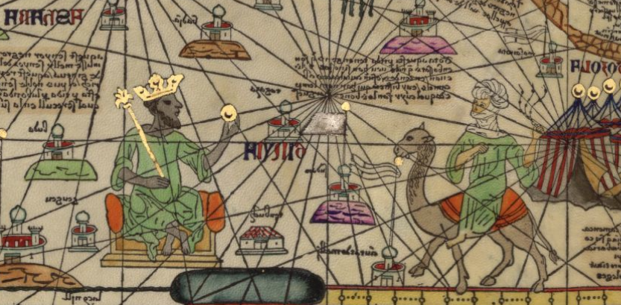
- Continuity and Change: Despite conflicts, trade continued to thrive due to its overwhelming benefits, showing the adaptability and resilience of human societies.

Check-In:
1. What were some of the main products traded on the trans-Saharan route and Silk Road?
- Answer: Silk, gold, and salt.

2. What does the king of Mali appearing on a Spanish map say about African gold?
- Answer: It was famous and far-reaching.

Practice:
1. In what ways do these trade routes resemble our forms of communication and trade today?
- Sample answer: Similar to our internet, the trade routes helped people share and transfer ideas. While the internet is faster, the routes were still an effective way to communicate with the wider world.

2. How has this information broadened your understanding of Africa, the Middle Ages, and cross-cultural communication?
- Sample answer: The information provided reveals that places such as Africa were not as isolated as some may perceive. It also reveals that contact occurred frequently between people from different regions.

- Trade and Conflict Along the Trade Routes of Africa, Europe, and Asia

Objective 3: Describe the relationship between conflict and trade through primary sources from various perspectives and continents before 1500.

Essential Question: How can trade interactions be examined through the relationship between trade and conflict along the trade routes that connected Africa, Europe, and Asia?

Key Terms:
1. Samarkand: A central trade city along the Silk Road.
2. Dynasties: Successive ruling families or groups.
3. Byzantine Empire: Eastern Roman Empire known for its capital, Constantinople.
4. Ottoman Empire: Empire that conquered Constantinople, transforming it into Istanbul.
5. Papacy: The central government of the Roman Catholic Church.
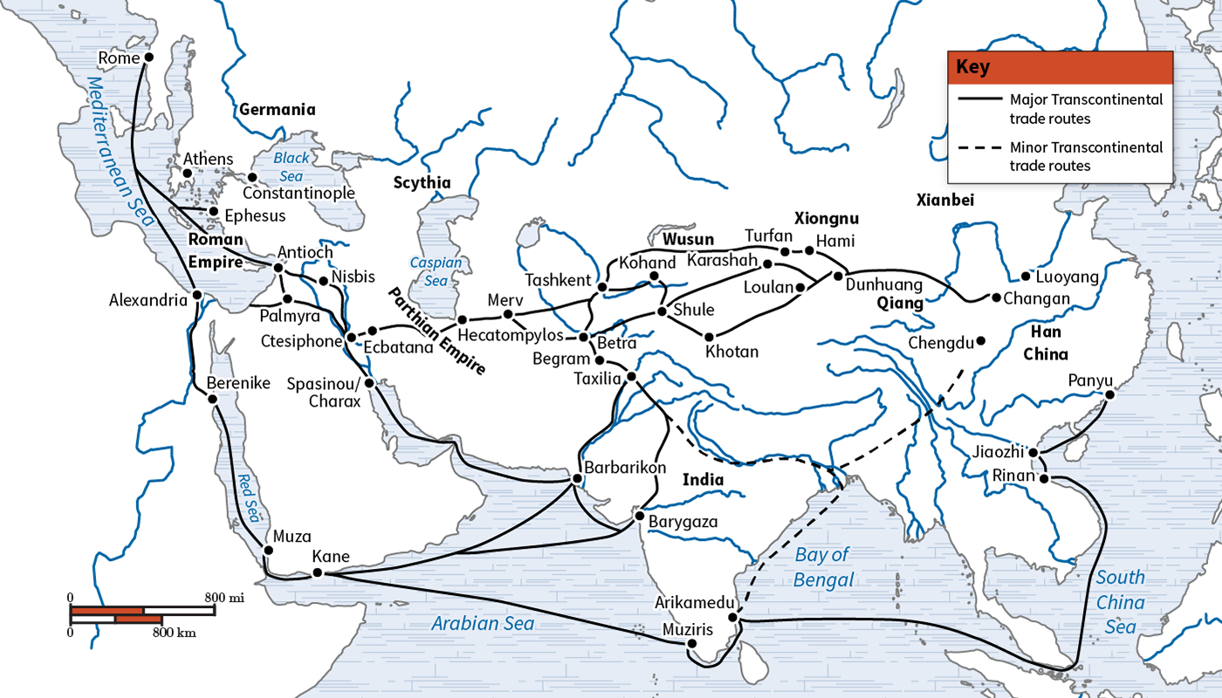
Big Ideas:
- Trade and Conflict Co-existence: Trade did not stop due to conflicts; instead, it adapted. Merchants continued trade despite the political and military upheavals.
- Case Studies: Examples like the trade in Samarkand and the agreement between the Genoese and the Ottoman Empire illustrate the resilience of trade networks.
- Geopolitical Shifts: Major historical events such as the fall of Constantinople and Arab conquests affected trade routes but also led to new opportunities and alliances.
- Local and State-Level Conflicts: Even at smaller scales, such as piracy, trade persisted through diplomatic and commercial agreements.
- Trade’s Political Significance: Control over trade routes equated to economic and political power, influencing global interactions. 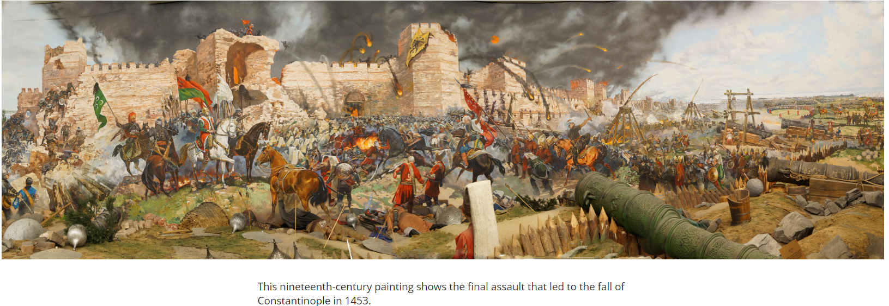

Check-In:
1. Who was affected by the relationship between trade and conflict, and what was the nature of this effect? Give an example from the text.
- Sample answer: Both larger kingdoms and smaller traders were impacted. For example, the Genoese continued to trade with Constantinople even after the Ottoman conquest.

2. In what ways can we see people of different backgrounds come together for the sake of trade?
- Sample answer: The text describes Muslim traders partnering with Christian traders, showing cooperation despite their differing beliefs.

Practice:
1. Why did trade persist in these regions, regardless of the conflict that occurred?
- Sample answer: Trade was deemed important and beneficial enough to forget past conflicts, emphasizing the prioritization of wealth and cooperation.

2. What do examples of trade prevailing over conflict and differences reveal about interactions between different civilizations?
- Sample answer: It reveals that trade was prioritized above all else, as differences did not prevent people from interacting and cooperating.

- Impact of Physical Geography on Trade

Objective 4: Explain the effect of physical geography on trade and interactions with other civilizations before 1500 CE.

Essential Question: How do humans respond to limitations created by physical geography?

Key Terms:
1. Physical Geography: The branch of geography dealing with natural features and processes.
2. Silk Road: Ancient trade route connecting various parts of Asia, Europe, and Africa.
3. Caravan: Groups of traders and animals traveling together for safety and companionship.
4. Oasis: Fertile spots in a desert where water is found.
5. Indian Ocean Trade Network: Maritime trade routes connecting the Middle East, Africa, and Asia.
Big Ideas:
- Geographical Barriers: Mountains, rivers, and deserts created significant challenges for ancient traders but also shaped the trade routes they used. 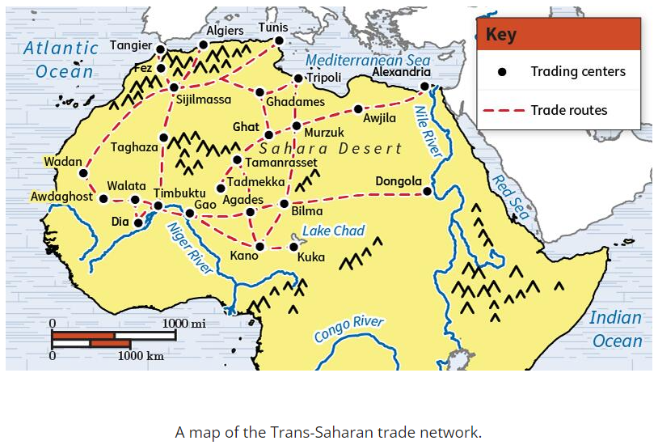
- Adaptation to Environment: Traders developed caravans, utilized rivers, and designed routes with regular stops to overcome geographical challenges.
- Maritime Trade: The Indian Ocean trade routes emerged as an alternative to land routes, leveraging favorable winds and avoiding land-based obstacles.
- Cultural Interaction: Trade routes facilitated cultural exchanges and the spread of religions, integrating diverse societies despite physical barriers.
- Legacy of Trade Routes: Historical trade routes laid the groundwork for modern trade practices and international connections.

Check-In:

1. Why were North and South China politically fractured many times throughout ancient history?
- Answer: They were isolated from one another by physical barriers.

2. What did the Trans-Saharan Trade network depend on?
- Answer: Camel caravans.

Practice:

1. Use the map to answer the question. Analyze how physical geography impacted the organization of trade routes. Identify one trading center and use it to explain how the area was impacted by physical geography.
- Sample answer: The map shows each stretch of the trade route connecting to a nearby water source. Their stops were purposeful. The Saharan Desert was difficult to travel through. Stopping regularly at different oases, such as lakes and rivers, helped traders to survive.

2. Read the article “Silk Road.” Use it to analyze how traders on the Silk Road were impacted by their environment, and how they responded to these challenges.
- Sample answer: Camel caravans were necessary for trade on the Silk Road. The physical geography of China included rivers, mountains, and deserts. These could be difficult to pass through. Camels helped merchants to travel farther and to transport goods.
Synthesize
Study Guide: Global Impact of Trade

- Unit 5 Lesson 5: Global Impact of Trade

- Impact of Global Trade on Economies

Objective 1: Compare the impact of trade interactions on the economic development of African, European, American, and Asian societies by using information from a variety of primary and secondary sources.

Essential Question: How does trade impact the economic development of civilizations?

Key Terms:
1. Globalization: The process by which businesses or other organizations develop international influence or start operating on an international scale. 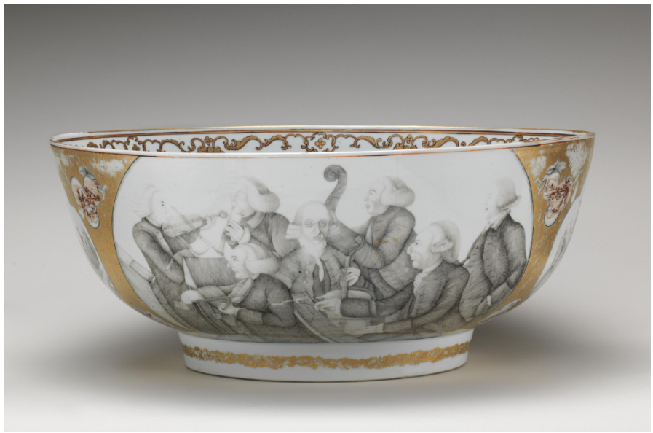
2. Silk Road: An ancient network of trade routes that connected the East and West, significant for the trade of silk and other goods.
3. Mercantilism: An economic policy that is designed to maximize the exports and minimize the imports for an economy.
4. Middle Passage: The sea journey undertaken by slave ships from West Africa to the West Indies. 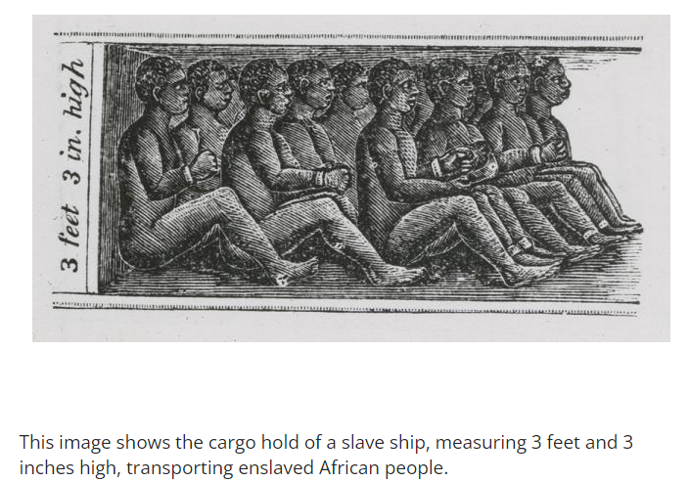
5. Transatlantic Trade Network: The trade system that involved the transportation of goods and enslaved people between Europe, Africa, and the Americas.

Big Ideas:
- Global Connections: Trade networks like the Silk Road and the Indian Ocean trade network connected various civilizations, leading to cultural exchanges and economic growth.
- Economic Impact: Trade brought wealth to many regions, but also led to exploitation and negative impacts, especially as European nations sought power.
- Trade in Asia: Asian civilizations benefited greatly from trade, especially through the Silk Road and Indian Ocean routes, which brought in luxury goods and economic growth.
- European Trade Policies: Europe initially benefitted from systems like mercantilism, which favored state control and the establishment of colonies for resource extraction.
- African Trade: Initially, African nations profited from trade networks, but European exploitation, particularly through the slave trade, had detrimental effects on their societies and economies.
- American Trade: Pre-European trade in the Americas was extensive, with civilizations like the Maya and Aztec building vast networks, but European colonization led to significant disruption.

Check-In Questions:
1. What societies were a part of the Indian Ocean trade network?
- Answer: Asian, African, and Middle Eastern.
2. What did the French and Indigenous Americans trade?
- Answer: They traded fur, weapons, and textiles.

Practice Questions:
1. Use effective reasoning to explain how European exploitation through trade affected other societies.
- Answer: European exploitation led to the enslavement of Africans and Indigenous Americans, resulting in death, disease, and significant population decreases. It also led to the near destruction of economies and cultures.
2. Compare how African and American economies were affected by trade.
- Answer: People from both societies were enslaved by Europeans. Both had their resources and trade goods taken and received few, if any, profits from trade after Europeans controlled them. Their economies took a downward turn due to European intervention.

- Africa’s Role in Global Trade

Objective 2: Describe Africa’s role in the global economy in the sixteenth and seventeenth centuries and how this role impacted its civilizations.

Essential Question: How did the role of Africa in global trade in the sixteenth and seventeenth centuries lead to the decline of the Kingdom of Kongo and the Swahili coast of East Africa?

Key Terms:
1. Indian Ocean Trade Network: A network of trade routes that connected the East African coast with the Middle East, South Asia, and Southeast Asia.
2. Trade Networks: Systems of interconnected trade routes that facilitate the exchange of goods and services.
3. Slave Trade: The capturing, transporting, and selling of people as slaves.
4. Trans-Atlantic Slave Trade: The massive transportation of Africans to the Americas, where they were sold as slaves.
5. Cultural Diffusion: The spread of cultural beliefs and social activities from one group to another.

Big Ideas:
- Wealth from Trade: Africa was wealthy from exporting goods like ivory and gold before European involvement.
- European Exploitation: European nations, especially Portugal, exploited Africa’s trade networks, leading to the decline of African civilizations like the Kingdom of Kongo and Swahili city-states.
- Trans-Atlantic Slave Trade: Portugal’s growing interest in the slave trade led to millions of Africans being kidnapped, enslaved, and transported to the Americas, devastating African societies. 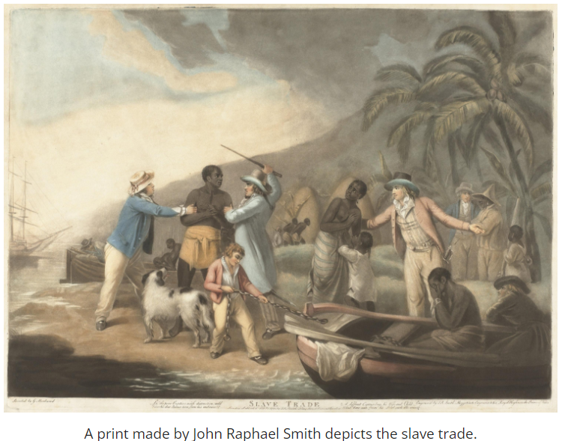
- Decline of African Kingdoms: The arrival of Europeans and their control over trade contributed to the decline and fragmentation of once-prosperous African kingdoms.

Check-In Questions:
1. Describe the role of Africa in the global economy during the sixteenth century.
- Answer: Africans traded goods like ivory, gold, and wood. Initially, they profited, but European arrival and control diminished these profits and led to economic decline.
2. How was the Swahili coast of East Africa impacted by its role in the global economy?
- Answer: The Swahili coast profited from trade with Asia and the Middle East until Portugal took control, attacking cities and disrupting local trade.

Practice Questions:
1. Infer how African history might be different if Europeans never became involved in its trade.
- Answer: If Europeans had never become involved in African trade, Africa may have continued to make money from the Indian Ocean trade network and remained economically prosperous without European exploitation.
2. How did the geography of Africa impact its role in global trade?
- Answer: Societies, such as the Swahili coast of Africa, were located close to the Indian Ocean trade network and were able to profit more from the trade there. The proximity to multiple trade routes allowed different regions to flourish economically.

- The Effects of Cultural Diffusion

Objective 3: Explain how trade with Asia in the Indian Ocean influenced the culture of East Africa.

Essential Question: What was the impact of the Indian Ocean trade network on East African culture?

Key Terms:
1. Cultural Diffusion: The spread of cultural beliefs and activities from one group to another through trade, war, migration, etc.
2. Cultural Preservation: The act of maintaining and promoting the cultural heritage of a community.
3. Trade Network: A series of trade routes that facilitate the exchange of goods, ideas, and cultures.
4. Diaspora: The dispersion of a people from their original homeland.
5. Stone Towns: Historic urban centers along the Swahili Coast, influenced by centuries of trade with Asia and the Middle East.

Big Ideas:
- Cultural Exchanges: Traders traveling between Africa and Asia exchanged cultural practices, religions, and art styles, deeply influencing East African culture.
- Islamic Influence: Muslim merchants established themselves along the Swahili coast, spreading Islamic culture, which is still evident in modern Swahili culture and language.
- Art and Architecture: The diffusion of Islamic culture influenced Swahili art and architecture, seen in the intricate designs and carvings in buildings and mosques.
- Preservation of Traditions: Despite the cultural diffusion, many local traditions, like language and music, were preserved by East Africans. 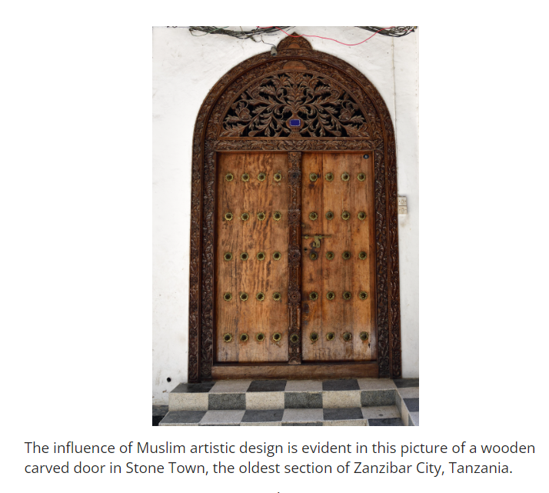

Check-In Questions:
1. What is the term for the global spread of people away from their homeland?
- Answer: Diaspora.
2. Which parts of Swahili culture were impacted by Islam?
- Answer: Swahili language, art, architecture, and religion.

Practice Questions:
1. How was culture spread in East Africa through trade networks?
- Answer: Traders shared their cultural ideas as they communicated and settled in Africa, leading to a blend of local and foreign cultures.
2. What is historically significant about the stone towns along the Swahili coast?
- Answer: Stone towns such as Kilwa showed the lasting impact of cultural diffusion. They were built to profit from trade and were influenced by Islamic architecture and culture.

- Unit 5 Lesson 6: Impact of Trade

- The Impact of Trade and Slavery on Economic Development

Objective 1: Compare the impact of trade on the economic development in African, European, American, and Asian societies and discuss the long-term impact slavery had on African, European, and American economies during the fifteenth century.

Essential Question: How did trade and slavery impact economic development during the fifteenth century?

Key Terms:
1. Silk Road: An ancient network of trade routes that connected the East and West, significant for the trade of silk and other goods.
2. Columbian Exchange: The widespread transfer of plants, animals, culture, human populations, technology, and ideas between the Americas, West Africa, and the Old World in the 15th and 16th centuries.
3. Cash Crops: Crops produced for their commercial value rather than for use by the grower, such as sugar, tobacco, and cotton.
4. Chattel Slavery: A form of slavery where individuals are treated as the personal property of an owner and can be bought, sold, or inherited.
5. Dum Diversas: A papal decree issued by Pope Nicholas V in 1452 that allowed the enslavement of non-Christians, legitimizing the slave trade. 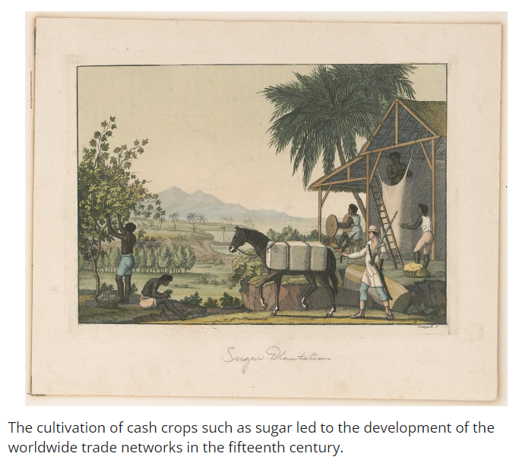

Big Ideas:
- Economic Foundation of Trade: Trade between Afro-Eurasian societies before the Columbian Exchange fostered economic growth and the exchange of valuable goods.
- Columbian Exchange: This exchange dramatically altered economies worldwide, introducing new agricultural products and setting the stage for European colonization.
- Impact of Slavery: The trade and exploitation of enslaved Africans had profound short- and long-term economic impacts on African, European, and American societies.
- Rise of Cash Crops: The development of plantations in the Americas and other continents relying on enslaved labor led to enormous profits and further fueled European colonization efforts.
- Historical Empathy: Understanding the ethical and human dimensions of the slave trade involves acknowledging the vast suffering and economic exploitation that African people endured.

Check-In Questions:
1. Why did Europeans want to find a route to trade with Asia by sea?
- Answer: After the fall of the Mongol Empire, the Silk Road became controlled by various countries imposing different rules and taxes, making the road dangerous and the travel long. Europeans sought a faster and safer sea route.
2. Which two European countries began the trans-Atlantic slave trade?
- Answer: Portugal and Spain.

Practice Questions:
1. Question: Conduct research online to locate at least three primary or secondary sources that describe the long-term impact trade, particularly the Columbian Exchange, had on economic development in Africa, Europe, Asia, and the Americas. Use your research findings and informational text from this lesson to identify the effects and long-term impact of slavery. Which continents (Africa, Europe, Asia, and/or Americas) did slavery have the most significant long-term effects and impacts on economic development? Use the table provided to record and organize your research findings.

Table Example:
Africa:
- Before European involvement, African empires like Ghana, Mali, and Songhai were wealthy due to trade in gold, salt, and other minerals.
- The introduction of the Columbian Exchange led to a shift in economic structures, with a greater focus on trading enslaved people.
- European demand for enslaved Africans significantly disrupted local economies and societies.
- European involvement in trade led to the decline of many African kingdoms, such as the Kongo.
- The trans-Atlantic slave trade led to the forced migration of millions of Africans.
- Led to population decline, loss of workforce, and disruption of social structures.
- Long-term economic stagnation because of losing skilled labor and leaders.
- Created long-lasting social and economic inequalities that still impact African nations today.

Europe:
- The Columbian Exchange brought wealth through new agricultural products and increased trade.
- Europe’s control over colonies and trade networks allowed it to amass enormous wealth.
- Development of powerful colonial empires that facilitated further global dominance.
- Funding from trade profits led to advancements in military, technology, and infrastructure.
- The use of enslaved labor in plantations helped produce valuable cash crops (sugar, tobacco, cotton) that fueled European economies.
- Spain and Portugal's initial participation set the stage for widespread acceptance of slavery.
- Financial gains from slavery financed European growth and colonization efforts.
- European societies experienced moral and social upheaval related to their involvement in slavery.

Asia:
- European interest in Asian commodities (spices, silk, tea) led to increased trade interactions.
- Introduction of crops from the Americas, such as maize and sweet potatoes, which boosted agricultural output.
- Economic growth supported by a diversified agricultural base.
- Strengthened Asia's position in global trade networks.
- Asia was not heavily involved in chattel slavery compared to Africa and the Americas.
- Asian societies engaged in other forms of labor exploitation but generally did not depend on the trans-Atlantic slave trade.
- The impact of slavery as seen in Africa and the Americas was less pronounced in Asia.

The Americas:
- Before European colonization, Indigenous cultures like the Aztecs and Incas had established trade networks.
- The Columbian Exchange introduced Europeans crops, animals, and disease, which reshaped local economies.
- Establishment of plantations and exploitation of natural resources by Europeans.
- Significant wealth generated for European colonizers through export crops.
- The discovery of the Americas and the establishment of plantations led to the large-scale use of enslaved Africans for labor.
- Indigenous populations were decimated by disease and forced labor, decreasing their ability to contribute to the economy.
- Long-term development of racial hierarchies and economic systems based on slavery.
- Created economic structures heavily reliant on slavery, with lasting social and economic consequences.

2. Question: Use the table to compare the impact trade had on the economic development in African, European, American, and Asian societies. Summarize your findings in at least four paragraphs. Then, use your research findings on slavery to discuss the long-term effects it had on Africa and the impact it had on African, European, and American economies. Present your discussion in at least one paragraph. (Note: You will use the rubric to assess your work on the portfolio.)

Considerations for the Portfolio:
- Important People/Groups: Identify key figures involved in trade and the slave trade, such as merchants, rulers, and explorers.
- Important Facts: Note significant developments in trade systems and slavery impacts.
- Important Dates: List key dates relevant to the rise and fall of trade networks, significant battles, and the implementation of new trade laws or routes.
- Important Places: Identify crucial geographical locations involved in trade and slavery.
- Long-Term Economic Impacts of Trade: Highlight the lasting economic consequences of pre-Columbian and Columbian trade networks on different continents.
- Long-Term Effects and Impact of Slavery: Analyze the enduring effects of the slave trade on Africa, Europe, and the Americas.

Summary Paragraphs for Practice Question 2:

Africa:
Before European involvement, African empires like Ghana, Mali, and Songhai were prosperous due to their trade in gold, salt, and other minerals. The introduction of the Columbian Exchange caused a shift towards trading enslaved people, which significantly disrupted local economies and social structures. The demand for enslaved Africans led to the capture and forced migration of millions, resulting in population decline, loss of workforce, and long-term economic stagnation. The decline of powerful African kingdoms, such as the Kongo, can be attributed to European exploitation, leaving a legacy of social and economic inequalities.

Europe:
The Columbian Exchange and subsequent control over global trade networks allowed Europe to amass enormous wealth. The influx of new agricultural products, particularly cash crops like sugar and tobacco, bolstered European economies. This wealth funded advancements in military, technology, and infrastructure, leading to the development of powerful colonial empires. However, European societies grappled with moral and social issues related to their involvement in the trans-Atlantic slave trade, which provided the labor force for the plantations.

Asia:
Asian economies flourished with the introduction of new crops from the Americas, such as maize and sweet potatoes, which boosted agricultural output. Europe’s heightened interest in Asian commodities like spices, silk, and tea spurred increased trade interactions, strengthening Asia's position in global trade networks. Although Asian societies did not heavily rely on chattel slavery, they engaged in other forms of labor exploitation, resulting in less pronounced direct impacts from the trans-Atlantic slave trade.

The Americas:
Before European colonization, Indigenous cultures had extensive trade networks, but the Columbian Exchange introduced dramatic changes. Europeans brought new crops, animals, and diseases, reshaping local economies and decimating Indigenous populations. The establishment of plantations led to the widespread use of enslaved Africans for labor, creating wealth for European colonizers while annihilating native cultures. The Americas saw the development of economic systems reliant on slavery, creating lasting social and economic vulnerabilities.

Discussion on Slavery:
The trans-Atlantic slave trade had profound effects on the continents involved. Africa experienced severe population decline and long-term economic stagnation due to the loss of skilled labor. In Europe, the financial gains from slavery facilitated colonial expansion and economic growth. The Americas became heavily reliant on enslaved labor for their plantation systems, leading to significant social and economic changes, including the entrenchment of racial hierarchies and economic inequality.

- Unit 5 Lesson 7: Africa and Religion
- Africa Prior to Christianity and Islam

Objective 1: Describe Indigenous religious practices in Africa.

Essential Question: What were Indigenous religious practices in Africa before the arrival of Christianity and Islam?

Key Terms:
1. Oral Traditions: Passing stories, history, and beliefs from one generation to the next by word of mouth.
2. Customs: Traditional practices followed by people of a particular group or region.
3. Yoruba: An Indigenous religion from southwestern Nigeria, Benin, and northern Togo.
4. Zulu: An Indigenous religion, and the largest ethnic group in South Africa.
5. Deities: Supernatural beings or gods worshipped in various religions.

Big Ideas:
- Diverse Beliefs: Before Christianity and Islam, Africa was home to a variety of Indigenous religions. These religions were often linked to specific ethnic groups and regions. 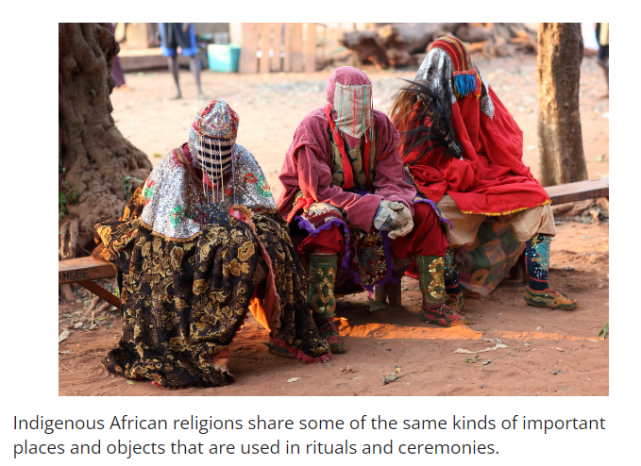
- Creator Gods: Most Indigenous religions believed in a creator god, who made the universe but did not interfere in daily life. Worship involved lesser deities and ancestors.
- Religious Rituals: Prayers, offerings, and sacrifices were common. Ancestors played a crucial role, and diviners helped connect people to the spiritual world.
- Influence on Modern Faiths: Even after adopting Christianity or Islam, many Africans continued to integrate their traditional practices with the new religions. 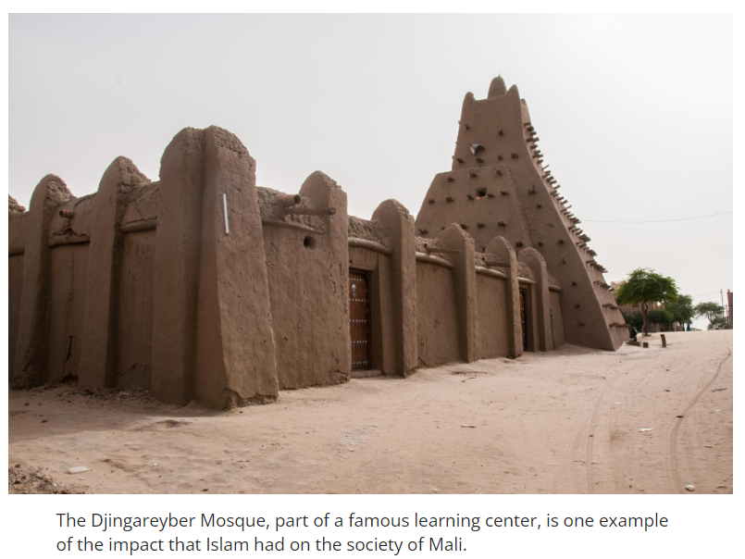

Check-In Questions:
1. What are shrines?
- Answer: Shrines are places regarded as holy that have a building or structure built on top.
2. Who are diviners?
- Answer: Diviners are people who are believed to be able to read and interpret signs from deities and connect directly to the spiritual world.

Practice Questions:
1. Describe the importance of ancestors in Indigenous African religions.
- Answer: Ancestors in Indigenous African religions are deceased family members. Prayers to ancestors are often used to ask for blessings and good fortune or for protection from illness or bad luck. Diviners or priests and priestesses often serve as intermediaries, connecting people to their ancestors.

2. Explain the idea of deities in some Indigenous African religions.
- Answer: Many Indigenous African religions, including the Yoruba and Zulu, believe that there was one creator god who made the universe. However, once this god created the universe, the god no longer interfered with humans’ everyday life. Instead, humans interacted with deities (lesser gods or supernatural beings) to determine the rules for worship and spiritual interaction.

- The Influence of Indigenous African Religions on Christianity and Islam

Objective 2: Explain how Indigenous religious practices in Africa influenced the African Christian and Islamic religions.

Essential Question: How did Indigenous African religious practices change the practice of Christianity and Islam in Africa?

Key Terms:
1. Oral Tradition: The practice of passing down stories and beliefs by word of mouth.
2. Custom: Traditional practices followed by a specific group or community.
3. Yoruba: Indigenous religion from southwestern Nigeria, Benin, and northern Togo.
4. Zulu: Indigenous religion and the largest ethnic group in South Africa.
5. Ancestor: A deceased family member who is honored and prayed to in many Indigenous religions.

Big Ideas:
- Mix of Religions: Christianity and Islam in Africa often included Indigenous beliefs and practices.
- Cultural Traditions: Many rituals and customs from Indigenous religions were carried over into African Christianity and Islam.
- Ancestral Worship: Respect and prayers to ancestors continued even as new religions were adopted.
- Hybrid Practices: Practices like wearing protective amulets with verses from the Bible or Quran show the blending of Indigenous and new religions.

Check-In Questions:
1. What was the dominant religion in Africa before the arrival of Islam and Christianity?
- Answer: There was no one dominant Indigenous African religion. Instead, people had a variety of faiths and spiritual practices that differed depending on a person’s ethnic identity and the area of Africa where they lived.
2. What is Voodoo?
- Answer: Voodoo is a religion that blends elements of Indigenous African religions and both Christianity and Islam.

Practice Questions:
1. Clearly communicate examples of the ways in which Indigenous African religions blended with Islam and Christianity in Africa.
- Answer: There are many examples of ways Indigenous religions blended with Islam and Christianity in Africa. The first is all three believe in one God. The second is that African Christians and Muslims incorporate similar rituals and sacrifices in their religious practices to those used in Indigenous religions such as the Yoruba and Zulu. A final example is that African Christians and Muslims often maintain a belief in witchcraft. They sometimes wear traditional amulets containing written verses from the Bible or Quran.

2. Search online to learn more about the spread of Christianity and Islam in Africa. Then summarize your research, writing a few sentences that clearly communicate why Islam spread faster than Christianity on the continent.
- Answer: Islam spread faster than Christianity in Africa for several reasons. For one, Africa was geographically close to the Islamic empires that had taken over the Middle East in the sixth century. This location led to the military conquest of African kingdoms, as well as the establishment of trade networks. Another reason Islam spread faster than Christianity was that Islam allowed many of the Indigenous African religions’ traditional rituals and practices to continue, while Christianity did not. A final reason is that Islam brought stability and education to many Africans during this time period.

- The Impact of Blended Religious Practices on Early African Societies

Objective 3: Explain the impact of blended religious practices on the early African societies of Mali and Songhay.

Essential Question: How did blended religious practices impact the early African societies of Mali and Songhay?

Key Terms:
1. Oral Tradition: The practice of passing down stories and beliefs by word of mouth.
2. Custom: Traditional practices followed by a specific group or community.
3. Polygamy: The practice of having more than one spouse at the same time.
4. Amulet: A small object worn to protect the person from bad luck or evil.
5. Ancestor: A deceased family member who is honored and prayed to in many Indigenous religions.

Big Ideas:
- Mali Empire: The Mali Empire blended Islam with traditional practices. King Mansa Musa was a devout Muslim and made significant contributions like the establishment of Sankoré University, yet traditional religious practices continued among the general population.
- Songhay Empire: In the Songhay Empire, Islam was the official religion, but rulers did not force people to convert from their traditional religions. The empire encouraged a multicultural society.
- Blending of Practices: Both empires showed a blend of traditional African and Islamic practices, indicating a harmonious coexistence of old and new beliefs.
- Historical Influence: The blending of religious practices influenced social structures and cultural developments in both empires.

Check-In Questions:
1. Which Mali king attempted to make Islam the official religion of nobility?
- Answer: Mansa Musa
2. Why is Sankoré University significant?
- Answer: Sankoré University was a large university. It was begun as an Islamic school in the Mali Empire. It grew to eventually teach thousands of students. It also housed the largest library in Africa at the time.

Practice Questions:
1. Use the information provided in the lesson to create a bulleted list that provides examples of the ways Indigenous religions blended with Islam in Africa.
- Sample answer:
- They both believed in one God.
- African Muslims used similar rituals and sacrifices to those of Indigenous African religions.
- Both Muslims and followers of Indigenous African religions wore amulets.
2. Access information online to learn more about the impact of Islam and traditional religions on the Mali and Songhay empires. Analyze this information and use it to write a few sentences that describe these impacts.
- Sample answer: Unlike the Kingdom of Ghana, the leaders of the Mali and Songhay empires adopted Islam. This led to support from Arab countries in the trading network. It brought great wealth for both empires. This connection also led to the development of large cities, mosques, and universities. Islam was named the official religion in Mali. However, while Islam was well adopted in both Mali and Songhay, the rulers of both empires did not force their people to convert. This led to the blending of religious practices. Many Africans who adopted Islam continued to use the same rituals, customs, and traditions from their traditional religions. In most cases, Mali and Songhay’s rural population chose to remain with their traditional religions.

