Additional Problems: Functions & Their Graphs

**Representing Functions**

1. Use the table to answer the question

|  |  |
| --- | --- |
| **X** | **f(x)** |
| -2 |  |
| -1 |  |
| 0 |  |
| 1 |  |
| 2 |  |

Finish creating the input-output table for the function f(x) = -2(x-1)^2 + 5. Which of the given x values produces the largest output for the function?

* 1. x = -2
  2. x = -1
  3. x = 0
  4. x = 1
  5. x = 2

1. Use the table to answer the question

|  |  |
| --- | --- |
| **X** | **f(x)** |
| -3 |  |
| -1 |  |
| 1 |  |
| 3 |  |
| 5 |  |

Finish creating the input-output table for the function f(x) = -(x-2)^2 + 8. Which of the given x values produces the largest output for the function?

* 1. x = -3
  2. x = -1
  3. x = 1
  4. x = 3
  5. x = 5

1. Sara is starting a tutoring business. She charges a flat rate of $20 plus an additional $25 per hour, regardless of the subject. Create a function and use a table to determine how much Sara will make if she works for 1, 1.5, 2, 2.5, and 3 hours.
   1. (1, 45), (1.5, 57.5), (2, 70), (2.5, 82.5), (3, 95)
   2. (1, 25), (1.5, 32.5), (2, 40), (2.5, 47.5), (3, 55)
   3. (1, 20), (1.5, 30), (2, 40), (2.5, 50), (3, 60)
   4. (1, 45), (1.5, 50), (2, 55), (2.5, 60), (3, 65)
2. Jake is starting a dog walking service. He charges a flat rate of $5 plus an additional $10 per hour, regardless of the number of dogs. Create a function and use a table to determine how much Jake will make if he works for 1, 1.5, 2, 2.5, and 3 hours.
   1. 1, 15), (1.5, 20), (2, 25), (2.5, 30), (3, 35)
   2. (1, 10), (1.5, 12.5), (2, 15), (2.5, 17.5), (3, 20)
   3. (1, 10), (1.5, 15), (2, 20), (2.5, 25), (3, 30)
   4. (1, 15), (1.5, 22.5), (2, 30), (2.5, 37.5), (3, 45)
3. Fatima is working on a painting for an art exhibit. She has already painted 50 square feet and can paint about 20 square feet per day. Which of the following functions correctly relates the verbal information about the function to an algebraic equation?
   1. y = 20x
   2. y = 50x + 20
   3. y = 20x - 50
   4. y = 20x + 50
4. Akio is saving money to buy a new bike. He already has $150 saved and can save an additional $25 per week. Which of the following functions correctly relates the verbal information about the function to an algebraic equation?
   1. y = 25x
   2. y = 150x + 25
   3. y = 25x - 150
   4. y = 25x + 150
5. Emma rents an electric scooter to use for the day. She has to pay a deposit and a minute rate. Using the information from this graph, enter the values that complete the equation for this situation:

y = _____x + ______

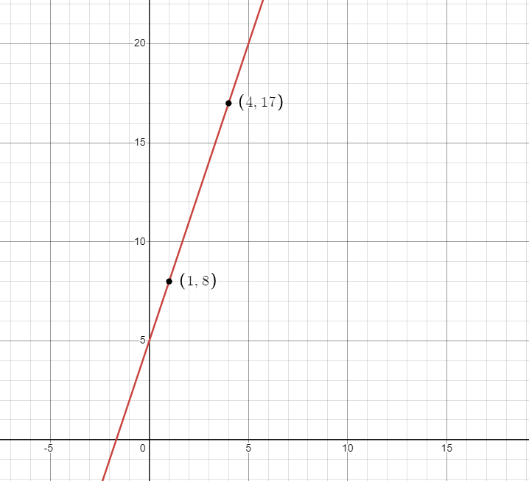

1. Beniah rents a bike to use for the day. He has to pay a deposit and an hourly rate. Using the information from this graph, enter the values that complete the equation for this situation:

y = _____x + ______

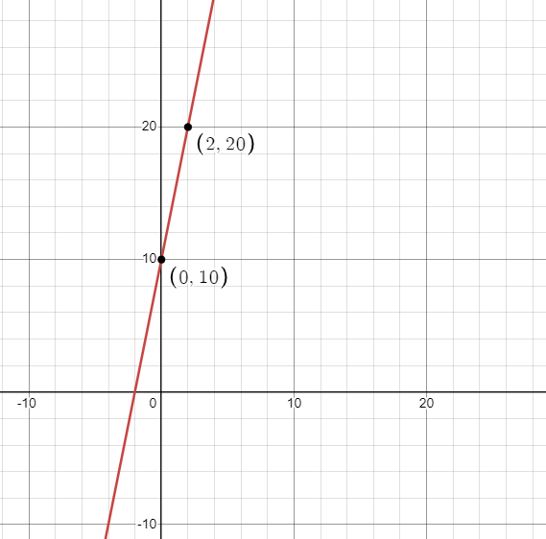

1. Use the table to answer the question

|  |  |
| --- | --- |
| Years (x) | Value of Machinery f(x) |
| 1 | 45,000.00 |
| 2 | 40,500.00 |
| 3 | 35,450.00 |
| 4 | 32,805.00 |
| 5 | ? |

A piece of machinery decreases in value after a given number of years. The following function represents the value of the machinery in dollars with respect to its age, x, in years f(x) = 50,000(0.90)^x. Use the input-output table to determine the value of the machinery after 5 years. Round your answer to the nearest cent. Rounded to the nearest cent, after 5 years, the value of the machinery will equal $____

1. Use the table to answer the question

|  |  |
| --- | --- |
| Years (x) | Value of Computer f(x) |
| 1 | 960.00 |
| 2 | 768.00 |
| 3 | 614.40 |
| 4 | 491.62 |
| 5 | ? |

A computer decreases in value after a given number of years. The following function represents the value of the computer in dollars with respect to its age, x, in years: f(x) = 1,200(0.80)^x. Use the input-output table to determine the value of the computer after 5 years. Round your answer to the nearest cent. Rounded to the nearest cent, after 5 years, the value of the computer will equal $____